Discussion Forum
Our journal (2011, Vol. 81, No. 4) published the article “Lessons of the Development of the Orbital Theory of the Paleoclimate” by V.A. Bol’shakov and A.P. Kapitsa. The topic discussed in it is being debated heatedly by specialists, one of whom decided to comment on the article and give reasons for the astronomical theory of the paleoclimate.
DOI: 10.1134/S1019331613010073
Analyzing the Lessons of the Development
of the Orbital Theory of the Paleoclimate
I. I. Smul’skii*

The problem of the astronomical theory of the paleoclimate, considered by V.A. Bol’shakov and A.P. Kapitsa in [1], is so important that it is worth analyzing the lessons of its development once more. The article by the above authors analyzes the astronomical theory of ice ages (as it was called previously) in different aspects, including its authorship and name. Bol’shakov and Kapitsa call it the orbital theory of the paleoclimate.
As the authors of the article point out, the opinion that this theory was created by M. Milankovič was developed in the literature. However, he had outstanding forerunners, such as J. Adhemar [2], J. Croll [3], and others. For example, Adhemar was of the opinion that glaciations might occur in a hemisphere if winter fell on the aphelion of the Earth’s orbit. In other words, the change of ice ages is determined by a shift of the aphelion or the perihelion, which is often called precession.
The authors are of the opinion that Croll’s contribution to the astronomical theory of ice ages has unjustly been forgotten. He believed that the small influence of insolation change on climate was strengthened at the expense of other climatic processes; for instance, even an insignificant expansion of the area of snow and ice covers, caused by an increase in the Earth’s albedo, would prompt further glaciation. The detaching of the Gulf Stream from Europe may be viewed as another factor that would lead to cooling in the Northern Hemisphere.
Bol’shakov [1, 4] calls these two factors of positive feedback. Criticizing Milankovič’s works, he suggests that we should abandon the term astronomical theory of the variations of the climate because, in

* Iosif Iosifovich Smul’skii, Dr. Sci. (Phys.–Math.), is chief researcher at the Institute of the Earth’s Cryosphere, RAS Siberian Branch.
his opinion, the only thing to which Milankovič’stheory may lay claim is the orbital theory of insolation. As for the orbital theory of the paleoclimate, it is still awaiting creation, because at present researchers’ opinions about the influence of a number of factors are diametrically different. The publication under discussion is mainly directed against Milankovič’s theory. The authors of the article see the following drawbacks in his theory. Climatic cycles last 100000 years, which is determined by the eccentricity, while Milankovič does not account for the eccentricity. Ice events fall on the minimums of the eccentricity, while in Milankovič’s theory they fall on its maximums. According to Milankovič’s theory, summer temperature decreases and winter temperature increases during glaciations, while, in the opinion of Bol’shakov and Kapitsa, both of them drop. After one million years, the main climatic periodicity changes from 41000 years to 100000 years, which is not accounted for in Milankovič’s theory. In both hemispheres, climatic changes are synchronous rather than asynchronous, as is stated in Milankovič’s theory. Milankovič attributed paleoclimatic significance to summertime insolation at 65° N: he interpreted its lowest values as glaciations, which correlated well with the then_popular Alpine scale developed by A. Penck and E. Brǘckner but found no confirmation later.
The authors of the article under discussion formulated the above drawbacks of Milankovič’s theory proceeding from analysis of the published sources that described the studies of the second half of the 20th century. In particular, Fig. 1 of their article compares changes in the eccentricity with the oxygen isotope curve that shows the correlation of the extrema of these dependences. Proceeding from the above dependence, Bol’shakov maintains that the eccentricity directly affects climate.

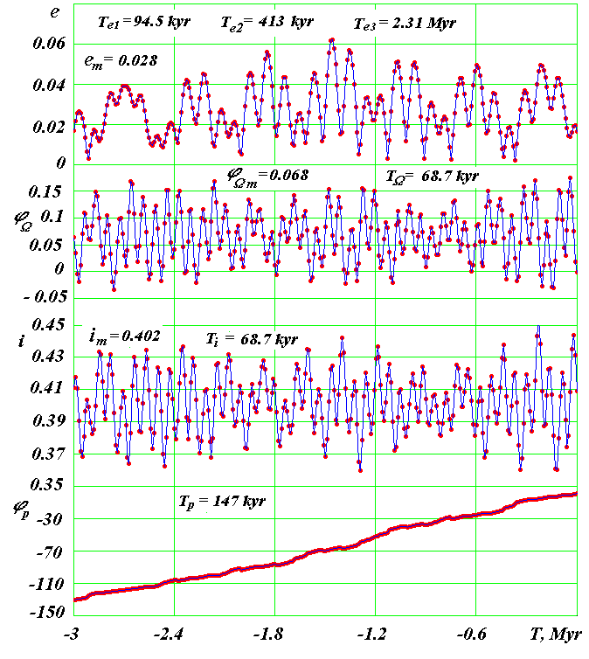
Fig. 1. Evolution of the Earth’s orbit over 3 million years [6].
(е) The eccentricity; (ϕ_{Ω}) the angular position of the ascending node of the orbit plane on the immobile plane of the equator; (i) the angle of the orbit plane tilt to the immobile plane of the equator; and (ϕ_{р}) the angular position of the perihelion from the ascending node of the orbit. The angles are in radians, and the time Т is in millions of years starting from December 30, 1949. In the graphs, the values with the m index are the average values of parameters over 50 million years; Т_{e}, Т_{i}, and Т_{Ω} are the main oscillation periods of the respective parameters in thousands and millions of years; and Т_{p} is the average period of the perihelion revolution over 50 million years.

ARGUMENTS FOR MILANKOVIČ’STHEORY
Bol’shakov and Kapitsa point out — and this issound — that Milankovič developed a rigorous mathematical theory of calculating insolation. According to it, the Earth’s insolation depends on the parameters of its orbit and axis. Changes in the Earth’s insolation are not determined, as the above authors believe, by changes in the three orbital elements: the eccentricity of the Earth’s orbit e, the tilt ε of the Earth’s axis to the perpendicular to the ecliptic plane, and the precession of the Earth’s axis. They are not purely orbital elements. It should be noted that the angle ε is generally referred to as obliquity of the Earth’s orbit.
In reality, two groups of independent movements determine changes in insolation. On the one hand, as a result of interaction between bodies of the solar system, the orbits of the planets change; on the other, owing to the oblateness of the Earth, the surrounding bodies create a moment of forces that acts on it, which changes its rotational movement. A change in the orbit occurs as a result of four movements: it deforms (the eccentricity changes); it rotates counterclockwise in its plane; the orbit axis rotates clockwise around the spatially immovable angular momentum vector of the solar system; and the orbit axis oscillates relative to this vector [5, 6]. The four movements are characterized by their own periods and amplitudes. Figure 1 shows the main oscillation periods of the orbit elements. The rotation of the orbit axis here is reflected by the oscillation of two parameters, i and ϕ_{Ω}, with the axis rotation period Т_{S} = Т_{i} = Т_{Ω} = 68700 years.
The Earth’s axis moves clockwise around the movable axis of its orbit and oscillates relative to it; hence, the Earth’s insolation is determined by the relative parameters of these two groups of movements: the tilt angle ε between the movable planes of the Earth’s orbit and the equator and the angle ϕ_{pγ} between the perihelion and the intersection line of the above planes. Only the third parameter, the eccentricity e, is purely orbital.
The above parameters are applicable in considering the Earth’s movement from outer space, while in observing the Sun from the Earth’s surface, the e, ε, and ϕ_{pγ} parameters mean the following: the eccentricity e determines the smallest per_year distance R_{p} = a(1 – e) of the Sun from the Earth. a here means the average annual distance to the Sun. It is practically invariable in all years. The ε angle determines the Sun’s angular altitude over the horizon at noon on June 22. For example, at latitude ϕ, the Sun’s latitude is 90° – ϕ° + ε°. The ϕ_{pγ} angle is equivalent to the number of days from the day of the Sun’s most significant approach (in the modern epoch, this is January 3) until the day of the spring equinox on March 22.
Note that many authors do not understand what they speak about when they are speaking about the influence of precession on climate. To calculate insolation, the above_mentioned ϕ_{pγ} angle is used, determined by three rotations: the counterclockwise rotation of the orbit in its plane with a period of 147000 years and two clockwise rotations — that of the orbit plane or its axis with a period of 68700 years and that of the Earth’s axis with a period of 25800 years.
In addition to the above_mentioned six movements, two more affect the Earth’s insolation: daily and yearly. More than 2500 years ago, Babylonian astronomers used to study these movements and created their mathematical models. Milankovič thoroughly studied the geometry of all the movements and, having generalized the works by his forerunners, developed an insolation calculation theory. Bol’shakov is of the opinion that Milankovič’s calculations neglect the direct contribution of changes in the eccentricity to the insolation curve. The illumination of an area of the Earth’s surface depends on three factors: its distance from the Sun, the angle of the ray’s tilt to it, and illumination duration. Milankovič’s insolation calculation theory accounts for all the movements; as a result, the three previously mentioned parameters — e, ε, and ϕ_{pγ} — are part of it. No other parameters should be added to this theory, either directly or indirectly. Milankovič fully understood the essence of this phenomenon and described it in strict mathematical terms.
Bol’shakov and Kapitsa understand the task of science differently, and they write that Milankovič’sinsolation curve mechanically combines qualitatively (structurally) different insolation signals of individual orbital elements. We will see below how these statements are reflected in their authors’ approach.
The astronomical theory of the paleoclimate is impossible without calculating insolation. Insolation may be calculated only on the basis of the Milankovič’s theory. This is why some statements from the article under discussion seem surprising, for example: “The statement about the validity of the Milankovič’s theory is one of the most long_standing mysteries of the 20th century” [1, p. 392]. To all appearances, the authors mean the deep_rooted tendency to explain all discovered paleophenomena by changes in the insolation curve. In this respect, one may agree with the opinion of the authors of the article under study, but this is not because of Milankovič’s theory but rather because of its application by our contemporaries.
Let us consider one of the drawbacks of Milankovič’stheory, mentioned by the authors of the article under study, namely the insolation factor at 65° N. To choose a certain insolation characteristic as the main paleoclimatic factor is a difficult task. It is necessary to perform preliminary studies and to determine which insolation characteristic correlates with paleoclimatic phenomena. Proceeding from studies of ice deposits in Europe, Milankovič’s forerunners and contemporaries concluded that the decisive moment for the rise of ice ages was the combination of cold summers with relatively warm winters [7, p. 151]. Snow accumulated because it had no time to thaw in summer. This conclusion also received confirmation through comparing the previous climate in Central Europe with modern conditions in Greenland and the Antarctic: a low temperature prevents the thaw of precipitation and leads to its accumulation. Milankovič brings forward Penck’s, Brǘckner’s, and other researchers’ arguments to prove that the depression of the snow line in the Alps was caused by the decreased sum of summertime temperatures rather than by an increase in precipitation. Researchers came to the same conclusion in comparing “the part of Siberia between 60° and 70° N” [7] and Southern Greenland, situated at the same latitude. Southern Greenland, covered with ice, has an average temperature that is 9°С higher than that in the above part of Siberia. However, summer in Southern Greenland is 11°С colder than summer in Siberia. That was why W. Kцppen and Milankovič concluded that summer played the central role in the glaciations process and chose insolation at 65° N during the summer half_year period as the paleoclimatic factor.
Scientists reviewed the orbital problem, the problem of the Earth’s rotation, and the insolation theory proceeding from a new basis. Within the first two items, there appeared specifications of the theories and even new results. The insolation theory was rearranged using the new mathematical apparatus, and Milankovič’sresults were recalculated with account for the Earth’s orbit and rotation parameters that he had used. The results coincided: Milankovič had done his job well and for full due.
Note that the insolation theory makes it possible to calculate insolation at any latitude. He who uses this theory determines at which latitude it is necessary to consider changes in insolation. In studying deep_sea sediments in the Indian Ocean, one should study their dynamics against the background of insolation changes in the sediment_sampling site. The structure of ice cores in the Antarctic should be compared with the evolution of insolation on the South Pole.
In addition to insolation, Milankovič paid significant attention to various other factors that also affect climate. For example, he studied the possibility to determine the temperature of the lower air layer proceeding from the calculated insolation. He developed a theory of processes in the atmosphere, soil, and the ocean that helped determine the temperature of the latter at a definite insolation [7]. The scientist derived certain relations that might be used as benchmarks. Note that this problem, which he tried to solve almost 100 years ago, is unmanageable for modern science. However, he found a “byway.” Milankovič’s reasoning was as follows: if insolation in an epoch T at the latitude ϕ_{T} is the same as insolation at the latitude ϕ₀ in the modern epoch T = 0, we should assume that climate in the epoch T was the same as it is now at the latitude ϕ₀. The presentation of insolation in equivalent latitudes made it possible to perform not only qualitative but also quantitative studies of the connection of insolation with the evolution of the climate. This approach partially accounts for all feedforward and feedback that were established on the Earth and have not been elucidated by modern science thus far.
Note also that Milankovič introduced caloric half-years, making it possible to compare insolation in different epochs adequately. Since the duration of astronomical half-year changes, the comparison of insolation on their basis would have led to distorted concepts of climate change. Hence, following Bol’shakov and Kapitsa, we should treat with care generalizations in which characteristics of climate oscillation are based on average daily or monthly insolation changes.
In his book [4], Bol’shakov gave a broad analysis of the literature and presented theses that he united in the form of the new concept of the orbital theory of the paleoclimate. However, there is no theory thus far except for Milankovič’s astronomical theory. We say about those who have done something: “He did this the best he could, and let others do better if they can.” There is nothing better than Milankovič’s theory thus far.
THE NEW CONCEPT
OF THE ASTRONOMICAL THEORY
What do the authors of the article under discussion propose, and what is the essence of the new concept of the orbital theory of ice ages? Supposedly, the insolation theory should be supplemented by the influence of feedback. They mean the increase in the reflecting power of the snow–ice sheet and the increased role of insolation in connection with departure of the Gulf Stream. In addition, in the opinion of Bol’shakov and Kapitsa, it is necessary to account for other feedback as well, including a negative manifestation — the transfer of warm moist air from low latitudes to high ones. This transfer mitigates the difference between the insolation levels of these latitudes. If the difference increases, the transfer strengthens, and the overcooling of high latitudes becomes weaker. The authors propose the following “chain of interactions in the process of climatic oscillations of the Pleistocene: insolation change → primary change in temperature (of high latitudes in the first place) → change in the area of the snow and ice cover → positive albedo feedback and subsequent global temperature change → change in the concentration of CO2 plus further change in the area of snow and ice → feedback at the expense of the albedo and the greenhouse effect → ultimate temperature change” [4].
Bol’shakov approaches the climate_change problem like a “black box.” There are three input signals: the eccentricity, tilt, and precession. He uses as the output signal the oxygen isotope curve of deep_sea sediments, selecting three coefficients (1, 0.7, and ⎯0.55) for the three input signals and the respective scales of the curves in such a way as to ensure that the change in the common curve of the input signals would best coincide with the change in the isotope curve. Bol’shakov is of the opinion that it reflects 100000-year periodicity quite well.
Thus, the theory is constructed. It turns out, however, that it does not reflect 40000-year periodicity. Since the theory is valid, it is supplemented by a new hypothesis, and a selective parametric resonance mechanism in the climatic system is proposed. Then a large number of hypothetical constructions are presented, involving positive and negative feedback. Here Bol’shakov manipulates an object that he names the “climatic system.” We do not know what it is, what its components and properties are, what processes occur in it, how they are described mathematically, and so on. We know nothing about the mechanism through which the eccentricity acts on the isotopic composition of sediments. There is no need for this because the climate system is viewed as a black box directly affected by input signals, including the eccentricity. This theory will hardly be better than Milankovič’s, which establishes an unambiguous mathematical connection between insolation and the eccentricity.
Bol’shakov’s work is a bright example of the approach developed in science in the 20th century. No one requires today that phenomena of the surrounding world should be studied to the point when it becomes possible to understand all its sides. It is implied that only God can understand everything, while scientists are guided by the paradigm accepted in their community. Within this paradigm, it is necessary to propose a number of promising hypotheses and to construct a theory. If a new Einstein or Milankovič comes around, the paradigm may be changed and new theories may be constructed.
Many such theories were constructed in the 20th century, especially to explain micro- and macro- worlds. Now we know many outlandish things about the world, but we do not know how it is organized. When humankind first encountered the problem of climate warming, it posed the following questions before scientists: why does the warming occur, and what are its possible negative consequences? In the face of the abundance of hypothetical constructions created by science of the 20th century, the intergovernmental panel of the most prominent specialists in this field [8] assigned to them different degrees of indefiniteness. Naturally, the conclusions of this panel of scientists were largely indefinite as well, from 100 to 50%. A 50-percent indefiniteness means that something may be this way or diametrically opposed to it.

IMPROVING THE ASTRONOMICAL THEORY
Milankovič’s theory is in accordance with the scientific traditions of the 19th century. It attempts to establish determinate connections that would make it possible to speak perfectly definitely about the future climate of the Earth. It turned out, however, that, even today, knowledge about the climate’s past is far from being sufficient to solve this task; many drawbacks of the above approach, justly noted by the authors of [1], have become clear. The main drawback is that small variations in insolation cannot explain the span of paleoclimate fluctuations from ice epochs to almost tropical conditions.
Are all the potentialities of the astronomical theory exhausted, however? It turns out that the orbital problem and the problem of the Earth’s rotation have not been solved to the full thus far. In the 20th century, in solving the orbital problem on large time intervals, scientists obtained divaricating orbits of the planets and came to the conclusion about the instability of the solar system [9]; for this reason the opinion that it is impossible to calculate insolation for periods exceeding 20 million years gained a foothold [10]. However, in the past few decades, a new method of the numerical integration of orbital movement equations has been advanced [11], which has made it possible to solve the orbital problem for a period of 100 million years [5]. All periods and amplitudes of variations in the parameters of the planets’ orbits were obtained. (Figure 1 shows them for the Earth’s orbit.) It turns out that the orbits of all the planets are stable, and there are no signs of their violation.
The orbit problem in the astronomical theory of the paleoclimate had an approximate solution, while the problem of the Earth’s rotation had no solution at all. Observed data about the precession of the Earth’s axis were used; they were prolonged in time with account for the influence of the Sun and Moon. Hence, this theory includes only axis variations with a period of 41000 years, determined by the relative precession of the Earth’s axis and the axis of its orbit. The Earth’s axis makes various oscillations with shorter periods. The entire set of oscillations may be accounted for only after the problem of the Earth’s rotation with account for the action of all bodies has fully been solved. On a new basis, differential equations of rotational movement were introduced [12] and integrated with account for the sole action of the planets, Sun, and Moon on the Earth. Figure 2 shows the dynamics of the θ angle of the Earth axis rotation tilt to the motionless axis of the orbit under the action of these bodies. The Moon’s action is the most significant. The action of the Sun is twice as small. Among the planets, Venus and Jupiter exert the strongest action on the Earth’s rotation.
The Earth rotation problem is the most difficult problem of mechanics. Many questions remain unanswered. For this reason a series of studies on modeling rotational movement using the compound model of the Earth was conducted [13]. In this case, a part of our planet’s mass is distributed among peripheral bodies. The surrounding bodies — the Moon, the Sun, and the planets — change the orbit of a peripheral body, and the axis of its orbit models the axis of the Earth’s rotation. The task for three different models was considered for an interval of 110000 years. Short-period fluctuations of the angle ε were obtained, the periods of which coincided with observations. However, the 41000-year period in these solutions was absent. Unfortunately, this model reflects only some properties of the Earth, and, hence, ultimate conclusions may be made only after the main problem has been solved.
When we undertook solving the problem about the Earth’s rotation with account for the simultaneous action of all the bodies on the Earth, we did not

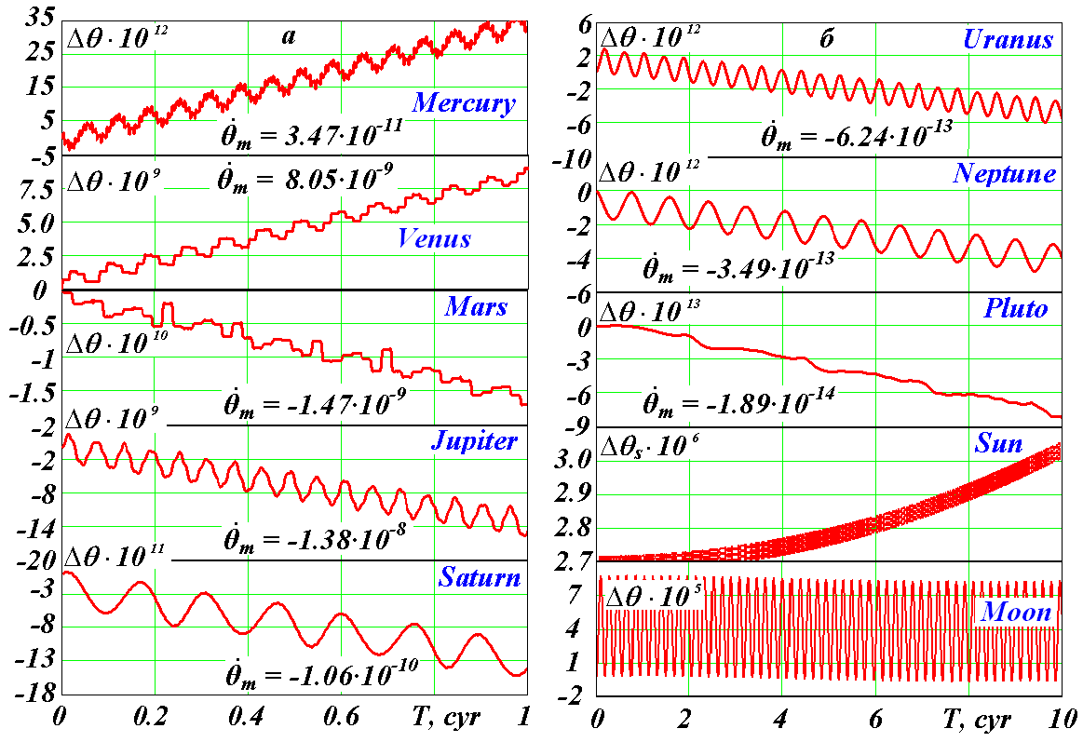

Fig. 2. Oscillations and trends of the Earth’s axis under the sole action of the planets, the Sun, and the Moon.
(a) On an interval of 100 years; (b) on an interval of 1000 years; and (θ) the angle of the equator plane tilt to the immobile plane of the orbit. On the above time intervals, the oscillation of the angle θ is identical to the oscillation of the obliquity ε. $Δθ=θ−θ_{0}$ is the difference between the tilt angles, where θ₀ is the tilt angle in the initial epoch December 30, 1949; ${\overset{˙}{θ}}_{m}$ is the average velocity of the tilt in radians over a century; in the graphs, the periods of the main oscillations of the Earth’s axis are equal, from Mercury to the Moon, to, respectively, 6.6, 8.1, 15.8, 5.9, 14.7, 42, 82.4, 248, 0.5, and 18.6 years. The angles are in radians [12].

expect to obtain substantially different results compared to those of other authors. This is why the evolution of the obliquity ε, represented by line 1 in Fig. 3, surpassed all expectations. In previous astronomical theories (line 2 and point 3), changes in the ε angle occurred from 22.3° to 24.3°, while in our solutions the tilt angle varies from 16.7° to 31°. Thus, the range of the obliquity ε variations increased by seven times. This should lead to fundamentally different insolation oscillation that affects climate in a different way.
In Fig. 4, insolation at 65° N (line 1), which we calculated, is compared with insolation given by the previous theory (line 2). Its oscillation is also seven times larger. In addition, comparison with Fig. 3 shows that the dynamics of insolation Q copies the dynamics of the obliquity ε; in other words, the other parameters — the eccentricity e and the perihelion ϕ_{pγ} — do not play a substantial role. Consequently, the obtained insolation dynamics affects climate differently. As opposed to the previous theory, the new results testify to simultaneous warming or cooling in both hemispheres. It was this thesis of the previous astronomical theory that gave rise to the main objection of the authors of [1].
Note that the eccentricity e and the perihelion ϕ_{pγ} affect the dynamics of the obliquity ε; i.e., owing to these parameters, ε oscillations in Fig. 3 have an irregular form. Moreover, the parameters e and ϕ_{pγ} exert an additional action on insolation, which is significant under a low ε oscillation and insignificant under a high one.
In the new solutions, the high amplitude of insolation oscillation fully, without engaging additional factors, explains the previous fluctuations in climate. For example, in 93600 years (see the highest maximum in Fig. 4), summertime insolation at 65° N will be higher than now at the equator; while in 109100 years (the lowest minimum in Fig. 4), insolation will become significantly lower than today’s summertime insolation on the pole. Moreover, in these solutions, not only summertime but also annual insolation changes substantially. For example, in the above epochs, annual insolation on the pole in the warm period will be 1.79 times higher; at 65° N, it will be 1.23 times higher than in the cold epoch. (Note that the practical invariability of annual insolation in

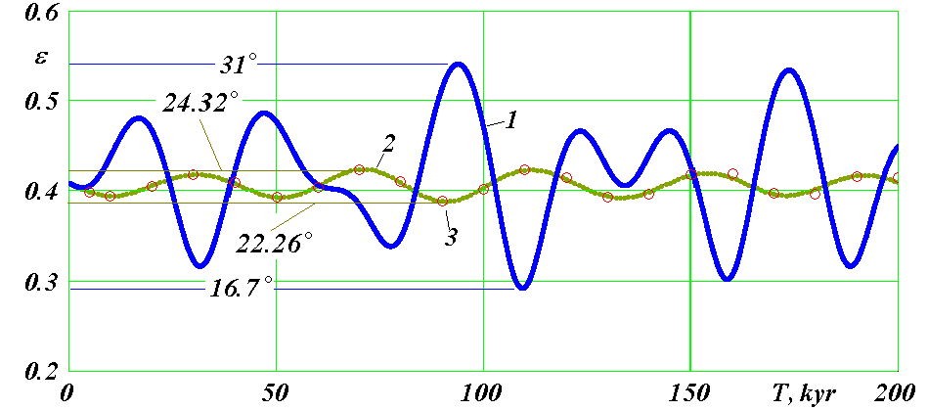

Fig. 3. Evolution of the Earth’s equator plane tilt angle ε (in radians) to the plane of the Earth’s orbit in an interval of 200000 years.
(1) According to the results of the numerical integration of rotational movement equations under the simultaneous action of the planets, the Sun, and the Moon; (2) according to the theory of J. Laskar and others [10]; and (3) according to the theory of Sh.G. Sharaf and N.A. Budnikova [14]. Presented in degrees are the maximal and minimal values of the obliquity ε.

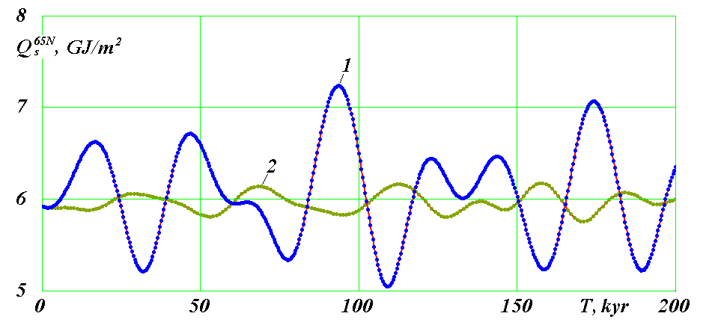

Fig. 4. Evolution of the specific (per 1 m³) heat quantity Q (in GJ/m²) over a summertime caloric half_year at 65° N over 200000 years.
(1) According to our calculations and (2) according to the calculations of Laskar et al. [10].

accordance with the previous astronomical theory also gave rise to Bol’shakov and Kapitsa’s objections.) Such changes in insolation may create in high and medium latitudes both necessary conditions for the existence of mammoth fauna and blanket glaciers.
Thus, the obtained data about the oscillation of the axis of the Earth’s rotation may explain previous variations in the climate. However, since the problem of the Earth’s rotation was solved for the first time (note that this is a difficult problem), error is likely. Various checks took more than a year. The obtained solutions on short time intervals yield the same periods and amplitudes of the Earth’s axis oscillations

as in observations. New changes in the obliquity ε up to 2500 years coincide with the ε changes in the previous theories. Ultimately, checks of all the equations of our planet’s rotational movement were performed, and no errors were discovered. Hence, we began solving this problem using a different method, namely, by creating such a compound model of the Earth’s rotational movement that would best simulate the evolution of our planet’s axis. We had considered more than ten different models before we found the precession velocity that would coincide with the velocity of the Earth axis precession. The fluctuations in the tilt ε of this model on short time intervals (300 years) coincided with the observed oscillation of the Earth’s axis. Now it is necessary to obtain solutions for 100000 – 200000 years.
This task requires a lot of time for calculations. It will probably take several years to accomplish them. However, if the results of the compound model confirm the results shown in Fig. 3, we will be able to calculate changes in insolation over the past epochs and to begin comparison with data about the paleoclimate. Overall, we represent the astronomical theory of climate change in the following way: the evolution of the orbits → the evolution of the Earth’s axis → insolation change → correlation between insolation and paleoclimate → forecasting 1000-year changes in the Earth’s climate.
We presented our work plan in a form equivalent to that of the authors of [1] to make them comparable. Our plan is a continuation of the deterministic trend in science of the 19th century. Note that G. Borchardt [15] analyzed the history of development of human thought and concluded that periods of indeterminism and determinism in science alternated. Most likely, in the 21st century, science will enter an epoch of determinism, and the astronomical theory will introduce definiteness into the Earth’s past. History teaches us, however, that intentions, seemingly realizable within existing knowledge, later encounter insuperable difficulties. Hence, the program of the authors of the paper under discussion deserves attention. Their approach is topical today, when humankind has accumulated a large amount of various data about changes that took place on the Earth. These data should be analyzed from different positions depending on various circumstances.
At present, the situation is such that, even if there appears a deterministic insolation theory accounting for large insolation fluctuations, definiteness in the understanding of paleoclimate will not become significantly higher. This is due to the fact that the existing data about the paleoclimate (its flora, fauna, soils, relief, continental and sea sedimentation, and icecores) are not interlinked. They do not provide an integral picture about climate changes thus far. We should work to establish connections between them, to interpret them, and to perform targeted search for additional data.

ON THE NAME OF THE THEORY
The name orbital theory of the paleoclimate, proposed by Bol’shakov and Kapitsa, does not account for the contribution of rotational movement to the evolution of insolation. Of course, many other astronomical factors may affect climate. It is clear that the exterior of the Earth could have changed because other bodies fell on it. The orbital and rotational movements of the Sun also evolve. Changes in its movement may lead to changes in physical conditions on the Sun and, consequently, may affect the Earth’s climate [5]. It is also possible that neighboring stars act on the solar system as well. The literature often mentions the Galaxy’s action: scientists introduce galactic cycles of 200 million years, equaling the Sun’s revolution period around the center of the Galaxy. They also consider the periodic haziness of interplanetary space when the solar system intersects the Galaxy’s arms. Many of these factors are hypothetical and have no reliable basis. For example, the arms of spiral galaxies were created by stars that moved along rather than across them. The spiral character of a galaxy shows that there is no orbital movement (like the revolution of the Earth around the Sun) in it. Rather, movement occurs in the form of the spiral’s coiling and uncoiling. The above scientific problems, just like the Galaxy’s action on the Earth’s climate, are still waiting for investigation.
Today, among all astronomical factors in the climate theory, only two are taken into account: the orbital and the rotational movements of the Earth. This is why, following the creators of the theory, it is necessary to preserve its name—the astronomical theory of climate change. If an additional factor turns out to be significant in the future, it will become a supplement to the former two. If there are several such factors, our descendants, no doubt, will find suitable terms to reflect adequately all the actions on the climate of our planet. Note that, for solving the above galactic problems, the Galactica free access system was developed [11]. Using it, we have been solving the orbital problem and modeling the rotation problems for the Earth [13] and Sun [16, 17].

* * *
What lessons of the development of the astronomical theory of the paleoclimate did we draw from the article by Bol’shakov and Kapitsa and the above considerations? The theory originated long ago, and we should remember its creators — Croll, Adhemar, Milankovič, and others. From time to time, it is necessary to recall original ideas: which of them have been realized, and which were lost and should be reconsidered. Milankovič formulated a rigorous theory of the Earth’s insolation, analyzed the connection of insolation with climate change on the Earth, and, through his selfless efforts, managed to make the astronomical theory of ice ages the main instrument that helped scientists interpret paleoclimatic data. Since Milankovič’s time, several groups of researchers have repeated his calculations. They increased the period under study to 30 million years [14], but the fundamental results remained unchanged. There are discrepancies between the theory’s conclusions and the accumulated data about climatic changes in the past: small insolation oscillation and strong changes in climate, asynchronous changes in insolation in the hemispheres against the background of synchronous climate fluctuations in them, and so on. It is necessary to continue working on the development of the astronomical theory of the climate.
Over the last century and a half, the original ideas of the creators of the astronomical theory about the influence of the Earth’s orbit and rotation axis oscillation on climate have been confirmed. However, the existing discrepancies between the theory and observations, as well as the lack of an integral picture of changes in the Earth’s paleoclimate, do not make it possible thus far to establish an unambiguous connection between insolation and climate. It is necessary to perform numerous studies in many fields to complete the astronomical theory of the paleoclimate.
The following question may arise: why do we need an astronomical theory of climate change? If it is created, all earth sciences will acquire an unambiguous chronological base, which will lead to a more effective use of knowledge. Another application of this theory is solution of the problem of modern climate warming. Success depends largely on understanding the causes of paleoclimate oscillation. The work of the Intergovernmental Panel on Climate Change [8] did not answer the question about the causes of modern warming, but its activity helped determine the vector of further studies.

REFERENCES
1. V. A. Bol’shakov and A. P. Kapitsa, “Lessons of the Development of the Orbital Theory of Paleoclimate,” Her. Russ. Acad. Sci. 81 (4), 387 (2011).
2. J. A. Adhemar, Revolutions de la mer: Deluges Periodiques (Carilian_Goeury et Dalmont, Paris, 1842).
3. J. Croll, Climate and Time in Their Geological Relations: A Theory of Secular Changes of the Earth’s Climate (Edward Stanford, London, 1875).
4. V. A. Bol’shakov, A New Concept of the Orbital Theory of Paleoclimate (Izd_vo MGU, Moscow, 2003) [in Russian].
5. V. P. Melnikov and J. J. Smulsky, Astronomical Theory of Ice Ages: New Approximations. Solutions and Challenges(Akademicheskoe izd_vo GEO, Novosibirsk, 2009).
6. I. I. Smulskiy, “Some Astronomical Problems of the Cryosphere Evolution,” in Proceedings of the Tenth International Conference on Permafrost, Vol. 2: Translations of Russian Contributions (Severnoe, Salekhard, 2012).
7. M. Milankovič, Mathematic Climatology and Astronomic Theory of Climatic Fluctuations (Borntreger, Berlin, 1930; GONTI, Moscow, 1939).
8. Climate Change 2007: The Physical Science Basis. Contribution of Working group I to the Fourth Assessment Report of the Intergovernmental Panel on Climate Change (Cambridge Univ. Press, 2007).
9. J. Laskar, “Marginal Stability and Chaos in the Solar System,” in Dynamics, Ephemerides, and Astrometry of the Solar System, Ed. by M. S. Mello et al. (IAU, 1996), pp. 75–88.
10. J. Laskar, P. Robutel, F. Joutel, et al., “A Long_Term Numerical Solution for the Earth,” Icarus 170 (2) (2004).
11. J. J. Smulsky, “Galactica Software for Solving Gravitational Interaction Problems,” Applied Phys. Res., No. 2 (2012).
12. J. J. Smulsky, “The Influence of the Planets, Sun, and Moon on the Evolution of the Earth’s Axis,” Int. J. Astronomy Astrophys. 1, 117 (2011).
13. V. P. Mel’nikov, I. I. Smul’skii, and Ya. I. Smul’skii, “Compound Modeling of Earth Rotation and Possible Implications for Interaction of Continents,” Russ. Geol. Geophys. 49 (11), 852 (2008).
14. Sh. G. Sharaf and N. A. Budnikova, “Secular Changes in the Elements of the Earth’s Orbit and the Astronomical Theory of Climate Fluctuations,” in Proceedings of the Institute of Theoretical Astronomy (Nauka, Leningrad, 1969), vol. 14 [in Russian].
15. G. Borchardt, The Scientific Worldview: Beyond Newton and Einstein (Progressive Science Institute, Berkely, 2007).
16. I. I. Smul’skii, “Numeric Modeling of the Evolution of a Satellite of a Rotating Body,” in Theoretical and Applied Problems of Nonlinear Analysis (VTs im. A.A. Dorodnitsyna RAN, Moscow, 2008) [in Russian].
17. J. J. Smulsky, “New Components of the Mercury’s Perihelion Precession,” Natural Science, No. 4 (2011).

