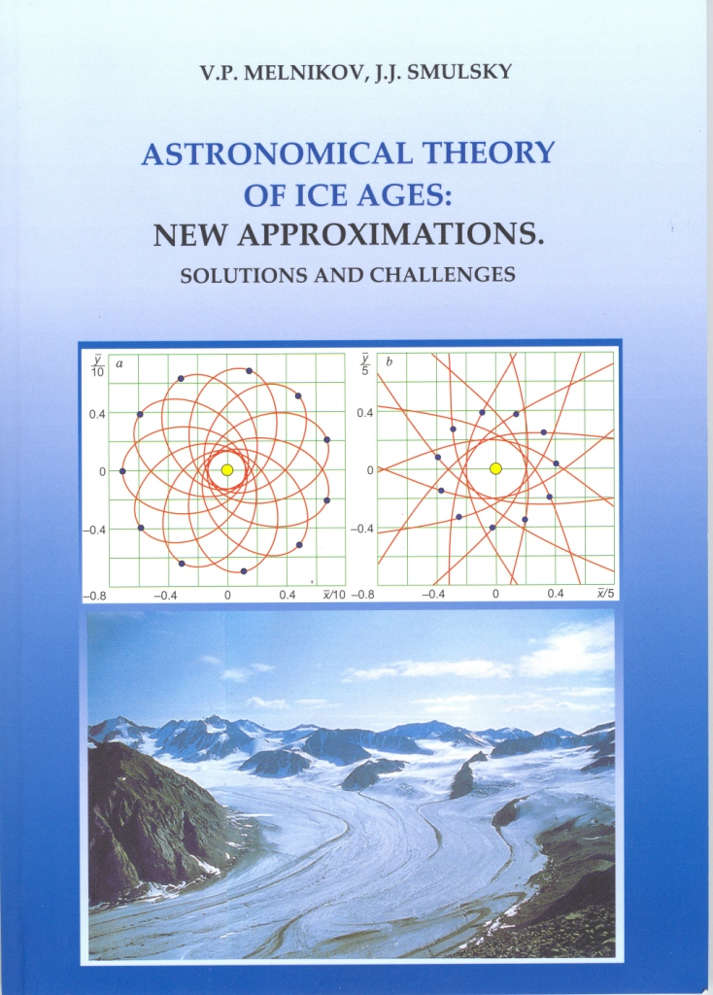

SIBERIAN BRANCH
RUSSIAN ACADEMY OF SCIENCES
INSTITUTE OF THE EARTH'S CRYOSPHERE

V.P. MELNIKOV, J.J. SMULSKY
ASTRONOMICAL THEORY OF ICE AGES:
NEW APPROXIMATIONS.
SOLUTIONS AND CHALLENGES
Edited by Prof. E.A. Grebenikov
NOVOSIBIRSK
ACADEMIC PUBLISHING HOUSE "CEO"
2009

UDK 523.2+551.34+551.324 BBK 22.62:26.237 M52
Melnikov, V.P. Astronomical theory of ice ages: New approximations. Solutions and challenges / V.P. Melnikov, JJ. Srnulsky; Russian Academy of Sciences, Siberian Branch, Institute of the Earth's Cryosphere. -Novosibirsk: Academic Publishing House "Gco", 2009. - 84 p.: col. pict. - ISBN 978-5-9747-0142-9.
The theory of orbital climate forcing is revisited with an approach which implies numerical integration of differential equations for the orbital and rotational motions. In the orbital motion problem, the new code is applied to integrate the orbits of eleven material particles of the Solar System (nine planets, the Moon, and the Sun) over a time span of 100 Myr. The accuracy and stability of the method are checked in several tests. The obtained solutions reliably predict that the Solar System remains stable within the integrated interval.
The rotational motion equations are derived from the law of angular momentum change and are integrated separately for the actions of each planet and the Sun on the Earth over 10 kyr. An-other way to solve the problem is to simulate the Earth rotation in a compound model in which 110 kyr integration is used to explore the motion of model bodies and the evolution of precession and nutation of the model spin axis. The modeling results agree with other reported solutions and with approximations of observation data.
Objectives of future work are outlined according to problems that remain unresolved in the astronomical theory of climate change.
The book is intended for those interested in climate forcing issues, including university and high school students.
Reviewed by
Yu.A. Ryabov, Doctor of Physics & Mathematics, professor
V. V. Dikusar, Doctor of Physics & Mathematics, professor
A. V. Shavlov, Doctor of Physics & Mathematics
Front cover:
- An exact analytical solution of the axisymmetrical problem of twelve bodies, for elliptical
(a) and hyperbolic (b) orbits, used as a basis for compound modeling of Earth rotation.
- "This glacier in today's Greenland resembles ice sheets which used to cover North Amer-
ica, northern Europe, and arctic Asia in the coldest times of the Pleistocene". Quoted ac-
cording to the site "The theory of evolution as it is", section "Pleistocene and Holocene", at
http://evolution.powernet.ru/history/Life_16/. The photograph is borrowed from the same
site where it is, in turn, copied from gs interactive software "The prehistoric world".

© V.P. Melnikov, JJ. Smulsky, 2009
© Institute of the Earth's Cryosphcre SB RAS, 2009
© L.J. Smulsky. front cover, 2009
ISBN 978-5-9747-0142-9 © Design, Academic Publishing House "Geo", 2009

TABLE OF CONTENTS
Editor's Preface 5
Introduction 7
1. One Myr evolution of insolation 9
- Insolation control from the Earth's orbital and rotational motions 12
- Problem formulation 15
4. Solving the orbital problem 18
- Equation of motion
- Initial conditions 19
- Solution method
- Solution accuracy 21
- Reliability checks
- Orbital displacement 23
- Comparison with ephemeris data for the planets and the Moon .... 24
- Motion of the Sun 25
- Earth's motion 29
- Secular drifts of the Earth's orbit 31
- Integrating equations (3)
- Numerical solutions versus approximated observation data 32
- Secular variations 35
- 3.76 Myr evolution of the Earth's orbit 36
- Orbital precession of the planets and the Earth 37
4.10. 50 Myr evolution of the Earth's orbit 42
4.1 1. 100 Myr evolution of the Earth's orbit and stability of the Solar System 45
- Comparison with approximate analytical solutions 47
- Comparison with other numerical solutions 50
- Moon's orbit. Results of the orbital motion study 51
5. Earth rotation 53
5.1. Integrating basic rotation equations
- State of the art
- Law of angular momentum change and its consequences
- Differential equations of rotational motion 56
5.1.4. Integrating equations (42)-(44) …………………………………….. 58

5.2. Compound modeling of Earth rotation 60
- Basic postulates
- Modeling bodies' dynamics 62
- Orbital evolution of a peripheral body 63
- Orbital precession of a peripheral body 65
- Spin axis nutation 66
- Checking against other results 68
- Possible mechanism of continent interaction 69
5.3. Results of the rotational motion study 70
- Obliquity evolution: flaws in the current theory 72
- Solutions and challenges 74
7.1. What we have done
7.2, What is to be done
- Orbital motion 75
- Rotational motion
Acknowledgements 76
References 78
Appendix. Tables of input data and initial conditions used in integration of
equations (3) and the integration results compared with ephemeris data ……………….. 81

EDITOR'S PREFACE
In the 1920s Milutin Milankovitch, a Serbian civil engineer, mathematician, and physicist, developed his theory of ice ages in which he related long-term climate change with insolation variations as a result of changes in the Earth's orbit and spin. The orbital problem in his theory was solved analytically in terms of secular perturbations. More interest to Earth's orbit evolution arose in the context of stability of the Solar System, a global problem which remains unresolved so far, primarily because the differential equations that govern this evolution are too complicated.
Still more sophisticated are the differential equations of planetary rotational mo-tion, and that is why they are commonly reduced to simpler Poisson's equations easily amenable to analytical integration.
There has been a disagreement between the classical theory and recent observation data collected with ever more precise instruments. To make for this misfit, new theories of orbital and rotational motion that appeared since the 1960s incorporated post-Newto-nian corrections for the small effects of relativity, tidal friction, etc.
The authors of this book choose an alternative way to bring the theory closer to facts. They are looking for more exact solutions of orbital and rotational differential equa-tions using the advanced numerical tools instead of simplifications and corrections. They suggest a new algorithm of numerical integration implying a special analytical proce-dure to calculate the derivatives, which substantially improves the accuracy. The new method allows Gyr-scale integration of orbital motion equations with consistent results, as it was proved in diverse accuracy tests, stability criteria, and comparisons with pub-lished data.
Integration in this study spans 100 Myr of the Solar System evolution in which the orbits of planets show periodic changes within exact confines and without any signature of chaos. Note that other workers, who used approximate analytical solutions, arrived at chaotic evolution of the Solar System. So, the stability for at lest 100 Myr inferred in this book is really the accomplishment that pays for all efforts of the research.
The reported integration results and the respective changes in orbital elements of all planets, being relevant to the globally important issues of climate change and Solar System stability, are available at http://www.ikz.ru/~smulski/Data/OrbtData/.
Numerical integration of Earth rotation is based on differential equations of rotational motion the authors derived using the law of angular momentum change. The physical experiments they tried and analysis of consequences from the law provided clues to the mechanisms of nutation change of the Earth's axis.
In addition to integrating the equations, the authors explore rotational motion in a compound model. The model predicts that the Earth's spin axis is subject to precession

editor's preface
relative to the moving orbital axis and to nutation with periods same as those following from direct integration and from observations.
The suggested research in the astronomical theory of climate change addresses five basic topics and is yet underway, but what has been done to date appears to be a good progress. Some of the formulated problems are nearing completion, and the immediate tasks of future work are outlined in the end of the book.
Note that the authors prove or derive themselves all equations they use. These are, specifically, the relationships for conversion between different frames of reference, which, being tied to the orbit geometries of the planets, are interpreted unambiguously.
The study is a great stride forward in understanding the dynamics of the Solar System and it certainly will draw attention of people engaged in astronomy, mathematics, mechanics, or geophysics, and whoever may be interested in the origin and evolution of the Solar System.
Professor E.A. Grebenikov,
Dorodnitsyn Computing Center,
Russian Academy of Sciences, Moscow

Price of the book with delivery is $15. The information on the book order: http://www.ikz.ru/~smulski/Papers/InOrdE.pdf.

Last edited 08.04.09 г.

