Computer Calculation of Components of the Mercury’s Perihelion Precession
J.J. Smulsky
Institute of Earth’s Cryosphere of Siberian Branch of
Russian Academy of Sciences
P.O.B 1230, 625000, Tyumen, Russia
Jsmulsky@mail.ru

Abstract. The velocity of perihelion rotation of Mercury's orbit relatively motionless space is computed. It is prove that it coincides with that calculated by the Newtonian interaction of the planets and of the compound model of the Sun’s rotation.

The computer calculations allow us to investigate the details of many complex phenomena that were previously impossible to explore. One such phenomenon is the precession of the perihelion of Mercury's orbit. The encyclopedia Wikipedia [1] posted an article "Tests of general relativity" of evidence confirming the General Relativity (GR) by the observations. In particular, Table 1 gives the confirmation of General Relativity in the perihelion of Mercury. The data in Table 1 are well known in theoretical physics. However, due to lack of awareness of theoretical physicists, several lines of this table are incorrect. Therefore, we consider the rotation of the perihelion of Mercury in detail.

Table. 1: Sources of the precession of perihelion for Mercury according to the encyclopedia Wikipedia [1].
Amount (arcsec/Julian century) | Cause
5028.83 ±0.04 | Coordinate (due to the precession of the equinoxes)
530 | Gravitational tugs of the other planets
0.0254 | Oblateness of the Sun (quadrupole moment)
42.98 ±0.04 | General relativity
5603.24 | Total
5599.7 | Observed
-3.54 (-0.0632%) | Discrepancy

The rotation of the Mercury perihelion can be determined as a result of the analysis of changes of several parameters of planets orbits. For this purpose we shall consider, what changes of the planets orbits occur and from which points the readout of angles is carried out. On Figure 1 in heliocentric equatorial system of coordinates xyz the orbit plane of planet (Mercury) draws an arc of circle DAB on celestial sphere, and the projection of the orbit’s perihelion is marked by point B. The motionless planes of equator A₀A₀' and ecliptics E₀E₀' are fixed on the certain epoch Т_{S}, for example, 1950.0 or 2000.0. Other planes of equator AA', of ecliptics EE' and of Mercury DAB in epoch Т are moving in space.

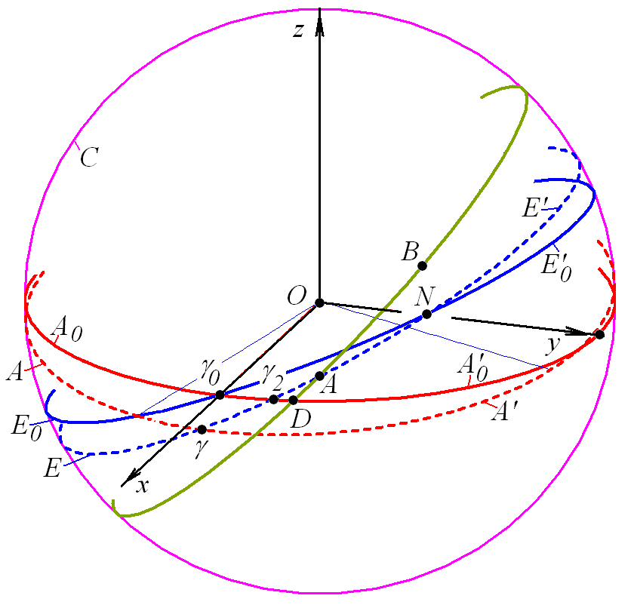
Figure 1: The basic planes on celestial sphere C: A₀A₀' - a motionless plane of the Earth’s equator for epoch Т_{S}; E₀E₀' - a motionless plane of the Earth’s orbit for epoch Т_{S} (a plane of motionless ecliptic); AA' - a mobile plane of the Earth’s equator in epoch Т; EE' - a mobile plane of the Earth’s orbit in epoch Т (the inclination for presentation is increased); γ₀ - vernal equinox point of epoch Т_{S}; γ - a point on a line of crossing of mobile equator in epoch Т with a mobile ecliptic (vernal equinox point in epoch Т); DAB - a plane of the Mercury’s orbit in epoch Т.

The angles between planes are submitted on Figure 2, there corresponds Figure 2a of our work [2] in which the results are given for Mars, but they are fair for any planet, including Mercury. As the planes of Earth equator AA' and of Earth orbit EE' on Figure 2 move in space, therefore the vernal equinox point γ retreats on an arc γ₂γ from motionless equator plane A₀A₀' with velocity
${p_{c}=\text{502 \{}5}^{''}\text{.}\text{641}+2^{''}\text{.}\text{223}⋅T_{t}$, (1)
where p_{c} – velocity in arcsec/century, T_{t} – time in tropical centuries from epoch of 1900.0. It is need noted, that in geocentric system the Sun passes point γ at spring, and in heliocentric system the Earth passes point γ at autumn.
The formula (1) is received by S. Newcomb [3] as a result of approximation of observation data on an interval several hundreds years. It gives velocity of retreating of point γ from a motionless equator plane A₀A₀', which is equal -5026.75 arcsec/century for 1950.0 and -5027.86 arcsec/century for 2000.0. As the point γ moves clockwise therefore the velocity is written down with is sign «-». Note that in modern treatment of observation data by J.L. Simon et al [4], the velocity of removal of the point γ is - 5028.82 arcsec per century.
Thus, the number 5028.83 arcsec per century in the first row in the Table 1 represents the motion of the vernal equinox γ relative to the motionless space.
In Astronomy the moton of perihelion point B is defined by a longitude π_{a}, which as result of approximation of observation data S. Newcomb [3] represents as a polynomial of the third power of time:
${π_{a}={\text{334}}^{{}_{{}^{∘}}}13^{'}05^{''}\text{.}\text{53}+\text{662 \{}6}^{''}\text{.}\text{73}⋅T_{j}+0^{''}\text{.}\text{4675}⋅T_{j}^{2}−0^{''}\text{.}\text{0043}⋅T_{j}^{3}$, (2)
where T_{j} – time counted in Julian centuries for 36525 day from fundamental epoch 1900.0.
Value π_{a} represents the sum of two different arcs (see Figure 2)
$π_{a}=γA+\text{AB}$, (3)
where arc γA = Ω_{a} refers as longitude of ascending node of Mercury’s orbit.

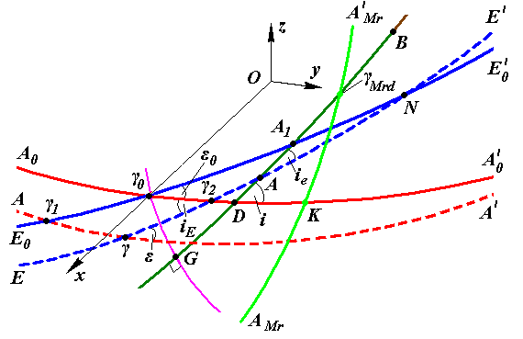
Figure 2: The parts of the Mercury’s perihelion rotation on the celestial sphere. The designations of planes it is given on Figure 1; γ₀G – an arc of the big circle, which is perpendicular to plane of the Mercury’s orbit GDAB; B – the heliocentric projection of the Mercury’s perihelion to celestial sphere; А – ascending node of the Mercury’s orbit on mobile ecliptic; D – ascending node of the Mercury’s orbit on motionless equator of epoch Т_{S}; the parameters of the Mercury’s orbit in inertial equatorial reference frame: ϕ_{Ω} = γ₀D; ϕ_{р}.= DB; i = ∠γ₀DG; i_{E} – inclination of the Earth mobile orbit (mobile ecliptic); and in mobile ecliptic system Ω_{a} = γA; ω_{a} = AB; π_{a} = γA + AB = Ω_{a} + ω_{a}; i_{еа} = i_{е} = ∠γAG; index «_{e}» – the angles relatively to mobile ecliptic; index “_{a}” – by results of approximation of observation data.

From the formula (2) the velocity of perihelion rotation on a way of arcs γA + AB is equal 5602.9 arcsec/century for 1950.0 and 5601.9 arcsec/century for 2000.0. For elements of J. L. Simon et al [4] it is equal to 5603.0 arcsec par century to 2000.0. From Figure 2 it is seen, that at definition of perihelion point B by value π_{a}, in velocity of perihelion will enter: 1) velocity of movement of point γ on mobile ecliptic EE'; 2) velocity of displacement of point A of mobile ecliptic EE' due to its rotation around point N and 3) velocity of displacement of ascending node A of Mercury orbit GDAB on mobile ecliptic EE', caused by rotation of plane GDAB.
Thus, the value 5599.7 arcsec per century in the 6-th row of Table 1 gives the velocity of the perihelion rotation from the moving point γ of the vernal equinox with the inclusion of velocities of change of the ecliptic and of the Mercury orbit.
To these velocities did not affect the velocity of perihelion movement, it should be counted from a motionless point. As such point we have taken the point G, which is on crossing of the circle of plane GDAB with perpendicular circle to it γ₀G.  In work [2] we have deduced the formula (29) for arc GB which depends on parameters of mobile orbit planes of the Earth (EE') and of the Mercury (GDAB) and have the following form:
$\begin{aligned}ϕ_{p0}^{a}=\text{GB}=π_{a}−Ω_{a}+\text{arcsin}\left[\text{sin}i_{\text{Ea}}\text{sin}\left(Ω_{a}−{\text{γγ}}_{2}\right)\text{/sin}i^{a}\right]+ \\ +\text{arccos}\left[\text{cos}ϕ_{{}_{Ω}}^{a}{\left(1−{\left({\text{sin}}_{Ω}^{a}\text{sin}i^{a}\right)}^{2}\right)}^{0\text{.}5}\right]\text{.}\end{aligned}$ (4)
The designations are given in the caption signature to Figure 2. For angles ϕ_{Ω}ª and i_{Ea} in work [2] are also given formulas, which depend on the ecliptic angles of orbits: Ω_{a}, i_{еа} etc. As a result of approximation of observation data S. Newcomb [3] has presented ecliptic angles as polynomials of the third degree on time which example is the formula (2). J.L. Simon et al. [4] have arranged Newcomb's results to 2000.0 epoch and have given as polynomials of 6-th degree.
The formula (4) gives velocity of perihelion rotation of Mercury orbit relatively motionless space is equal 582.05 arcsec/century for 1950.0 and 583.15 for 2000.0 [5]. It is velocity of perihelion rotation according to observation. Due to orbits elements by J.L. Simon et al. [4] it is equal 582.53 arcsec/century for 2000.0.
Thus, in the Table 1 the velocity of the perihelion rotation on observation data does not been determined. It is equal to 582 - 583 arcsec per century relatively to the motionless space.
Interaction of bodies of Solar system under the Newton law of gravitation results in change of their orbits, including the rotation of perihelion. In many of our papers, for example [6], the periods and the amplitudes of the changes of the planets orbits elements is established at different time spans, including up to 100 million years. In these calculations the bodies are considered as material points, which interact under Newton's law of gravity. We have determined that the velocity of motion of the Mercury perihelion relative to the fixed point G in Figure 2 is 529.86 arcsec per century [5]. This differs from the observation data at 53 arcsec per century, but not at 43 arcsec per century, as previously thought.
For finding out of the reason of difference of calculated on Newton interaction and according to observation of the velocity of Mercury perihelion rotation we have carried out various researches. First, we have established, that such difference of velocity of perihelion rotation is present only for the Mercury, which is the closest planet to the Sun. Second, the calculated on Newton interaction other parameters of Mercury orbit and velocity of their change practically coincided with the data of observation [5].
We investigated influence of gravity propagation velocity on results of interaction of two bodies. The General Theory of Relativity was created to take into account final velocity of gravity. The A. Einstein has based it on the equations and results received by Paul Gerber. Paul Gerber has thought up such mechanism of gravity propagation with velocity of light that it is explained rotation of perihelion in 43 arcsec/century [7]. However, as we have shown in paper [5], this mechanism is proved by nothing and is erroneous. Besides as it is above shown, the difference of calculations on Newton interaction and observation is equal no 43 arcsec/century but is 52÷53 arcsec/century.
In a nature the one mechanism of interaction propagation with speed of light is only known: it is mechanism of propagation of electromagnetic interaction. From experimental laws of electromagnetism we have deduced expressions for force of interaction of two charged particles [8]:
$\vec{F}(\vec{r},\vec{v})=\frac{k\left(1−β^{2}\right) \vec{r}}{{\left\{ r^{2}−\left[\vec{β}×\vec{r}\right] ^{2}\right\}}^{ 3/2}}$, (5)
where k = k_{e} = q₁ q₂/ε, $\vec{β}=\vec{v}/c_{1}$, r and v – distance and velocity of one particle relatively another; ε – dielectric permeability of media between particles, and c₁ – speed of light in media.
Apparently from (5), at not instant interaction the force depends not only on distance r between particles, but also from their relative velocity v. If for gravity to accept the same mechanism of interaction propagation the formula (5) will define the gravity force at k = k_{G} = -G·m₁·m₂, where m₁ and m₂ – masses of interacting bodies, and G – gravitational constant. With force $\vec{F}(\vec{r},\vec{v})$ we have calculated a trajectory of movement of one body relatively another at all possible changes of an eccentricity and velocity of body in a perihelion [9] - [11]. In case of an elliptic orbit the perihelion rotates and the more strongly, than there is the more velocity of body in a perihelion. In such orbit the length of the semimajor axis and period change in comparison with the orbit received at interaction of two bodies under the Newton law of gravity. The changes of the semimajor axis and the period have the same order as the change of the perihelion angle.
The calculation of rotation of Mercury perihelion at force $\vec{F}(\vec{r},\vec{v})$ has given velocity 0.23 arcsec/century, i.e. almost in 200 times smaller value, than explained by Paul Gerber velocity 43 arcsec/century [7] and accepted in GR. The conclusion from here follows that surplus of the perihelion rotation in 52÷53 arcsec/century may not be explained by the mechanism of gravity interaction propagation with speed of light.
The explanation of surplus of perihelion rotation of the Sun oblateness now is complicated with complexities of model of interaction and absence of knowledge of distribution of the Sun density on radius and along an axis of the Sun. Therefore the executed calculations of influence of the Sun oblateness, most likely, are doubtful.
If inside the Mercury orbit there was a planet of the certain mass it might make necessary rotation of the Mercury perihelion and at the same time to not render appreciable influence on other planets. Such planet is not present. But the Sun rotates about its axis, and the moving masses of its substance may influence Mercury the same as the planet offered above. We have developed compound model of the Sun rotation [5] and have considered various variants of its action under the Newton law of gravity together with interaction of other bodies of Solar system. Appeared, that at the certain mass of peripheral bodies of model the same velocity of rotation of perihelion may be received as observed one, i.e. 582 arcsec/century. In this case, the velocity of change of other parameters of the Mercury’s orbit essentially does not change. The velocity of the Venus perihelion does not change essentially, and parameters of planets more distant from the Sun also change still to a lesser degree. Let's note, that the compound model of the Sun rotation takes into account of the Sun oblateness and rotation of its masses.

Table 2: Velocity of rotation of the Mercury perihelion on observation and on Newton interaction. To compare in round brackets – accordingly Wikipedia [1].

Amount (arcsec/century) | Explanation
On observation data
-5027.86 – Ncb  -5028.82– Sim  (5028.83 – Wiki) | Velocity of movement of vernal equinox point γ relatively motionless space (according form. (1))
5601.9 – Ncb  5603.0 – Sim  (5599.7 – Wiki) | Velocity of perihelion rotation relatively the mobile vernal equinox point γ with including velocities changes of ecliptic and of Mercury orbit (according form. (2))
583.15 – Ncb  582.53 – Sim | Velocity of perihelion rotation relatively motionless space (according form. (4))
By results of interaction under the Newton law of gravity.
Velocity of rotation of a perihelion relatively motionless space
530  (530– Wiki) | Planets and the Sun interact as material points
582 | Planets interact as material points, and the oblateness and rotation of the Sun is taken into account as compound model

As a result of the carried out researches we shall write down the basic characteristics of rotation of Mercury perihelion in such form that they could be compared to the data on Wiki site (see. Tab. 2). The rotation velocities received on observation we give for 2000.0 on orbit elements of S. Newcomb [3] (Ncb) and J.L. Simon et. al. [4] (Sim).
Apparently from above-stated, the problem of perihelion rotation is defined by many circumstances. Here we have not mentioned a problem of reliability of observation data approximation. We have tried to state other problems clearly and with necessary explanatory that everyone might pass on this way and be convinced of our conclusions.
We have briefly outlined a number of stages of the research phenomenon of rotation of the Mercury perihelion, which were performed by computer algorithms. We used the numerical integration of the differential equations systems, a variety of calculations with geometric transformations, mathematical treatment of time series and other computer calculations. Due to them, it was found that the components of the perihelion rotation of the Mercury's orbit can be explained by the correct account of Newton's gravitational force in the interaction of the celestial bodies.
The material in this paper came from discussions of the problem with David Weber.
References
1. Wikipedia. http://en.wikipedia.org/wiki/Tests_of_general_relativity.
2. Grebenikov E.A., Smulsky J.J. Evolution of the Mars Orbit on Time Span in Hundred Millions Years / Reports on Applied Mathematics. Russian Academy of Sciences: A.A. Dorodnicyn Computing Center. Moscow. - 2007. 63 p. (In Russian http://www.ikz.ru/~smulski/Papers/EvMa100m4t2.pdf).
3. Newcomb S. The elements of the fourth inner planets and the fundamental constants of astronomy. Washington: Government printing office. 1895. –202 p.
4. Simon J.L., Bretagnon P., Chapront J. et al. Numerical Expression for Precession Formulae and Mean Elements for the Moon and the Planets // Astron. Astrophys. – 1994, vol. 282, p. 663-683.
5. Smulsky J.J.Gravitation, Field and Rotation of Mercury Perihelion// Proceedings of the Natural Philosophy Alliance. 15th Annual Conference 7-11 April 2008 at the University of New Mexiko, Albuquuerque, USA. Vol. 5, No. 2. Published by Space Time Analyses, Ltd. Arlington, MA, USA.– 2009. – Pp. 254-260. http://www.ikz.ru/~smulski/Papers/08Smulsky2c.pdf.
6. Melnikov V.P., Smulsky J.J.Astronomical theory of ice ages: New approximations. Solutions and challenges. - Novosibirsk: Academic Publishing House "GEO", 2009. - 84 p. The book in two languages. On the back side in Russian: Mel'nikov V.P., Smul'skiy I.I. Astronomicheskaya teoriya lednikovykh periodov: Novye priblizheniya. Reshennye i nereshennye problemy. - Novosibirsk: Akademicheskoe izdatel'stvo "Geo", 2009. - 98 stranitz.
http://www.ikz.ru/~smulski/Papers/AsThAnE.pdf.
7. Gerber P. Die raumliche und zeitliche Aubreitung der Gravitation// Z. Math. Phis.- 1898.- Vol. 43.- P. 93-104. http://bourabai.narod.ru/articles/gerber/gerber.htm.
8. Smulsky, J.J. 1994. "The New Approach and Superluminal Particle Production", Physics Essays. - Vol. 7. - No. 2. - P. 153 - 166.
http://www.smul1.newmail.ru/English1/FounPhisics/NApSup.pdf.
9. Smulsky, J.J. The Theory of Interaction. - Ekaterinburg, Russia: Publishing house "Cultural Information Bank", 2004. - 304 p. (In English)
http://www.smul1.newmail.ru/English1/FounPhisics/TVANOT1.doc.
10. Smulsky J.J. The new Fundamental Trajectories: part 1 - Hyperbolic/Elliptic trajectories//Galilcan Electrodynamics. Vol. 13, No. 2, 2002, pp. 23-28.
11. Smulsky J.J. The new Fundamental Trajectories: part 2 - Parabolic/ Elliptic trajectories// Galilcan Electrodynamics. Vol. 13, No. 3, 2002, pp. 47-51. http://www.smul1.newmail.ru/English1/FounPhisics/NFT.pdf

