Basic researches

The preamble to the paper with its discussion (in Russian) is presented at the end of the paper.
UDC 521.172 + 523.2
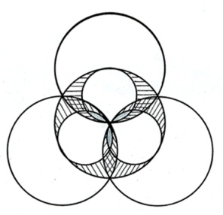
THE EVOLUTION OF THE EARTH'S ROTATIONAL MOVEMENT FOR MILLIONS YEARS
Smulsky J.J. (Dr. Sci. (Physics and Mathematics), prof.)
Institute of Earth's Cryosphere, Tyum. SC of SB RAS, Federal Research Center, Tyumen, Russian Federation
jsmulsky@mail.ru
Abstract. There are the main points of the derivation of the differential equations of the Earth’s rotational motion. The periods of oscillation of the Earth's axis are grounded by the angular momentum theorem. The constants of the equations, the initial conditions, and the theory of their computations are discussed. The results of integrating the equations over time intervals from 0.1 year to 1 million years are considered. The theory of solutions transformation to the mobile plane of the Earth's orbit is considered for millions of years, and the solution results are presented at different time intervals from 100 years to 20 million years. The evolution of the Earth's axis is analyzed. It is established that the Earth's axis precesses with respect to a fixed direction in space, which differs from the direction of the precession of planetary orbits. Physical explanations of the received oscillations of the Earth's axis from 14.68° to 32.68° are given. The oscillations of the Earth's rotation period are shown. Evidence of the reliability of the solutions obtained is presented. The work is of interest to a wide range of researchers in the fields of astronomy, paleoclimate and geophysics.
Keywords: differential equations, Earth rotation, precession, oscillations, evolution, periods, causes, Moon, Sun, planets.

1. INTRODUCTION
The problem of the Earth's rotation over large time intervals is one of the three components of the Astronomical paleoclimate theory [12, 13, 29]. This problem did not clearly appear in the previous versions of the theory, starting with Milutin Milankovich [5]. The rotation of the equatorial plane was used to determine the precession of the Earth’s orbit perihelion relative to the moving equator. Solutions of the Poisson equations were used for this purpose.
According to P.S. Laplace [2], the problem of the Earth’s rotation was first considered by I. Newton. Since then, the rotational equations have been more than once derived by various authors. However, they were based on different theorems of mechanics; they used different coordinate systems, different symbols, and different solution methods. In the process of deriving equations, all authors began to simplify them in order to further solve the equations using analytical methods. In the vast majority of cases, the second derivatives and the products of the first derivatives were discarded in these equations. The resulting equations are called Poisson equations.
In this regard, there are no generally accepted simplified differential equations of the Earth's rotation, which could be subjected to numerical integration without any previous change. In addition, a number of specific problems arise during numerical integration, for example, setting initial conditions that cannot be solved unless all the features for the derivation of differential equations are presented in detail. There are often contradictions between the interpretation of the complex rotational motion of the Earth in astronomy and the requirements that follow from the laws of mechanics. In this regard, we had to analyse different derivations of the equations, as a result of which the simplest one was chosen, which is presented in this paper. Due to its bulkiness, only basic provisions are presented here, and logical scheme for derivation of main stages is given.
In the second half of the 20th century, high-precision systems for observing the Earth's rotation were introduced, which made it possible to study the dynamics of the Earth's axis at small time intervals. Theories of precession and nutation were created in order to explain it. The discrepancy between these theories and observations forced researchers to introduce additional effects besides the main gravitational action [22]. We list some of them below. A correction was introduced for the distribution of geopotential over the Earth's surface to compute the gravitational interaction between an Earth's mass element and a point body. In addition, a non-axisymmetric Earth was considered with unequal against each other inertia moments J_{x} and J_{y,}, the difference of which was also determined with the use of the surface geopotential. A correction was introduced to consider slowing down of the Earth rotation due to tidal forces. In the rotational equations, relativistic forces were also added to gravitational forces by taking into account the geodesic precession [19], as well as by taking into account the relativistic addition to the force function in the equations for orbital motion [24].
To explain the differences between theory and observations, a nonrigid Earth model was introduced, as well as a structured Earth, in which each structure, for example, the Earth core had its own motion [20]. It also seems that redistribution of ice in the Polar Regions leads to a change in the inertia moments over long time intervals. Therefore, it is taken into account when considering the Earth evolution for large periods of time.
Almost all the additional effects are not defined as precisely as the gravitational impact. The influence of a number of them is hypothetical in nature. Some of them were proposed by specialists from different fields of physics, and specialists in theoretical and celestial mechanics have to apply them on faith, without subjecting them to rigorous analysis. These include relativistic additives. These forces depend not only on distance, but also on speed [7]. In theoretical mechanics, systems with such connections are called nonholonomic systems. For nonholonomic systems, energy methods of mechanics require correction. Without those corrections, motion equations of the general relativity contradict with the conservation laws.
All these additional low-level exposures are based on discrepancies between the computations of the main gravitational effect on the Earth's rotational motion and observations. However, as noted earlier, this computation was performed approximately. When deriving the differential equations for Earth's rotational movement, there were a number of simplifications of these equations, which can give the differences between the computation results and observation. Therefore, it is of great interest to obtain the most accurate solutions possible on the basis of only gravitational interaction, so that there were no doubts that the discrepancies between the computations and the observations should indeed be explained by other factors. This position is even more relevant in the study of rotational motion over large periods of time. Additional low-level exposures which are introduced by fitting the computation results to observations over hundreds of years can give unrealistic results at intervals of millions of years. In this regard, only Newtonian gravitational action on the rotational motion of an axisymmetric Earth is considered below.
The Earth's rotational motion is the most difficult mechanics problem, including celestial mechanics. The author has been dealing with this problem for more than ten years. Work on it was preceded and accompanied for 50 years by other works on interactions and motions of bodies [7, 10], as a result of which dozens of previously unsolved problems were solved. Nevertheless, when large oscillations of the Earth’s axis 7-8 times exceeding the oscillations from the previous solutions were obtained as a result of solving the problem of the Earth’s rotation, the author was alerted. Therefore, over the course of three years, various checks and solutions to this problem were carried out by other methods. All of them confirmed the reliability of the solutions obtained [28].
This made it possible to incorporate the results of the Earth's rotation problem into the new Astronomical paleoclimate theory. Its results coincided with the totality of information about the paleoclimate over the past 50 thousand years [11]. The farther into the past, the more uncertain the ideas about the paleoclimate become. However, it is completely clear for the author that as day is replaced by night, and summer is replaced by winter, so it is exactly that warm spells are replaced by cold spells in high latitudes. All these phenomena are due to the characteristics of the orbital and rotational motion of the Earth and their evolution. Therefore, there is no doubt that the new solutions for the evolution of the Earth's rotational motion, included in the Astronomical theory of climate, will allow paleoclimatologists to confidently systematize knowledge of the past, as well as clarify the age of those solutions.
The coincidence noted for his results with the paleoclimate features allowed the author to examine in more detail the results of the Earth rotation problem. Unlike previous representations in celestial mechanics and astronomy, the author introduced physical objects (the Earth rotation axis, the axis orbit, etc.) instead of mathematical objects (precession caused by planets, precession caused by the moon and the sun, etc.). Therefore, it is not mathematical evolution that is considered, but the evolution of physical objects. A detailed analysis of this evolution explains the causes of large oscillations in the axis of the Earth, and it also becomes clear why the predecessors received incorrect results.
It should also be noted, that the author used not energy approach in mechanics, but force one. Features of the moment of force behaviour determine the oscillations of the Earth's axis and their periods. Both features of evolution and features of the moment of force are additional evidence of the reliability for the results obtained.
The paper also considers the short-period evolution of the Earth's axis, as well as the issues of oscillations in its rotation speed. In Earth’s physics, these problems are attracted to understanding its structure. The new results obtained in the paper are of interest to specialists in this field.

2. THEOREM OF MOMENTS
Rotating Earth, as non-solid, i.e. moving body takes an equilibrium axisymmetric form under the action of two systems of forces: gravitational and centrifugal. It forms a geoid flattened at the poles with the axis of symmetry z (Fig. 1) located along the eigenrotation angular velocity vector $\overset{˙}{\vec{ϕ}}$. This vector makes in space a complex motion which represents the absolute speed of the Earth's rotation $\vec{ω}$ in a non-rotating coordinate system x₁y₁z_{1.}. The angular velocity vector $\overset{˙}{\vec{ϕ}}$ is inclined at an angle $θ$ to the axis z_{1.}
Anything B located in the plane of its orbit 3 acts on two halves of the Earth: on the near half by force ${\vec{F}}_{1}$ and on the distant half by force ${\vec{F}}_{2}$. If the Earth would be a centrally symmetric ball, the resultant of forces ${\vec{F}}_{1}$ and ${\vec{F}}_{2}$would pass through the centre of the Earth being a point O. For a flattened Earth, the centre of mass of the near part of the Earth will approach the body B, and will move away for the distant part. Therefore, the force ${\vec{F}}_{1}$ will increase, and the force ${\vec{F}}_{2}$ will decrease, as a result of which there will arise a moment of forces m_{O} directed clockwise.
As a result of influence by the moment of forces, the z axis of the Earth will begin to rotate around the point O with angular velocities $\overset{˙}{θ}$ and $\overset{˙}{ψ}$. The absolute angular velocity vector of the Earth will be
$\vec{ω}=\overset{˙}{\vec{ϕ}}+\overset{˙}{\vec{θ}}+\overset{˙}{\vec{ψ}}$ (1)
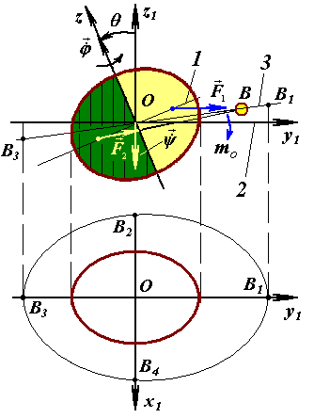

Fig. 1. The scheme for influence of the body B on the Earth in two ways: at the top - in the vertical plane perpendicular to the equatorial plane 1, and at the bottom - in the horizontal plane perpendicular to the axis z₁; 1 and 2 – the plane of the Earth equator and the plane of its orbit, respectively; 3 - the plane of the body B orbit affecting the Earth.

This process of affecting on the Earth is determined by the theorem on the change of angular momentum:
$\frac{d{\vec{K}}_{O}}{\text{dt}}=\sum{{\vec{m}}_{O}({\vec{F}}_{k})}$, (2),
where ${\vec{K}}_{O}$ is the Earth angular momentum relative to the centre O in a non-rotating coordinate system x₁ y₁ z_{1 ;}
$\sum{{\vec{m}}_{O}({\vec{F}}_{k})}$is the sum of the moments of forces ${\vec{F}}_{k}$ from the bodies acting on the Earth.
Based on the analysis of the theorem of moments (2), we can establish the periods of oscillations of the Earth's axis. The body B creates maximum moments of forces $m_{O\text{max}1}$at points B₁ and B_{3,} moreover, they have the same direction. When the body is in the plane of the equator (points B₂ and B₄₎, the moments of forces are equal to zero, i.e. during one revolution of the body in its orbit, the moment of force varies twice from 0 to $m_{O\text{max}1}$. Therefore, the axis of the Earth will be subject to oscillations with half-periods of revolution of the planets, the Sun and the Moon relative to the moving plane of the equator.
The Earth and planets become closer in the course of their orbital motion. If their approach occurs at points B₁ or B_{3,} then the maximum moment will increase to a value of $m_{O\text{max}2}$. Therefore, the axis of the Earth will oscillate with periods of approach between the Earth and planets, especially close ones to the Earth, at points B₁ and B_{3.}
Since the orbits of the Earth, the Moon, and other planets do not lie in the same plane and are not circular, but elliptical, these two circumstances will lead to the modulation of the periods noted above. For example, the amplitude of the Earth’s axis oscillation will be greater during that half-period of the Moon revolution around the Earth when the Moon is in its perigee.
The moment of force created by body B also depends on the angle of inclination between the plane of the moving equator 1 (Fig. 1) and the plane of orbit 3. Therefore, the Earth’s axis will have oscillations with the precession period of the body orbit relative to the moving plane of the Earth's equator. For example, the precession period of the moon’s orbit is 18.6 years. Since it is much shorter than the precession period of the equatorial plane (25.7 thousand years), the Earth’s axis will undergo yet another oscillation under the influence of the Moon with a period of 18.6 years. And the precession period of the Earth’s orbit (68.7 thousand years) is comparable with the period of 25.7 thousand years. Therefore, in addition to semi-annual, the Sun will create oscillations which period is determined by the difference in the precession speeds of the Earth’s orbit and its equator.

3. DIFFERENTIAL ROTATIONAL EQUATIONS
The differential equations of the Earth's rotational motion are derived from the theorem of moments (2). For this, on the one hand, it is necessary to express the angular momentum of the Earth $K_{O}$ depending on its inertia moments and the components of the angular velocity. And on the other hand, it is necessary to find the moment of the forces ${\vec{m}}_{O}({\vec{F}}_{k})$ from bodies acting on the Earth, depending on their masses and distances to the Earth. This requires consideration of the problem of the Earth's rotation in different coordinate systems (Fig. 2).
In the problem of the Earth rotation, the orbital motion of the solar system bodies is considered in unaccelerated ecliptic barycentric coordinate system x₁₀, y₁₀, z₁₀ (Fig. 2) bound with the earth orbit plane 1 stabilized for epoch T₀. The axis x₁₀ is directed to the vernal equinox. The beginning point O of the non-rotating system x₁ y₁ z₁ is located in the Earth mass centre, and it is progressively moving relative to the system x₁₀ y₁₀ z_{10.} Axis z of rotating equatorial system xyz bound with the rotating Earth is directed along the velocity vector $\overset{˙}{\vec{ϕ}}$ of the Earth's eigenrotation and axis x is in a zero meridian plane at the initial instant t = 0 passing through Greenwich. Absolute angular velocity of the Earth rotation $\vec{ω}$ is considered with the projections ω_{x,} ω_{y,} ω_{z} to the rotating system xyz axis: $\vec{ω}=\vec{i}ω_{x}+\vec{j}ω_{y}+\vec{k}ω_{z}$. With these projections, it is used in the system x₁ y₁ z_{1.}
The rotational motion of the Earth is considered with respect to the non-rotating coordinate system x₁ y₁ z₁ (Fig. 2). Moving equatorial plane of the Earth 2 is defined by the tilt angle θ to the plane 1 and the precession angle ψ = γ₀K. In addition, the Earth's eigenrotation velocity relative to its moving axis z is considered.
In the theorem of moments (1), the kinetic moment $K_{O}$ is created by all the masses of the rotating Earth in the coordinate system x₁ y₁ z_{1.}
Since in this system the Earth rotates with angular velocity $\vec{ω}$, then any element dM with radius vector $\vec{r}=\vec{i}x+\vec{j}y+\vec{k}z$ (Fig. 2) moves at a speed $\vec{ν}=\vec{ω}×\vec{r}$and has the angular momentum ${\vec{m}}_{O}(\text{dM}⋅\vec{ν})=\vec{r}×\vec{ν}⋅\text{dM}\text{.}$ relative to the centre O. Here vectors $\vec{r}$, $\vec{ν}$, ${\vec{m}}_{O}$ are regarded in the projections on the axes of the rotating coordinate system. After integration over the entire Earth mass M, kinetic moment will be: ${\vec{K}}_{O}=\int_{M}{m_{O}(\text{dM}⋅\vec{v})=\int_{M}{\vec{r}×\vec{v}⋅\text{dM}}}$.
Differentiating ${\vec{K}}_{O}$with respect to time and substituting the vectors $\vec{r}$, $\vec{ω}$ and $\vec{ν}$, after the conversion we obtain the derivatives of the kinetic moment projections on the axes of the rotating system xyz:
${\overset{˙}{K}}_{\text{Ox}}=J_{x}ε_{x}−(J_{y}−J_{z})ω_{y}ω_{z},$ ${\overset{˙}{K}}_{\text{Oy}}=J_{y}ε_{y}−(J_{z}−J_{x})ω_{z}ω_{x},$ ${\overset{˙}{K}}_{\text{Oz}}=J_{z}ε_{z}$, (3).

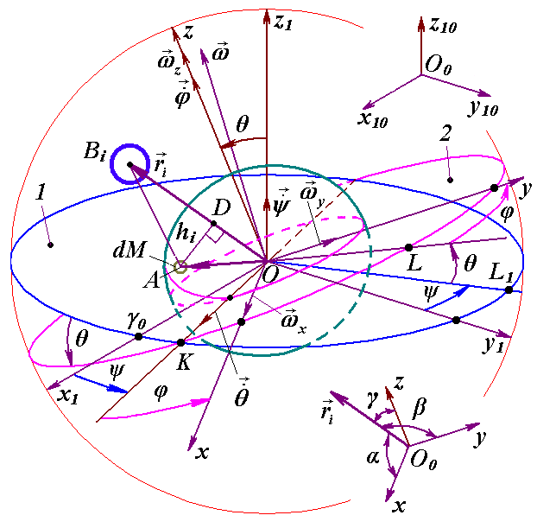

Fig. 2. Coordinate systems and the influence of the body B_{i} on the Earth element dM: x₁₀ y₁₀ z₁₀ - motionless barycentric ecliptic geocentric system; x₁ y₁ z₁ - non-rotating ecliptic geocentric system, and xyz - equatorial and rotating together with the Earth geocentric system. ψ, θ and φ are Euler angles of the system xyz position with respect to x₁ y₁ z₁. 1 - fixed ecliptic plane; 2 - moving plane of the Earth equator; r = OA is the distance from the element of mass dM to the Earth centre.

Where J_{x,} J_{y} and J_{z} are the inertia moments of the Earth projected on the axes of the rotating coordinate system xyz ; ε_{x,} ε_{y} and ε_{z} are angular acceleration projections.
From the observed precession velocity, it is possible to determine only the ratio between the two inertia moments J_{z} and J_{x,} but not their absolute values. In recent years, models of triaxial Earth have been considered, in which the third moment of inertia J_{y} is estimated by the distribution of the gravity potential over the Earth's surface. However, this method also does not allow determining the exact value of the inertia moments. Here, we note that in the case of the triaxial Earth it is necessary to introduce terms with the centrifugal inertia moments J_{xy,} J_{xz,} J_{xy} into the equations due to the asymmetric distribution of the potential. Traditionally, the terms with these moments are omitted in the derivations, and the terms with the third moment J_{y} are left out. However, in the final expressions, J_{y} are equated to J_{x.} Therefore, expressions (3) are written for an axisymmetric Earth: J_{y} = J_{x,} and J_{xy} = J_{xz} = J_{yz} = 0. For a non-axisymmetric Earth, the kinetic moment derivatives are given in [26].
Like the computation of the kinetic momentum projections (3), the components of the moments of forces in theorem (1) are computed by integration over all elements of the Earth dM. They will also depend on the inertia moments of the Earth.
When deriving the rotational equations, a problem arises: when a body rotates, either its inertia moments or the projections of the angular velocity change depending on the coordinate system. Therefore, at first, the equations are considered in those coordinates where the inertia moments J_{x}, J_{y}, J_{z} do not change. Then transition to Euler angle coordinates ψ, θ and φ takes place, in which the angular velocity does not depend on the body rotation. Due to the complexity and cumbersomeness of the Earth's rotation equation derivation [26], here we consider only the logical derivation scheme presented in the block diagram in Fig. 3.
Initially, the kinetic momentum derivatives are expressed in a rotating coordinate system xyz (step 1). This action was demonstrated above and the expressions (3) were obtained. After representing the angular velocity in the Euler variables (step 2), we obtain the projections of the kinetic moment derivatives in the direction of the Euler velocities (steps 3 and 4).
To find the moment of forces, it is necessary to determine the force function (step 5). Projecting the moments of forces on the directions of Euler angular velocities (step 6) according to the theorem of moments (2), and after substituting the kinetic moment and force function (steps 7 and 8) into it, we obtain differential equations of the Earth's rotation (step 9). They have the following form :
$\begin{aligned}\overset{¨}{ψ}=−2\overset{˙}{ψ}\overset{˙}{θ}\frac{\text{cos}θ}{\text{sin}θ}+\overset{˙}{θ}\frac{J_{z}ω_{E}}{J_{x}\text{sin}θ}−\sum_{i=1}^{n}{\frac{3{\text{GM}}_{i}E_{d}J_{z}}{r_{i^{5}}J_{x}}}\left\{0\text{.}5\text{sin}(2ψ)(x_{{1i}^{2}}−y_{{1i}^{2}})−\right. \\ −x_{1i}y_{1i}⋅\text{cos}(2ψ)+\left.z_{1i}\frac{\text{cos}θ}{\text{sin}θ}(x_{1i}\text{cos}ψ+y_{1i}\text{sin}ψ)\right\};\end{aligned}$ (4)
$\begin{aligned}\overset{¨}{θ}=0\text{.}5{\overset{˙}{ψ}}^{2}\text{sin}(2θ)−\frac{J_{z}ω_{E}\overset{˙}{ψ}\text{sin}θ}{J_{x}}−\sum_{i=1}^{n}{\frac{3{\text{GM}}_{i}⋅E_{d}J_{z}}{2r_{i^{5}}J_{x}}}\left\{\text{sin}(2θ)[x_{{1i}^{2}}{\text{sin}}^{2}ψ+\right. \\ +y_{{1i}^{2}}{\text{cos}}^{2}ψ−z_{{1i}^{2}}−x_{1i}y_{1i}\text{sin}(2ψ)]+2z_{1i}(x_{1i}\text{sin}ψ−\left.y_{1i}\text{cos}ψ)\text{cos}(2θ)\right\},\end{aligned}$ (5)
$\overset{˙}{ϕ}=ω_{E}−\overset{˙}{ψ}⋅\text{cos}θ$, (6),
where J_{x,} J_{y} and J_{z} - Earth inertia moments about the axes of the coordinate system bound with rotating Earth;
$E_{d}=(J_{z}−J_{x})/{J_{z}}$ - dynamic ellipticity of the Earth;
$ω_{E}$= const is the projection of the absolute speed of the Earth's rotation on its z axis (see Fig. 2);
n is the number of bodies acting on the Earth, and M_{i} is their mass, and x_{1i,} y_{1i,} z_{1i} are their coordinates.
It should be noted that the invariance of the angular velocity $\vec{ω}$projection on the z axis (Fig. 3), i.e. ω_{z} = ω_{E} = const, is caused by the equality to zero of the force moment projection m_{Oz.} And this is due to the axisymmetry of the Earth. On the other hand, for a non-axisymmetric model of the Earth, for example, a triaxial or nonrigid model, the moment of forces m_{Oz} is not equal to zero. Therefore, in addition to two second-order differential equations (4) - (5), there will be one more equation for the angle φ. The expressions for the kinetic moment ${\vec{K}}_{O}$ and moment of forces ${\vec{m}}_{O}({\vec{F}}_{k})$ in Theorem (2) will additionally include the centrifugal inertia moments J_{xy,} J_{xz} and J_{yz.} In the models with a changing Earth, centrifugal moments will change.
Therefore, when computing the kinetic moment according to (3), this expression will include the derivatives of the centrifugal moments J_{xy,} J_{xz} and J_{yz.} The last circumstance is not taken into account in all theories with non-axisymmetric model of the Earth. Assuming that their chosen axes x, y, z are the main axes of inertia, authors of the theories equal the centrifugal inertia moments to zero. As is known from theoretical mechanics, this is possible only in one case if the axes x, y, z are the axes of symmetry for the body. Therefore, there is an error in solving the models for the non-axisymmetric Earth at the level of differential equations. The differences obtained in such theories of rotation of the Earth from solutions in an axisymmetric Earth are primarily due to this error.
Equations (4) - (5) determine the inclination θ and precession angles ψ for moving equator 1 relative to the fixed orbit plane 2 (Fig. 2).

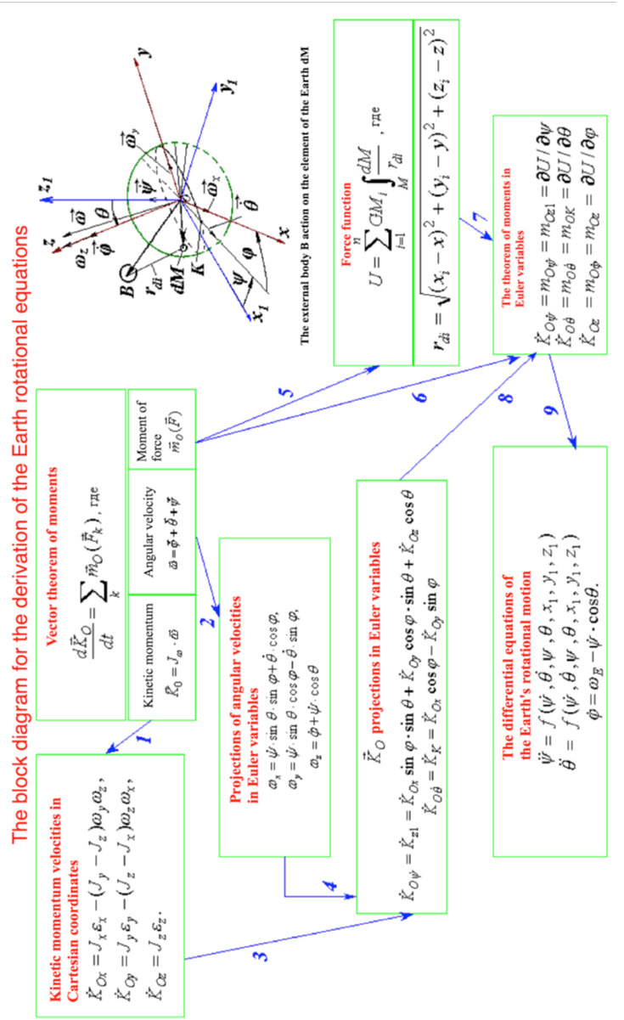

Fig. 3. Block diagram for the derivation of differential equations of the Earth rotation. The numbers on the arrows indicate the order of derivation (step number).
Since $ω_{E}$ is 6 orders of magnitude higher than $\overset{˙}{ψ}$ and $\overset{˙}{θ}$ derivatives, then neglecting the terms with $\overset{˙}{ψ}⋅\overset{˙}{θ}$ and ${\overset{˙}{ψ}}^{2}$ and in equations (4) - (5), we obtain:
$\overset{˙}{θ}≈−\sum_{i=1}^{n}{\frac{3{\text{GM}}_{i}E_{d}\text{sin}θ}{2ω_{E}r_{i}^{5}}}[\text{sin}(2ψ)(x_{1i}^{2}−y_{1i}^{2})−2x_{1i}y_{1i}\text{cos}(2ψ)+2z_{1i}\frac{\text{cos}θ}{\text{sin}θ}(x_{1i}\text{cos}ψ+y_{1i}\text{sin}ψ)]$; (7)
$\begin{aligned}\overset{˙}{ψ}≈−\sum_{i=1}^{n}{\frac{3{\text{GM}}_{i}E_{d}}{2ω_{E}r_{i}^{5}\text{sin}θ}}\left\{\text{sin}(2θ)[x_{1i}^{2}{\text{sin}}^{2}ψ+y_{1i}^{2}{\text{cos}}^{2}ψ−z_{1i}^{2}−x_{1i}y_{1i}\text{sin}(2ψ)]+\right. \\ \left.+2z_{1i}(x_{1i}\text{sin}ψ−y_{1i}\text{cos}ψ)⋅\text{cos}(2θ)\right\}\text{.}\end{aligned}$ (8)
Equations (7) - (8) are identical to the Poisson equations. As a consequence of their approximate analytical solutions, the results were obtained for the previous evolution theory of rotational motion of the Earth.

4. EQUATION CONSTANTS AND INITIAL CONDITIONS
4.1. The Earth angular velocity. The difference between the geoid and the sphere influencing the evolution of the Earth’s rotational motion is characterized by its dynamic ellipticity E_{d} = (J_{z} - J_{x}) / J_{z.} In the equations (4) - (5) the ratio of the inertia moments J_{z} / J_{x} can be expressed by the dynamical ellipticity as: J_{z} / J_{x} = 1 / (1 - E_{d}). Therefore, equations depend on two constants: projection onto the axis z of the absolute velocity of its rotation ω_{E} and dynamical ellipticity of the Earth E_{d.} The angular velocity of the Earth rotation ω_{E} represents its average value over a long time interval. It can be identified using the sidereal period of the Earth revolution around the Sun P_{orsd} = 365.25636042 days. An Earth's surface point rotates during P_{orsd} with respect to fixed stars through an angle φ_{Psd} = 2π∙P_{orsd} + 2∙π, where the last term 2∙π is due to annual rotation of the Earth around the Sun. Then the angular speed of the Earth rotation is:
ω_{E} = φ_{Psd} / P_{orsd} = 2∙π∙(1 + 1/P_{orsd})∙24∙3600 = 7.292115082711576∙10⁻⁵ 1/s. (9)
This value is equal to the value in [16], which is given with 7 characters. The value (9) matches up to 8 digits with values in sources with a larger number of significant digits [15, 24].
4.2. Dynamical ellipticity of the Earth. Knowledge of the distribution of the Earth's density is currently insufficient to be able to compute the inertia moments J _{z} and J _{x} with the necessary accuracy. Therefore the dynamic ellipticity of the Earth E_{d} is determined by comparing the computed precession velocity $\overset{˙}{ψ}$ with the observed value, for example, with precession of the Earth’s axis relative to the fixed ecliptic [15, 23] for a tropical year T _{tr}
$p_{1}=\text{50} . 37084\text{+0}\text{.}\text{00493} T_{\text{tr}}$. (10)
As a result of multiple computations by various authors of Earth's rotation theories, the dynamic ellipticity of the Earth E_{d} was refined and has not changed significantly in recent works. We also conducted studies on the value of E_{d} [26] and we came to the conclusion that the value of E_{d} = 3.2737671∙10⁻³ is acceptable at the present time. This value was used by a number of authors, including [20].
4.3. Initial conditions. When integrating the equations (4) - (5), at the initial time it is necessary to set the initial values of the angles ψ and θ, and the initial derivative values $\overset{˙}{ψ}$ and $\overset{˙}{θ}$. The parameters of the Earth's rotational motion and the orbital motions of the acting bodies are set in the motionless ecliptic system for the epoch of 2000.0 with a Julian day JD _{s} = 2451545, and the beginning of the solution is taken at the moment T = 0 shifted by 0.5 century, with the date of December 30, 1949 and Julian day JD ₀ = 2433280.5.
Setting the initial conditions is a significant problem. Integration of equations (4) - (5) with the action of one body [14, 26] showed that the variables ψ, θ, $\overset{˙}{ψ}$ and $\overset{˙}{θ}$ oscillate with the periods of a day, a half of month, six months and 18.6 years. In astronomy, averaged changes in parameters are given, in which these oscillations are absent. Therefore, the initial conditions (IC) are determined in several stages. Initially, the initial conditions are computed based on averaged astronomical elements reflecting the orbital and rotational motion of the Earth. The main geometric characteristics of these movements are presented in Fig. 4. Unlike fig. 2, other notations for Cartesian coordinates are adopted here: xyz and x_{e}y_{e}z_{e} are fixed equatorial and ecliptic systems, respectively. They are connected with the equatorial A₀A₀' and the ecliptic E₀E₀' planes, respectively, in the epoch of JD_{s.} In any other epoch JD, the equatorial AA' and the ecliptic EE' planes are in different positions.
In the 20th century, a system of averaged astronomical elements was used, created at the end of the 19th century by S. Newcomb [23]. At the end of the 20th century, such a system was also created by J. Simon et al. [25]. Appendix 1 provides an algorithm for determining the initial conditions for the epoch JD_{0,} as well as their values for each of these systems.
With these initial conditions, equations (4) - (5) are integrated over a short time interval, for example, over 0.1 years. Daily and half-month periods of oscillations are manifested over this interval. The amplitudes of daily oscillations have a certain value. It can be seen from the equations that the second derivatives on the left side of the equations depend on the first derivatives on the right side.
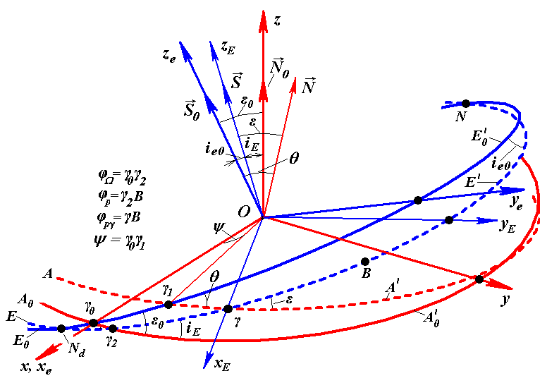

Fig. 4. Equatorial xyz and ecliptic x_{e} y_{e} z_{e} coordinate systems: A₀ A'₀ and E₀ E'₀ - planes on the celestial sphere of the fixed equator and the ecliptic in the epoch JD_{S.} AA' and EE' - moving planes of the equator and ecliptic in an arbitrary epoch JD; ${\vec{S}}_{0}$and $\vec{S}$ - unit perpendiculars to the planes E₀ E'₀ and EE', respectively; ${\vec{N}}_{0}$ and $\vec{N}$ - unit perpendiculars to the planes A₀ A'₀ and AA', respectively. The angles of equatorial plane movement along the stationary ecliptic: θ and ψ = γ₀ γ_{1.} The plane rotation in order to derive dependencies is shown counter clockwise when time changes from the past to the future.

Therefore, in the case where the initial values ${\overset{˙}{θ}}_{0}$ and ${\overset{˙}{ψ}}_{0}$ do not correspond to actual conditions of interactions, second derivatives would be great that will result to large amplitudes of diurnal oscillation. It is believed that during the preceding evolution of the Earth's rotational motion, such interaction conditions have been established, in which diurnal amplitudes are minimal. Therefore, performing sequential integration over the selected time interval, values ${\overset{˙}{θ}}_{0}$ and ${\overset{˙}{ψ}}_{0}$ are updated from the condition of vanishing diurnal amplitudes of angles ψ, θ, or diurnal amplitudes of their derivatives $\overset{˙}{ψ}$ and $\overset{˙}{θ}$. Thus, over 9 iterations, the value ${\overset{˙}{θ}}_{0}$was refined up to the 3rd sign, and ${\overset{˙}{ψ}}_{0}$to the 4th sign. In this case, the amplitudes of oscillations of the angles and their derivatives decreased by two to three orders of magnitude.
At the third stage, the angles ψ₀ and θ₀ are specified. As already noted, at the first stage, the angles ψ₀ and θ₀ were determined by astronomical elements that do not contain the aforementioned short oscillations, but contain a linear trend in time reflecting long-period oscillations. The obtained solutions also have this trend, but it starts from the initial point θ_{0.} In fact, the trend of averaged observational data should follow the middle line of oscillations. Therefore, the value of the angle θ₀ is refined by the coincidence of the computed and observed beginnings of the trends of the angle ε between the moving equatorial and orbital planes. For this purpose, equations (4) - (5) were integrated over an interval of 100 years.
The precession angle ψ₀ was specified in another way. In the reference frame used for the JD_{S} epoch, the angles, including the precession angle ψ, are counted from the ascending node γ_{0,} i.e. at the moment JD_{S,} the angle ψ must be equal to zero. By this condition, the value of ψ₀ was refined at the beginning of JD₀ integration. Such a refinement has the disadvantage that the phase of the computed short-period oscillations may differ from the phase of the observed oscillations. In these studies on the evolution of the Earth's rotational motion over millions of years, this does not matter, so we limited ourselves to these three stages of determining the initial conditions. They are given in table 1.

Table 1. Refined initial conditions for the epoch JD₀ in the stationary ecliptic system for the epoch of 2000.0: angles are in radians, angular velocities are in rad / century.
ψ | θ | $$\overset{˙}{ψ}$$ | $$\overset{˙}{θ}$$
0.012255883726341 | 0.409046452218535 | -2.545885550373⋅10⁻² | -4.6315231174⋅10⁻³

Initially, equations (4) - (5) with unspecified initial conditions were integrated over different time intervals, including ± 200 thousand years. The long-term changes in these solutions are the same as in the case of refined ICs. However, in the initial integration software DfEqAl1.for, the daily amplitudes increased with time. To solve the problem, a second refinement was introduced for millions of years. A third refinement was required when comparing the results of decisions over 100 years with observational data.

5. RESULTS FOR THE INTEGRATION OF EQUATIONS (4) - (5)
Figure 5 presents the results for the numerical integration of equations (4) - (5) over six time intervals In from 0.1 year to 10 thousand years. The actions of planets, Moon and Sun on the Earth rotation are taken into account. On the diagrams, the letter In indicates the time interval in years, and the letters θ_{ai} and ψ_{ai} indicate the oscillation amplitudes with the number i. On the interval of 0.1 year, the precession angle ψ decreases, starting from the initial value, ψ₀, and performing daily oscillations with a period of P₁ = 0.99727 days and an amplitude ψ_{a1} =7.28·10⁻¹⁰ rad = 0.15 mas, where 1 mas = 10⁻³ arcseconds. These oscillations are barely noticeable on the diagram. Two periods of half-month oscillations are more noticeable.
The angle of inclination θ in Fig. 5 is represented as the difference Δθ = θ - θ_{0.} On the interval of 0.1 year, daily oscillations are more clearly visible. Their amplitude is θ_{a1} = 3.01·10⁻¹⁰ rad. = 0.062 mas. Half-monthly oscillations are also more pronounced here. It should be noted that these diagrams are constructed with the aim of representing daily oscillations according to the initial conditions under which their amplitude is increased by two orders of magnitude.
On the interval of 1 year, the angle ψ continues to decrease with half-monthly oscillations and a period of P₂ =13.66 days and an amplitude ψ_{a2} = 9.37·10⁻⁷ rad. = 193 mas. In addition, the graph shows two periods of semi-annual oscillations of the angle ψ. Similarly, the Δθ diagram shows half-monthly oscillations with an average amplitude θ_{a2} = 3.93·10⁻⁷ rad. = 81.0 mas, as well as two periods of semi-annual oscillations.
On the interval of 10 years, the decrease in the angle ψ continues. On this interval, there are 20 periods of semi-annual oscillations with a period of P₃ = 182.6282 days. Their average amplitude is ψ_{a3} = 6.64·10⁻⁶ rad. = 1.37″. The behaviour ψ differs from linear, because the formation of oscillations with a large period begins. The change in the angle θ on the graph Δθ also shows the formation of oscillations with a large period. And the average amplitude of semiannual oscillations is θ_{a3} = 2. 67·10⁻ ⁶ rad. = 551 mas.

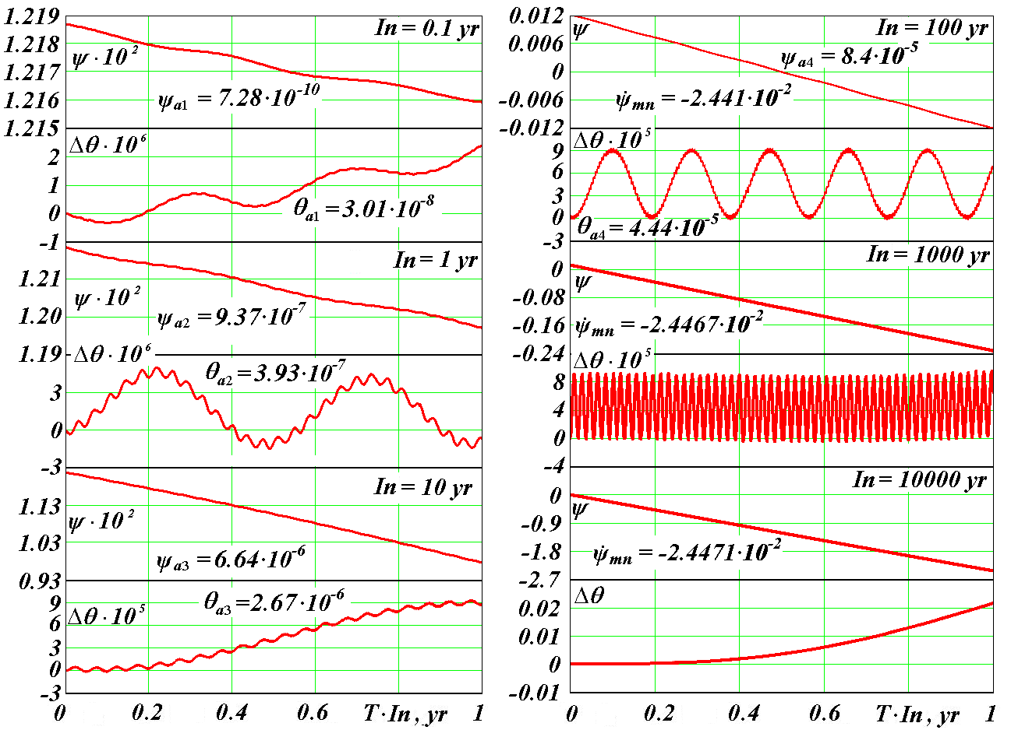

Fig. 5. Dynamics of the precession ψ and inclination θ angles (in radians) for the Earth rotation axis in 6 time intervals In in years (yr). Δθ= θ - θ_{0,} where θ₀ is the axis inclination angle at T = 0. Oscillation periods: P₁ = 1 day; P₂ = 0.5 months; P₃ = 0.5 years; P₄ = 18.6 years. ${\overset{˙}{ψ}}_{\text{mn}}$- the average precession velocity in the interval In (radian / century).

The diagrams of the half-month and six-month oscillations show that the amplitudes of the neighbouring oscillations are different. The amplitude is greater in the oscillation during which the Moon is at perigee (for half-month oscillations), and when the Earth is at perihelion (for half-year oscillations). The sequence of larger and smaller amplitudes and their time difference varies. This is due to perigee and perihelion movements.
On the interval of 100 years, the average amplitude of the precession angle oscillations ψ_{a4} = 8.4·10⁻⁵ rad. = 17.4'', and the average precession velocity = -2.441·10² radian / century. The period of these oscillations P₄ = 18.6 years is due to the precession of the Moon orbit. The angle oscillation amplitude θ with this period is θ_{a4} = 4.44·10⁻⁵ rad. = 9.2''.
On intervals of 1000 years and 10 thousand years, oscillations continue with a period of P₄ = 18.6 years. The average precession velocity on the intervals is -2.438·10⁻² and 2.425·10⁻² radian / century, respectively. The diagram Δθ for 10 thousand years shows the beginning of a new oscillation with a period of more than 10 thousand years.
So, oscillations of the angles ψ and θ with daily, half-monthly, half-yearly periods and a period of 18.6 years are manifested in the studied time interval of 10 thousand years. The oscillation amplitudes increase with increasing the periods. In this case, the angle oscillation amplitude ψ is 2-3 times greater than the angle oscillation amplitude θ. Earlier, the availability of these periods was physically justified on the basis of the theorem of moments (2). The amplitudes of the periods are consistent with the amplitudes in the works of other researchers, for example [19]. The amplitude θ_{a4} = 9.2'' for the period of 18.6 years is available for measurement. It is fixed in astronomy and is called a nutation constant [15]. Due to the availability of oscillations, the average precession velocity changes with a change in the averaging period. On the interval of 100 years its value = -2.441·10⁻² radian / century also coincides with the observed value according to [23] equal to - 2,442 ⋅10⁻² radian / century and [25] equal to - 2.439 ⋅10⁻² radian / century (see table 1a in the Appendix).
As noted earlier, the former Astronomical theory of climate change used solutions of the Poisson equations which are identical to equations (7) - (8). The latter are a simplification of the differential Earth rotation equations (4) - (5) due to neglect of the second derivatives and products of the first derivatives. Therefore, oscillations with periods P₁ - P₄ are not obtained in these solutions. This fact casts doubt on the long periods in the former Astronomical theory of climate change.
In fig. 5, we considered the results of solving the problem (4) - (5) with a change in time orienting to the future. In fig. 6 they are presented for 1 million years ago (m.y.a.). The precession angle ψ oscillating and grows into the past with an average rate ${\overset{˙}{ψ}}_{m}$= -0.024417015 rad / century for 1 million years.

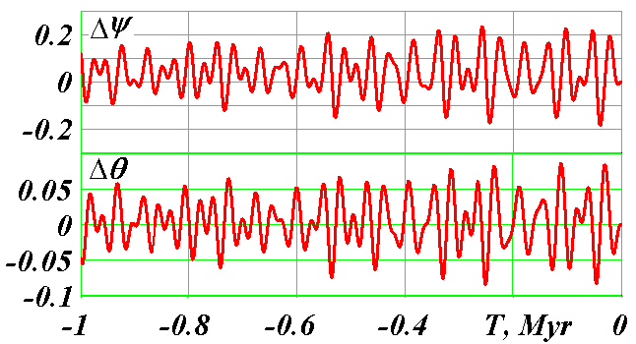

Fig. 6. The evolution of the Earth's rotational motion for 1 million years ago. Differences in the precession Δ$ψ$and inclination angles $Δθ=θ−θ_{0}$ are given in radians.

The sign " - " means that the Earth's rotation axis $\vec{N}$ (Figure 4) precesses clockwise with respect to the axis ${\vec{S}}_{0}$. The average period of this precession or rotation P _{pr} = 2 π /${\overset{˙}{ψ}}_{m}$ = 25738 years. Therefore, the averaged change in the precession angle occurs linearly
$ψ_{a}=ψ_{0}+{\overset{˙}{ψ}}_{m}⋅T\text{.}$ (11)
Further, we will mention this rounded value of the precession period P _{pr} = -25.74 thousand years.
Fig. 6 shows the evolution of the difference in the precession angle Δψ = ψ - ψ_{a.} During 1 million years, vibrations Δψ occur within the range from -0,184 to 0.233 rad., i.e. the oscillation amplitude is 0.417 radians. The value Δθ oscillates like Δψ, but within a smaller range from -0.0845 to 0.0855 rad., i.e. the oscillation amplitude is 0.17 radians. Thus, the maximum oscillation amplitude of the angle θ is 2.45 times smaller than the maximum oscillation amplitude of the angle ψ. In addition, the oscillations Δθ do not coincide in phase with the oscillations Δψ, they are shifted along the time axis T by -7.5 thousand years.
As shown in fig. 5, the duration of long periods of oscillation exceeds 10 thousand years. The contribution of the Moon to the oscillations of the axis of the Earth ended with a period of 18.6 years. As shown in works [14, 26], the contribution of planets is small in comparison with the contribution of the Moon and the Sun. Therefore, the periods of oscillations of the angles ψ and θ on the interval of 1 million years are due to: 1) the precession of the Earth’s axis itself with a period of 25.7 thousand years, 2) the precession period of the Earth’s orbit relative to the moving equator, 3) the periods of change in the eccentricity of the Earth’s orbit and 4) the rotation period of its perihelion relative to the moving equator. The influence of these four factors leads to the irregular nature of the ψ and θ oscillations in Fig. 6. One of the basic periods of oscillations in these diagrams is the period of 25.74 thousand years due to the precession of the Earth's axis.

6. CHANGE OF EARTH ROTATION MOTION PARAMETERS REGARDING THE EARTH'S MOVING ORBIT
The evolution of the Earth's rotational motion is of interest in relation to the evolution of its orbital motion. For example, the illumination of the Earth by the Sun depends on this relationship. As a result of integration of equations (4) - (5), the precession angle ψ and the inclination angle θ of the equatorial plane AA' (Fig. 4) relative to the fixed plane of the orbit or ecliptic E₀E₀' were obtained. The moving plane of the orbit EE' is coordinated by the inclination angles i_{E} and the position of the ascending node φ_{Ω} relative to the fixed equatorial plane A₀ A₀'. Projection of the Earth perihelion orbit on the celestial sphere is designated by the letter B, and its position relative to the fixed equator A₀ A₀' is defined by the angle φ_{p} = γ₂B. The evolution of angles i_{E,} φ_{Ω} and φ_{p} is determined as a result of solving the orbital problem for 100 million years [4, 30]. It is necessary to determine the evolution of the inclination angle ε between the moving planes of the Earth equator AA' and the orbit EE', as well as the evolution of the perihelion angle φ_{pγ} measured relative to the moving node γ.
When considering this problem for large time intervals, multiple ambiguous situations arise. Therefore, the transition from fixed to moving coordinates was performed in two ways: in spherical and in Cartesian coordinates. In spherical coordinates, the angles between the aforementioned planes were considered. In Cartesian coordinates, the angles between the axes of the equatorial plane $\vec{N}$and the orbit plane $\vec{S}$ were considered. In fig. 4 they are shown at the time moment T, and at the time moment T₀ are indicated, respectively, as ${\vec{N}}_{0}$ and ${\vec{S}}_{0}$. These axes are unit vectors perpendicular to the corresponding planes. The derivation of the expressions for ε and φ_{pγ} is presented in Appendix 2.
Fig. 7 shows the changes in the inclination angle ε between the moving planes of the Earth equator and the Earth’s orbit at two time intervals In for 100 years and 10 thousand years. In astronomy, the angle ε is called obliquity. Oscillations of the obliquity ε οn smaller time intervals are identical to the oscillations of the angle θ in Fig. 5.
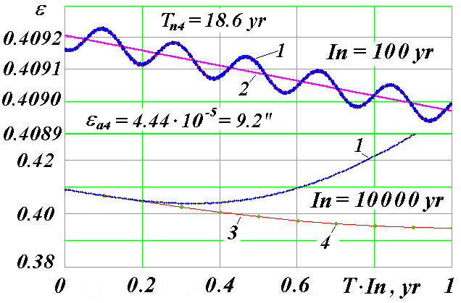
Fig. 7. Dynamics of the obliquity ε (in radians) of the Earth equatorial plane to the plane of its orbit at two time intervals In: yr - year; T_{n4} and ε_{a4} - oscillation period and amplitude of the obliquity ε; 1 - according to our results of numerical integration; 2 - approximation of observational data according to [15, 23]; 3 - based on the results of integration by Laskar et al. [21]; 4 - according to the results of integration by Sh.G. Sharaf and N.A. Budnikova [18].

On the interval In = 100 years it is shown that the computed 1 obliquity ε ranges around the observed average angle 2 according to works [15, 23]. As already mentioned, the oscillation amplitude ε_{a4} = 9.2˝ of the period T_{n4} =18.6 years also coincides with observations. Computed precession angle ψ also oscillates relative to the averaged precession angle according to observations, and the average ψ dynamics also coincides with observations.
As can be seen from fig. 7, there are up to 2,000 years for such coincidence on the interval In = 10 thousand years with the observation data approximation and the results of solutions of other authors [18, 21]. Further, the obliquity ε computed by us begins to differ from the results of their solutions.
In fig. 8 it is shown on the interval of 200 thousand years that differences grow with time, and the subsequent evolution of the obliquity ε computed by us significantly differs from the evolution obtained by other authors who have decided the simplified problem (7) - (8) of the Earth rotation. As can be seen from the diagrams, the angle ε oscillations according to our solutions occur within the range from 16.7º to 31º, while according to the previous solutions it was within the range from 22.26º to 24.32º, i.e., the oscillations range is 7 times larger.
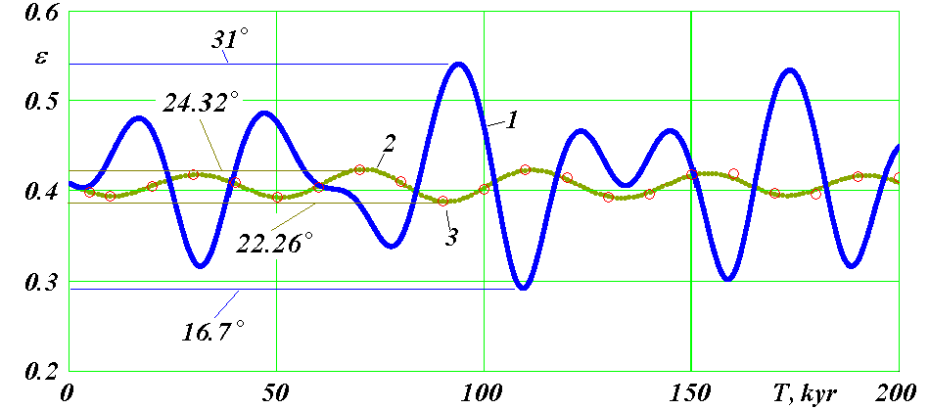
Fig. 8. Evolution of the inclination angle ε (in radians) of the Earth equator plane to its orbit plane on the interval of 200 thousand years: 1 - according to our numerical integration results; 2 - according to the results of integration by Laskar et al. [21] ; 3 - according to the results of the integration by Sh. G. Sharaf and N. A. Budnikova [18]. The maximum and minimum values of the obliquity ε are shown in degrees.
7. EVOLUTION OF THE EARTH ROTATION MOTION PARAMETERS FOR MILLION YEARS
7.1. Evolution of inclination and perihelion angles for 5 m.y.a. Fig. 9 shows evolution of the angles ε and φ_{pγ} for 5 m.y.a. The oscillations of the obliquity ε occur irregularly and with different amplitudes. The main period of oscillation is the average one for 5 million years, T_{εm} = 25.73 thousand years. It is equal to the precession period of the Earth’s axis. The period of oscillations in a particular epoch may differ from the average period by a thousand years. There may be more significant differences. For example, in the epoch of 4.6 m.y.a. one minimum ε degenerates, and two oscillations occur over three intervals T _{εm,} i.e. the oscillation period becomes equal to 38.6 thousand years. The oscillation amplitude is variable and varies from zero to maximum which is equal to 9°. On average, the amplitude is equal to 2.74°, and the average value of the obliquity ε is 23.8° with its current value of 23.44°.
On the interval of 5 million years, there are no repeating sections of the change in the obliquity ε. The distribution of large oscillation amplitudes is also irregular. There are two sections with very large amplitudes: 0 ÷ 0.25 m.y.a. and 2.2 ÷ 2.8 m.y.a. There are areas with very small oscillation amplitudes, e.g., in epochs T ≈ 3.3 m.y.a. and T ≈ 4.2 m.y.a. The largest ε values are shown in Fig. 9 in degrees: 32.68° in the epoch T = 2.6582 m.y.a. and 14.68° in the epoch T = 0.2508 m.y.a. Thus, the maximum oscillation amplitude of the Earth's axis for 5 m.y.a. is ε_{amx} = 9°.
As can be seen from fig. 9, the perihelion angle φ_{pγ} varies from 1.776 radians in the epoch of December 30, 1949 to -1445.7 radians in the epoch of 5 m.y.a. This change indicates the rotation of the perihelion counterclockwise when the time changes into the future, i.e. in the direction of the orbital motion of the Earth. Fig. 9 also shows the current rotation periods T_{pγt} at intervals of 20 thousand years. As can be seen, the rotation periods are uneven; they vary from 13.8 to 41.8 thousand years. On average, these changes occur in the range from 19 to 25 thousand years. And the average period of the perihelion rotation over 5 million years is T_{pγm} = 21.7 thousand years. It should be recalled that this is the period of perihelion rotation relative to the moving line of intersection between the planes of the equator and the Earth’s orbit. The average period of the perihelion rotation for 5 m.y.a. relative to the fixed space is T_{p} = 138.5 thousand years.
7.2. Evolution of obliquity for 20 m.y.a. Line 1 in Fig. 10 shows the evolution of the obliquity ε for 20 m.y.a. in the form of ten 2 million year time intervals. The left limit of each time interval is denoted as T_{l,} which for the 2 m.y.a. upper diagram is written as T_{l} = -2. Therefore, at the bottom, the time axis T begins with T_{l.} For comparison, line 2 in the diagrams shows the change in the obliquity ε according to the previous theory of the Earth's axis evolution using the example of [21].
To perform a statistical analysis of these results, gradations of the angle ε are introduced. The entire range of oscillations from ε_{max} to ε_{min} is divided into 6 levels with an interval
Δε = (ε_{max} - ε_{min}) / 6. (12)
The average value of the oscillations ε is equal to
ε_{mo} = 0.5 (ε_{max} + ε_{min}). (13)
And the boundaries of the first and second levels of large inclination angles will be
ε_{t1} = ε_{mo} + Δε ; ε_{t2} = ε_{mo} + 2·Δε. 14)
The boundaries of the first and second levels of small inclination angles are written as follows
ε_{c1} = ε_{mo} - Δε ; ε_{c2} = ε_{mo} - 2·Δε. (15)

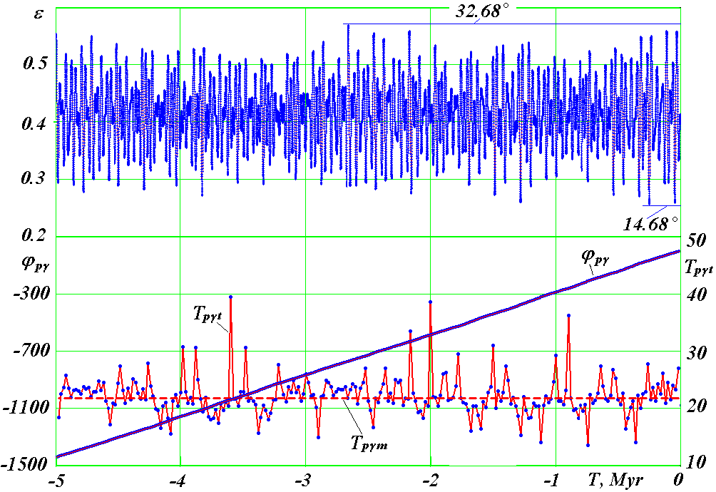

Fig. 9. The evolution of the obliquity ε and the angle of the perihelion position φ_{pγ,} for 5 m.y.a.: T_{pγt} is the current period of the perihelion rotation for 20 thousand year time intervals, in millennia; T_{pγm} = 21.7 thousand years - the average period of perihelion rotation.
Large values for the obliquity ε correspond to warm spells at latitudes φ > 45º, and small values correspond to cold spells [12, 13, 29]. According to these correspondences, boundary indices are introduced: t - warm, c - cold.
For 20 m.y.a., the greatest value of the angle ε_{max} = 0.57038 = 32.68º was 2.6582 m.y.a., and the smallest ε_{min} = 0.24255 = 13.897º was 14.208 m.y.a.
The average values ε_{mo} and the boundaries ε_{t1,} ε_{t2,} ε_{c1} and ε_{c2} are plotted in the diagrams of Fig. 10. Consider the distribution of the amounts of the highest levels concerning obliquity ε, the largest ε_{t2} and the lowest levels less than ε_{c2} at time intervals of 1 million years. High levels of inclination correspond to strong warm spells at high latitudes, and low latitudes correspond to strong cold spells.
As can be seen in fig. 10, during the first million years T = -1 Myr = 1 m.y.a. there were 6 periods with an obliquity ε > ε_{t2} and 7 periods with ε < ε_{c2.} The angles ε differently exceed the second levels; therefore, these periods have different intensities and different durations. Neglecting this difference, we classify the evolution of ε at million year intervals by the number of exceeding the boundaries ε_{t2} and ε_{c2} by the angle ε (Table 2).
As can be seen from the table 2, there were a total of 172 cases on exceeding the second levels. Of those, there were 90 cases on exceeding the very large obliquities and 82 cases of very small exceeding. Thus, on average, for 1 million years, 8.6 excesses of the second boundaries occur. Moreover, there were on the average 4.5 periods with very large angles ε, and 4.1 with very small angles.
We distribute the million year intervals into three modes of evolution of the Earth's rotational motion: ordinary, unsteady, and calm. Taking into account the average number of excesses equal to 8.6, we assign to the ordinary ε evolution mode the million year intervals with the number of excesses ε_{t2} + ε_{c2} from 7 to 10.
As can be seen from the table 2, there were 8 of them. In the ordinary evolution mode ε, (see, for example, Fig. 10), the interval with T _{l} = 19 m.y.a. occurs during 4 periods with very large obliquities and 4 with very small angles.
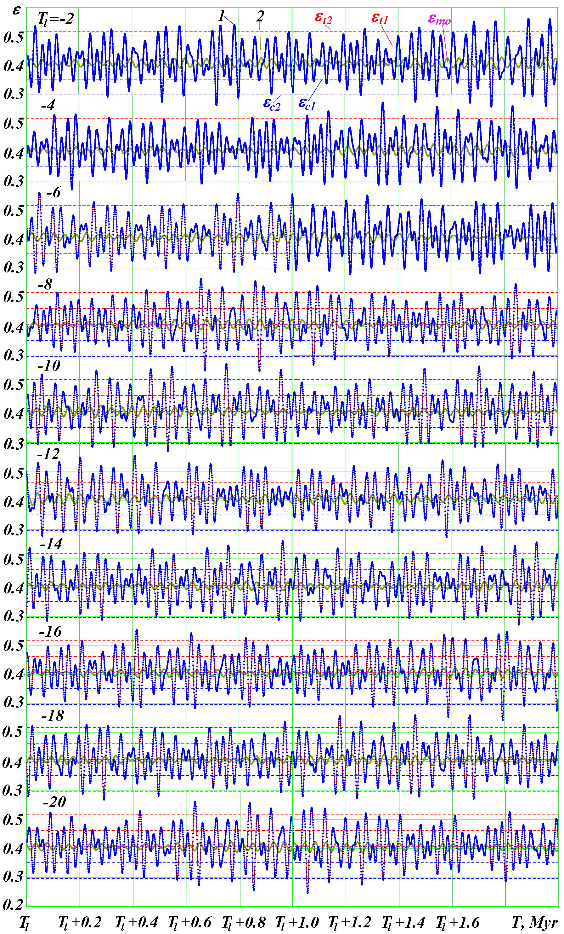

Fig. 10. The evolution of the obliquity ε for 20 m.y.a. in the form of 10 diagrams of 2 million years: line 1 according to our solutions and line 2 according to previous solutions on the example of [21]; T_{l} - left counting on the time axis, in million years, shown in the left corner of each diagram; ε_{t1,} ε_{t2} and ε_{c1,} ε_{c2} are the first and second boundaries of large (_{t}) and small (_{c}) levels of the obliquity, respectively; ε_{mo} is the average value of the angle ε oscillations; the interval between the points on the diagrams is 200 years at the interval 0 - 5 m.y.a. and 500 years after 5 m.y.a..
Table 2. Number of cases where the obliquity ε exceeds boundaries ε_{t2} and ε_{c2} for million year time intervals: T_{l} - left timing boundary in m.y.a; ε_{t2} + ε_{c2} - the sum of the excesses of the boundaries ε_{t2} and ε_{c2.}
T_{l} | ε_{t2} | ε_{c2} | ε_{t2} + ε_{c2} | T_{l} | ε_{t2} | ε_{c2} | ε_{t2} + ε_{c2} | T_{l} | ε_{t2} | ε_{c2} | ε_{t2} + ε_{c2}
1 | 6 | 7 | 13 | 8 | 5 | 2 | 7 | 15 | 5 | 4 | 9
2 | 6 | 5 | 11 | 9 | 3 | 3 | 6 | 16 | 3 | 4 | 7
3 | 7 | 6 | 13 | 10 | 6 | 6 | 12 | 17 | 6 | 6 | 12
4 | 2 | 3 | 5 | 11 | 2 | 1 | 3 | 18 | 2 | 4 | 6
5 | 6 | 5 | 11 | 12 | 7 | 5 | 12 | 19 | 4 | 4 | 8
6 | 5 | 5 | 10 | 13 | 4 | 3 | 7 | 20 | 4 | 3 | 7
7 | 2 | 3 | 5 | 14 | 5 | 3 | 8
Total: |  |  |  |  |  |  |  |  | 90 | 82 | 172

Or there may be 5 such excesses as on the interval T_{l} = 6 m.y.a. In other million year intervals, the number of very large or very small angles may differ by 1. Only on the interval with T_{l} = 8 m.y.a. there were 5 periods with very large ε and only 2 periods with very small ε.
We assign to the unsteady mode of the angle ε evolution the intervals with the number of all excesses equal to 11 and more. As can be seen from the table 2, there were 7 of such intervals. Under an unsteady evolutionary mode (see, for example, intervals with T_{l} = 3 m.y.a. and 12 m.y.a.), there are 7 periods of very large angles ε. In other million year intervals, such as with T_{l} = 1 m.y.a., there were 7 periods with very small inclination angles. The last million year interval (T_{l} = 1 m.y.a.), in which we live, refers to the unsteady evolution of the angle ε: here was one of the largest numbers of total excesses, namely 13.
The calm evolution mode ε includes intervals with the number of all excesses of 6 or less. There were 5 such intervals. Two of these intervals (T_{l} = 4 and 7 m.y.a.) have 2 cycles with large inclination angle and 3 with the small one. Most calm evolution mode was the million year interval with T_{l} = 11 m.y.a. There were only 3 periods with exceeding the boundaries of ε_{c2} and ε_{t2.}
In addition to the obliquity ε, the evolution of the Earth's insolation is affected by the perihelion angle φ _{pγ} and the orbit eccentricity e. Therefore, the periods with the greatest obliquities do not always coincide with the periods of the highest insolation at high latitudes [12, 13, 29]. The same applies to the smallest obliquities ε and the smallest insolation. But in general, the mentioned statistics for the evolution modes ε and the three climate groups for unsteady, ordinary, and calm periods coincide [12, 13, 29].
The results presented in fig. 10 and their analysis show that stable oscillations of the obliquity ε occur at the interval of 20 m.y.a. The range of angle ε oscillations from 14.8° to 32.1° [12, 13] shown over the first 50 thousand years remains practically unchanged during the entire 20 m.y.a.
Extreme obliquities occur in an irregular order. Such an irregular order of occurrence of events is usually called chaotic. However, in this case, these events are strictly determined and occur as a result of the influence of many factors that determine the orbital motion of the solar system bodies and the rotational motion of the Earth. Therefore, the considered example is the case when the randomly occurring circumstances that we perceive turn out to be caused by strictly determined causes. In this case, these deterministic reasons are: 1) the gravitational action of planets, Sun and Moon on the Earth's orbital motion, 2) the action of the bodies on the Earth's rotational movement and 3) changing in the rotational movement relative to the orbital one.
The above changes in the angles ε and φ_{pγ,} as well as the eccentricity of the orbit e are presented on the website http://www.ikz.ru/~smulski//Data/Insol/ in the file OrAl0-5My.prn for the interval 5 m.y.a., in the file OrAl-5-10My.prn for the interval 6 m.y.a. - 10 m.y.a. and in the file OrAl-11-20My.prn for the interval 11 m.y.a. – 20.369 m.y.a. It is possible to analyse this data and build diagrams using the software Insl2bd.mcd which is available on this site.

8. FEATURES OF THE EARTH ROTATION MOTION EVOLUTION
8.1. The precession of the Earth's axis relative to motionless space. The presented changes in the rotational motion parameters ε and ψ allow us to consider the evolution of the Earth's rotation axis $\vec{N}$ itself (Fig. 11). Such an evolution of the Earth’s orbit axis $\vec{S}$was previously considered by us [4, 8]. It was shown that the orbit axis precesses clockwise around the vector $\vec{M}$, which is the angular momentum of the entire solar system. In the barycentric equatorial coordinate system xyz, the plane which is perpendicular to $\vec{M}$ has coordinates φ_{M} = 0.0680946 and i_{M} = 0.401834, where φ_{M} is the ascending angle of this plane, and i_{M} is its inclination angle to the plane of equator 2. Using the projections S_{x,} S_{y} and S_{z,} according to (40a) - (42a) (Appendix 2), and these angles, the projections of the Earth's orbit axis S_{xM,} S_{yM} and S_{zM} in the coordinate system bound to the vector $\vec{M}$are determined.

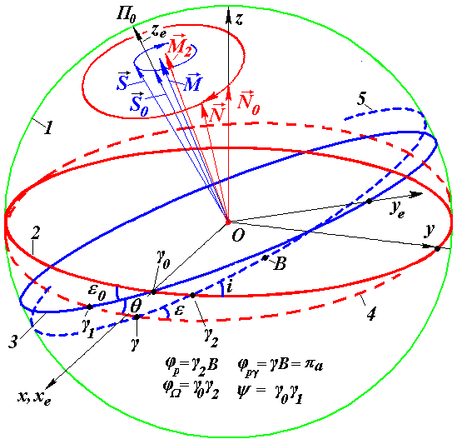
Fig. 11. Parameters of the Earth's orbit and axis in fixed equatorial xyz and ecliptic x_{e} y_{e} z_{e} coordinate systems: 1 - celestial sphere; planes shown are in the epoch T_{0:} 2 — the Earth equator, 3 — Earth’s orbits; planes shown are in the T epoch: 4 - the Earth equator, 5 - Earth’s orbits ; unit vectors: $\vec{N}$- the Earth’s axis, $\vec{S}$- the Earth orbit axes, $\vec{M}$- the angular momentum of the Solar system; γ_{0 }- point of the vernal equinox in the epoch T₀ ; B - the perihelion position on the celestial sphere in the epoch T₀ ; ϕ_{Ω}= γ₀γ₂ - the angle of the ascending node of the orbit ; ϕ_{p} = γ₂B – the perihelion angle ; i is the orbit obliquity.

Fig. 12,a shows the orbit $\vec{S}$axis precession for 5 million years around the moment vector of angular momentum $\vec{M}$. The axis $\vec{S}$ movement both for 5 million years and for 100 million years [4] takes place mainly in the region with a distance of 0.045 from the vector $\vec{M}$, which corresponds to the angle of 2.578° between $\vec{S}$ and $\vec{M}$. Only in one precession cycle there is the largest deviation of the axis $\vec{S}$ from the vector $\vec{M}$, with a distance greater than 0.05. The maximum deviation of 0.0510672 of axis $\vec{S}$ from $\vec{M}$ occurs in the point 2_{S} in the epoch T = -2.326 kyr, at an angle of 2.926°.
A coordinate system x_{M}y_{M}z_{M,} associated with the vector $\vec{M}$ of the angular momentum related to the solar system is an inertial system, in which orbit axes of all the planets and Sun [4, 8]. The following question arises: will axes of planet rotation precess around the vector $\vec{M}$?
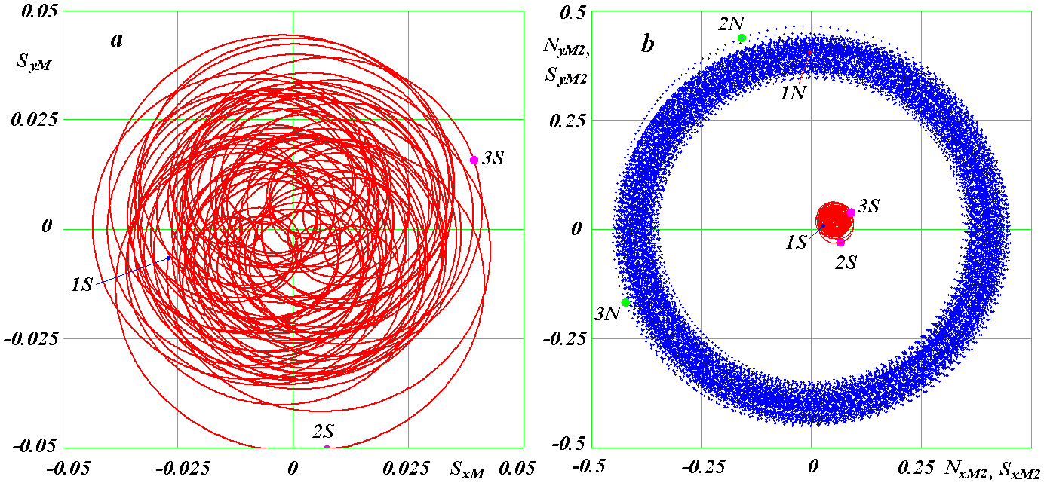

Fig. 12. Projections of axis precession trajectories of the Earth’s orbit $\vec{S}$ (a) and its axis of rotation $\vec{N}$ (b) for 5 m.y.a. on the plane perpendicular to the vectors $\vec{M}$ and ${\vec{M}}_{2}$, accordingly: the positions of the axes at time instants and the angles between them: 1_{S} and 1_{N} - T = 0 kyr, ε= 23.443°; 2_{S} and 2_{N} - T = -0.2326 Myr, ε = 30.778°; 3_{S} and 3_{N} - T = -2.6582Myr, ε = 32.680°.

To this end, the motion of the axis $\vec{N}$of the Earth rotation was similarly studied. As a result of studies, it was found that precession of $\vec{N}$occurs around an axis that is shifted from the angular moment $\vec{M}$ vector. The following algorithm was used to find this axis. The projections of the Earth’s axis in the equatorial coordinate system xyz were determined using the projections N_{xe,} N_{ye,} and N_{ze} of the axis $\vec{N}$in the barycentric ecliptic coordinate system x_{e}y_{e}z_{e,} according to (34a) - (36a) (Appendix 2),
N_{x} = N_{xe} ; N_{y} = N_{ye}⋅cos ε₀ - N_{ze}⋅sin ε₀; N_{z} = N_{ye}⋅sin ε₀ + N_{ze}⋅cos ε_{0.} (16)
The projections (16) are used to compute their average values N_{xm,} N_{ym} and N_{zm,} e.g., during 5 m.y.a. and their average module
$N_{m}=\sqrt{N_{\text{xm}}^{2}+N_{\text{ym}}^{2}+N_{\text{zm}}^{2}}$ . (17)
We assume that the unit vector ${\vec{M}}_{2}$, around which the precession of the Earth's axis takes place, coincides with the average position of the Earth's axis N _{m,} i.e. has the same projections N_{xm,} N_{ym,} and N_{zm} in the equatorial coordinate system xyz. Then the plane perpendicular to the vector ${\vec{M}}_{2}$ is inclined to the equator plane 2 (Fig. 11) at an angle:
i_{M2} = arcsin ((N_{xm}² + N_{ym}²)^{0.5} / N_{m}), (18)
and the ascending angle of this plane
φ_{M2} = arcsin (N_{xm} / (N_{m}² + N_{ym}²) ^{0.5}). (19)
For 5 m.y.a., the angles are: i_{M2} = 0.417728 and φ_{M2} = -0.0664662. In fig. 11 precession of the Earth's rotation axis is shown around a stationary vector ${\vec{M}}_{2}$. The angle between the stationary vectors ${\vec{M}}_{1}$ and ${\vec{M}}_{2}$ is 3.201402°. Given the angles (18) and (19), the projections of the Earth rotation axis on the axis of the coordinate system associated with the vector will be:
N_{xM2} = N_{x}·cos φ_{M2} + N_{y}·sin φ_{M2}; (20)
N_{yM2} = N_{x}·sinφ_{M2}·cosi_{M2} + N_{y}·cosφ_{M2}cosi_{M2} + N_{z}·sini_{M2}; (21)
N_{zM2} = N_{x}·sinφ_{M2}·sini_{M2} + N_{y}·cosφ_{M2}·sini_{M2} + N_{z}·cosi_{M2}. (22)
Fig. 12b shows the Earth's axis $\vec{N}$precession around the vector ${\vec{M}}_{2}$ for 5 million years. Point 1_{N} marks the axis position at the initial time, and points 2_{N} and 3_{N} - in other epochs. The diagram shows that, in fact, the Earth's axis precession is axisymmetric with respect to the origin of coordinates. The vector ${\vec{M}}_{2}$ vertex is projected onto this point. The Earth’s axis precesses clockwise as time changes into the future. Precession occurs within the ring with an average distance from the vector ${\vec{M}}_{2}$ equal to 0.4. The average deviation of the axis $\vec{N}$from ${\vec{M}}_{2}$ is θ _{M2} = 23.614 °, and the maximum deviation is θ _{M2 max} = 27.756 °. Here the angle between these vectors is defined as
θ_{M2} = arcos N_{zM2.} (23)
Thus, the precession of the Earth rotation axis $\vec{N}$takes place in the second inertial system associated with the vector ${\vec{M}}_{2}$. Obviously, this vector will be different for each planet. It is determined by its conditions of origination, as well as its development associated with a change in mass.
Fig. 12b also shows the Earth’s axis $\vec{S}$orbit motion with respect to the vector ${\vec{M}}_{2}$. Points 1_{S,} 2_{S} and 2_{S} indicate the position of the axis $\vec{S}$in the corresponding epochs. The epoch T = -0.232 Myr with the largest angle θ_{M2max} is 600 years ahead of the epoch T = -0.2326 Myr (point 2_{S} in Fig. 12b), where there is the maximum deviation of the orbit axis $\vec{S}$. In this epoch (point 2_{N} in Fig. 12, b) the angle is equal θ_{M2} = 27.736°, i.e. very close to θ_{M2max.}
So, at the points 2_{N} and 2_{S}, the axes $\vec{N}$ and $\vec{S}$ are in the same epoch T = -0.2326 Myr. As you can see, a large deviation of the orbit S axis caused a large deviation of the Earth’s axis $\vec{N}$. However, the axis precession centre $\vec{S}$ is shifted in the perpendicular direction with respect to the line 2_{N}2_{S} of the deviation from the axes $\vec{N}$ and $\vec{S}$. Therefore, the angle ε between them in this epoch equal to 30.778° is not maximum (Fig. 10). The angle ε maximum for 5 million years is equal to 32.68° in the epoch T = -2.6582 Myr, when the axes $\vec{N}$ and $\vec{S}$ are located at opposite points of their trajectories (point 3_{S} and 3_{N} in Fig. 12 b).
8.2. The evolution of the Earth’s rotation axis in the second inertial coordinate system. In the inertial system associated with the vector ${\vec{M}}_{2}$, the inclination angle θ _{M2} in the form (23) has already been introduced for the axis $\vec{N}$. The precession angle of the axis $\vec{N}$ measured in relation to the axis x_{M2}, is determined as follows:
ψ_{M2} = arcsin (N_{xm 2}/(N_{x m2}²+N_{ym2}²)^{0.5}), (24),
Where the x_{M2} axis is directed along the line of intersection of the equator plane and the x_{M2}Oy_{M2} plane.
Fig. 13 shows the evolution of the angles θ_{M2} and Δψ_{M2} of the Earth’s rotation axis relative to a stationary vector ${\vec{M}}_{2}$ for 1 million years. The inclination angle θ_{M2} for 5 million years is varied from 20.044° to 27.756°. The main oscillation period is P_{θM2} = 41.1 kyr. It also shows the evolution of the angle between the axes $\vec{N}$and z_{e,} i.e. angle θ. It ranges from 18.594° to 28.677°. Thus, the angle oscillation range θ is 2.37° greater than the oscillation amplitude θ_{M2.} In addition, intermediate oscillations appeared at the angle θ (Fig. 13).
Fig. 13 also shows the evolution of the obliquity ε between the moving axes of the Earth $\vec{N}$and its orbit $\vec{S}$. It varies within the range from 14.676° to 32.68°. Thus, the range of oscillations ε is greater than the range of oscillations of the angle θ_{M2} by 10.292°. In addition, the structure of oscillations has changed. New oscillations of the angle θ appeared; they acquired large amplitudes for the angle ε. All these changes in the angles θ and ε compared with the angle θ_{M2} are explained by the dynamics of the axes $\vec{N}$ and $\vec{S}$ in Fig. 12b.

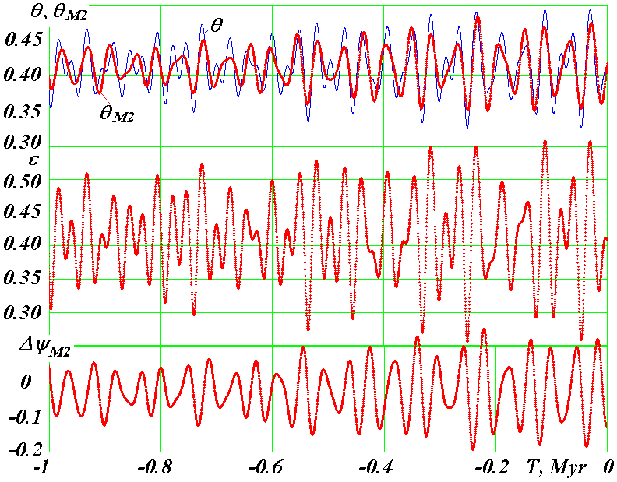
Fig. 13. Evolution of angles θ_{M2} and Δ ψ_{M2} of Earth's axis rotation relative to the fixed vector ${\vec{M}}_{2}$ for 1 m.y.a. and comparing the inclination angles θ_{M2} with the angles θ and ε.

The precession angle ψ_{M2} for the Earth rotation axis $\vec{N}$relative to the vector ${\vec{M}}_{2}$ (Fig. 11) on average for 5 m.y.a. varies linearly
ψ_{M2a} = ψ_{M20} + 2 πT / P_{prM2}, (25),

where ψ_{M20} = 3.153580 is the precession angle at T = 0; P_{prM2} = -25.732623 kyr is the average period of axis precession relative to the vector. It differs from the precession period of the axis relative to the axis z_{e} only by 0.346 years, i.e. almost coincides with.
Fig. 13 shows the precession oscillations of the axis $\vec{N}$in the form of a difference
Δψ_{M2} = ψ_{M2} - ψ_{M2a}. (26)
The main period of these oscillations is the same as the inclination angle θ_{M2,} i.e. equals to P_{ΘM2} = 41.1 kyr. The oscillation range of the angle Δψ _{M2} is 20 °, with the range of oscillations θ_{M2} = 7.7°. Thus, the largest oscillation amplitude of the precession angle ψ_{M2} exceeds the largest amplitude of the angle θ _{M2} by 2.6 times. The oscillations of the angles θ_{M2} and ψ_{M2} are not simultaneous. The extrema θ_{M2} are ahead of the extrema ψ_{M2} by 0.25 P_{θM2} = - 10.275 kyr, i.e. as time changes to the future, the extremum θ _{M2} first appears, and after 10.275 kyr the extremum Δψ_{M2} appears.
8.3. The physical difference between the old and the new evolution theories for the Earth’s rotation axis. In the previous evolution theory of the Earth’s rotation axis, the main period of oscillations was 41 thousand years. As already noted, this theory was based on the solution of simplified differential equations (7) - (8) of the first order. As a result of such a simplified consideration, the positions of the vectors ${\vec{M}}_{2}$ and $\vec{M}$coincided (Fig. 11) that in Fig. 12b corresponds to the coincidence of the trajectory centre of the Earth orbit axis $\vec{S}$ with the trajectory centre of the rotation axis $\vec{N}$. Since these axes precess in one direction (clockwise), the effect of orbital motion on the rotational one will depend on their relative precession velocity 2π/P_{prM2} - 2π/P_{prS,} i.e. the period of this influence will be defined as follows:
$P_{\text{rl}}=\frac{P_{\text{prS}}⋅P_{\text{prM}2}}{P_{\text{prS}}−P_{\text{prM}2}}=−\text{41}\text{.}1$kyr, (27),
where P_{prS} = - 68.7 kyr.
Thus, in the previous theory of the Earth's axis evolution, the angle ε oscillation period is the period of relative precession P_{rl} of the rotation axis $\vec{N}$and orbit axis $\vec{S}$. From here a physical explanation of the difference between the new evolution theory of the Earth's axis and the previous theory follows. In the previous theory, the precession axes $\vec{M}$ and ${\vec{M}}_{2}$of the orbit axis $\vec{S}$ and the Earth’s axis $\vec{N}$ coincided. In the new theory (Fig. 11 and Fig. 12b) they do not coincide. Due to the mismatch of the vectors $\vec{M}$ and ${\vec{M}}_{2}$, moments of the forces acting by all bodies on the Earth have a larger oscillation range. Therefore, the oscillation amplitude θ increases relative to the fixed coordinate system x_{e}y_{e}z_{e.} In addition, the angle ε oscillation range between the moving orbit axis $\vec{S}$ and the axis $\vec{N}$ increases. As a result, the oscillation amplitude of the angle ε according to the new theory exceeds the oscillation amplitude according to the previous theory by 7-8 times.
8.4. Short-period evolution of the Earth's axis. Short-period oscillations of the Earth's axis, which are shorter than periods of tens of thousands years, begin with a period of 18.6 years. Therefore, we consider the evolution of the Earth's axis at time intervals of 100 years or less. According to (34a) - (36a), we average the projections of the Earth's axes N_{xe,} N_{ye,} N_{ze,} in the stationary ecliptic system for the current time intervals of 18.6 years. Then the moving averages of these values N_{xet18.6,} N_{yet18.6,} N_{zet18.6} would represent the projections of the Earth's axis ${\vec{N}}_{t\text{18}\text{.}6}$for 18.6 years. Consider the evolution of the Earth’s instantaneous axis relative to the average:
ΔN_{xe1} = N_{xe} – N_{xet18.6}; ΔN_{ye1} = N_{ye} – N_{yet18.6}; ΔN_{ze1} = N_{ze} – N_{zet18.6} (28)
Fig. 14a shows the evolution of the Earth’s instantaneous axis in a plane perpendicular to the mid-axis vector ${\vec{N}}_{t\text{18}\text{.}6}$. The equations (4) - (5) have been solved on the interval from T = 0 to T = -100 years. The results were issued with an interval Δ T_{e} = 0.04 years. The starting point 1 corresponds to the moment T ₁ = -9.28 years, and the entire diagram with the ending point 2 is presented for 18.6 years. As can be seen from fig. 14a, the instantaneous axis $\vec{N}$makes a complete revolution around the average axis ${\vec{N}}_{t\text{18}\text{.}6}$ for 18.6 years. Its movement occurs clockwise with a change in time to the future. The trajectory of this movement is a symmetrical oval with a large axis a_{N1} = 4.2 10^{-5,} located vertically. Other revolutions for the equation solutions (4) - (5) with regard to the remaining 100 years are superimposed on this oval. They are not shown so as not to obscure the short-period movements of the instantaneous axis.
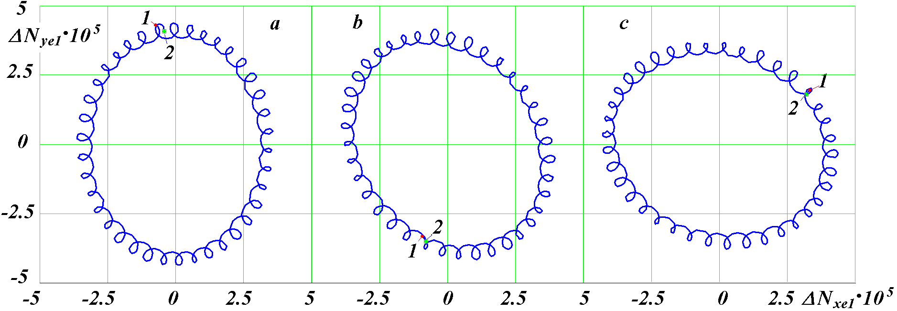

Fig. 14. Movement into the past for 18.6 years of the instantaneous Earth’s rotation axis relative to the moving average axis at different epochs: 1 and 2 - the initial and final points of motion, respectively; the initial moments of time T₁ in the epoch: a - T₁ = -0.00928 kyr ; b - T₁ = -2.50928 kyr ; c - T₁ = -5.00928 kyr.

As can be seen from fig. 14a, the instantaneous axis also performs smaller counterclockwise rotations as time changes into the future. Their period is 0.5 years. There are more than 37 such small rotations for the period over 18.6 years.
The rotation of the instantaneous axis $\vec{N}$relative to the average ${\vec{N}}_{t\text{18}\text{.}6}$occurs following the oval, and not a circle. This feature required additional studies with projections of the vector $\vec{N}$ in other coordinate systems associated with the moving equator and the ecliptic, as well as in a stationary system associated with the vector ${\vec{M}}_{2}$. The trajectory remained oval in all these systems. The computations for 100 years were repeated, but only in other epochs: T = -2.5 kyr (Fig. 14b) and T = -5 kyr (Fig. 14c). The oval shapes did not change, but the location of the major axes turned out to be rotated: by 36° for -2.5 kyr (Fig. 14b) and by 72° for -5 kyr (Fig. 14c). These results show that the oval makes a complete revolution during the precession period P_{pr} = -25.74 kyr. Rotation occurs clockwise as time changes to the future.
Since the axis vectors have a unit length, the largest deviation of the instantaneous axis $\vec{N}$from the average ${\vec{N}}_{t\text{18}\text{.}6}$
Δθ₁ = arcsin(a_{N1}) = 8.7” (29)
If the beginning of the axis ${\vec{N}}_{t\text{18}\text{.}6}$vector is located in the centre of the Earth perpendicular to the equator, then the instantaneous axis $\vec{N}$on its surface will describe the oval with a large axis
R_{P1} = R_{EP} a_{N1} = 267 m, (30)
where R_{EP} = 6356.765 km is the polar radius of the Earth.
So, when changing time to the future, the instantaneous Earth’s rotation axis follows an oval clockwise around the average ${\vec{N}}_{t\text{18}\text{.}6}$ during 18.6 years. This oval also rotates clockwise, making a complete revolution in 25.74 thousand years. These movements on the Earth's surface correspond to the movement of the instantaneous North Pole along the oval with a major axis equal to 267 m. The movement along the oval for 18.6 years and its rotation for 25.74 thousand years occurs clockwise. In this case, small rotations of the instantaneous pole counterclockwise with a period of 0.5 years occur.
To study shorter periods of evolution of the Earth's axis, equations (4) - (5) were integrated over the past 20 years with the output of the results through ΔT_{e} = 0.002 years. The moving average projections of the Earth's axis over 0.5 years were computed: N_{xet 0.5,} N_{yet 0.5,} N_{zet 0.5,} as well as deviations from their instantaneous axis ΔN_{xe2,} ΔN_{ye2,} ΔN_{ze2,} which were determined similarly (28). Fig. 15a shows the trajectory of the instantaneous axis $\vec{N}$relative to the average ${\vec{N}}_{t0\text{.}5}$.

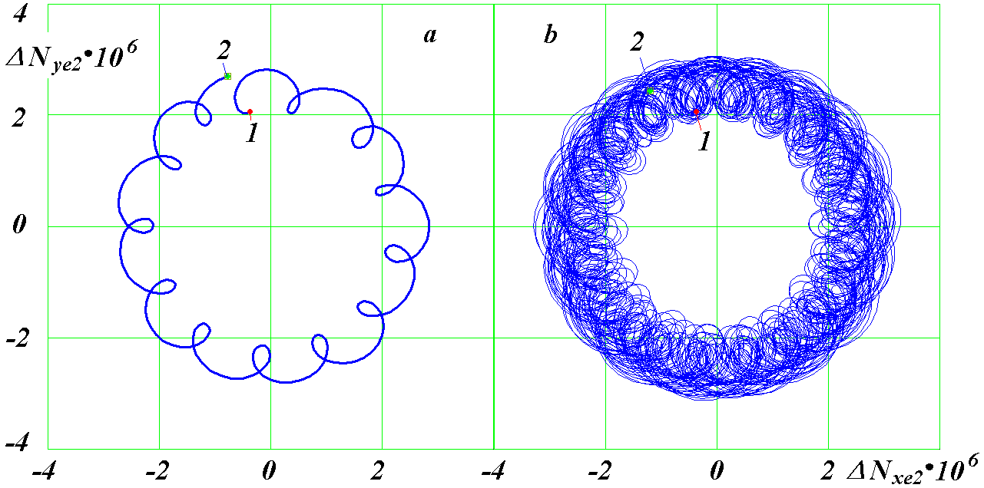

Fig. 15. Movement into the past for six months (a) and for 19.5 years (b) of the instantaneous Earth’s rotation axis relative to the moving average axis ${\vec{N}}_{t0\text{.}5}$: 1 and 2 - the starting and ending points of movement, respectively; initial time moment T₁ = -0.0025 kyr.

The axis $\vec{N}$ makes a complete revolution for 0.5 years counterclockwise when changing the time to the future, starting from point 2 and ending with point 1 at T = -0.25 years. In this case, almost 13 additional small revolutions occur, also directed counterclockwise. The duration of small revolutions is equal to a half-month. In fig. 15b, these movements of the Earth's axis from the initial point 1 to the final 2 are shown for 19.5 years. In this case, semi-annual movements occur in a circle with a radius of not more than a_{N2} = 3 10^{-6.} This corresponds to the deviation of the instantaneous axis from the average by an angle Δθ₂ = 0.62''. On the Earth surface, the instantaneous axis will make these movements around the average ${\vec{N}}_{t0\text{.}5}$ within a circle of radius R_{P2} = 19 m.
Similar studies were carried out for the half-monthly movements of instantaneous Earth’s axis $\vec{N}$ relative to the average ${\vec{N}}_{t0\text{.}5M}$of for a 0.5 month. These movements are shown in the diagram ΔN_{ye3} (ΔN_{xe3}) for 0.5 years in fig. 16a.
The instantaneous Earth’s rotation axis moves counterclockwise with a change in time to the future starting from point 2 to moment 1 at T = -0.0018. For half a month it makes a revolution along a trajectory close to a circle. However, these circles are open and shift with each revolution. Over 20 years, half-month turns of the Earth's axis fill the annular region with a radius of 3 10⁻⁷ to 7 10⁻⁷ (Fig. 16b), i.e. with an average distance from the centre a_{N3} = 5 10⁻⁷. This corresponds to the deviation of the instantaneous axis from the average ${\vec{N}}_{t0\text{.}5M}$by Δθ₃ = 0.1'' and its half-month movement on the Earth’s surface in a circle of radius R_{P3} = 3 m.
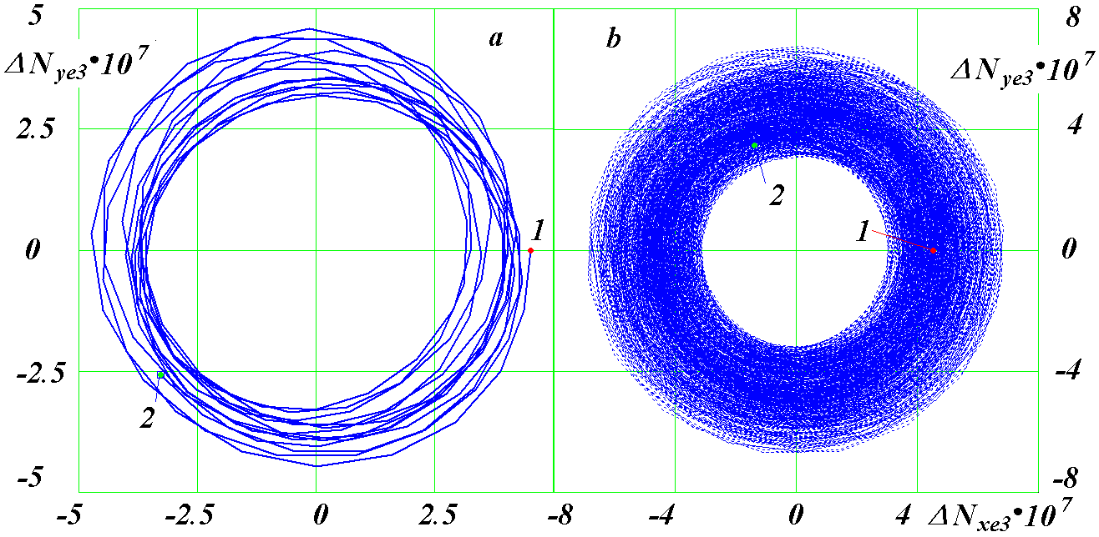

Fig. 16. Movement into the past for six months (a) and for 20 years (b) of the instantaneous Earth’s rotation axis $\vec{N}$ relative to the moving average axis ${\vec{N}}_{t0\text{.}5M}$: 1 and 2 - the starting and ending points of motion, respectively; initial time T₁ = -0.00018 kyr ; scales in figures a and b are different.

So, when the time changes in the future, the instantaneous Earth’s rotation axis makes a six-month movement against the clockwise direction around the 0.5-year average axis ${\vec{N}}_{t0\text{.}5}$and also half-monthly movement directed in the same direction around the half-monthly average axis${\vec{N}}_{t0\text{.}5M}$. At the same time, the radius of the half-month movement is 6 times less than of the six-month one.
The continuous movement of the Earth's axis leads to the problem of determining the points of its intersection with the Earth's surface, which are called poles. They are determined by the position of the average Earth’s rotation axis. Then the instantaneous Earth’s rotation axis will make cyclic movements relative to the pole. Above studies show that the form of these movements depends on what averaging point is assigned to be geographic poles of the Earth.
In this regard, we consider the movement of the instantaneous Earth’s axis relative to the moving average ${\vec{N}}_{\text{tPpr}}$ for the precession period of the Earth's axis P_{pr} = -25.74 thousand years. We compute the projections${\vec{N}}_{\text{tPpr}}$, and similarly (28), the projections of the deviations ΔN_{ye4} and ΔN_{xe4} of the instantaneous axis from the moving average ${\vec{N}}_{\text{tPpr}}$. The diagram ΔN_{ye4}(ΔN_{xe4}) is a narrow ring with a thickness of 0.02 and a radius of 0.4. This corresponds to the deviation of the instantaneous axis from the average${\vec{N}}_{\text{tPpr}}$by Δθ₄ = 23.58° and its movement over the Earth surface in a circle with radius R _{P 4} = 2542 km. When time changes to the future, the Earth’s instantaneous axis rotates clockwise around ${\vec{N}}_{\text{tPpr}}$ for 25.74 thousand years.

9. OSCILLATIONS OF THE EARTH'S ROTATION ANGULAR SPEED
The literature considers a number of factors that can influence the Earth’s rotation. These are changes in the distribution of air masses in the atmosphere, snow and ice cover, changes in sea level, the interaction between the Earth’s inner shells, etc. [6]. All of these factors are implied. Therefore, oscillations in the angular velocity of the Earth’s rotation, which directly follow from the interaction of the Earth with the bodies around it, are of interest.
As can be seen from equation (6), the Earth's eigenrotation speed $\overset{˙}{ϕ}$ depends on the precession speed $\overset{˙}{ψ}$of the Earth's axis and its inclination angle θ. Therefore, variations of the last two parameters lead to variations in the angular velocity of the Earth's rotation $\overset{˙}{ϕ}$. Next, we will consider the change in the period of the Earth's eigenrotation, which is associated with $\overset{˙}{ϕ}$ as follows:
P_{rt} = 2π/$\overset{˙}{ϕ}$ . (32)
Since the variations of the period P_{rt} are small, we will consider their differences in milliseconds in the form ΔP = P_{rt} - P_{rtm,} where P_{rtm} is the average value of the period P_{rt} in the studied time interval. Sidereal period of the Earth rotation is P_{rtm} = 0.997270 days with accuracy of up to 6 characters.
Fig. 17 shows the change in the deviation ΔP at four time intervals: 0 - 2 years; 0 - 20 years; 0 - 5 thousand years, and 0 - 500 thousand years. The first two intervals represent the integration results for the equations (4) - (5) over -20 years with a step of ΔT_{s} = 0.4 10⁻⁴ years. On the interval of 0 - 5 thousand years, the integration step was ΔT_{s} = 1 10⁻⁴ years, and the last interval represents the results of integration over -5 million years with the same step. The points on the diagrams are given with steps ΔT_{e,} which significantly exceed the integration steps ΔT_{s.}
At the first interval of 0 - 2 years, half-monthly oscillations ΔP with periods of 13.66 days and 182.6 days, respectively, are visible. Their average amplitudes are 5.2 ms and 2.5 ms, respectively, where 1 ms = 1 · 10 ⁻³ sec. The amplitudes in the neighbouring oscillations are different. Here are their average values. Half-monthly oscillations have the largest amplitude. Semi-annual oscillations with lower amplitude modulate them.

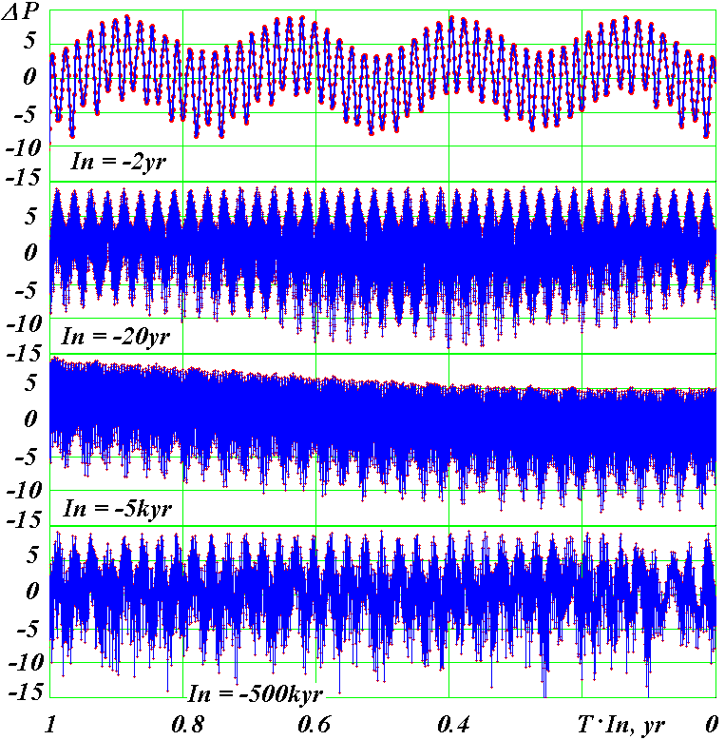

Fig. 17. The dynamics of the sidereal period deviation for the Earth's rotation at four time intervals In = 2, 20, 5000 and 500000 years ago: yr is the year.

In the second interval 0 - 20 years, the bottom portions of oscillations vary, that is modulated oscillation of the value ΔP with a period of 18.6 years takes place. The amplitude of these oscillations is 1 ms. These oscillations are due to the precession of the Moon orbit axis with the same period.
In the last two intervals of 0 - 5 thousand years and 0 - 500 thousand years, the value of ΔP does not exceed the deviation limits at the previous intervals. This indicates that, in addition to the identified three periods of oscillation, there are no other periods with significant amplitudes. The ΔP oscillations observed in the last two diagrams with periods of 152 years and 13.2 thousand years are due to sparse data: the intervals between the points are 1 year and 200 years, respectively, while the periods of oscillations are equal to half a month and half a year. Therefore, the selected points of these oscillations with the sequence ΔT_{e} form fictitious oscillations with periods of 152 years and 13.2 thousand years. The trend ΔP is also observed on the diagram of the interval 0 - 5 thousand years. It is also due to sparse data. This conclusion is confirmed over the entire studied interval for -5 million years: the deviation range ΔP is in the range from -15 to 10 ms.
So, the sidereal period of the Earth’s eigenrotation oscillates with half-month, half-year periods and periods of 18.6 years. The amplitudes of these oscillations decrease with increasing periods in the sequence: 5.2, 2.5, and 1 ms, respectively.
As already noted, the amplitudes of the neighbouring half-month and six-month oscillations are not the same. They are larger for oscillations corresponding to those half-months and half-years that contain the pericentric orbits of the Moon and the Earth, respectively.
The proper Earth's axis rotation angle φ is measured along the moving equator 4 from the line Oγ₁ (Fig. 11) of its intersection with the fixed plane of the Earth’s orbit 3. This line is moving in space, therefore the speed of its eigenrotation $\overset{˙}{ϕ}$ and its period P_{rt} oscillate due to the oscillation of the reference system associated with this line.

10. PROOF OF VERACITY OF SOLVING THE EARTH'S ROTATION PROBLEM
Veracity issues for solving the Earth's rotation problem are considered in detail in [12, 13, 28, 29]. Within the framework of the adopted technology of its solutions, all necessary checks were performed. For example, the problem was solved sequentially, under the action of one of 10 bodies: the Sun, 8 planets and the Moon [14, 26]. The obtained periods of oscillations of the Earth's axis were confirmed by general theoretical conclusions based on the theorem of moments, as well as the results of other authors [19]. Under the influence of all bodies, the problem was solved for different time intervals, and, as shown earlier, the results obtained coincided with the observations. The integration of equations (4) - (5) over 200 thousand years was carried out with different initial conditions and with different integration steps. This did not lead to a change in the periods of oscillations, their amplitudes, and the moments of extrema.
As already noted, the Earth rotation problem is one of the most complex problems of mechanics. This is also confirmed by the form of equations (4) - (5). Their derivation is associated with a series of transitions from one coordinate system to another, with the adoption of certain simplifications and approximations. The type of solutions may depend on the choice of the initial conditions, the method of solution, as well as on the transformations of the solutions regarding the Earth’s moving orbit. Therefore, a cardinal check of the obtained results would be to obtain them without solving differential equations (4) - (5).
When studying orbits, it turned out that the evolution of the Moon orbit axis is similar to the evolution of the Earth’s rotation axis. This result led us to a compound model of the Earth, in which part of the Earth mass is evenly distributed between peripheral bodies that rotate around a central body in a circular orbit. The orbits of peripheral bodies begin to change under the influence of the Moon, the Sun, and planets. The orbit axis evolution of one of these bodies models the evolution of the Earth’s rotation axis. Such a simulation of the Earth's rotational motion involves several stages of solving the orbital problem using the Galactica software. In the initial series of studies [3, 4], three models were studied and the possibility of modelling the evolution of the Earth’s axis was confirmed. In these models, the periods of precession of the orbit axes of the models were 170 years and 2604 years, while the average precession period of the Earth’s axis P_{pr} = -25740 years. Subsequently, 11 more models were developed until the necessary precession period was reached. In the 13th model, the radius of the orbit of the peripheral bodies is equal to the radius of the Earth, their orbital period is 0.142 hours, and the interaction between the bodies of the model is enhanced 9.6 times in comparison with the gravitational interaction. Thus, the bodies of the 13th model rotate 170 times faster than the Earth. In order to investigate the evolution of such models, the Galactica software was created with a modified interaction between certain bodies.
The solution of the problem for the 13th compound model of the Earth over an interval of 300 years [12, 13, 29] gave all the characteristics of the dynamics of the Earth’s axis, including half-monthly, half-year oscillations, and oscillations with a period of 18.6 years, concerning the angles ε and ψ. Their amplitude also coincided with the results of the problem (4) - (5). Such a coincidence of the model problem results with the straight line results occurs up to 3 thousand years. The further solution of the problem is hindered by the need to reduce the integration step to such values for which impossible counting time is required.
So, a compound model of the Earth over an interval of 3000 years has confirmed the results of integration of differential equations (4) - (5) of the Earth's rotation. This indicates that the assumptions and simplifications made when deriving the equations, their derivation, the method of solution, and the conversion of the integration results to the final form were also confirmed.
The second independent verification was to use a more accurate method for integrating equations (4) - (5), namely, the 8th-order Runge-Kutta method in the implementation of Dormand and Prince [17]. Prior to this, the DfEqAl1-.for software used the fourth-order Runge-Kutta integration method in the implementation of Krutko et al. [1]. We have used it for several decades to solve a variety of problems, and always get satisfactory results. When integrating equations (4) - (5) over time intervals of the 200 thousand years order, we encountered an unexpected drawback of this method. Daily oscillations amplitude for derivatives $\overset{˙}{ψ}$ and $\overset{˙}{θ}$ by the end of the integration interval was increased by several orders of magnitude. A program for solving the DfEqADP8-.for problem with the Dormand-Prince method was developed, and equations (4) - (5) were integrated at different time intervals, including 200 thousand years. All previously obtained results were confirmed. Thus the daily oscillation amplitudes $\overset{˙}{ψ}$ and $\overset{˙}{θ}$ do not increase and remain at the same level. So, the method of integrating equations does not affect the results, and the use of a more accurate method confirms this.
The third independent check consisted in changing the technology for solving the problem. The differential rotational equations (4) - (5) include the coordinates x_{1i,} y_{1i,} z_{1i} of the bodies acting on the Earth. They are determined when solving the orbital problem using the Galactica software. However, the data array with the increments on integrating the problem (4) - (5) catches unrealizable memory size for long intervals. Therefore, we created a mathematical model of the solar system [9], which allows us at the right time to obtain the coordinates of the bodies x_{1i,} y_{1i,} z_{1i} based on the results of the task for two bodies: the mother body and its satellite. The parameters of the body orbit: e, i, φ_{Ω,} φ_{p,} R_{p.} and others are determined at each moment by data previously computed using the Galactica software. In the process of solving this problem, the mathematical model of the solar system was comprehensively tested. Nevertheless, there remained the possibility that, over long time intervals, insignificant differences between the results of the mathematical model of the Solar System and the coordinate values obtained using the Galactica software could affect the evolution of the parameters of the rotational motion ε and ψ. New software, glc3rte2.for, was developed for the joint solution of the orbital problem and the Earth rotation problem. In it, the Galactica method solves the orbital problem for one step in time, and then the Dormand-Prince method solves the Earth rotation problem during this step. With the help of the new software, these two tasks were accomplished for different time intervals, including the interval of 200 thousand years. All previously obtained results were confirmed. This test also confirmed the mathematical model of the solar system over a long time interval.
Table 3 shows quantitative comparisons of the precession period P_{pr} and the minimum ε_{min} and maximum ε_{max} inclination angles with an accuracy of the fifth significant digit. With this accuracy, the first two methods completely coincided. As can be seen from table 3, the results of the third method for to the precession period, P_{pr}, differ in the 4th sign, and in the 5th sign as to the inclination angle ε. Since this method is more accurate, the latter quantities are a refinement of the results obtained by the first two methods.

Table. 3. Comparison of the results for three methods intended for integrating the rotational equations (4) - (5) for 200 thousand years: RG-4 - 4th-order Runge-Kutta method; DP-8 - 8th-order Runge-Kutta method in the implementation of Dormand-Prince ; Gal - the coordinates of the bodies included in equations (4) - (5) determined by the Galactica software; the equations are solved by the DP-8 method.
Method | P_{pr,} years | ε_{min} | ε_{max}
RG-4 | -25774 | 14.806° | 32.073°
DP-8 | -25774 | 14.806° | 32.073°
Gal | -25749 | 14.802° | 32.077°

So, various tests and checks of the initial method for solving the Earth’s rotation problem, as well as independent solutions to this problem by three other methods confirmed that the Earth’s axis of rotation oscillates with amplitude which is 7-8 times greater than in the solutions of our predecessors.
It should be noted that the precession established above of the Earth's rotation axis relative to the vector ${\vec{M}}_{2}$allows us to outline the applicability limits of the compound model of the Earth's rotation. As already noted, when solving the orbital problem for 100 m.y.a., it was found that the axes of the planetary orbits precess around angular momentum vector $\vec{M}$, and the lunar orbit axis precesses around the Earth’s orbit axis $\vec{S}$. Similarly to the Moon orbit, the peripheral bodies of the composite model will also precess. Therefore, this model can be applied at time intervals of shorter periods of the Earth’s axis and orbit precession. As noted above, its research really yielded reliable results on the interval of 3 thousand years, which is much less than the Earth's axis precession period of 25.74 thousand years.

CONCLUSION
The gravitational influence of the Moon, the Sun and the planets leads to a precession of the Earth's axis with an average period of 25.74 thousand years. The precession movement is not constant. It takes place with oscillations. Short-period oscillations consist in additional precession movements with half-month and half-year periods and a period of 18.6 years. The sizes of additional precessions increase with the period. When a period is maximal and equals to 18.6 years, oscillation amplitude of the obliquity ε is 9.2″.
Long-term oscillations of the Earth’s axis precession are caused by oscillations of the Earth’s orbit. They lead to the displacement of bodies acting on the Earth relative to its equatorial plane, primarily of the Moon and the Sun. The Earth’s rotational motion is influenced by three characteristics of the Earth’s orbital motion: the precession motion of the Earth’s orbit with a period of 68.7 thousand years, the movement of its perihelion with a strongly varying period, and eccentricity oscillations with several periods. The effect of orbit precession and perihelion rotation is determined by relative periods of those two relative orbit movements and the Earth`s axis precession movement.
The Earth’s axis and its orbit precession movements take place around the different directions in space, the angle between which is equal to 3.2°. Therefore, there are time moments on the orbit precession and perihelion movement circles, when there is an approaching or removing and the Earth is positioning on the circle of its precession. This circumstance leads to additional modulation of the obliquity ε. The entire combination of these effects leads to oscillations of the Earth's axis ranging from 14.68° to 32.68°. The level of these oscillations is maintained over the entire studied interval of 20 million years.
Many of these factors are the reason that long-term oscillations of the Earth's axis occur irregularly, and this order is called chaotic. However, these oscillations are strictly determined, and each of them has an exact date of manifestation.
The new astronomical theory of climate change, based on these solutions of the Earth's rotation problem, has been compared with the paleoclimate behaviour. Being scattered and often contradictory due to different interpretations of the evidence of paleoclimatic oscillations, those data are combined with new oscillations in the Earth's insolation. Moreover, the new structure of oscillations in solar heat at high latitudes shows the inevitability of the observed variations in the paleoclimate. Therefore, in our opinion, these oscillations of the orbital and rotational motion of the Earth are the main cause of long-term climate oscillations.
Features of the Earth's rotational motion are among the sources of various geophysical models of the Earth and its spheres. It seems to us that the results acquired will be a source for their refinement. As an example, we give some considerations on the Earth's magnetic field. It is currently assumed that its source is some structure inside the Earth.
However, there is some evidence that the Earth’s atmosphere which has an electric charge can make a significant contribution to the Earth’s magnetic field. Sun flares are manifested by streams of solar matter, which disturb the atmosphere of the Earth. In this case, significant disturbances of the Earth's magnetic field occur, which are called magnetic storms. Planets like Mercury and Mars, which have an extremely rarefied atmosphere, do not have a significant magnetic field. Nonrotating planets having powerful atmosphere, like Venus, also have no magnetic field. Only planets like Earth, Jupiter and Saturn have a strong magnetic field: they have an atmosphere and also rotate.
The rotating atmosphere is not rigidly bound to the Earth. Therefore, it will precess like the Earth itself under the action of external bodies. If the periods and phases of the precession of the atmosphere and the Earth would not coincide, then their axis of precession would not coincide, too. Thus, the magnetic pole will shift relative to the geographical. A picture will be observed similar to the motion of the instantaneous Earth’s rotation axis $\vec{N}$relative to the moving average ${\vec{N}}_{\text{tPpr}}$ considered earlier in paragraph 8.4. In our opinion, the observed movements of the magnetic pole are confirmation of the atmospheric origin of the magnetic field.
We gave this example of the possible impact of the results obtained on the understanding of the geophysical processes in the Earth to draw the attention of specialists. The mechanism of evolution of the Earth’s axis presented here will make it possible to take a fresh look at the facts they know, and possibly explain them differently.
Acknowledgments. This paper is the result of 20 years of work by the author at the Institute of the Earth Cryosphere on this topic which has been carried out in recent years as part of the state task Reg.No. R&D AAAA-A17-117051850061-9. The presented results on the evolution of the Earth's rotational motion are based on the solution of the problems on the Earth's orbital and rotational motions using supercomputers of the Central Computer Centre of the Siberian Supercomputer Centre of IVMiMG (Institute of Computational Mathematics and Mathematical Geophysics) SB RAS.

APPENDIX 1. DEFINITION OF INITIAL CONDITIONS
1.1. Introduction. The Earth rotation problem is solved in a fixed ecliptic system for the 2000.0 year epoch with the Julian day JD_{S} = 2451545, and the beginning of the solution is considered at the time moment T = 0 shifted by 0.5 century with the date 30/12/1949 and the Julian day JD₀ = 2433280.5. The position of the Earth orbital planes and the equator in the celestial sphere for the JD_{S} epoch and an arbitrary JD epoch is shown in Fig. 4.
In astronomy, averaged changes in parameters reflecting the orbital and rotational movements of the Earth are given. As a rule, outstanding astronomers get them as a result of a generalization of all observational data and an analysis of their previous generalizations. Such generalizations follow after many decades and even after several centuries. The last generalization obtained by S. Newcomb [23] at the end of the 19th century was the astronomical basis for computations in the 20th century. At the end of the 20th century, a generalization of J. Simon et al. [25] appeared. Therefore, we consider the distribution of the initial conditions for these two generalizations.
1.2. Initial conditions by S. Newcomb. To determine the initial values of the angles θ and ψ and their derivatives in the epoch T = 0 according to S. Newcomb [23] for the necessary angular parameters (see Fig. 4), we use the following relationships:
ε = 23○.45229444 - 0○.0130125·T_{tp}(T) - 0○.16388889·10⁻⁵·(T_{tp}(T))² +
+ 0○.50277778·10⁻⁶·(T_{tp}(T))³; (1a)
p₁ = dγ₀γ₁/dT = dψ/dt = -[50″.37084 + 0″.00493⋅T_{tp}(T)]; (2a)
p = dγ₂γ/dT = -[50″.25641 + 0″.02223⋅T_{tp}(T)]; (3a)
π_{ε} = di_{e0}/dT = 0″.47107 - 0″.00068⋅T_{tp}(T), (4a)

where T_{tp}(T) is the time in tropical centuries for 36524.22 ephemeris days from the fundamental epoch 1900.0 with the Julian day JD_{f} = 2415020.3134 [15]:
T_{tp} (T) = k_{jt} [T+ (JD₀ - JD_{f})/36525], (5a)
Where k_{jt} = 36525 / 36524.22; T is in the Julian centuries beginning from the epoch of JD _{0.}
The angular velocities of equator rotation p and p ₁ are taken with opposite signs, since they rotate clockwise. The angular velocities p_{1,} p and π_{ε} in expressions (2a) - (4a) have a dimension of ″/year. Integrating these velocities at zero angles in the epoch JD_{S,} to which the coordinate system belongs, we obtain expressions for the corresponding angles in radians:
ψ(T) = γ₀γ₁(T) = - {[5037″.084⋅[T_{tp}(T) - T_{st}] + 0.5⋅0″.493 [(T_{tp}(T))² - T_{st}²]}/k_{rd}; (6a)
γ₂γ(T) = - {[5025″.641⋅[T_{tp}(T) - T_{st}] + 0.5⋅2″.223⋅[(T_{tp}(T))² - T_{st}²]}/k_{rd}; (7a)
i_{e0}(T) = 100 {0″.47107⋅[T_{tp}(T) - T_{st}] - 0.5⋅0″.00068⋅[(T_{tp}(T))² - T_{st}²]}/k_{rd}, (8a)
where T_{st} is the time in tropical centuries beginning from the epoch of JD _{S} to the initial epoch of JD_{0:} T_{st} = T_{tp}(T_{s}), where T_{s} = (JD_{s} - JD₀)/36525 is the time in Julian centuries beginning from the initial epoch of JD₀; k_{rd} = 3600 180/π.
The displacement γ₀γ₂ of the ecliptic plane EE' (Fig. 4) along the fixed equator A₀ A₀' is difficult to determine from Newcomb data; therefore, we use the refined results of our solutions to the orbital problem [4]:
γ₀γ₂(T_{sd}) = a_{q}⋅(T_{sd} - ΔT_{c})² + b_{q}⋅(T_{sd} - ΔT_{c})+ c_{q}, (9a)
where a_{q} = 2.376361216684775⋅10⁻⁶; b_{q} = 4.788549396485488⋅10⁻⁵; c_{q} = -2.325022430798324⋅10⁻⁵;
T_{sd} = Tk_{js} - time in sidereal centuries having 36525.636042 days in 1 century beginning from the epoch of JD₀ ;
k_{js} = 365.25/365.25636042;
ΔT_{c} = 0.02567575 is the correction time introduced so that in the epoch of JD_{S} the ascending nodes γ₀ and γ₂ coincide, i.e. γ₀γ₂(T_{s}) = 0.
In the triangle γ₀γ₂N in Fig. 4, three elements are known: the arc γ₀γ₂ and two angles: i_{e0} and ∠γ₀ = ε_{0.} Using the sine theorem, sin i_{e0}/sin γ₀γ₂ = sin ε₀/sin γ₂N, we find the arc γ₂N through the function arcsin x. This function gives two values: x and π-x. An ecliptic plane evolution is considered in astronomy as instantaneous rotation relative to an axis which lies in its plane and passing through the point K. It is located near the point N (not shown in Fig. 4) and has a longitude Π= γK = 173○ 57′03″ [15]. Therefore, for arcsin x, we choose the second value π- x. Then for the arc γ₂ N we get the expression:
γ₂N = π- arcsin[(sinγ₀γ₂⋅sinε₀₎/sini_{e0}]. (10 a)
To simplify the expressions, we hereinafter show no dependence on the time values T. Now we can (see Fig. 4) define the arc
γN = γ₂N - γ₂γ, (11 a)
where the arc γ₂γ is determined by the formula (7a).
In the triangle γNγ₁ (see Figure 4), the two angles are known: ∠γ= (π- ε) and i_{e0} and the side γN. Using the cosine theorem, we find the angle θ
θ= arccos [- cos (π- ε) ⋅cos i _{e 0} + sin (π- ε) ⋅sin i _{e 0} ⋅cos γN)]. (12 a)
Since all quantities, including θ and ψ, are functions of T, the derivatives of these quantities in the epoch of T can be computed as follows:
$\overset{˙}{ψ}$ = (1/k_{js})⋅[ψ (T + ΔT) - ψ (T - ΔT)]/2⋅ΔT; (13a)
$\overset{˙}{θ}$ = (1/k_{js})⋅[θ (T + ΔT) - θ (T - ΔT)]/2⋅ΔT, (14a)
where ΔT = 0.001 century; time T is counted in sidereal centuries.
Table 1 shows the initial values of the angles and velocities computed by the expressions (13a) - (14a) at ΔT = 0.001 century in the epoch of JD_{0,} i.e. at T = 0. With a ten times decrease of ΔT, $\overset{˙}{ψ}$ changes in the 13th character, and $\overset{˙}{θ}$ changes in the seventh character. Note that the precession angle derivative determined according to (2a) $\overset{˙}{ψ}$= 100⋅p₁/k_{js} = -2.4422092576843⋅10⁻² 1/century differs in the sixth character. All this indicates a sufficient accuracy degree in the determination of derivatives.
1.3. Initial conditions by J. Simon et al. In the work by J. Simon et al. [25, pp. 677] there are elements of planetary orbits in the dynamic ecliptic and equinox for the current date, depending on the time in Julian millennia measured from the JD _{S} epoch. These expressions for the Earth [25, p. 664] when counting the time beginning from the JD ₀ epoch are written as follows:
ε_{Si} = 23○26′21″.412 - 468″.0927 (T_{k} + T_{k0}) - 0″.0152 (T_{k} + T_{k0})² + 1″.9989 (T_{k} + T_{k0})³ -
- 0″.0051 (T_{k} + T_{k0})⁴ - 0″.0025 (T_{k} + T_{k0})⁵; (15a)
γ₂γ_{Si} = P = -[50288″.200 (T_{k} + T_{k0}) + 111″.2022 (T_{k} + T_{k0})² + 0″.0773 (T_{k} + T_{k0})³ -
- 0″.2353 (T_{k} + T_{k0})⁴ - 0″.0018 (T_{k} + T_{k0})⁵ + 0″.0002 (T_{k} + T_{k0})⁶], (16a)
where T_{k} is the time in the Julian millennia from the epoch of JD₀, and T_{k0} = -0.050005475701574 is the time of the JD_{S} epoch from the JD₀ epoch; the letters Si in the index indicate the origin of data from the work by J. Simon and others.
In [25, p. 67 5], the longitude of the Earth’s moving orbit ascending node (Fig. 4) γ₀N_{Si} and the rate of change of its inclination angle di_{e0}/dt relative to the stationary ecliptic E₀E'₀ are also given. After integrating the velocity di_{e0}/dt, we obtained the expression for the angle i_{e0Si.} We give these expressions:
γ₀N_{Si} = Ω = 174○87317577 - [8679″.27034 (T_{k} + T_{k0}) - 15″.34191 (T_{k} + T_{k0})² -
- 0″.00532 (T_{k} + T_{k0})³ + 0″.03734 (T_{k} + T_{k0})⁴ + 0″.00073 (T_{k} + T_{k0})⁵ - 0″.00004 (T_{k} + T_{k0})⁶];
(17a)
i_{e0Si} = {469″.97289 (T_{k} + T_{k0}) - 3″.35053 (T_{k} + T_{k0})² - 0″.12374 (T_{k} + T_{k0})³ +
+ 0″.00027 (T_{k} + T_{k0})⁴ - 0″.00001 (T_{k} + T_{k0})⁵ + 0″.00001 (T_{k} + T_{k0})⁶}. (18a)
Two angles are known in the triangle γ₀γ₂N (Fig. 4): ε₀ and i_{e0} and the arcγ₀N between them. By the cosine theorem, we find the opposite angle
∠γ_{2Si} = arccos [-cos ε_{0Si}⋅cos i_{e0Si} + sin ε_{0Si}⋅sin i_{e0Si}⋅cos γ₀N_{Si}], (19a)
where ε_{0Si} is the inclination of the moving equator to the moving ecliptic in the JD _{s} epoch; it is defined (15a) at T_{k} = - T_{k 0.}
By the sine theorem, we find the side from the same triangle
γ₂N_{Si} = π - arcsin [(sin γ₀N_{Si}⋅sin ε_{0Si})/sin γ_{2Si}], (20a)
Since the function α= arcsin A for A > 0 has two values: α and π- α, then the second value is chosen in expression (20a). It is due to the situation in Fig. 4: arc γ₀ N _{Si} ≈π, according to formula (17a).
According to fig. 4 arc γN can be defined as follows:
γN_{Si} = γ₂N_{S}i - γ₂γ_{Si}. (21a)
Then in the triangle γ₁γN two angles ∠γ= π- ε and i_{e0}, and the side between them are known. Using the cosine theorem, we find the opposite angle
θ_{Si} = arccos [- cos (π- ε_{Si}) ⋅cos i _{e 0 Si} + sin (π- ε_{Si}) ⋅sin i _{e 0 Si} ⋅cos γN _{Si}]. (22a)
From the triangle γ₁γN, we determine the arc by the sine theorem
γ₁ N _{Si} = π- arcsin [(sin (π- ε_{Si}) ⋅sin γN _{Si}) / sin θ_{Si}]. (23a)
The second arcsin value is also selected in this expression. Then according to fig. 4 precession angle will be:
ψ_{Si} = γ₀ γ₁ = γ₀ N _{Si} - γ₁ N _{Si.} (24a)
The parameters defined by formulas (15a) - (24a) depend on the time T_{k} in the Julian millennia from the epoch JD_{0.} Therefore derivatives of angles precession ψ_{Si} and inclination θ_{Si} can be computed according to formulas (13a) - (14a), but functions ψ_{Si}(T_{k}) and θ_{Si}(T_{k}) ⋅determine the time interval ΔT = 0.1 ΔT.

Table 1a. Initial conditions for the epoch JD₀ according to various sources: Ncmb [23]; Sim [25]; angles are given in radians, angular velocities are given in rad / sidereal century.
Source | ψ | θ | $$\overset{˙}{ψ}$$ | $$\overset{˙}{θ}$$ | ε(T₀)
Ncmb | 0.012212730552039 | 0.409092667186117 | -2.4422614127533⋅10⁻² | -2.283968651419633⋅10⁻⁷ | 0.4092062055476293
Sim | 0.01219338124895 | 0.409092696300943 | -2.4388200586794⋅10⁻² | -2.757427063983771⋅10⁻⁷ | 0.4092061095921452

The row Sim of table 1a shows the initial values of angles and velocities computed from these expressions. A comparison of the initial conditions according to S. Newcomb and J. Simon et al. shows that the quantities ψ, $\overset{˙}{ψ}$ and $\overset{˙}{θ}$ differ in the third significant digit, and θ differ in the seventh digit. The inclination angle between the equator and the ecliptic ε at the epoch JD₀ also differs in the 7th character.
The parameters ε and θ are the angles of the triangle γ₁γN (Fig. 4). Other elements of γ₁γN were also compared. As can be seen from table 2a, they differ in the fourth character. Apparently, the differences between these elements give the differences in the third character of the parameters ψ, $\overset{˙}{ψ}$ and $\overset{˙}{θ}$. Due to the fact that the parameters by J. Simon et al. [25] were obtained relatively recently, we will use the initial conditions arising from them.

Table 2a. Comparison of other parameters of the triangle γ₁γN (Fig. 4) obtained according to S. Newcomb [23] and J. Simon et al. [25]

Source | i_{e0} | γN
Ncmb | -1.1408⋅10⁻⁴ | 3.044
Sim | -1.1398⋅10 ⁻⁴ | 3.042

APPENDIX 2. TRANSITION FROM THE EARTH’S AXIS PARAMETERS ψ AND θ REGARDING THE FIXED ECLIPTIC TO THE PARAMETERS ε AND ϕ_{pγ} REGARDING MOVING ECLIPTICS
2.1. Spherical coordinates. After integrating the differential equations of the Earth's rotational motion (4) - (5), we obtain the precession angle ψ and the inclination angle θ of the moving equatorial plane AA' relative to the fixed ecliptic E₀E'₀ (see Fig. 4). We must go to the parameters regarding the moving ecliptic EE': to angle ε of the moving equator and the perihelion angle ϕ_{p γ}= γB.
The angle θ is known in the triangle γ₁γN (Fig. 4), and the angle i_{e0} and the arc γ₁N can be determined there. Then the inclination angle of the moving equator to the moving ecliptic is determined by the cosine theorem in the form:
ε = π - arccos [-cos θ⋅cos i_{e0} + sin θ⋅sin i_{e0}⋅cos γ₁N]. (25a)
From another triangle γ₀γ₂N and by the same theorem, the inclination angle between the moving and stationary ecliptic is
i_{e0} = arccos [-cos ε₀⋅cos (π - i_{E}) + sin ε₀⋅sin (π - i_{E})⋅cos ϕ_{Ω}]. (26a)
The arc γ₁N is defined through the longitude Ω = γ₀N of the ascending node of the moving ecliptic’s EE' plane as follows:
γ₁N = Ω - ψ; (27a),
where according to the theorem of sines, longitude for the triangle γ₀γ₂N can be written as:
Ω = γ₀N = arcsin [sin ϕ_{Ω} sin (π - i_{E})/sin i_{e0}]; for i_{E} < ε₀ Ω' = π - Ω. (28a)
In the expression (28a), the condition is taken into account: when i _{E} < ε_{0,} then a new value of the angle Ω' is adopted.
Here ε₀ is the inclination angle between the fixed equator and the ecliptic. Angles i_{E,} ϕ_{Ω} and ϕ_{p} used below are the angle of inclination, the angle of ascending node longitude of moving Earth orbital plane and the angle of orbital perihelion, respectively. The evolution of these angles are obtained from our numerical solutions for orbital task as of 100 m.y.a. [4, 30] using the Galactica software [27].
The perihelion arc ϕ_{pγ}= γB in a moving ecliptic (see Fig. 4) is computed as follows:
ϕ_{pγ}= ϕ_{p} - γ₂γ, (29a)
where the arc γ₂γ and its arcs are determined by the formulas:
γ₂γ = γ₂N - γN; (30a)
γ₂N = arcsin [sin ϕ_{Ω}⋅sin ε₀/sin i_{e0}]; for i_{E} < ε₀ γ₂N' = π - γ₂N; (31a)
γN = arcsin [sin γ₁N⋅sin θ/sin (π - ε)]; for i_{E} < ε₀ γN′ = π - γN, (32a)
where γ₂N' and γN′ are the new values of γ₂N and γN, respectively.
2.2. Cartesian coordinates. When considering the problem for large periods of time, the angular parameters of the orbit and equatorial plane change so much that the values of the inverse trigonometric functions pass from one value to another due to their ambiguity. Therefore, multiple violations occur: jumps, gaps, etc., and it is difficult to foresee and exclude them. Therefore, the transition to the moving planes of the equator and the ecliptic was also carried out in Cartesian coordinates.
Instead of the equator and the Earth's orbit planes, projections of unit vectors of the Earth rotation axis $\vec{N}$and the Earth's orbit axis $\vec{S}$ in the Cartesian coordinate system are considered. Fig. 4 shows a vector $\vec{N}$perpendicular to the moving equator AA' plane, and a vector $\vec{S}$perpendicular to the plane of the Earth’s moving orbit EE', as well as vectors ${\vec{N}}_{0}$ and ${\vec{S}}_{0}$perpendicular to the planes A₀A₀' and E₀E₀', respectively, which position in the epoch JD_{S} is connected with a fixed reference system.
We denote the angle ε (see Fig. 4) between the vectors $\vec{N}$ and $\vec{S}$in Cartesian coordinates like ε_{d.} It is determined through their scalar product as follows:
εε_{d} = arccos (N_{xe}⋅S_{xe} + N_{ye}⋅S_{ye} + N_{ze}⋅S_{ze}), (33a),
where the projections of the vectors $\vec{N}$ and $\vec{S}$ on the axes of the fixed ecliptic x_{e}y_{e}z_{e} and equatorial xyz coordinate systems are computed by the formulas:
N_{xe} = - sin θ⋅sin ψ; (34a)
N_{ye} = sin θ⋅cos ψ; (35a)
N_{ze} = cos θ; (36a)
S_{xe} = S_{x}; (37a)
S_{ye} = S_{y}⋅cos ε₀ + S_{z} sin ε₀; (38a)
S_{ze} = - S_{y}⋅sin ε₀ + S_{z} cos ε₀; (39a)
S_{x} = sin i_{E}⋅sin ϕ_{Ω}; (40a)
S_{y} = - sin i_{E}⋅cos ϕ_{Ω}; (41a)
S_{z} = cos i_{E}. (42a)
The perihelion angle in Cartesian coordinates is denoted by ϕ_{pγd} (see Fig. 4). It is computed as follows:
ϕ_{pγd} = ϕ_{p} - γ₂γ″, (43a)
where the strokes indicate the second correction γ₂γ″ of the angle γ₂γ. It is determined using a number of conditions.
First, the arc γ₂γ is computed, the dependence for which on a large time interval has many discontinuities and kinks according to the formula:
γ₂γ = arcsin (sin (γ₂Oγ)), (44a)
where γ₂Oγ is the central angle of this arc (Fig. 4).
Next, central angles β = NOγ_{0,} β₂ = NOγ and β₃ = NOγ₂ are implemented (not shown in Fig. 4), which coordinate the position of the axes $\vec{N}$ and ${\vec{N}}_{0}$ relative to NO being the line of intersection of planes E₀E₀' and EE'. Below are the trigonometric functions of these angles depending on the projections $\vec{N}$ and $\vec{S}$ on the Cartesian coordinate axes. The trigonometric functions of the angle γ₂Oγ = β₃ - β₂ are equal to:
sin (γ₂Oγ) = sin β₃⋅cos β₂ - sin β₂⋅cos β₃; (45a)
cos (γ₂Oγ)= cos β₃⋅cos β₂ + sin β₃⋅sin β₂. (46a).
The line OL is drawn perpendicular to NO in the plane E₀E₀ ', and the line OL₁ is drawn in the plane EE' (not shown in Fig. 4). Trigonometric functions for angles β₂ and β₃ through projections $\vec{N}$ and ${\vec{N}}_{0}$ on these lines are written as follows:
sin β₂ = N_{ON} /(N_{ON}² + N_{OL1}²)^{0.5}; cos β₂ = -N_{OL1}/(N_{ON}² + N_{OL1}²)^{0.5}; (47a)
sin β₃ = N_{0ON} /(N_{0ON}² + N_{0OL1}²)^{0.5}; cos β₃ = -N_{0OL1}/(N_{0ON}² + N_{0OL1}²)^{0.5}, (48a)
where the projections of the vectors $\vec{N}$ and ${\vec{N}}_{0}$computed as follows:
N_{ON} = N_{xe}⋅cos β + N_{ye}⋅sin β; (49a)
N_{OL} = N_{xe}⋅sin β - N_{ye}⋅cos β; (50a)
N_{OL1} = N_{OL}⋅cos i_{e0} - N_{ze}⋅sin i_{e0}; (51a)
N_{0xe} = 0; N_{0ye} = sin ε₀; N_{0ze} = cos ε₀; (52a)
N_{0OL} = N_{0xe}⋅sin β - N_{0ye}⋅cos β; (53a)
N_{0ON} = N_{0xe}⋅cos β + N_{0ye}⋅sin β; (54a)
N_{0OL1} = N_{0OL}⋅cos i_{e0d} - N_{0ze}⋅sin i_{e0d}, (55a)
where
i_{e0d} = arcos (S_{ze}). (56a)
In these expressions, the functions of the angle β are determined by the projections of the orbit axis $\vec{S}$according to the formulas:
sin β = S_{xe}/(S_{xe}² + S_{ye}²)^{0.5}; cos β = -S_{ye}/(S_{xe}² + S_{ye}²)^{0.5}. (57a)
In order to eliminate the kinks of the arc γ₂ γ in dependence (30a), the condition is used
γ₂γ′ = π - γ₂γ for cos (γ₂Oγ) > 0. (58a)
Depending on time there arc jumps on the arc γ₂γ′ by the value ∼2π. Since all the quantities used are obtained by numerical integration and presented in the form of series with a time step ΔT_{e}, we can find the difference of the arc γ₂γ′ between adjacent time moments T_{i} and T_{i - 1}:
Δγ₂γ_{i} = γ₂γ′_{i} - γ₂γ′_{i-1}. (59a)
The main values of the difference are near a certain level, for example, equal to 0.05 for the interval between the points ΔT_{e} = 2 centuries, and at the moment of arc jumps γγ₂ the value Δγ₂γ_{i} reaches 2π. The average value of the module Δγ₂γ_{i} is
${Δγ}_{2}γ_{m}=\sum_{i=1}^{N_{4}}{{\left|{Δγ}_{2}γ_{i}\right|}/{N_{4}}}$, (60a)
where i = 1,. 2,.., N_{4,} and N₄ – the total number of points.
In order to eliminate jumps by the value of 2π, the operation is performed
at |Δγ₂γ_{i}| > 2⋅Δγ₂γ_{m} Δγ₂γ′_{i} = Δγ₂γ_{i} - 2π for T >0 and Δγ₂γ′_{i} = Δγ₂γ_{i} + 2π to T < 0, (61a)
otherwise Δγ₂γ′_{i} = Δγ₂γ_{i}.

After that, the new value of the arc γ₂γ is computed:
γ₂γ″_{i} = γ₂γ″_{i-1} + Δγ₂γ′_{i}, where γ₂γ″₁ = γ₂γ′₁, (62a)
where γ₂γ″ becomes a continuous function of time. Then the perihelion angle from the moving node γ in the form of a continuous function in time in Cartesian coordinates is completely determined by the expression (43a).
It should be noted that, apparently, this geometric method of computing the astronomical parameters of the equator and the ecliptic has not been previously applied. It allows one to obtain continuous time dependences of the desired characteristics, which are difficult to obtain by conventional methods of spherical geometry. This method also made it possible to eliminate uncertainties in the derivation of transformations in spherical coordinates.

REFERENCES
1. Krutko P. D., Maksimov A. I., Skvortsov L. M. Automated system engineering algorithms and programs. Moscow, Radio and Communication, 1989, 306 p. [In Russian].
2. Laplace P.S. Exposition du Système du Monde. Fayard, Paris, 1984, 376 р.
3. Melnikov V. P., Smulskii I. I. & Smul’skii Ya. I. Compound modeling of earth rotation and possible implications for interaction of continents. Russian Geology and Geophysics, 2008, no. 49, pp. 851-858.
4. Melnikov V. P., Smulsky J. J. Astronomical theory of ice ages: New approximations. Solutions and challenges. Novosibirsk, Academic Publishing House, 2009. URL: http://www.ikz.ru/~smulski/Papers/AsThAnE.pdf.
5. Milankovich M. Mathematical climatology and the astronomical theory of climate change. Moscow, Gonti, 1939, 207 p. [In Russian].
6. Sidorenkov N.S. Earth rotation instabilities. Herald of the Russian Academy of Sciences, 2004, no. 74 (8), pp. 701-709.
7. Smulsky J.J. The theory of interaction. Novosibirsk, Publishing house of Novosibirsk University, 1999, 294 p. [In Russian]. URL: http://www.ikz.ru/~smulski/TVfulA5_2.pdf.
8. Smulsky J.J. The New Geometry of Orbits Evolution. In: Proceeding of The Joint International Scientific Conference "New Geometry of Nature", August 25 - September 5, 2003, Kazan State University, 2003, pp. 192-195.
URL: http://www.ikz.ru/~smulski/smul1/Russian1/IntSunSyst/NeGeEv2.doc.
9. Smulsky J.J. A mathematical model of the solar system. In: The theoretical and applied tasks of the nonlinear analysis. Moscow, Russian Academy of Sciences, 2007, pp. 119-138. [In Russian]. URL: http://www.ikz.ru/~smulski/Papers/MatMdSS5.pdf.
10. Smulsky J.J. Actual Mathematical Problems and Thorny Way of Science. The Way of Science. International scientific journal, 2015, no. 10 (20), pp. 10-38. URL: http://scienceway.ru/arhiv.
11. Smulsky J.J. New results on the Earth insolation and their correlation with the Late Pleistocene paleoclimate of West Siberia. Russian Geology and Geophysics, 2016, no. 57, pp. 1099-1110. URL: http://dx.doi.org/10.1016/j.rgg.2016.06.009.
12. Smulsky J.J. Evolution of the Earth’s axis and paleoclimate for 200 thousands years. Saarbrucken, GR, LAP Lambert Academic Publishing, 2016, 228 p. [In Russian]. URL: http://www.ikz.ru/~smulski/Papers/InfEvEAPC02MEn.pdf.
13. Smulsky J.J. New Astronomical Theory of Ice Ages. “LAP LAMBERT Academic Publishing”, Riga, Latvia, 2018, 132 p. [In Russian]. ISBN 978-613-9-86853-7.
URL: http://www.ikz.ru/~smulski/Papers/InfNwATLPEn.pdf.
14. Smulsky J.J., Sechenov K.E. Equations of the earth’s rotational motion and their solutions with regard to action of the sun and the planets. 2007, 35 p. [In Russian], Deposited in VINITI 02.05.07, no. 492-V2007. URL: http://www.ikz.ru/~smulski/Papers/UVrVzSPc.pdf.
15. Duboshin G. N. (Editor). Celestial Mechanics and Astrodynamics: A Handbook. Moscow, Nauka, 1976, 864 p. [In Russian].
16. Ephemeris Astronomy, Transactions. St. Petersburg: Institute of Applied Astronomy, 2004, no. 10, 488 p.
17. Hairer E., Nersett S. & Vanner G. Solving ordinary differential equations. Moscow, Mir, 1990, 513 p. [In Russian].
18. Sharaf Sh. G., Budnikova N.A.. Secular changes in the orbital elements of Earth and the astronomical theory of climate change. In: Trans. Inst. Theor. Astron., Issue XIV, L: Nauka, 1969, pp. 48-109. [In Russian].
19. Bretagnon P., Rocher P. and Simon J.L. Theory of the rotation of the rigid Earth. Astronomy & Astrophysics, 1997, vol. 319, pp. 305-317.
20. Bretagnon P., Simon J.L. Towards the construction of a new precession-nutation theory of nonrigid Earth. Celest. Mech & Dyn. Astr, 2001, vol. 80, pp. 177-184.
21. Laskar J., Robutel P., Joutel F., Gastineau M., Correia A.C.M., Levrard B. A Long-term numerical solution for the insolation quantities of the Earth. Astron. and Astrophys, 2004, vol. 428, pp. 261-285.
22. Mathews P.M., Bretagnon P. Polar motions equivalent to high frequency nutations for a nonrigid Earth with anelastic mantle. Astronomy & Astrophysics, 2003, vol. 400, pp. 1113-1128.
23. Newcomb S. The elements of the four inner planets and the fundamental constants of astronomy. Washington, Government printing office, 1895, 202 p.
24. Quinn T. R., Tremaine S., Duncan M. A three million year integration of the Earth's orbit. Astronomical Journal, 1991, vol. 101, pp. 2287-2305.
25. Simon J.L., Bretagnon P., Chapront J., Chapront-Touze M., Francou G., & Laskar J. Numerical Expression for Precession Formulae and Mean Elements for the Moon and the Planets. Astron. and Astrophys, 1994, vol. 282, pp. 663-683.
26. Smulsky J.J. The Influence of the Planets, Sun and Moon on the Evolution of the Earth's Axis. International Journal of Astronomy and Astrophysics, 2011, no. 1, pp. 117-134. URL: http://dx.doi.org/10.4236/ijaa.2011.13017.
27. Smulsky J.J. Galactica Software for Solving Gravitational Interaction Problems. Applied Physics Research, 2012, vol. 4, no. 2, pp. 110-123. URL: http://dx.doi.org/10.5539/apr.v4n2p110.
28. Smulsky J.J. Fundamental Principles and Results of a New Astronomic Theory of Climate Change. Advances in Astrophysics, 2016, vol. 1, no. 1, pp. 1-21. URL: http://www.isaacpub.org, http://www.isaacpub.org/Journal/AdAp.
29. Smulsky J.J. Future Space Problems and Their Solutions. Nova Science Publishers, New York, 2018, 269 p., ISBN: 978-1-53613-739-2. URL: https://novapublishers.com/shop/future-space-problems-and-their-solution.
30. Smulsky J.J., Smulsky Ya.J. Dynamic Problems of the Planets and Asteroids, and Their Discussion. International Journal of Astronomy and Astrophysics, 2012, no. 2, pp. 129-155. URL: http://dx.doi.org/10.4236/ijaa.2012.23018.

Преамбула.
1. Моя статья “Эволюция вращательного движения Земли за миллионы лет” 15.11.2017 г. была направлена в журнал «Астрономический вестник».
29 января 2019 г. я получил следующий ответ из редакции «Астрономического вестника»:
“Добрый день, Иосиф Иосифович!
Ваша статья "Эволюция вращательного движения..." была рассмотрена на заседании редколлегии от 22.01.2019 г. и отклонена на основании отзыва.
С уважением
Зав. редакцией журнала "Solar System Research" ("Астрономический вестник")
Лубнина Татьяна Дмитриевна.
Отзыв о статье И.И. Смульского
“ЭВОЛЮЦИЯ ВРАЩАТЕЛЬНОГО ДВИЖЕНИЯ ЗЕМЛИ ЗА МИЛЛИОНЫ ЛЕТ”
В рецензируемой статье описаны результаты численного моделирования изменений наклона оси и других параметров вращения Земли на длительных интервалах времени. Следует отметить, что основной результат, сформулированный в работе (о том, что долговременные колебания оси вращения Земли имеют амплитуду в 7-8 раз больше чем согласно общепринятым данным других авторов), уже опубликован автором (J.J. Smulsky, “New results on the Earth insolation and their correlation with the Late Pleistocene paleoclimate of West Siberia” Russian Geology and Geophysics, Volume 57, Issue 7, Pages 1099-1110 (2016).). Поэтому рецензируемая статья не может быть рекомендована к публикации в Астрономическом вестнике.
Также необходимо отметить, что указанный вывод нельзя считать обоснованным. Автор не локализует четко предполагаемую ошибку предшественников. В статье утверждается, что предшественники “решали упрощенную задачу”, однако сравнение постановок задачи в рецензируемой работе и в уже ставшей классической (около тысячи цитирований) статье Ласкара и др. (Astron. Astrophys. 428, 261–285 (2004); в рецензируемой статье дана неверная ссылка) показывает, что упрощенной является, наоборот, задача, решаемая автором. Коль скоро автор считает, что работа Ласкара и др. грубо ошибочна, естественно было бы направить комментарий к этой статье для публикации в Astronоmy and Astrophysics, где она была напечатана.”
Это решение редакции окончательное и обжалованию не подлежит. Поэтому 4 февраля 2019 г. я направил письмо со своими аргументами третьей стороне.
Отделение математики РАН:
академику В.В. Козлову,
академику Б.С. Кашину,
чл.-корр. В.А. Гущину

Главному редактору журнала
“Астрономический вестник”
академику М.Я. Марову

Глубокоуважаемые коллеги:
Валерий Васильевич,
Борис Сергеевич,
Валентин Анатольевич!

Мировая наука находится в кризисе: вместо знаний о мире она плодит заблуждения. И чем более они экстравагантнее, тем больший у них рейтинг. Нет доверия общества к результатам такой науки.
Эта наука создала неопределимый барьер для ее критики, и тем самым законсервировала себя в своих заблуждениях. Как говорят западные исследователи, неконвенциональные работы не публикуют Мейнстрим-журналы.
В науке потеряно представление об истине и доказательстве. В ней воцарилась ложь и обман. Из науки эта парочка перекочевала в общество. И теперь, даже на межгосударственном уровне ложь, обман и клевета правит миром.
Отечественная наука следует в фарватере мировой, где-то на ее задворках. Одни ученые в своих выступлениях сетуют, что кризис обусловлен недостатком финансирования. Другие считают, что кризис усугубляется неквалифицированными действиями руководства страны. Нет, кризис – в другом, а действия руководства соответствуют разумению, которое создано самой Мейнстрим-наукой.
Чтобы это все исправить, нужно начинать с науки. Каждый может внести свою лепту, и мир будет становиться лучше. Ложь в науке происходит здесь, рядом с нами. В этом письме приведен один из таких случаев. Можно пройти мимо. А можно вмешаться и предотвратить. Каждый из нас может внести свою лепту, и мир будет становиться лучше!
Есть важная статья (прилагаемый файл EVDZ02_1.pdf) и отрицательный отзыв на нее (см. выше). Результаты в статье получены с помощью математики. Кто, если не математики, может сказать, плоха или хороша статья?
Математика – тоже разная. В статье – математика, основы которой создали Эвклид, К. Птолемей, И. Ньютон, Л. Эйлер, П.-С. Лаплас и др.

Глубокоуважаемый Михаил Яковлевич!
В Ваш журнал “Астрономический вестник” 20.11.2017 г. поступила моя статья “Эволюция вращательного движения Земли за миллионы лет”, а 29.01.2019г. я получил первое извещение о ней: это Ваше решение от 22.01.2019 г. об отклонении статьи на основании отзыва.
Этот отзыв после года и 2-х месяцев рассмотрения статьи приведен выше.
Моя статья (прилагаемый файл EVDZ02_1.pdf) объемом ~1.5 п.л. (16000 слов) содержит 17 рисунков, 92 формулы и 2 приложения.
Вас не удивляет этот короткий отзыв в виде отписки на такую основательную статью после 1 года и 2-х месяцев её рассмотрения?
Меня не удивляет, потому что это обманный и лживый отзыв, изготовленный специально для отклонения статьи.
О чем моя статья? В статье рассмотрена и решена самая сложная задача как небесной, так и теоретической механики. Это самая сложная задача современной науки (если кто-то не согласен, пусть мне об этом сообщит), и она решена в этой статье! Уровень решения этой задачи, анализа её результатов и их оформления представлен в статье, и каждый может убедиться: он очень высокий! Кто с этим не согласен, пусть мне также сообщит.
Я повторно прошу сообщить мне отрицательное мнение о моей работе, потому что ни об одной своей работе, ни от кого я не слышал отрицательных мнений, за исключением таких обманных отзывов, как этот, когда имя рецензента скрыто. К сожалению, таковы реалии современной науки, которые создают условия, чтобы ученый, инкогнито, мог безбоязненно лгать и обманывать, и забыть о святом предназначении науки: истине и доказательстве. Но с Главного редактора ответственность не снимается: за ложь и обман в журнале он несет полную ответственность.
О содержании статьи можно судить по названию её основных параграфов:
1. Введение.
2. Теорема моментов.
3. Дифференциальные уравнения вращательного движения.
4. Константы уравнений и начальные условия.
5. Результаты интегрирования дифференциальных уравнений.
6. Изменение параметров вращательного движения Земли относительно подвижной орбиты Земли.
7. Эволюция параметров вращательного движения Земли за миллионы лет.
8. Особенности эволюции вращательного движения Земли.
9. Колебания угловой скорости собственного вращения Земли.
10. Доказательства достоверности решения задачи о вращении Земли.
Благодарности.
Заключение.
Список литературы.
Приложение 1. Определение начальных условий.
Приложение 2. Переход от параметров оси Земли ψ и θ относительно неподвижной эклиптики к параметрам ε и ϕ_{pγ} относительно подвижной эклиптики.

Во Введении, кратко и по существу, изложено состояние проблемы, её история, прежние методы решения, их недостатки, и как эти недостатки преодолеваются, и какие методы применяются, чтобы решить эту задачу. Содержание остальных параграфов каждый может посмотреть в статье.
Остановлюсь только на главном отличии моего решения от решений предшественников. Они отбрасывали вторые производные в дифференциальных уравнениях вращательного движения в задаче о вращении Земли за большие интервалы времени. Что это значит? Это идентично тому, если в дифференциальных уравнениях поступательного движения отбросить вторые производные. То есть отбросить силу. Тогда тела совершают равномерные и прямолинейные движения.
Во вращательном движении при отброшенных вторых производных происходят более сложные движения, чем при поступательном. Но это не те движения, которые происходят в действительности. Например, ось Земли испытывает короткопериодические колебания. При отброшенных производных они отсутствуют.
При моем неупрощенном решении задачи все короткопериодические колебания оси Земли получены, и они совпали с наблюдениями, как по частоте, так и амплитуде.
Как я уже отметил, это проблема – сложная проблема современной науки. Для решения этой задачи необходимо решить ряд дополнительных проблем. Это сложные геометрические и математические задачи. Они решены аналитически и их результаты приведены в этой статье. Решение этих проблем является дальнейшим развитием небесной механики.
Может эта задача о вращении Земли – никчемная и никому не нужна? Нет, она очень важна для понимания многих процессов, происходящих на Земле и в космосе. От положения оси вращения Земли по отношению к плоскости орбиты зависит освещение Земли Солнцем. Полученные решения об эволюции оси Земли за 20 млн. лет позволили определить эволюцию количества тепла по поверхности Земли за такой же период времени. Колебания этого тепла совпали с эпохами наступления ледниковых периодов и эпохами потеплений между ними. Таким образом, созданная мной новая Астрономическая теория климата, объяснила причину потеплений и похолоданий, имевших место на Земле, в то время как прежняя не объясняла их и им противоречила.
Существует масса вопросов, связанных со строением Земли. Все её физические модели зависят от эволюции её полюсов. В течение сотни лет ведутся их наблюдения, а понимание причины нет. Полюс Земли – это точка пересечения оси вращения Земли её поверхности. Движение оси в работе исследованы с высокой детальностью, в том числе её траектория при различных осреднениях, а также колебания периодичности вращательного движения. Эти движения надежно установлены, и можно отбросить все предположительные и гипотетические модели. Вычтя из движения полюсов движения оси Земли, мы получим чистые движения самой поверхности Земли. Это позволяет создавать адекватные модели физического строения Земли.
Вся технология решения этой сложной задачи компактно представлена в статье. Она позволит исследователям решить проблемы по вращению других планет, в частности Марса. Астрономическая теория изменения климата Марса покажет, почему на нем остались следы деятельности воды, и когда это происходило. От вращения Солнца зависит ряд процессов на Земле, в том числе короткопериодические изменения климата и погода. Решение задачи об эволюции вращательного движения Солнца позволит определить эволюцию соответствующих процессов.
А теперь вернемся к Отзыву.
1. В первом пункте сообщается, что основной результат о больших колебаниях оси Земли опубликован в журнале “Геология и Геофизика” в статье по корреляции новой инсоляции Земли с палеоклиматом. Поэтому статья не рекомендуется для публикации в Астрономическом вестнике.
В рассматриваемой статье “Эволюция вращательного движения Земли за миллионы лет” решена сложная задача современной науки и никакой её частный использованный результат никаким образом не отменяет публикацию решения этой задачи. Наоборот, успешный эффект от этого результата требует незамедлительной публикации решения этой задачи.
Это первая ложь и обман рецензента.
2. В отзыве говорится, что вывод о больших колебаниях нельзя считать обоснованным. А это как понять? В первом пункте сообщается, что статья не представляет интереса для публикации, так как уже все известно, а тут оказывается вывод – не обоснованный! С логикой то все в порядке у рецензента?
Это вторая ложь и обман. Она является следствием первой лжи. Таков закон лжи, она проявляется множество раз: шила в мешке не утаишь, - говорят в народе.
3. Далее в отзыве сообщается, что автор не локализует четко предполагаемую ошибку предшественников. Это неверно. Об ошибке, все с повышающей степенью детализации, объяснятся во Введении и других параграфах. А в параграфе 8 имеется даже пункт 8.3. Физические отличие прежней и новой теории эволюции оси вращения Земли.
Это третья ложь и обман рецензента.
4. Далее в отзыве говорится, что сравнение постановок показывает, что, наоборот, упрощенной является задача, решаемая автором.
Это главная ошибка статьи! Как можно говорить о такой ошибке без всяких доказательств?!
Это четвертая ложь и обман рецензента.
5. Далее рецензент советует о грубой ошибке Дж. Ляскара дать комментарий к его статье в журнале Astronomy and Astrophysics.
Видимо. Рецензент при изготовлении своего отзыва почувствовал свое величие и позволил себе снобистскую издевку.
Если мою статью в отечественном журнале с такой легкостью отклоняют, то в зарубежном от комментария российского автора об ошибке маэстро еще с большей легкостью отмахнуться.
Тем не менее, мысль о комментарии не безнадежна. Если рецензент покается в своих преступлениях (покаянных и убогих у нас прощают), и мою статью опубликуют, то рецензент по материалам статьи сам сможет дать такой комментарий. Он получит не как Дж. Ляскар, 1000 цитирований, а несколько тысяч.
Дело не в Дж. Ляскаре и его многочисленных учениках. Им много сделано в науке. Но сделано на тех основаниях, которые были до него. Во Введении моей статьи эта ситуация описана. Задача о вращении Земли последовательно рассматривалась Ньютоном, Лапласом, Эйлером и др., и шло её развитие. В 20-ом веке развития её не было. И в 21 веке я продвинул её решение, начиная с вывода уравнений и заканчивая её решением за 20 млн. лет.
Итак, Михаил Яковлевич, Ваше решение отклонить статью основано на четырех ложных и обманных положениях отзыва. Мне, кажется, любой исследователь увидит ложь и фальшь Отзыва даже без моих разъяснений.
Это третья моя статья, которую Вы отклонили. В 2007г. также необоснованно были отклонены статьи “Эволюция орбиты Марса в течение 100 млн. лет, сопоставление и стабильность Солнечной Системы” и “Прецессия и нутация оси вращения Земли под воздействием Солнца и планет”. Если бы они были опубликованы, то ссылок на них было бы не меньше, чем у Дж. Ляскара.
Эти статьи, как и первая, дают знания о том, как устроен наш мир. Например, в статье по эволюции орбиты Марса показана стабильность Солнечной системы, в то время как у других авторов, в том числе у Дж. Ляскара, в Солнечной системе наступает хаос.
Как расценивать такую деятельность журнала и его главного редактора? Может, Вы даже не осознаете, и не понимаете. Так поступали Ваши учителя, так поступают Ваши коллеги. Нет ничего здесь страшного!
Отнюдь, не так. Общество выделяет средства для науки, чтобы она получала знания о мире и прокладывала путь его дальнейшего развития. Но эти средства используются для других целей. Эти цели – обслуживать интересы узкого круга людей, связанных с журналом. В угоду этим целям устанавливаются препятствия, чтобы полученные исследователем знания не достигали общества, если он не принадлежит к этому кругу.
Такая деятельность является преступной.
С уважением 04.02.2019 г. И.И. Смульский
625026, Тюмень, ул. Малыгина, 86, Институт криосферы Земли ТюмНЦ СО РАН,
г.н.с., д. ф.-м. н., профессор Смульский Иосиф Иосифович
http://samlib.ru/s/smulxskij_i_i/;
http://www.ikz.ru/~smulski/smul1/
-----------------------------------------------------------------------------------------------------------------
От третьей стороны, которой направлялось вышеприведенное письмо, я не получил ответа.
-----------------------------------------------------------------------------------------------------------------
2. Эту статью 10.04.2019 г. я направил в журнал “Физика Земли”.
14 августа 2019 я получил следующий ответ.
“Уважаемый Иосиф Иосифович!
Высылаю Вам на доработку рецензию на Вашу статью "Эволюция вращательного движения...". Просьба также учесть замечание куратора статьи (я приведу отрывок из его заключения): "...беспокоит большой объем статьи, просьба к автору, по возможности, несколько сократить текст и число рисунков (например, возможно сослаться на опубликованные работы, где есть материал, изложенный в Приложении)".
Просьба вместе с исправленной статьей прислать ответы рецензенту и куратору.
С уважением. Зав.редакцией Стороженко Людмила Львовна”.
Рецензия на статью
«Эволюция вращательного движения Земли за миллионы лет»
автор Смульский И.И.
Статья посвящена исследованию вращательного движения Земли на длительных интервалах времени (до 100 миллионов лет). Статья состоит из введения, десяти пунктов, заключения и списка использованных источников из тридцати наименований.
Из положительных моментов следует отметить, что задача рассматривается с учётом нелинейных членов в уравнениях вращения. Уравнения вращения Земли решаются методом численного интегрирования. Получено решение, приведены графические иллюстрации, на которых изображены изменения во времени различных параметров вращения.
Однако, следует сделать несколько критических замечаний.
Прежде всего, в статье четко не указана и не описана модель Земли, для которой решается задача. Так, в начале статьи, говорится об изменениях моментов инерции со временем, различных эффектах, связанных с оледенениями и других. Однако, затем выписываются основные уравнения (4) - (7) из которых следует, что решается задача для невязкой и недеформируемой модели Земли в которой вся Земля моделируется твердым телом.
Кроме того, следует развеять заблуждение автора о том, что центробежные моменты инерции в имеющихся теориях опускают. Это не так: в современных теориях считают, что при отсутствии приливных сил (в невозмущённом состоянии) центробежные моменты равны нулю. А при наложении приливного воздействия возникают малые отклонения от равновесных значений, которые приближённо могут быть выражены через так называемый вектор наклона. Вектор наклона наряду с угловой скоростью входит в уравнения вращения современных теорий и именно он отвечает за изменение моментов инерции со временем.
Модель твёрдой недеформируемой модели Земли является слишком грубым приближением к реальной Земле, чтобы можно было серьёзно говорить о применимости результатов, полученных в рамках этой модели к реальной Земле на таких больших интервалах времени. Тем не менее, автор пишет о том, что его результаты хорошо согласуются с экспериментом и дополняют астрономическую теорию палеоизменений климата Миланковича. На самом деле, теория Миланковича объясняет палеоизменения климата изменением геометрии и положения орбиты Земли вокруг Солнца, которое действительно может приводить к изменениям суммарного потока солнечной энергии, получаемой Землей от Солнца (при изменении параметров вращения этого нет). Кроме того, известно, что теория Миланковича не может объяснить главной части наблюдаемых изменений палеоклимата, что заставляет искать другие факторы. Следует также отметить что, если наложить кривую изменения угла наклона оси вращения Земли к эклиптике из статьи на график палеоизменений средней температуры Земли, то никакой заметной корреляции обнаружить не удается.
Таким образом, в текущем варианте статья не может быть опубликована и нуждается либо в переработке, либо в решении задачи в рамках другой модели Земли. Переработка может быть произведена в следующем ключе. Автор не будет претендовать на описание вращения Земли на длительных интервалах времени, а только лишь на совершенствование метода численного интегрирования уравнений вращения с учётом нелинейных членов в уравнениях вращения, который он в будущем планирует использовать для изучения вращения Земли на длительных интервалах времени. В качестве пробной модельной задачи он применяет свой метод к задаче о вращении твёрдой Земли и сравнивая свои результаты с предшественниками доказывает, что его метод работает и что он даёт новые интересные и достоверные результаты. На дальнейшее, он планирует выписать систему уравнений более подходящую для реальной Земли (как минимум, мантию с жидким ядром и как-то учитывать изменение моментов инерции из-за глобальных оледенений/потеплений), которую планирует решать с помощью разработанного им метода численного интегрирования. Что же касается изменений палеоклимата, то здесь задача обратная: автору придётся учитывать изменение моментов инерции Земли на основе данных о ледниковых и межледниковых периодах, а не объяснять возникновение этих периодов изменением параметров вращения Земли.
18 августа 2019 я отправил в журнал “Физика Земли” следующий ответ.
Ответ на Рецензию статьи
«Эволюция вращательного движения Земли за миллионы лет»
Смульский И.И.
Задача о вращательном движении Земли сформировалась в результате трудов Ньютона, Эйлера и Лапласа. Дифференциальные уравнения второго порядка за счет пренебрежения вторых производных сведены к дифференциальным уравнениям первого порядка, которые были решены приближенными аналитическими методами. Эти решения не содержат короткопериодических колебаний оси Земли, а основные долгопериодические колебания имели период 41 тыс. лет.
В 20-м веке эта проблема не решалась. Чтобы получить короткопериодические колебания начали создавать различные модели Земли: трехосной Земли, нежесткой Земли и т.д., а прежнюю задачу обозвали моделью жесткой Земли.
Однако эта задача, по существу не была решена, т.е. дифференциальные уравнения второго порядка не были проинтегрированы. Я эту задачу решил и получил все колебания оси Земли: и короткопериодические и долгопериодические. Короткопериодические с периодом 18.6 лет доступны наблюдениям. Наблюдаемые колебания такие, как я получил в решениях. Совпадают с наблюдениями и другие параметры вращательного движения.
Таким образом, полученные мной решения полностью определяют вращательное движение Земли. Поэтому отпадает необходимость в изобретении различных моделей Земли: трехосной, вязкой, с мантией и ядром и т.д.
К сожалению, рецензент поверхностно познакомился со статьей. Из рецензии видно, что он сторонник создания различных моделей Земли, по его мнению, могущих уточнить ее вращательное движение за счет разных моделей строения Земли, учета льда ледниковых периодов и т.д.
Рецензент предлагает автору решить задачу о вращении Земли за короткие интервалы времени, сравнить свои результаты с предшественниками, доказать их достоверность и показать, что они интересные. Именно это имеется в статье, наряду с результатами и за большие интервалы времени.
Рецензент также поверхностно представляет Астрономическую теорию изменения климата, поэтому его Рецензия содержит ряд ошибочных умозаключений.
Распределение солнечного тепла по широте Земли зависит от трех параметров: эксцентриситета орбиты Земли, угла перигелия, отсчитываемого от дня равноденствия, и угла между плоскостями орбиты и экватора Земли. Эволюция последних двух параметров может быть получена в результате решения двух задач: орбитальной задачи и задачи о вращении Земли. До меня последняя задача не была решена, поэтому прежняя Астрономическая теория изменения климата давала неверные результаты. Созданная мной, новая Астрономическая теория изменения климата, дает результаты, которые полностью совпадают с надежно установленными изменениями палеоклимата за последние 50 тыс. лет. Таким образом, колебания параметров орбитального и вращательного движений Земли являются причиной изменения палеоклимата.
Поэтому нет необходимости, как предлагает рецензент, создавать модели Земли с учетом изменения палеоклимата. Более того, отпадает необходимость изобретения различных моделей Земли, так как цели, для которых они создавались, достигнуты.
Наоборот новые результаты по вращению Земли, в частности по колебаниям ее периода вращения, помогут выяснить ее реальное строение.
Как я уже отмечал, в Рецензии имеется множество ошибочных умозаключений. Так рецензент не увидел корреляции между углом наклона и средней температурой Земли. Средняя температура Земли точно не определена даже в современную эпоху, а назначена в рамках стандартной атмосферы. Что касается изменения температуры за прошлые эпохи, то их имеется столько, сколько существует гипотез о связи палеопараметров со средней температурой. Это с одной стороны. А с другой, за счет изменения параметров орбитального и вращательного движения изменяется распределение тепла по широте Земли, а общее количество тепла, поступающего на Землю, остается неизменным. Следовательно, не изменяется и средняя температура Земли.
Из этого примера видно, что рецензент имеет поверхностное и диффузное представление об окружающем мире, навеянное различными гипотетическими построениями о нем, которыми переполнена современная наука. Досадно, что таким рецензентам доверяется оценка работы, в которой строгими методами теоретической и небесной механик получены результаты, которые показывают, как на самом деле устроен наш мир.
Этот текст моего ответа повторяет сведения, имеющиеся в рассматриваемой статье. В ней имеются доказательства использованных аргументов, ссылки на мои работы, где приведены результаты и установлена их достоверность. Но, как я уже отметил, рецензент познакомился со статьей поверхностно, что и стало причиной ошибочности его Рецензии.
Ответ куратору статьи
Я согласен с куратором статьи, статья, действительно, большая. Я еще раз прочитал ее с целью сокращения статьи. Есть некоторые иллюстрации, например, рис. 2, рис. 4 и рис. 11 с системами координат, которые имеются в других моих работах. К этим рисункам идет обращение на всем протяжении статьи. На других иллюстрациях представлены графики результатов за определенный период времени. Если их убрать, то весь этот период времени выпадает из статьи. Материал в Приложениях нигде не опубликован. А он уникален. Без него невозможно решить задачу и получить представленные в статье результаты.
В статье изложена проблема, к решению которой человечество шло 300 лет. Она решалась мной на протяжении нескольких десятилетий. Статьи по отдельным этапам направлялись в журналы, в том числе и в “Физику Земли”, но были отклонены. Материал по этой проблеме огромен, и при благоприятных обстоятельствах она была бы опубликована в десятках статей. В настоящей статье этот материал я представил в конспективном виде и так, чтобы он охватил основные стороны проблемы и был понятен широкому кругу исследователей. Остальная детализация имеется в моих работах, которые доступны, и ссылки на которые имеются в статье. Все это, в совокупности, позволит пытливому исследователю осознанно использовать результаты работы в своей области, может повторить решение этой проблемы, или решить ее для другой планеты, например для Марса.
Рассчитываю, что куратор статьи учтет мои аргументы и примет решение опубликовать статью в ее теперешнем объеме.
Файлом EVDZ02_3tx.doc высылаю текст статьи, в котором исправлены замеченные мной грамматические ошибки.
05.02.2020 г. из редакции журнала “Физика Земли” я получил следующее письмо.
“Уважаемый автор!
Ваша статья «Эволюция вращательного движения Земли …» рассмотрена редколлегией журнала «Физика Земли».
Статья посвящена решению ряда актуальных задач астрономии и небесной механики – построению системы уравнений, описывающих особенности вращательного движения Земли. Эта тема относится к исследованиям в области астрономии. Связь полученных автором результатов с проблемами физики Земли в статье не раскрыта. На этом основании редколлегия приняла решение отклонить статью, как не соответствующую тематике журнала «Физика Земли»”.
Мой комментарий. С момента подачи статьи 10.04.2019 г. прошло 10 месяцев. Они позволили, редколлегии журнала убедиться, что статья не соответствует тематике журнала по физике Земли.
Я считаю, что, скорее, журнал не соответствует этой тематике, чем моя статья.
А может, я ошибаюсь? Если да, прошу мне сообщить.
-----------------------------------------------------------------------------------------------------------------
Ссылаться на статью на русском и английском языках так:
Смульский И.И. Эволюция вращательного движения Земли за миллионы лет // Сложные системы. 2020. № 1 (34). С. 4-49. https://thecomplexsystems.ru/archive/.
Smulsky J.J. The Evolution of the Earth’s Rotational Movement for Millions Years // The Complex Systems. 2020, № 1 (7), 3-42.

