Program GALACTICA for the Solution of the Space Problems

Joseph J. Smulsky

Institute of Earth’s Cryosphere, PO Box 1230, Tyumen, 625000, RUSSIA
e-mail: Jsmulsky@mail.ru

The high-precision method for integrating differential equations of the gravitational interaction of point-mass bodies is developed. On the basis of a computer program Galactica the various problems of celestial, stellar and space dynamics have solved.
With this program Galactica one can compute interaction of any number of bodies that are permitted by the RAM and the speed of the computer. It is developed the technology and the number of additional programs to create files of the initial conditions and to analyze the results of integrating of differential equations of motion.
The program Galactica have be used to solve the next problems.
1. The evolution of the orbits of the planets and the Moon for 100 million years [1] - [2]. Such integration of differential equations for the period no one exercised before. The periods and amplitudes of the oscillations of the bodies’ orbits were obtained and the stability of the Solar System is established.
2. For research of influence of the Sun to the Earth climate the missions to the Sun are planning. The task of optimum flight to the Sun was considered [3]. It is determined that the gravimanoeuvre at the Venus reduces by 20% of the initial velocity of the spacecraft and in a few times reduces flight time.
3. The evolution of the asteroid Apophis in 1000 years [4] - [6]. According to the calculations the minimum distance Apophis with the Earth will occur April 13, 2029. The experts of NASA are finding probability of encounter of Apophis with the Earth in the 2036-37 years. We found that in the coming 1000 years the Apophis’s approach at April 13, 2029 will be minimal.
4. The evolution of the asteroid 1950DA for 1000 years [7]. The experts of NASA are thought that there is the probability of encounter the asteroid 1950DA with the Earth in 2880. We have found that the asteroid 1950 DA to the time period in 1000 will double-pass near the Earth at a distance of about 2.25 million km: in 2641 and 2962.
5. The transformation of the trajectories of the asteroid Apophis and 1950DA in the orbits of satellites [4] - [7]. With this program Galactica the asteroids’ parameters are identified which necessary to transform them into satellites and the evolution of these satellites are studied.
6. The compound model of the Earth's rotation and the evolution of its axis [2], [8]. The Earth is regarded as a set of bodies located along the equator. The movement of one of these bodies simulates the motion of Earth's rotation axis. The evolution of motion of the Earth's axis was calculated for 110 thousand years, the oscillation periods are determined and established that the Earth's axis precesses relative to the moving axis of the Earth’s orbit.
7. The compound model of the Sun rotation and its influence on the planet [9] - [12]. The Sun rotates with a period of 25.38 days. With the program Galactica the influence of compound model of the solar rotation to the nearest planets was found. The calculations give the excess rotation of Mercury's perihelion, which is explained by other mechanisms.
8. Multilayer ring structures [13]. The structure consists of several rings, each containing several bodies. The evolution of several variants of these structures was calculated and the stable and unstable structures were received.
References
1. Grebenikov E.A., Smulsky J.J. Evolution of the Mars Orbit on Time Span in Hundred Millions Years / Reports on Applied Mathematics. Russian Academy of Sciences: A.A. Dorodnicyn Computing Center. Moscow. - 2007. 63 p. (In Russian http://www.ikz.ru/~smulski/Papers/EvMa100m4t2.pdf).

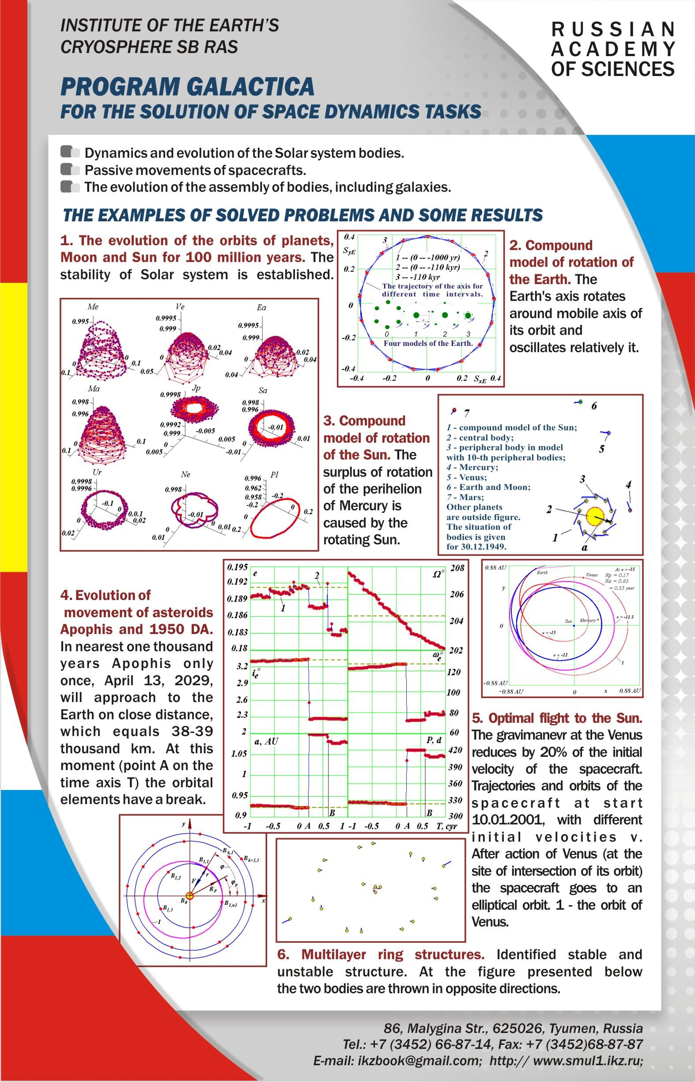
Fig. 1. View of planshet at the Exhibition “Year of Russia in Spain. Scientific, technical and innovative achievements of Russia", 12 -15 May, 2011, Madrid.
The presentation on the stage of the hall in Power Point format is contained in the form of archived files and Gal5Vid5.part1.rar, Gal5Vid5.part2.rar and Gal5Vid5.part3.rar each to 23 Mbt at: http://www.ikz.ru/~smulski/Gal5Vid/. In this archive the file Galact5MdE.ppt is itself presentation in English, as well as of its sound and video files.
This report is also available on YouTyube in the form of a video: https://youtu.be/uDc-DmTCcZk and in the form of a presentation: https://youtu.be/Z17B3F4oPEI.

2. Melnikov V.P., Smulsky J.J. Astronomical theory of ice ages: New approximations. Solutions and challenges. - Novosibirsk: Academic Publishing House "GEO", 2009. - 84 p. The book in two languages. On the back side in Russian: Mel'nikov V.P., Smul'skiy I.I. Astronomicheskaya teoriya lednikovykh periodov: Novye priblizheniya. Reshennye i nereshennye problemy. - Novosibirsk: Akademicheskoe izdatel'stvo "Geo", 2009. - 98 stranitz. http://www.ikz.ru/~smulski/Papers/AsThAnE.pdf.
3. Smulsky J.J. Optimization of Passive Orbit with the Use of Gravity Maneuver // Cosmic Research, 2008, Vol. 46, No. 5, pp. 456–464. Original Russian Text ©, 2008, published in Kosmicheskie Issledovaniya, 2008, Vol. 46, No. 5, pp. 484–492. http://www.ikz.ru/~smulski/Papers/COSR456.PDF.
4. Smulsky J.J., Smulsky Ya.J. Evolution of Apophis Orbit for 1000 Years and New Space Targets // "Protecting the Earth Against Collisions with Asteroids and Comet Nuclei" - Proceedings of the International Conference "Asteroid-Comet Hazard-2009", Eds.: A. Finkelstein, W. Huebner, V. Shor. - Saint-Petersburg: "Nauka". - 2010. -Pp. 390-395. http://www.ikz.ru/~smulski/Papers/EvlAp3Ec.pdf.
5. Smulsky J.J., Smulsky Ya.J. Evolution of Movement of Asteroids Apophis and 1950 DA for 1000 Years and their Possible Use / Institute of the Earth Cryosphere SB RAS. - Tyumen, 2011. - 36 p. - Fig.: 10. Refer.: 27. - Russian. - Dep. In VINITI 25.01.11. No. 21-V2011. (In Russian http://www.ikz.ru/~smulski/Papers/EvAp1950c.pdf). (Similar paper in English http://www.ikz.ru/~smulski/Papers/AsAp1950E4c.pdf).
6. Smulsky J.J., Smulsky Ya.J. Orbit Evolution of Apophis and its Transformation into the Earth's Satellite // Proceedings of the Natural Philosophy Alliance. 17th Annual Conference 23-26 June, 2010, at Long Beach, CA, USA. Vol. 7. Published by NPA, Ltd. Mt. Airy, MD, USA.- 2010. - Pp. 569-578. http://www.ikz.ru/~smulski/Papers/AstApophsE4c.pdf.
7. Smulsky Ya.J. The Transformation of Asteroids in the Satellites - Real Direction in Counteracting Asteroid Hazard of the Earth // Proceeding of the Congress-2010 "Fundamental Problems of Natural Sciences and Engineering". Part II (M - U). A Series "Problems of the Universe Researching". Issue 34-2. St.-Petersburg, 2010. - P. 263 - 272. (In Russian http://www.ikz.ru/~smulski/Papers/PrAsSp04c.pdf).
8. Mel’nikov V.P., Smul’skii I.I., Smul’skii Ya.I., 2008. Compound modeling of Earth rotation and possible implications for interaction of continents // Russian Geology and Geophysics, 49, 851–858. http://www.ikz.ru/~smulski/Papers/RGG190.pdf.
9. Smulsky J.J. Numerical modeling of evolution of the satellite of a rotating body / In Col. The Theoretical and Applied tasks of the Nonlinear Analysis. Russian Academy of Sciences: A.A. Dorodnicyn Computing Center. Moscow. - 2008. Pp. 100-117.(In Russian http://www.ikz.ru/~smulski/Papers/ModSun07c.pdf).
10. Smulsky J.J. Compound model of rotation of the Sun and displacement of Mercury perihelion / The Fundamental and Applied Problems of the Mechanics: Proceeding of the VI All-Russian scientific Conference, devoted 130-th anniversary of Tomsk state university and 40-th anniversary NII of Applied Mathematics and Mechanics of Tomsk State University. Tomsk, September 30 - October 2, 2008 - Tomsk: University Publishing House. – 2008 - Pp. 433-434. (In Russian http://www.ikz.ru/~smulski/Papers/ModSun51c.pdf).
11. Smulsky J.J. Gravitation, Field and Rotation of Mercury Perihelion// Proceedings of the Natural Philosophy Alliance. 15th Annual Conference 7-11 April 2008 at the University of New Mexico, Albuquuerque, USA. Vol. 5, No. 2. Published by Space Time Analyses, Ltd. Arlington, MA, USA.– 2009. – Pp. 254-260. http://www.ikz.ru/~smulski/Papers/08Smulsky2c.pdf.
12. Smulsky J.J. New Components of the Mercury’s Perihelion Precession // Natural Science. Vol. 3, No.4, 268-274 (2011). doi:10.4236/ns.2011.34034. http://www.scirp.org/journal/ns,
13. Smul'skii I. I. Multilayer Ring Structures // Physics of Particles and Nuclei Letters, 2011, Vol. 8, No. 5, pp. 436-440. DOI: 10.1134/S1547477111050189.

