GALACTICA Software for Solving Gravitational Interaction Problems

Joseph J. Smulsky
Institute of Earth's Cryosphere SB RAS,
625000, Russia, Tyumen, P.O.B. 1230
Tel. +7-3452-688-714
E-mail: jsmulsky@mail.ru, webpage: http://www.smul1.newmail.ru/.

Abstract
Galactica software has been developed to clarify the astronomical theory of climate change. It is designed to provide the numerical solution of problems of the gravitational interaction of bodies. It tackles a whole range of problems: the evolution of the solar system for 100 million years, the evolution of Earth's rotation axis, the influence of the Sun on the Mercury’s perihelion, the motion of near-Earth asteroids, the optimal motion of the spacecraft and the destruction of a system of interacting bodies. The Galactica system is developed for the free access. It contains everything that is needed to solve problems, even a novice researcher.
Keywords: gravitational interaction, computer calculations, the Solar system, free access.

1. Introduction
The Institute of Earth Cryosphere of SB RAS has been studying the Evolution of the Earth Cryosphere as a result of the interaction of Solar system bodies for several years. We consider the problem of evolution of the Cryosphere as five stages, which are presented in Fig. 1 in the form of successive tasks. In addition to the sequent order of their solutions, as seen from the figure, there are parallel links between the stages. For example, in problem 4, to determine relationships between the evolution of natural processes and changes in the Earth’s insolation, the results of all stages should be considered.
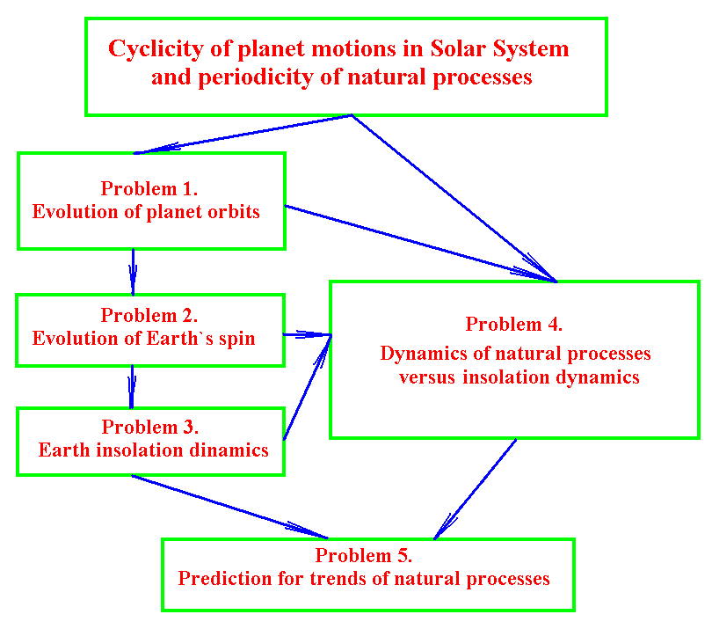
Fig. 1. The problems and relationships between them in the study of the evolution of the Earth’s Cryosphere as a result of the interaction of Solar system bodies.
In the process of solving the orbital problem, the equations of orbital motion were firstly integrated for 100 million years, and the new results about the evolution of the orbits were obtained. In the second problem the equations of the rotational motion are derived founding at new basis and the influence of the planets, the Sun and the Moon on the evolution of the Earth's axis is investigated.
During these stages, a number of methods were developed which allowed solving some important problems. While solving them, we proved the advantages of our methods, in particular, the Galactica software. So, below are the results obtained with its help, and the system Galactica is proposed for free access.
2. Differential equations of body’s motion and method of their solution
According to the law of Newton’s gravity, the attraction force to the body numbered i by the body numbered k is expressed as follows:
${\vec{F}}_{\text{ik}}=−G\frac{m_{i}m_{k}}{r_{{\text{ik}}^{3}}}\vec{r}$, (1)
where G is the gravitational constant;
${\vec{r}}_{\text{ik}}$is the radius-vector from the body with mass m_{k} to the body with mass m_{i}.
If there are n bodies given, then the all bodies will act on the i-th body with a total force, expressed as:
${\vec{F}}_{i}=−{\text{Gm}}_{i}\sum_{k≠i}^{n}{\frac{m_{k}{\vec{r}}_{\text{ik}}}{r_{{\text{ik}}^{3}}}}$. (2)
Under the action expressed by the force (2), in accordance with the second law of mechanics $\vec{a}={\vec{F}}/m$, the i-th body will move with respect to an inertial (non-accelerated) frame of reference with acceleration below:
$\frac{d^{2}{\vec{r}}_{i}}{{\text{dt}}^{2}}=−G\sum_{k≠i}^{n}{\frac{m_{k}{\vec{r}}_{\text{ik}}}{r_{{\text{ik}}^{3}}},}$ i = 1,2,…,n, (3)
where ${\vec{r}}_{i}$ is the radius-vector of the body $m_{i}$ relative to a center, for example, the center of mass in a non-accelerated frame of reference.
For the integration of Eq. (3) we have developed the following algorithm. The value of the function at the following moment of time t=t₀ + Δt is determined with the help of the Taylor series, which, for example, for x coordinate looks like:
$x=x_{0}+\sum_{k=1}^{K}{\frac{1}{k!}x_{0^{(k)}}(Δt)^{k}}$, (4)
where x₀^{(k)} is derivative of k order at the initial moment t₀.
The value of velocity x’ is defined by a similar formula, and the acceleration x₀’’ is obtained by Eq. (3). The higher derivatives x₀^{(k)} are defined by the expressions that we derived from analytical differentiation of right sides of equations (3), which are written, as an example, for coordinate x. The addition of each new term with the derivative increases the accuracy by three orders of magnitude. Therefore, when double-length number with 17 decimal places is used, then the sixth-order derivatives, i.e. at K = 6 are sufficient. In this case, the numerical integration occurs without an increase in errors over time. The Galactica program was developed based on this method (Smulsky, J.J., 1999), (Smulsky, J.J., 2004). As a result, the studies have shown that the accuracy of the calculation using the Galactica program exceeds the accuracy of the existing programs for calculating motions.
3. The evolution of the orbits of the planets and the Moon for 100 million years
With the help of Galactica, the evolution of the orbital motion of Solar system consistently was studied for several thousand years (Melnikov,V.P. et al, 2000), a few million years and 100 million years. The results of calculations for the seven thousand years, for example, for Mercury are shown by points in Fig. 2. The graphs show the dynamics of six elements of Mercury's orbit: e, i, ϕ_{Ω}, ϕ_{p0}, a and P. The angle of inclination i of the orbital plane is defined with respect to the plane of the fixed equator, the angle ϕ_{Ω} is measured by the arc on the celestial equator of 1950.0 from the axis x to the point of intersection with the circle of the orbital plane. The axis x passes through the vernal equinox of 1950.0. The angle ϕ_{p0} perihelion is determined by arc of the orbit from a fixed point on it to the point of perihelion. These three angles and the eccentricity e, as seen from the graphs, are changing over time T. The semi-major axis a and orbital period P on the average remain unchanged, so on Fig. 2 their deviations from the mean values are given. These fluctuations relative to the average values 5.79⋅10⁺¹⁰ м and P_{m} = 2.408⋅10⁻³ cyr (1 cyr is equal to one hundred years) are of little value. The parameters e, i, ϕ_{Ω} and ϕ_{p0} also oscillate with the same relative amplitudes as parameters a and P.
In Fig. 2 the lines 2 and 3 show the approximation of observation data. As one can see, the eccentricity e and the angles i, ϕ_{Ω} coincide exactly with the observations in the interval ±1000 years, i.e. within the validity of approximations of S. Newcomb and J. Simon et al. The calculations for semi-major axis a and orbital period P also coincide with the observations, and the resulting oscillations in magnitude less than the difference between the approximations of different authors.
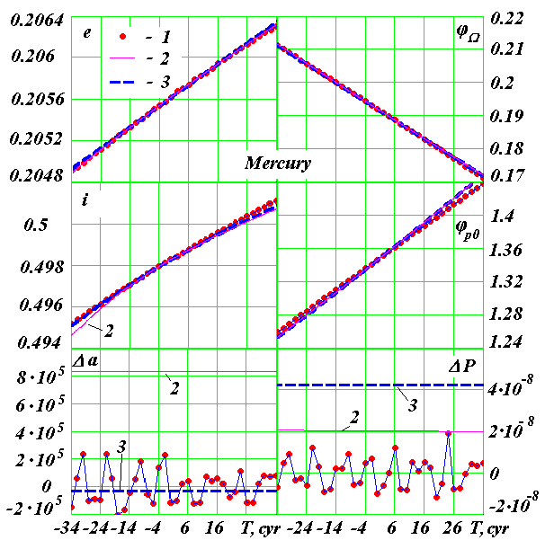
Fig. 2. The secular changes of the Mercury’s orbital elements in a span of 7 thousand years: e is the eccentricity; i is the angle of inclination of orbit plane to equator plane of 1950.0; ϕ_{Ω} is the angle of the ascending node of the orbit; ϕ_{р0} is the angle of the perihelion; Δa is the semi-major axis deviation from the average of 7 thousand years, the values in meters; ΔP is the orbital period deviation from average of 7 thousand years in centuries. The angles are in radians, and the time T is in centuries in the past and the future from the epoch 30.12.1949, 1 cyr = 1 century. 1 shows the results of the numerical solution of the Galactica program; 2 shows the secular changes according to Newcomb, S. (1895) 3 shows the secular changes according to Simon, J.L.et al (1994).
Similar studies were carried out on all the planets. All calculated parameters of all bodies are consistent with observations. Only one parameter and only for one planet is slightly different from the observations. As can be seen from Fig. 2, the slope of the change in the calculated angle of the Mercury’s perihelion ϕ_{p0} (points) is slightly smaller than the observational data (lines). As we found, the calculated velocity of the perihelion with respect to the fixed space f is 530″ per century, and according to the observations, it is 583″ per century. The reason for this discrepancy will be discussed later.
As a result of research over several million years, the periods and amplitudes of oscillation of the orbit parameters of the Earth and other planets are received. The system of equations (3) was integrated for 100 million years ago and the orbits evolution of the planets and the Moon were studied (Melnikov, V.P. & Smulsky, J.J., 2009). Fig. 3 shows the change in the parameters of the Mars orbit in the interval from -50 to -100 Myr (Grebenikov, E.A. & Smulsky, J.J., 2007). The eccentricity e, the angles of inclination i, the ascending node ϕ_{Ω} of the orbit and its other parameters oscillate monotonically. These oscillations are a few periods, and the duration of the highest of them is much less than the interval of 50 million years. Within the interval from 0 to -50 million years, the graphs have the same shape (Grebenikov, E.A. & Smulsky, J.J., 2007), i.e. the Mars orbit is both stable and steady and does not tend to change.
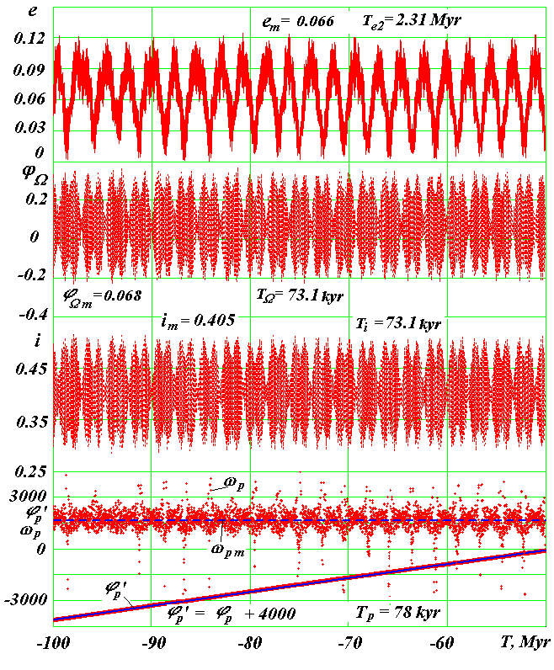
Fig. 3. The evolution of the Mars orbit in the second half of the period of 100 million years: T is the time in millions of years into the past from the epoch 30.12.1949; the interval between adjacent points is equal to 10 thousand years; e is the eccentricity; i the the angle of inclination of the orbit plane to the equator plane of 1950.0; ϕ_{Ω} is the angle of the ascending node of the orbit in radians; ϕ_{p} is the angular position of the perihelion in the orbital plane from the ascending node in radians; ω_{p} is the angular velocity of the perihelion rotation in the "/century for the time interval of 20 thousand years: ω_{pm} = 1687 "/century is the average angular velocity of perihelion rotation during 50 million years. Index m gives the averages values of the parameters, and the indexed letter T corresponds to the main periods of the relevant parameters.
Similar results were obtained for other planets, i.e. these studies have established the stability of the orbits and the Solar system as a whole. The result is important, since in many papers, e.g. (Laskar, J., 1994), (Laskar, J. et al, 2004) that focus on solving the problem by existing methods, after 20 million years the orbits begin to change, which further leads to the destruction of the Solar system. Based on these solutions, the authors concluded that there are instability of the Solar system and chaotic motions in it. Fig. 4 shows the calculated by Laskar, J. et al (2004) changing the obliquity of the Mars orbit at different initial conditions (the obliquity is the inclination of Mars orbit plane to moving Mars equator plane). The lower left graph shows that over past 50 million years the obliquity varies from 24º to 60º. Whereas our results in Fig. 3 show that the angle of inclination of the orbit of Mars i steadily oscillates in the range from 16.5º to 30º.
The cause of instability of the solutions in the works of the above authors is the imperfection of their methods of integration. But as they are not aware of more accurate methods they came to a conclusion about the instability and chaotic motion of celestial bodies. These ideas were picked up in other areas of science. There were lines on the study of chaos (even chaotic dynamics), in which the idea is: all the processes on the Earth and the Universe are caused by chaos. Furthermore, these ideas have migrated to social theories: nobody knows the truth, one should show tolerance for any opinion, the decisions can only be made by consensus; the society is determined by the chaotic behavior of individuals and not subject to the planned regulation. Therefore, the best organization it can have is the market economy.
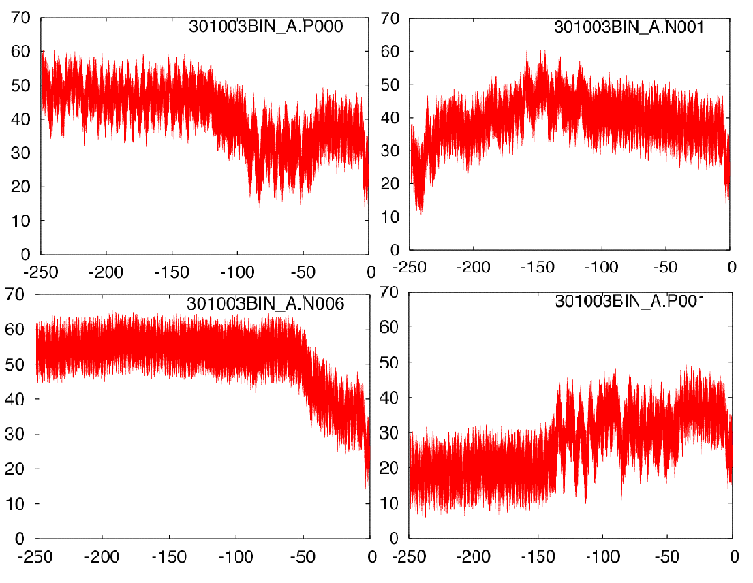
Fig. 4. The angle between the planes of the orbits of Mars and its equator at different initial conditions in the solutions (Laskar, J. et al, 2004): the angle (Y-axis) is in degrees, and the time (X-axis) is in the past 250 million years.
The idea about chaotic motion prevails in other tasks of space dynamics. For example, using the existing methods of calculation the different results for the motion of the asteroid Apophis are received. Based on this, it is considered that after it approaches the Earth in 2029, the Apophis moves chaotically. So the whole strategy research is based on the search for statistical regularities and the determination of the probability of collision in 2036, rather than on the development of deterministic methods for calculating the motions.
4. The compound model of the Earth's rotation
The problem of rotation of the Earth is a very difficult task of mechanics. At present there is its approximate solution. For complete understanding of the reasons of the Earth’s climate change, it is necessary to get a more exact solution of the equations of rotational motion of the Earth. We are engaged in their solution (Smulsky, J.J., 2011b). However, there are several issues that need to found out, regardless of the equations of rotational motion. For this purpose, we developed a compound model of the Earth's rotation, in which a part of the Earth's mass is distributed between the peripheral bodies (see Fig. 5), orbiting around a central body in the Earth’s equatorial plane (Melnikov et al, 2008). The parameters of the compound model of the Earth’s rotation are determined by the following conditions:
1) the total mass of the peripheral bodies and of the central body equals the Earth’s mass;
2) the peripheral bodies turn in circles around the central body;
3) the moments of the Earth’s inertia and the system of bodies relative to the axes x and y are equal.
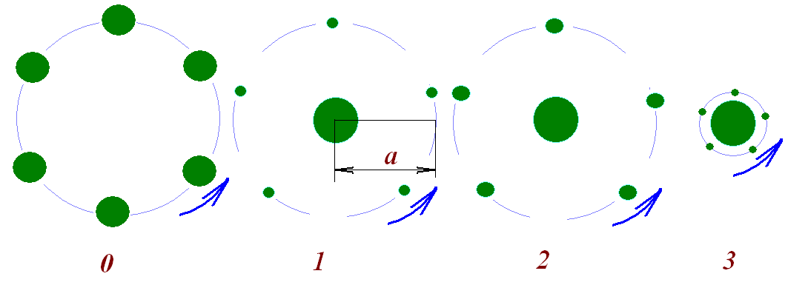
Fig. 5. The compound models of the Earth's rotation and their parameters with the radius and mass of the Earth, respectively: R_{Ee} = 6.37816·10⁶ m and M_{E} = 5.9742·10²⁴ kg: in the table: m₁ is the mass of a peripheral body, a is the radius of its orbit in the Earth's radius and P is the orbital period of a peripheral body around the Earth:
Model No | m₁ 10⁻¹⁹ | a | P
Model No | kg | R_{Ee} | hours
0 | 9.9610⁴ | 4.45 | 23.93
1 | 3.57 | 6 | 23.93
2 | 7.21 | 6 | 23.93
3 | 0.54 | 1 | 1.408
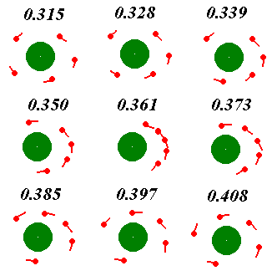
The each peripheral body’s orbit changes under the influence of the Moon, the Sun and the planets. As a result of the research, we found that the evolution of its axis imitates the evolution of the Earth's rotation axis. With the help of Galactica, the models of the Earth's rotation, which are shown in Fig. 5, have been investigated. The version of the model without a central body (model 0) was unstable, and therefore not further investigation was performed.

Fig. 6. The peripheral body dynamics of the third model at different points in time (the numbers given in years) from the initial moment.

The evolution of three models within the time span of 110 thousand years was investigated. The axis of the model orbit, similar to the Earth’s axis of rotation, precess and make nutational oscillations. The precession of the axis, i.e. its rotation, is around the moving axis of the Earth's orbit. The periods of nutational oscillations of 0.5 months, 0.5 years and 18.6 years coincide with the periods of observed fluctuations of Earth's rotation axis. These and other findings are the independent criteria that are necessary to control the results of integrating the equations of the Earth’s rotational motion (Smulsky, J.J., 2011b).
The compound model of the Earth's rotation may have another application. In Fig. 6 the position of peripheral bodies is presented relative to the central body at different moments of time. As can be seen, the distance between the peripheral bodies is changing periodically: they either converge or diverge. Such convergence and divergence of bodies come in all models in the entire span of 110 thousand years.
The Earth's continents, as well as the model's bodies, are exposed to the Moon’s, the Sun’s and the planets’ action. Presumably, by analogy with the bodies of the models, they can vary in the latitudinal direction. It is possible that the similarity between the American continent’s coastline and the coastline of Africa and Europe is due to such multiple convergences. Special studies are required to check this.
5. The compound model of the Sun’s rotation
For 200 years the problem remains unresolved of superfluous rotation of the Mercury’s perihelion. Back in the 19th century, scientists found that as a result of the Newtonian interaction of the Solar system bodies, the perihelion of Mercury's orbit should rotate at a velocity of 530″ per century. However, the analysis of observation results of Mercury's positions for many hundreds of years indicated that the rotation of the perihelion of its orbit is 573″ per century, i.e. 43″ higher. In the 19th century, several hypotheses about the possible causes of excessive rotation of the perihelion were put forward. The greatest recognition was given to the hypothesis of the finite speed of gravity propagation. In 1898, Paul Gerber (1898) published the paper in which he presented a speculative mechanism of propagation of gravity, created his theory and derived the expression for the excess of rotation of the perihelion. In 1915, these results were used by A. Einstein to build the General relativity.
Our predecessors did not know all the features of changes in the parameters of the planets orbits, including their perihelion. First, the perihelion of the planets does not rotate with the constant velocity. As can be seen from Fig. 3, velocity ω_{p} of the perihelion of the Mars orbit varies from +4500″ per century to -3000″ per century at average value of ω_{pm} = 1687″/century. As can be seen, along with a direct rotation of the perihelion in the direction of orbital motion, there are epochs of its reverse motion. In Mercury's perihelion there is a smaller range of rotation velocities of the perihelion: from 765″ to 86.5″ per century with the average velocity over 50 million years being ω_{pm} = 520″ per century. In addition, there are short-period oscillations of the perihelion, for example, the Mercury’s orbit has oscillations with periods of 1.38 and 5.92 years.
Second, the processing of observational data did not consider that the initial point of the perihelion longitude moves in space. Knowing the characteristics of changes in orbital parameters, we can choose a fixed point in space for the reference of the perihelion. The rate of the Mercury’s perihelion relative to that point is 583″ per century according to the observations, and as a result of integration of the equations (3) using Galactica we have got a rate of perihelion of 530″ per century for the modern epoch. Thus, the excess of the perihelion rotation is not 43″ but 53″ per century.
Third, we examined all the aspects of the problem of the perihelion rotation (Smulsky, J.J., 1999, 2004, 2008a, 2008b, 2009 and 2011a), including the finite speed of gravity propagation. It was found that at light speed of gravity the excess of the perihelion rotation is 0.23″ per century, which is significantly less than the 53″ per century, obtained from observations.
Fourth, all the hypotheses about the causes of the excess of the perihelion rotation, including the hypothesis of finite speed of gravity, lead to similar changes in other parameters of the orbit: eccentricity e, period P, inclination angle i. However, as we have already noted, all calculated parameters coincide with the observations.
As a result of research, we found that if there were another planet within the Mercury’s orbit, it could give an excess of the required rotation of the Mercury’s perihelion without changing other parameters of its orbit and orbital parameters of other bodies. However, there is no such planet, but the Sun rotates around its axis, and the moving its mass may have the same effect as the planet. In order to test the influence of the Sun, a compound model was created in several variants. The models are considered with different masses and with different numbers of peripheral bodies: five and ten bodies.
With the help of Galactica, the interaction of the Solar system with the Sun in the form of a compound model was studied. The evolution of the orbits of the first four planets was studied for 6000 years. We found that the farther the planet is from the Sun, the less the parameters of its orbit depend on the influence of the Sun’s compound model. At some value of the peripheral bodies’ mass the calculated rotation of Mercury's perihelion coincides with that obtained from observations, while the other orbital parameters remain the same. The orbital parameters of Venus are practically independent on this variant of the Sun’s compound model, and even more so, the parameters of the orbits of the Earth and Mars are independent too.
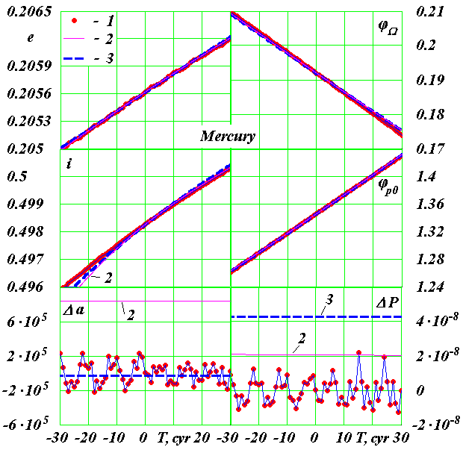
Fig. 7. The change of the Mercury’s orbit under the influence of the planets and the Sun’s compound model No. 4. The angles are in radians, the time T is in centuries, Δa is in m and ΔP is in centuries. 1 shows the results of Galactica’s numerical calculation; 2 shows the secular changes according to Newcomb, S. (1895); 3 shows the secular changes according to Simon, J.L.et al (1994).
Fig. 7 shows the results of these studies for model 4 with five peripheral bodies. As can be seen from the graphs, the dynamics of the calculated angle ϕ_{p0} of the Mercury’s perihelion (dots) coincided with the dynamics of the angle of the perihelion, as defined by secular changes according to S. Newcomb and J. C. Simon et al. The graphics of other parameters, as can be seen by comparing with Fig. 2, have not changed. The similar studies have been performed for compound model 5 with ten peripheral bodies. The total mass of these bodies is the same as in model 4. The results are absolutely the same.
So, with the help of Galactica we established, that all the observed motions in the Solar system are explained and described by Newtonian interactions of bodies.
6. The motion of the asteroid Apophis
In several papers, e.g. (Giorgini, J.D. et al, 2008), (Rykhlova, L.V. et al, 2008) and others, it is shown that the asteroid Apophis will pass Earth onApril 13, 2029, at the distance from the center of the Earth in the range of 5.62 to 6.3 of its radius, and because of the chaotic change of its trajectory the further prediction of the Apophis movement is impossible. These authors believe that there is some probability of its collision with the Earth in 2036. We have reviewed their papers and found that the uncertainties in the trajectory of Apophis are caused by imperfection of methods of its determination. With the help of Galactica we have integrated differential equations of motion of Apophis, the planets, the Moon and the Sun for 1000 years and have studied the evolution of Apophis orbit (Smulsky, J.J. & Smulsky, Ya.J., 2009, 2010a, 2010b and 2011).
Fig. 8 shows the change in distance between Apophis and the Earth for different initial conditions assumed for the integration of the equations (3). The second version of the initial conditions was specified based on newer observations of Apophis. The refinement of the initial conditions, as seen from the graphics, begins to influence the motion of the asteroid 25 years later. However, the basic results will not change: it will approach the Earth on April 13, 2029 at the distance of 6 Earth’s radii, pass the planet in 2036 (see point H in Fig. 8) at the distance not less than 50 million kilometers and will approach the Earth for the second time in the century at the distance not less than 600 thousand km. These results were repeated also for 3 sets of initial conditions, which were different in degree of refinement.
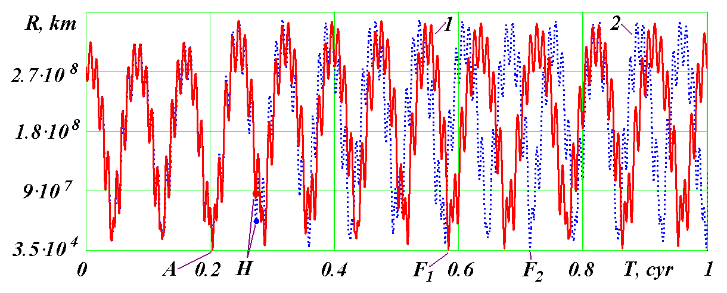
Fig. 8. The evolution of the distance R between Apophis and the Earth for 100 years under different initial conditions (IC): 1 is IC as of November 30.0, 2008; 2 is IC as of January 04.0, 2010. Calendar dates of encounters at the points: A is April 13, 2029; F₁ is April 13, 2067; F₂ is April 14, 2080; T is the time in centuries from November 30, 2008. For IC 1: R_{A} = 38 907 km, R_{H} = 86 million miles, R_{F} = 622 000 km.
So, April 13, 2029, Apophis will pass at the distance of Rmin = R_{min} = 38 ÷ 39 thousand kilometers from the Earth’s center and over 1000 years will not approach the Erather closer than that. We propose to use this chance and to transform Apophis in the satellite.
Many of the pioneers in astronautics viewed the exploration of the near-Earth space as usng a large manned orbital station. However, to deliver such a large mass from the Earth is a serious technical and environmental problem. Therefore, thank to a happy occasion, we can create a manned station by transforming the asteroid Apophis into a satellite.
There are other possible applications of such satellite. It can serve as the basis for the space lift. It can be used as a "shuttle" for delivering cargo to the Moon. In this case, the satellite must have an elongated orbit with a perigee radius close to the radius of the geostationary orbit and the radius of apogee approaching to perigee radius of the lunar orbit. Then from the geostationary orbit, cargo could be delivered to the satellite Apophis in a perigee, and then at the apogee the cargo could be delivered to the Moon. The last two applications are possible, if the satellite motion coincides with the direction of the Earth’s rotation and the Moon's motion.
With the help of Galactica the transformation of the Apophis trajectory into satellite orbit was studied. It was found that the problem have to be solved in two stages. Half a year before the approach of Apophis to the Earth its velocity should be reduced by 2.5 m/s. Then it will pass near the Earth by the night side. This will ensure the same direction of the satellite as the direction of the Moon motion. The second step is when it approaches the Earth, to reduce its velocity by 3.5 km/s. As a result the Apophis become a satellite with the same direction of revolution around the Earth as the Moon. The studies using Galactica has shown that the orbit of the satellite is stable. Therefore, it can perform its task for a long time.
The transformation of an asteroid in a satellite is a very difficult task. However, the solution to this problem greatly increases the opportunity to prevent a serious asteroid hazard. Therefore, if the society will undertake to do this, it would indicate a transition from a purely theoretical research to practical work in the asteroid-hazard protection of the Earth.
7. Optimization of passive orbit with the use of gravity maneuver
Many weather disasters are caused by the influence of the Sun. In order to prevent them, the Sun must be observed from a close distance. Therefore, the number of papers is devoted to the problem of optimal launch a spacecraft to the Sun. In contrast to the options well-known in the literature, we direct the launch of the device in the opposite direction of the Earth’s motion (see line 2 in Fig. 9) with velocity v = -11.5 km/s. But relative to the Sun it moves in the direction of the Earth.
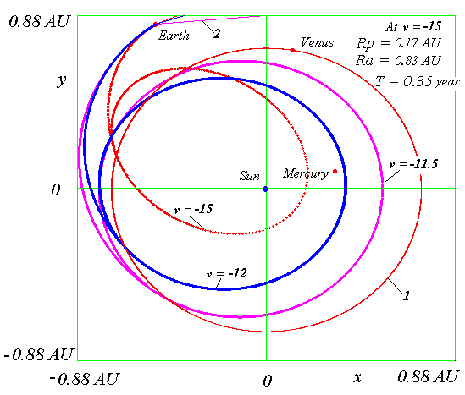
Fig. 9. The trajectories and orbits of the device when launched on January 20, 2001, with different initial velocities v. The flight is passive. After the influence of Venus (when it crosses its orbit), the device goes into an elliptical orbit. 1 is the orbit of Venus.
The time of launch of the device and its motion parameters are calculated so that at the intersection with the Venus orbit (line 1 in Fig. 9), the planet was near the point of intersection. Under the influence of Venus there is an additional braking of the device, and it reaches a stable orbit around the Sun. These studies were performed using Galactica for several initial velocities, for which the trajectories are shown in Fig. 9.
Using the gravity of Venus allows getting to the Sun 1.7 times closer at the same initial velocity of device, but with the same approach to reduce the initial velocity from -18.2 km/s to -15 km/s (Smulsky, J.J., 2008c).
While working on this problem we have solved a number of analytical tasks that allow defining the necessary conditions for the launch of a device from the Earth and for passing it around Venus. The solutions of tasks and the Galactica program altogether constitute a computer system, which allows considering the new technology of space missions. Its essence lies in the fact that the device is removed from the Earth's atmosphere with certain parameters of movement. Its further mission is in the passive flight without corrective engines. This significantly reduces the cost of space missions. Such flights in large quantities may be needed for the asteroid-hazard protection of the Earth, at creating interplanetary probes and at performing other space tasks.
8. Multilayer ring structures
The study of evolution of multi-ring structures is important for understanding the problems of existence and stability of rings of the planets, globular star clusters and galaxies. Creating ring structures is based on the following two positions (Smulsky J.J., 2008d), (Smul'skii, I. I., 2011).
1. For a body, located outside of the ring structure, the exerted force equals the force, which would create a body located in the center of the structure and has a mass equal to the mass of the entire structure.
2. For a body, located inside the ring structure, the total force exerted by all its bodies is equal to zero.
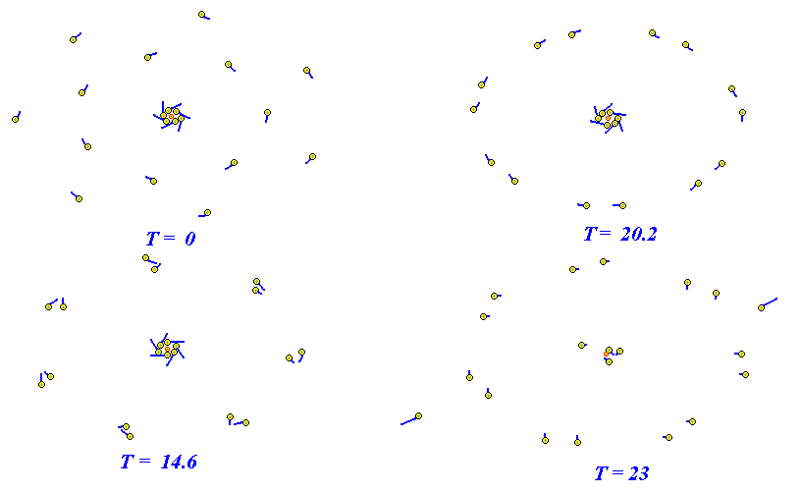
Fig. 10. Dynamics of the 10-th ring structure model: the mass m₀ of the central body is equal to half the Sun’s mass. The central body is marked red; body size does not correspond to the value of its mass, the lines at bodies correspond to the direction and magnitude of their velocities. Time T is given in years.
These positions are exactly satisfied for the uninterrupted ring, and when used for a discrete number of bodies, further movement of the bodies is caused by their real interaction. The position and velocity of bodies in these ring structures were set on the basis of our exact solution of n-body problem, which are symmetrically arranged on a plane (Smulsky, J.J., 2003). It should be noted that, compound models of the Earth and of the Sun also use the solution of this problem.
We considered 10 models of ring structures, each consisting of three rings. On each ring there are from 5 to 8 bodies, and in the center there is the central body. The mass of all bodies is equal to mass of the Solar system. As a result of research of evolution of these models using Galactica, the steady and unstable structures were revealed. Fig. 10 shows 4 moments in dynamics of one of unstable models. The change begins from the interaction between the bodies of the two outer rings, which further leads to the formation of a common ring and after 23-year movement the destruction of the inner ring occurs. In this case the two bodies are ejected from the system in the opposite directions.
The divergence of bodies takes place at high velocities. Such ejections occur in clusters of stars, galaxies and in the appearance of supernovae. They are explained by the explosion of such objects. As one can see, these phenomena are caused by Newtonian interaction.
9. The free-access Galactica system
We have looked at several examples of solutions of various problems with the program Galactica: the evolution of the Solar system; evolution of the Earth's rotation axis (and at the same time, the problem of modeling movement of continents); modeling the influence of the rotating Sun (thus the new mechanism for Newtonian action is discovered); the optimal motion of the spacecraft; evolution of the asteroid, as well as various artificial manipulations with it, for example, turning it into a satellite; the evolution of aggregate bodies. This list of tasks and the results will increase many times, if the free access for working with the Galactica program will be created.
We are working at creating free access to the Galactica system for solving the gravitational interaction of bodies on a supercomputer. Such free-access system, Horizons, for solving the dynamics of the Solar system was created by NASA (http://ssd.jpl.nasa.gov/?horizons). It is effectively used both for implementing space missions within NASA, and for solving problems by external researchers.
Horizons is approximation-based. The position of planets and the Moon there are based on the approximation of hundreds of thousands of observations. Formally, the system, except for the gravitational Newton’s force, the standard dynamic model (SDM) takes into account a number of small additional influencing factors. However, their influence is actually canceled by the fact that the results of calculations are approximated to observational data. The position of the existing celestial bodies, whose motion is approximated, is calculated with sufficient accuracy. If it is necessary to calculate the motion of any body, Horizons integrate the movement of a given body only and the motion of other bodies are taken from the approximation-based system. If the body is not included in the base of the approximation of the system, or is considered outside the framework of observation, the accuracy of the calculation of motion worsens over time at a distance from the base of the observations.
Galactica, developed by us, solves the problem of body’s motion as Newton's gravity interacting material points. The precision method of integration of the equations is used in our system. The initial conditions are specified for the calaculation, and the base of the observations is not used. Therefore, Galactica can help to compute the motion of bodies that have not previously been observed, and in any configuration and in any quantity.
Galactica differs from Horizons in other principles and methods of calculation. This can be especially useful, when it is necessary to check up the important decisions for mankind. In addition, Galactica can solve such problems, which Horizons is not intended for. It can solve various problems for space research, as well as simulated tasks that arise in the study of the evolution of the Earth, the planets and the Solar system.
For the problem of the gravitational interaction of bodies to be well-defined and resolved, a wide and abundant knowledge is needed in the field of mechanics and mathematics. Since a researchers has no such deep knowledge in specific areas, they usually seeks to use existing mathematical tools to solve such problems. This allows them, by analogy with the known problems, to use the techniques for preparing the problem for the solution, executing and monitoring the solutions, controlling the errors, as well as post-processing of results. Those steps have been implemented while developing Galactica and using it for the solution of various tasks. Very often they require solving additional problems in the mechanics either numerically or analytically. Some of these techniques can be attributed to the general domain, and some to specific tasks only. Therefore, it is advisable to provide free access to the problems solved: their statement, the input and initial data and the received results.
The free-access Galactica system, user version, can be found at: http://www.ikz.ru/~smulski/GalactcW/. Its description is available in GalDiscrp.pdf and GalDiscrE.pdf in Russian and in English, respectively. The description allows even a novice researcher to define and solve problems by using Galactica. After the free-access system is created based on a supercomputer, we will post the information at the above site. For tasks requiring short term for the statement of problems and solution, one can use Galactica on a personal computer and supercomputer-based free-access system will be used for bulk applications.
At present, the Galactica system has examples of tasks performed only by us. Subsequently, the set of the solved problems will be supplemented by other researchers. This will enable each new investigator to put and to solve the new challenges quickly and successfully, based on reliable tools and techniques. Not only be experienced professionals, but also capable pupils and students can become users of the system.
10. Conclusion
The paper presents basic information on the Galactica software and its capabilities. The system of Galactica, except the program Galactica, includes several components, which are described in the User's Guide http://www.ikz.ru/~smulski/GalactcW/GalDiscrE.pdf. The Guide also provides detailed instructions for all stages of solving the problem.
Acknowledgments
This work was supported by grants from the Governor of the Tyumen Region 2003 and 2004 and by integration program of the Presidium of RAS № 13 in 2008 – 2011.
The calculations were performed based on the supercomputers of the Siberian Supercomputing Centre in the ICMMG SB RAS, Novosibirsk, Russia.
The work at different stages involved: L.I. Smulsky, Ya.I. Smulsky, P.A. Apasev, O.I. Krotov, M.E. Chikmareva, M.A. Ponomarev, I.V. Bineev, E.N. Nevidimova, N.J. Anokhin, V.S. Botvina, E.A. Kovrizhkina, A.A. Pavlova, I.A. Shabolina, M.L. Panova and E.F. Safina.
References
Gerber, P. (1898). Die raumliche und zeitliche Aubreitung der Gravitation, Z. Math. Phis. Vol. 43,pp. 93-104. http://bourabai.narod.ru/articles/gerber/gerber.htm.
Giorgini, J.D., Benner, L.A.M., Ostro, S.I., Nolan, H.C. & Busch, M.W. (2008). Predicting the Earth Encounters of (99942) Apophis, Icarus, Vol.193, pp. 1-19. http://dx.doi.org/10.1016/j.icarus.2007.09.012.
Grebenikov, E.A. & Smulsky, J.J. (2007). Evolution of the Mars Orbit on Time Span in Hundred Millions Years. Reports on Applied Mathematics. Russian Academy of Sciences: A.A. Dorodnicyn Computing Center. Moscow. -. 63 p. (In Russian http://www.ikz.ru/~smulski/Papers/EvMa100m4t2.pdf).
Laskar, J. (1994). Large-Scale Chaos in the Solar System, Astron. Astrophys., Vol. 287, L9 – L12.
Laskar, J., Correia, A. C. M., Gastineau, M., Joutel, F., Levrard, B. & Robutel, P. (2004). Long term evolution and chaotic diffusion of the insolation quantities of Mars, Icarus, Vol. 170, Iss. 2.– P. 343-364.
Melnikov,V.P., Smulsky, J.J., Krotov, O.I. & Smulsky, L.J. (2000). Orbits of the Earth and the Sun And Possible Their Influences On of The Earth Cryosphere (Statement of a Problem and the First Results), Cryosphere of the Earth, Vol. IV, No. 3, Pp. 3-13. (In Russian http://www.smul1.newmail.ru/Russian1/IntSunSyst/OrZS.pdf).
Melnikov, V.P. & Smulsky, J.J. (2009). Astronomical Theory of Ice Ages: New Approximations. Solutions and Challenges. Novosibirsk: Academic Publishing House “GEO”, 84 p. The book in two languages. On the back side in Russian: Mel’nikov V.P., Smul’skiy I.I. Astronomicheskaya teoriya lednikovykh periodov: Novye priblizheniya. Reshennye i nereshennye problemy. Novosibirsk: Akademicheskoe izdatel’stvo “Geo”, 98 stranitz. (Information see http://www.ikz.ru/~smulski/Papers/AsThAnE.pdf).
Mel’nikov, V.P., Smul’skii, I.I. & Smul’skii, Ya.I. (2008). Compound Modeling of Earth Rotation and Possible Implications for Interaction of Continents, Russian Geology and Geophysics, 49, pp. 851–858. http://dx.doi.org/10.1016/j.rgg.2008.04.003. http://www.ikz.ru/~smulski/Papers/RGG190.pdf.
Newcomb, S. (1895). The Elements of the Four Inner Planets and the Fundamental Constants of Astronomy. Washington: Government printing office. 202 p.
Rykhlova, L.V. Shustov, B.M. Pol, V.G. & Sukhanov, K.G. (2008). Nasuschnye problemy asteroidnoj opasnosti (Urgent problems in protecting the Earth against asteroids), Proceedings of Intern. Conf. Near-Earth Astronomy 2007, September 3-7, Terskol, Nal’chik, Russia, pp. 25-33.
Simon, J.L., Bretagnon, P., Chapront, J., Francou, G., & Laskar, J. (1994). Numerical Expression for Precession Formulae and Mean Elements for the Moon and the Planets, Astron. and Astrophys., Vol. 282, p. 663-683.
Smulsky, J.J. (1999). The Theory of Interaction. Novosibirsk: Publishing house of Novosibirsk University, Scientific Publishing Center of United Institute of Geology and Geophysics Siberian Branch of Russian Academy of Sciences, - 294 p. (In Russian http://www.ikz.ru/~smulski/TVfulA5_2.pdf).
Smulsky, J.J. (2003). Axisymmetrical Problem of Gravitational Interaction of N-bodies, Mathematical modelling, Vol. 15, No 5, pp. 27-36. (In Russian http://www.smul1.newmail.ru/Russian1/IntSunSyst/Osvnb4.doc).
Smulsky, J.J. (2004). The Theory of Interaction. Ekaterinburg, Russia: Publishing house "Cultural Information Bank", 304 p. (In English http://www.ikz.ru/~smulski/TVEnA5_2.pdf)
Smulsky, J.J. (2008a). Numerical Modeling of Evolution of The Satellite of a Rotating Body, In Col. The Theoretical and Applied tasks of the Nonlinear Analysis. Russian Academy of Sciences: A.A. Dorodnicyn Computing Center. Moscow. Pp. 100-117. (In Russian http://www.ikz.ru/~smulski/Papers/ModSun07c.pdf).
Smulsky, J.J. (2008b). Compound Model of Rotation of the Sun and Displacement of Mercury Perihelion. The Fundamental and Applied Problems of the Mechanics: Proceeding of the VI All-Russian scientific Conference, devoted 130-th anniversary of Tomsk state university and 40-th anniversary NII of Applied Mathematics and the Mechanics of Tomsk State University. Tomsk, September 30 - October 2, 2008, Tomsk: University Publishing House. Pp. 433-434.(In Russian http://www.ikz.ru/~smulski/Papers/ModSun51c.pdf).
Smulsky, J.J. (2008c). Optimization of Passive Orbit with the Use of Gravity Maneuver, Cosmic Research, Vol. 46, No. 5, pp. 456–464. http://dx.doi.org/10.1134/S0010952508050122. http://www.ikz.ru/~smulski/Papers/COSR456.PDF.
Smulsky J.J. (2008d). Designing of ring structures. The Fundamental and Applied Problems of the Mechanics: Proceeding of the VI All-Russian scientific Conference, devoted 130-th anniversary of Tomsk state university and 40-th anniversary NII of Applied Mathematics and the Mechanics of Tomsk State University. Tomsk, September 30 - October 2, 2008. Tomsk: University Publishing House, pp. 431-432. (In Russian http://www.ikz.ru/~smulski/Papers/CnsKoStr2.pdf).
Smulsky, J. J. (2009). Gravitation, Field and Rotation of Mercury Perihelion. Proceedings of the Natural Philosophy Alliance. 15th Annual Conference 7-11 April 2008 at the University of New Mexiko, Albuquuerque, USA. Vol. 5, No. 2. Published by Space Time Analyses, Ltd. Arlington, MA, USA. Pp. 254-260. http://www.ikz.ru/~smulski/Papers/08Smulsky2c.pdf.
Smulsky, J.J. (2011a). New Components of the Mercury’s Perihelion Precession, Natural Science, Vol. 3, No.4, pp. 268-274 doi:10.4236/ns.2011.34034. http://www.scirp.org/journal/ns.
Smulsky, J.J. (2011b). The Influence of the Planets, Sun and Moon on the Evolution of the Earth’s Axis, International Journal of Astronomy and Astrophysics, Vol. 1, Issue 3, 117-134. http://dx.doi.org/10.4236/ijaa.2011.13017. (http://www.SciRP.org/journal/ijaa).
Smul'skii, I. I. (2011). Multilayer Ring Structures, Physics of Particles and Nuclei Letters, Vol. 8, No. 5, pp. 436-440. http://dx.doi.org/10.1134/S1547477111050189. http://www.ikz.ru/~smulski/Papers/PHPL436.pdf.
Smulsky, J.J. & Smulsky, Ya.J. (2009). Evolution of the Apophis Orbit and New Space Tasks. Science And Technology. - Brief communications of XXIX of the Russian school devoted 85-years from birthday of the academician V.P. Makeev. Ural’s Branch of RAS, pp. 181-183.(In Russian).
Smulsky, J.J. & Smulsky, Ya.J. (2010a). Evolution of Apophis Orbit for 1000 Years and New Space Targets. "Protecting the Earth Against Collisions with Asteroids and Comet Nuclei" - Proceedings of the International Conference "Asteroid-Comet Hazard-2009", Eds.: A. Finkelstein, W. Huebner, V. Shor. - Saint-Petersburg: "Nauka". Pp. 390-395. http://www.ikz.ru/~smulski/Papers/EvlAp3Ec.pdf.
Smulsky, J.J. & Smulsky Ya.J. (2010b). The Transformation of Asteroids in the Satellites - Real Direction in Counteracting Asteroid Hazard of the Earth. Proceeding of the Congress-2010 "Fundamental Problems of Natural Sciences and Engineering". Part II (M - U). A Series "Problems of the Universe Researching". Issue 34-2. St.-Petersburg, pp. 263 - 272. (In Russian http://www.ikz.ru/~smulski/Papers/PrAsSp04c.pdf).
Smulsky, J.J. & Smulsky, Ya.J. (2011). Evolution of Movement of Asteroids Apophis and 1950 DA for 1000 Years and their Possible Use. Institute of the Earth Cryosphere SB RAS. Tyumen,. 36 p. Fig.: 10. Refer.: 27. Russian. Dep. In VINITI 25.01.11. No. 21-V2011. (In Russian http://www.ikz.ru/~smulski/Papers/EvAp1950c.pdf). (Similar paper in English http://www.ikz.ru/~smulski/Papers/AsAp1950E4c.pdf).

