The Influence of the Planets, Sun and Moon on the Evolution of the Earth's Axis
Joseph J. Smulsky
Institute of the Earth’s Cryosphere, Siberian Branch of Russian Academy of Sciences,
P.O. Box 1230, Tyumen, Russia, 625000

Abstract
To study climate evolution, we consider the rotational motion of the Earth. The law of angular momentum change is analyzed, based on which the differential equations of rotational motion are derived. Problems with initial conditions are discussed and the algorithm of the numerical solution is presented. The equations are numerically integrated for the action of each planet, the Sun and the Moon on the Earth separately over 10 kyr. Results are analyzed and compared to solutions of other authors and to observation data.

Key Words: Angular momentum; Differential equations; Numerical solution.

1. Introduction
In the history of the Earth the periodical changes of sedimentary layers on continents and in oceans, their chemical composition and magnetic properties are observed. The oscillations of oceans levels and repeating traces of activity of glaciers are traced also. The climatic changes are determined by different factors, including: the solar heat quantity acting to the Earth, which depends on angle of fall of solar beams on the Earth's surface, the distance from the Sun and duration of illumination. In the 1920s the Yugoslavian scientist М. Milancovitch [1] created the astronomical theory of ice ages in which these three factors are expressed by a tilt between the Earth’s orbital and equatorial instant planes (obliquity), an eccentricity of an orbit and position of a perihelion. Subsequently calculations of Milankovich were repeated by other researchers: D. Brouwer and A. Van Woerkom [2], Sh. Sharaf and N. Budnikova [3], A. Berger and V. Loutre [4], J. Laskar et al. [5] and also others.
As a result of interaction of Solar system bodies there are changes of orbits of the planets. When rotating, the Earth becomes stretched in its equatorial plane. Therefore each of external bodies creates a moment of force, which causes precession and nutation of the Earth's spin axis. The joint motion of the Earth's spin axis (or equatorial plane) and orbital plane produces a tilt between the two moving planes, which controls the terrestrial insolation.
In the above mentioned works the problem of orbital movement was solved approximately by analytical methods, within the framework of the so-called theory of secular perturbations. In the second problem of the rotational motion, the second-order differential equations for Earth rotation have been commonly reduced to first-order Poisson equations and were also solved approximately and analytically.
Each of the mentioned above followings groups of the researchers used more perfect analytical theories of secular perturbations. However, the theories of rotary motion were based on the Poisson equations with taking into account only the action of the Moon and the Sun. With the today's computing facilities and advanced processing tools, the simplifications applied in the analytical method are no longer indispensable. We have integrated the equations of the Sun, the planets and the Moon orbital motion for 100 Myr with the help of a numerical method [6]. The results of a numerical integration of the rotational motion equations are presented in this work.
According to P. Laplace [7], Isaac Newton apparently was the first who solve the problem of Earth’s rotation. Since then the equations of rotary movement have been repeatedly derived by different authors. Thus they were based on different theorems of the mechanics, used different systems of coordinates, different designations and different methods of solution. All authors began to simplify equations during the deriving them with the purpose of using analytical methods for solution. In the great majority these equations were reduced to Poisson equations. Thus, there are no standard non-simplified differential equations of the Earth rotary movement in the literature, which could be integrated without any change.
Besides, numerical integration causes a number of problems. For example it is impossible to solve the task of initial conditions without understanding of all the features and details of the differential equations deriving. Frequently there are contradictions between treatment of complex Earth's spin in astronomy and requirements, which follow from the mechanics laws. Therefore we had to analyze different ways of the deriving of the equations and the simplest way submitted in the present work was chosen. Taking into account the large derivation only the basic mathematical transformations of the differential equations are given here and the scheme of derivation of others is described.
The appearance of precise observation systems about 50 years ago made it possible to investigate the short-term dynamics of the Earth’s spin. This dynamics was explained by theories of precession and nutation. Researchers were forced to enter additional effects besides the basic gravitational influence because there were the divergence between these theories and observation [8]. For instance, a geopotential correction was applied to estimate the gravitational interaction of the Earth's mass element with a point mass. Or, the Earth was assumed as non-axisymmetrical having unequal equatorial moments of inertia J_{x} and J_{y} with their difference being found likewise from the surface geopotential. Other models incorporated tidal connection. Or, post-Newtonian relativity was added to gravitational forces in the rotation equations via geodetic precession [9], and relativistic addition in force function in orbital motion equations as well [10].
To understand the distinction between the theory and observation there were models of a nonrigid Earth or of a structured Earth in which every structure, for example, the core, followed its own motion [11]. Ice redistribution in polar areas leads to change of the moments of inertia on long-term intervals. Therefore they are taken into account at long-term Earth evolution.
Practically all additional effects are not determined as precisely, as gravitational forces. Influence number of them has hypothetical character. Some of them are offered by experts from different areas of physics and experts in the theoretical and celestial mechanics should apply them on belief without a strict analysis. Relativistic additives are concerned to those. These forces depend not only on distance between interacting bodies, but on their velocities as well [12] - [13]. Systems with such connections are known as non-holonomic systems in theoretical mechanics. Contradictions between equations of motion and laws of conservation are familiar to experts in the General Theory of Relativity. Therefore, energy methods of mechanics demand correction for non-holonomic systems.
All these small additional actions are based on divergences between computations of the basic gravitational action on Earth's spin and observation. However, this calculation was executed approximately as it was mentioned. There are a number of simplifications in the derivation of the Earth’s rotational motion differential equations, which can give difference in computations and observation data as it will be shown below. Therefore, one represents the great interest in obtaining the most accurate solutions given no doubts that the discrepancy between calculations and observation are really explained by other factors. This position is more actual in the long-term rotational motion research. Additional small short-term observational actions may yield unreal results in millions years intervals. Thereby, only Newtonian gravitational interaction on rotational motion of axisymmetrical Earth is described further.

2. The law of angular momentum change and its consequences
According to the theorem of momentum relative to moving center of mass [14], the rotational motion of a mechanic system is described as the law of angular momentum change:
$\frac{{dK}_{O}}{\text{dt}}=\sum{m_{O}(F_{k})}$, (1)
where $K_{O}$ is the angular momentum of a mechanic system relative to the center О in the non-rotating coordinates x₁y₁z₁ (Fig. 1), and $m_{O}(F_{k})$ is the moment of the applied force $F_{k}$ relative to this center in the same coordinates.
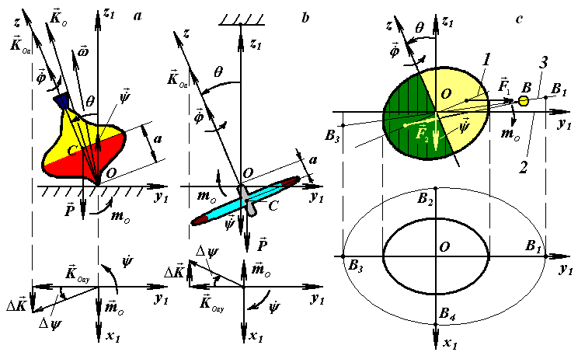
Fig. 1 Precession of rotational bodies: а – whirligig on bearing surface x₁Oy₁; b – wheel suspended at the point O; c – free Earth. 1 and 2 – Earth’s equatorial and orbital planes; 3 – orbital plane of the body B

We provided а number of experiments (Fig. 1) to understand better the mechanism of gravitation force action on a rotating body. Let a whirligig (Fig. 1, a) rotates on a table. Having its own axis counterclockwise inclination from a vertical at the angle $θ$, it is treated by gravitation force $P$ creating the moment of force $m_{O}$, which is counterclockwise also. In case of the suspended wheel (Fig. 1, b) the torque $m_{O}$ will be clockwise. Experiments were executed at different $θ$ angles and angular speeds of these bodies. Direction of precession of the whirligig and a suspended wheel axes were opposite in all experiments.
Now we consider the law of angular momentum (1) on an example of rotational movement of three bodies submitted on Fig. 1 in more details. Let a whirligig (Fig. 1, a) be at angle $θ$ to the axis z₁ and spin about its axis z at the angular velocity $\overset{˙}{ϕ}$, and the gravitational force $P$ be applied to its gravity center. The torque (moment of force) $m_{O}=\text{Pa}⋅\text{sin}θ$ makes the whirligig axis rotate about the point O at the angular velocities $\overset{˙}{θ}$ and $\overset{˙}{ψ}$. The vector of the whirligig absolute angular velocity is
$ω=\overset{˙}{φ}+\overset{˙}{θ}+\overset{˙}{ψ}$. (2)
Let a axisymmetrical whirligig with the moment of inertia J_{z} relative to z has the velocity $\overset{˙}{ϕ}$ which is much faster than the velocities of its axis $\overset{˙}{θ}$ and $\overset{˙}{ψ}$. If we neglect the deviation of $K_{O}$ from z (Fig. 1, a), the whirligig approximate angular momentum $K_{\text{Oa}}≈K_{O}≈J_{z}⋅\overset{˙}{φ}$ is directed along z, and law (1) becomes written approximately as
${\overset{˙}{K}}_{\text{Oa}}≈m_{O}$. (3)
This approach is employed in the elementary gyroscope theory. The torque $m_{O}$ being normal to $K_{\text{Oa}}$ (Fig. 1, a), the angular momentum remains invariable in magnitude $K_{\text{Oa}}=J_{z}⋅\overset{˙}{ϕ}=$ const but changes its direction $ΔK$ in the plane x₁Oy₁ according to $m_{O}$. Then, for the time $Δt$, the angular momentum receives the increment $ΔK={\overset{˙}{K}}_{\text{Oa}}⋅Δt=m_{O}⋅Δt$ which causes its rotation with the angle $Δψ$ about z₁. If the increment ΔK is expressed via the angle increment $Δψ$, $ΔK=K_{\text{Oay}}⋅Δψ=K_{\text{Oa}}⋅\text{sin}θ⋅Δψ$ the rotation velocity becomes
$\overset{˙}{ψ}=\underset{Δt→0}{\text{lim}}{Δψ}/{Δt}={m_{O}}/(K_{\text{Oa}}⋅\text{sin}θ)\text{.}$ (4)
Inasmuch as the whirligig spin axis coincides with the angular momentum ${\overset{˙}{K}}_{\text{Oa}}$ in this formulation, it will rotate in the same way as ${\overset{˙}{K}}_{\text{Oa}}$, i.e., will precess counterclockwise at the velocity $\overset{˙}{ψ}$. After the moment $m_{O}$ is substituted into (4), the precession velocity becomes
$\overset{˙}{ψ}={\text{Pa}}/(J_{z}⋅\overset{˙}{ϕ})$. (5)
In the applied approximation, the precession velocity does not depend on the tilt of the whirligig spin axis $θ$ and moreover, there are no nutation oscillations (changes of angle $θ$).
In case of a wheel suspended at the point O (Fig. 1, b), $m_{O}$ is directed clockwise, and the wheel axis precesses also clockwise at a velocity governed by (5).
Fig. 1, c shows the action of body B on the rotating Earth. If the Earth is centrosymmetrical, the action of B on the Earth’s parts nearest and farthest to B corresponds to the forces $F_{1}$ and $F_{2}$, whose resultant passes through the center O. For an oblate Earth, the purchases of these forces become farther from the center O. Then, $F_{1}$ increases while $F_{2}$ decreases producing the torque $m_{O}$ directed clockwise as in Fig. 1, b. Therefore, the Earth’s spin axis will precesses clockwise at a velocity given by (4).
Above we considered the rotation at an angular velocity $\overset{˙}{ϕ}>0$, i.e. counterclockwise. If the rotation changes its direction from counterclockwise to clockwise, the precession changes correspondingly, i.e. the velocity changes sign. It was proved by experiments.
It is possible to establish the precession cycles of the Earth's spin axis by analyzing the action body B on Earth (Fig. 1, c). The body B produces the maximum torques $m_{O\text{max}1}$ of the same direction at points B₁ and B₃, which are zero when the body is in the Earth's equatorial plane (B₂ and B₄), i.e., the torque changes twice from 0 to $m_{O\text{max}1}$ during a single orbiting cycle of B. Therefore, the precession and nutation cycles of the Earth's spin axis equal the half orbiting periods of the Sun, the Moon, and the planets relative to the moving Earth's axis Oz, or to the moving equatorial plane.
The Earth and the planets may approach in their orbital motion. If the approachment occurs at the points B₁ and B₃, the maximum torque increases to $m_{O\text{max}2}$. Thus, the Earth’s axis oscillates with periods corresponding to cycles at which the Earth approaches with planets are especially the closest to it at the points B₁ and B₃. Note, that with the purpose of simplification Fig. 1, c the three planes are shown with intersection at line B₁B₂: 1 and 2 – Earth’s equatorial and orbital planes, 3 – orbital plane of the body B. Therefore these oscillation periods are modulated because the orbits of the Earth and the planets do not belong to the same plane and are rather elliptical than circular.
The torque produced by body B, depends also on parameters of its orbit, in particular from a tilt between the equatorial plane 1 (Fig. 1, c) and the orbital plane 3. Therefore the Earth's spin axis will oscillate with the period of orbit precession of the body B relative to the Earth’s moving equatorial plane. For example, the precession cycle of the Moon’s orbit relative to the Earth's orbital plane is equal 18.6 yrs. The Earth's spin axis will oscillate with this cycle at the Moon action. There will not be an essential difference between this cycle and the cycle of the Moon's precession because the precession cycle of the Earth's equatorial plane exceeds the last one in more than thousand times, i.e. during the cycle of the Moon’s orbital precession the Earth’s equatorial plane is practically motionless.

3. Differential equations of rotational motion
3.1. Earth’s angular momentum
There arises a problem in the derivation of the rotation equations: as the body rotates the moment of inertia or the angular velocity components are changed depending on the coordinate system. Therefore, we first use the coordinates in which the moments of inertia remain invariable and then we proceed to the coordinates where the angular velocities are independent of the body rotation.
Motion of the Solar system bodies is considered in non-rotating barycentric ecliptic coordinates x₁₀y₁₀z₁₀ (Fig. 2) connected to the Earth’s orbital plane fixed at T₀ epoch. Axis x₁₀ is pointed toward the vernal equinox. Let the non-rotating system of geocentric ecliptic coordinates x₁y₁z₁ with the center of mass at O moves translationally relative to the system x₁₀y₁₀z₁₀. Axis z of the rotating geocentric ecliptic coordinates xyz is directed along the Earth’s own angular velocity $\overset{˙}{φ}$ and axis x at the initial moment t = 0 lies in the Greenwich Meridian plane. The Earth’s absolute angular velocity $ω$ in system x₁y₁z₁ with the projections ω_{x}, ω_{y}, ω_{z} to rotating axes of system xyz will be $ω={iω}_{x}+{jω}_{y}+{kω}_{z}$.
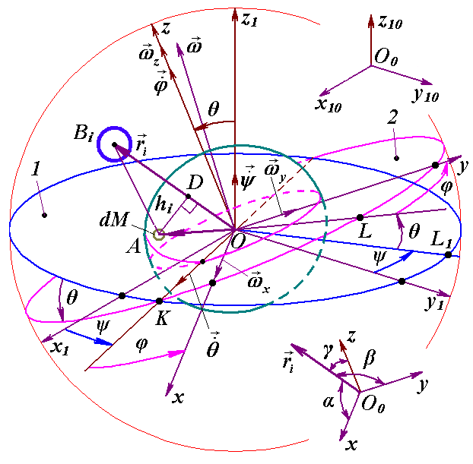
Fig. 2 Coordinate systems and action of the body B on the Earth’s element dM: x₁₀y₁₀z₁₀ – fixed barycentric ecliptic system; x₁y₁z₁ – non-rotating geocentric ecliptic system; xyz – rotating with Earth geocentric equatorial system. $ψ$, $θ$ and $ϕ$ are Euler angles of position of system xyz relative to system x₁y₁z₁. 1 – fixed ecliptic plane; 2 – Earth’s moving equatorial plane; $r=\vec{\text{OA}}$– radius vector of mass element dM relative to center O
In the law (1), angular momentum $K_{O}$ is produced by all the masses of rotating Earth in system x₁y₁z₁, and $\sum{m_{O}(F_{k})}$ is moment of forces produced by all the Solar system bodies. First define derivation of the angular moment and then the sum of torques.
As in system x₁y₁z₁ the Earth rotates with angular velocity $ω$, thus any of its element dM with a radius vector $r=ix+jy+kz$ (Fig. 2) moves with velocity $ν=ω×r$ and has angular momentum $m_{O}(\text{dM}ν)=r× v\text{dM}$ relative to the center O.
After integration taking into account the entire Earth’s mass M, $K_{O}$ is
$K_{O}=\int_{M}{m_{O}(\text{dM}v)=\int_{M}{r×v\text{dM}}}$. (6)
Having differentiated $K_{O}$ on time and then having substituted vectors $r$, $ω$ and $ν$, after transformation we obtain derivatives of the projections of the angular momentum to axes of rotating system xyz
${\overset{˙}{K}}_{\text{Ox}}=J_{x}ε_{x}−J_{\text{xy}}(ε_{y}−ω_{z}ω_{x})−J_{\text{xz}}(ε_{z}+ω_{y}ω_{x})−(J_{y}−J_{z})ω_{y}ω_{z}−J_{\text{yz}}(ω_{y}^{2}−ω_{z}^{2}),$ (7)
${\overset{˙}{K}}_{\text{Oy}}=J_{y}ε_{y}−J_{\text{yz}}(ε_{z}−ω_{x}ω_{y})−J_{\text{yx}}(ε_{x}+ω_{z}ω_{y})−(J_{z}−J_{x})ω_{z}ω_{x}−J_{\text{zx}}(ω_{z}^{2}−ω_{x}^{2}),$ (8)
${\overset{˙}{K}}_{\text{Oz}}=J_{z}ε_{z}−J_{\text{zx}}(ε_{x}−ω_{y}ω_{z})−J_{\text{zy}}(ε_{y}+ω_{x}ω_{z})−(J_{x}−J_{y})ω_{x}ω_{y}−J_{\text{yx}}(ω_{x}^{2}−ω_{y}^{2}),$ (9)
where ε_{x}, ε_{y}, ε_{z} are projections of the Earth angular acceleration in system x₁y₁z₁ to axes of rotating system xyz;
$J_{x}=\int_{M}{(y^{2}+z^{2})\text{dM}},$ $J_{y}=\int_{M}{(z^{2}+x^{2})\text{dM}},$ $J_{z}=\int_{M}{(x^{2}+y^{2})\text{dM}}$ – the Earth’s axial moments of inertia, and $J_{\text{xy}}=\int_{M}{\text{xydM}},$ $J_{\text{xz}}=\int_{M}{\text{xzdM}},$ $J_{\text{yz}}=\int_{M}{\text{yzdM}}$ – its centrifugal moments of inertia.
As the system xyz is connected with the rotating Earth, the moments of inertia do not depend on the Earth’s rotation and remain constants. Today’s knowledge of the Earth’s density distribution is insufficient for definition of the moments of inertia. As it will be shown below, it is possible to define only the relation between two moments of inertia J_{z} and J_{x}, from observable angular velocity $\overset{˙}{ψ}$ (precession), but not their absolute values. Last years the three-axial model of Earth is described where the third moment of inertia is estimated by potential of the gravitational distribution on Earth’s surface. However, this method can not give precise estimation of the moments of inertia. Note, that in case of three-axial Earth it is required to add terms with centrifugal moments of inertia because of nonsymmetrical distribution of potential as shown from (7)-(9). Traditionally, terms with these moments are unaccounted and terms containing third moment J_{y} are in equations though in last forms J_{y} is equal J_{x}. Nevertheless, avoiding of complications with unaccounted terms it is considered axisymmetrical Earth J_{y} = J_{x}, and J_{xy} = J_{xz} = J_{yz} = 0. Then derivatives of the angular momentum (7)-(9) are:
${\overset{˙}{K}}_{\text{Ox}}=J_{x}ε_{x}−(J_{y}−J_{z})ω_{y}ω_{z},$ ${\overset{˙}{K}}_{\text{Oy}}=J_{y}ε_{y}−(J_{z}−J_{x})ω_{z}ω_{x},$ ${\overset{˙}{K}}_{\text{Oz}}=J_{z}ε_{z}\text{.}$ (10)
For axes with zero centrifugal moments of inertia the moments J_{x}, J_{y}, J_{z} are named principal moments of inertia.
3.2. The law of angular momentum in Euler angles
Position of rotating system xyz (Fig. 2) relative to non-rotating system x₁y₁z₁ is determined by Euler angles: $ϕ$, $ψ$, $θ$, here precession angle $ψ$ defines position of nodes line OK, where moving equatorial plane intersects fixed orbital plane (ecliptic), nutation angle $θ$ defines a tilt between equatorial plane and ecliptic and $ϕ$ is angle of the Earth’s own rotation around axis z. Fig. 2 shows directions of this angles accepted in theoretical mechanics. In astronomy angles, which are directed according to observably movements, are accepted: $ψ_{a}=2π−ψ,$ $ϕ_{a}=ϕ$ and $θ_{a}$= -$θ$. Directions of angular velocities $\overset{˙}{ψ},$ $\overset{˙}{θ},$ $\overset{˙}{φ}$ are shown on Fig. 2, i.e. turn of angles $ψ$, $θ$ and $ϕ$ is visible counterclockwise from the side of these vectors. It is seen from Fig. 2 that Euler’s velocities stay constant at the Earth’s turn. Therefore let all the variables and equations will be expressed in Euler variables.
As it is possible to present the vector of absolute angular velocity as (2), thus in projections to axes x, y, z it is
$ω_{x}={\overset{˙}{ϕ}}_{x}+{\overset{˙}{ψ}}_{x}+{\overset{˙}{θ}}_{x},$ $ω_{y}={\overset{˙}{ϕ}}_{y}+{\overset{˙}{ψ}}_{y}+{\overset{˙}{θ}}_{y},$ $ω_{z}={\overset{˙}{ϕ}}_{z}+{\overset{˙}{ψ}}_{z}+{\overset{˙}{θ}}_{z},$ (11)
where ${\overset{˙}{ϕ}}_{x},$ ${\overset{˙}{ψ}}_{x},$ ${\overset{˙}{θ}}_{x}$ etc. – projections of the Euler angular velocities to axes xyz. Having calculated expressions (11) with the help of Fig. 2 it is received Euler well-known equations:
$ω_{x}=\overset{˙}{ψ}⋅\text{sin}θ⋅\text{sin}ϕ+\overset{˙}{θ}⋅\text{cos}ϕ,$ $ω_{y}=\overset{˙}{ψ}⋅\text{sin}θ⋅\text{cos}ϕ−\overset{˙}{θ}⋅\text{sin}ϕ,$ $ω_{z}=\overset{˙}{ϕ}+\overset{˙}{ψ}⋅\text{cos}θ\text{.}$ (12)
After differentiation (12) the angular accelerations in Euler variables become:
$ε_{x}=\overset{¨}{ψ}\text{sin}θ\text{sin}ϕ+\overset{˙}{ψ}\overset{˙}{θ}\text{cos}θ\text{sin}ϕ+\overset{˙}{ψ}\overset{˙}{ϕ}\text{sin}θ\text{cos}ϕ+\overset{¨}{θ}\text{cos}ϕ−\overset{˙}{θ}\overset{˙}{ϕ}\text{sin}ϕ,$ (13)
$ε_{y}=\overset{¨}{ψ}\text{sin}θ\text{cos}ϕ+\overset{˙}{ψ}\overset{˙}{θ}\text{cos}θ\text{cos}ϕ−\overset{˙}{ψ}\overset{˙}{ϕ}\text{sin}θ\text{sin}ϕ−\overset{¨}{θ}\text{sin}ϕ−\overset{˙}{θ}\overset{˙}{ϕ}\text{cos}ϕ,$ (14)
$ε_{z}=\overset{¨}{ϕ}+\overset{¨}{ψ}⋅\text{cos}θ−\overset{˙}{ψ}\overset{˙}{θ}⋅\text{sin}θ\text{.}$ (15)
Having substituted angular velocities (12) and angular accelerations (13)-(15) in (10), the projections of derivatives of the angular momentum depending on Euler angles are:
$\begin{aligned}{\overset{˙}{K}}_{\text{Ox}}=J_{x}\overset{¨}{ψ}\text{sin}θ\text{sin}ϕ+J_{x}\overset{¨}{θ}\text{cos}ϕ+(2J_{x}−J_{z})\overset{˙}{ψ}\overset{˙}{θ}\text{cos}θ\text{sin}ϕ+J_{z}\overset{˙}{ψ}\overset{˙}{ϕ}\text{sin}θ\text{cos}ϕ− \\ −J_{z}\overset{˙}{θ}\overset{˙}{ϕ}\text{sin}ϕ+(J_{z}−J_{x}){\overset{˙}{ψ}}^{2}\text{sin}θ\text{cos}θ\text{cos}ϕ;\end{aligned}$ (16)
$\begin{aligned}{\overset{˙}{K}}_{\text{Oy}}=J_{y}\overset{¨}{ψ}\text{sin}θ\text{cos}ϕ−J_{y}\overset{¨}{θ}\text{sin}ϕ+(2J_{x}−J_{z})\overset{˙}{θ}\overset{˙}{ψ}\text{cos}θ\text{cos}ϕ−J_{z}\overset{˙}{ψ}\overset{˙}{ϕ}\text{sin}θ\text{sin}ϕ− \\ −J_{z}\overset{˙}{θ}\overset{˙}{ϕ}\text{cos}ϕ−(J_{z}−J_{x}){\overset{˙}{ψ}}^{2}\text{sin}θ\text{cos}θ\text{sin}ϕ;\end{aligned}$ (17)
${\overset{˙}{K}}_{\text{Oz}}=J_{z}\overset{¨}{ϕ}+J_{z}\overset{¨}{ψ}\text{cos}θ−J_{z}\overset{˙}{ψ}\overset{˙}{θ}\text{sin}θ$. (18)
Let us transform the law of the angular moments (1) to Euler angles. The moments of forces can be defined directly through forces for the actions of each body on an Earth mass element (see Fig. 2). However, hereinafter at their series representation they are reduced to other terms. Here we define the moments through the force function U by a traditional method to safe continuity with previous works. As it is known from the theorem of theoretical mechanics, the moments of forces in a direction of axes are equal derivatives of force function on an angle of turn relatively to this axis. Therefore in system OKz₁z with the axes located on vectors of angular velocities $\overset{˙}{ψ},$ $\overset{˙}{θ}$ and $\overset{˙}{φ}$, the moments of forces are (Fig. 2): $m_{O\overset{˙}{ψ}}=m_{\text{Oz}1}=∂U/∂ψ,$ $m_{O\overset{˙}{θ}}=m_{\text{OK}}=∂U/∂θ,$ $m_{O\overset{˙}{ϕ}}=m_{\text{Oz}}=∂U/∂ϕ$. Taking into account these moments we project the right and left part of (1) on the axes of system OKz₁z:
${\overset{˙}{K}}_{O\overset{˙}{ψ}}=∂U/∂ψ$, ${\overset{˙}{K}}_{O\overset{˙}{θ}}=∂U/∂θ$, ${\overset{˙}{K}}_{\text{Oz}}=∂U/∂ϕ$. (19)
Let us express derivatives of the angular momentum in Eq. (19) through derivatives ${\overset{˙}{K}}_{\text{Ox}}$, ${\overset{˙}{K}}_{\text{Oy}}$ and ${\overset{˙}{K}}_{\text{Oz}}$ in Cartesian coordinates Oxyz, and draw axis OL perpendicularly to axis OK (Fig. 2).
Then, projections of the derivatives ${\overset{˙}{K}}_{\text{Ox}}$, ${\overset{˙}{K}}_{\text{Oy}}$ and ${\overset{˙}{K}}_{\text{Oz}}$ (on Fig. 2 are not seen but identical to projections $ω_{x}$, $ω_{y}$ и $ω_{z}$) on axes of system OLKz₁ are
${\overset{˙}{K}}_{L}={\overset{˙}{K}}_{\text{Ox}}\text{sin}ϕ+{\overset{˙}{K}}_{\text{Oy}}\text{cos}ϕ$; ${\overset{˙}{K}}_{K}={\overset{˙}{K}}_{\text{Ox}}\text{cos}ϕ−{\overset{˙}{K}}_{\text{Oy}}\text{sin}ϕ$; ${\overset{˙}{K}}_{z1}={\overset{˙}{K}}_{\text{Oz}}\text{cos}θ+{\overset{˙}{K}}_{L}\text{sin}θ$,
and then:
${\overset{˙}{K}}_{O\overset{˙}{θ}}={\overset{˙}{K}}_{K}={\overset{˙}{K}}_{\text{Ox}}\text{cos}ϕ−{\overset{˙}{K}}_{\text{Oy}}\text{sin}ϕ$; (20)
${\overset{˙}{K}}_{O\overset{˙}{ψ}}={\overset{˙}{K}}_{z1}={\overset{˙}{K}}_{\text{Ox}}\text{sin}ϕ⋅\text{sin}θ+{\overset{˙}{K}}_{\text{Oy}}\text{cos}ϕ⋅\text{sin}θ+{\overset{˙}{K}}_{\text{Oz}}\text{cos}θ$. (21)
Further the Cartesian projections (16)-(18) are substituted in equations (20)-(21), and the last ones are substituted in (19) in system OKz₁z. Then, having expressed the second derivatives it is received two differential equations of the Earth’s spin in Euler’s variables:
$\overset{¨}{ψ}=\left(\frac{∂U}{∂ψ}−(2J_{x}−J_{z})\overset{˙}{ψ}\overset{˙}{θ}\text{sin}θ\text{cos}θ+J_{z}\overset{˙}{θ}\overset{˙}{ϕ}\text{sin}θ\right)⋅\frac{1}{J_{x}{\text{sin}}^{2}θ}−\frac{{\overset{˙}{K}}_{\text{Oz}}}{J_{x}}\text{cos}θ$ ; (22)
$\overset{¨}{θ}=\left(\frac{∂U}{∂θ}+(J_{x}−J_{z}){\overset{˙}{ψ}}^{2}\text{sin}θ\text{cos}θ−J_{z}\overset{˙}{ϕ}\overset{˙}{ψ}\text{sin}θ\right)⋅\frac{1}{J_{x}}$ , (23)
where the derivative of the angular momentum ${\overset{˙}{K}}_{\text{Oz}}$ is defined by the third formula in the equations (19) for the law of angular momentum.
3.3. The force function in Cartesian coordinates
Now we define force function for the action of body B_{i} with mass M_{i} (Fig. 2) on the Earth by the traditional way presented, for example, in [15]. Its coordinates in rotating system xyz are x_{i}, y_{i}, z_{i}. The force function of the action of this body on the Earth’s element of mass dM with coordinates x, y, z is $\text{dU}=\frac{{\text{GM}}_{i}\text{dM}}{r_{\text{di}}},$ where G is the gravitation constant, $r_{\text{di}}=\sqrt{(x_{i}−x)^{2}+(y_{i}−y)^{2}+(z_{i}−z)^{2}}$ is the distance between the element of mass dM and the body B_{i}. Having summarized on all Earth’s mass M and on all bodies n the force function is:
$U=\sum_{i=1}^{n}{{\text{GM}}_{i}\int_{M}{\frac{\text{dM}}{r_{\text{di}}}}}$, (24)
where $\text{dM}=ρ\text{dxdydz};$ $ρ=ρ(x,y,z)$ is the Earth’s density.
It is obviously impossible to integrate Eq. (24) because today’s distribution of the Earth’s density is studied only qualitatively. Therefore direct definition of the force function for the action of external bodies on the Earth as mechanical system is impossible. All further solutions are in simplification of Eq. (24) and in derivation of the force function depending on the Earth’s moments of inertia J_{x}, J_{y}, J_{z}. Correlation between them are defined on observable rate of the Earth’s precession.
Taking into account that the distance r_{i} between the Earth and the body М_{i} is considerably exceeds distance r to the element dM the Eq. (24) is simplified. Let the line segments OD = ξ_{i} and AD = h_{i}. Having applied the theorem of Pythagoras to cathetus h_{i} of both rectangular triangles ΔODA and ΔADB_{i}, we obtain:
$r_{\text{di}}=\sqrt{r^{2}−ξ_{i}^{2}+(r_{i}−ξ_{i})^{2}}=r_{i}\sqrt{1+b_{i}},$ (25)
where $b_{i}=\frac{−2r_{i}ξ_{i}+r^{2}}{r_{i}^{2}}$.
As $\left|b_{i}\right|<1,$ then subintegral function $\frac{1}{r_{\text{di}}}$ in (24) is represented as Taylor series at b powers. Taking into account terms that are no more the fourth order in relation to$\sqrt{\left|b_{i}\right|}$, the force function is in form
$U=\sum_{i=1}^{n}{\frac{{\text{GM}}_{i}}{r_{i}}\int_{M}{[1+\frac{ξ_{i}}{r_{i}}+\frac{3ξ_{i^{2}}−r^{2}}{2r_{i^{2}}}+\frac{5ξ_{i^{3}}−3ξ_{i}r^{2}}{2r_{i^{3}}}+\frac{\text{35}ξ_{i^{4}}−\text{30}ξ_{i^{2}}r^{2}+3r^{4}}{8r_{i^{4}}}]\text{dM}}}\text{.}$ (26)
Line segment $ξ_{i}$ (Fig. 2) is expressed through coordinates x, y, z of the element dM by means of direction cosines $α_{i},$$β_{i},$$γ_{i}$:
$ξ_{i}={\hat{l}}_{i}x+{\hat{m}}_{i}y+{\hat{n}}_{i}z,$ (27)
where
${\hat{l}}_{i}=\text{cos}α_{i}={x_{i}}/{r_{i}},$ ${\hat{m}}_{i}=\text{cos}β_{i}={y_{i}}/{r_{i}},$ ${\hat{n}}_{i}=\text{cos}γ_{i}={z_{i}}/{r_{i}},$ (28)
By definition, the axes of a body, which are on intersection of planes of symmetry, are the principal axes of inertia. Axes of rotating system Oxyz are directed along the Earth’s principal axes of inertia. Therefore integrals of type $\int_{M}{x^{k}f(x,y,z)\text{dM},}$ where k – an odd integer, and f (x, y, z) – even function of coordinates, will consist of two equal on size and opposite on a sign parts at the intervals x < 0 and x > 0, i.e. these integrals are equal zero in the sum. Because, according to (27), variable $ξ_{i}$ is proportional to coordinates x, y, z, the integrals in (26), depending on $ξ$ and $ξ^{3}$, are equal zero. Note, that these integrals are necessary to consider in case of the non-symmetrical Earth and absence of symmetry on one of the planes zOx or zOy, i.e. the force function as well as the derivatives of angular momentum (7)-(9) will include centrifugal moments of inertia.
Integral of the first term in (26) is the Earth’s mass. Numerator of the third term with the account (27) is
$3ξ_{i}^{2}−r^{2}=3(x^{2}−{\hat{m}}_{i}^{2}x^{2}−{\hat{n}}_{i}^{2}x^{2}+{\hat{m}}_{i}^{2}y^{2}+{\hat{n}}_{i}^{2}z^{2})−x^{2}−y^{2}−z^{2}+2({\hat{l}}_{i}{\hat{m}}_{i}\text{xy}+{\hat{l}}_{i}{\hat{n}}_{i}\text{xz}+{\hat{n}}_{i}{\hat{m}}_{i}\text{yz})\text{.}$ (29)
As ${\hat{l}}_{i^{2}}+{\hat{m}}_{i^{2}}+{\hat{n}}_{i^{2}}=1,$ thus in (29) it is taken into, that ${\hat{l}}_{i^{2}}=1−{\hat{m}}_{i^{2}}−{\hat{n}}_{i^{2}}$. The terms integration having coordinates in the second power gives the moments of inertia and the last ones gives centrifugal moments as $J_{\text{xy}}=\int{\text{xy}}\text{dM},$ which are zero for the Earth with principal axes along x, y, z.
After substitution (29) in (26) and integration we obtain the force function without the last fifth term
$U=\sum_{i=1}^{n}{{\text{GM}}_{i}\left(\frac{M}{r_{i}}+\frac{J_{y}+J_{z}−2J_{x}+3{\hat{m}}^{2}(J_{x}−J_{y})−3{\hat{n}}^{2}(J_{z}−J_{x})}{2r_{i^{3}}}\right)\text{.}}$ (30)
In this case the action on the Earth’s rotational motion is defined by the third and the fifth terms in (26) as they depend on Euler angles. Having divided the fifth term on the third, we find that the order of their relation is equal $\frac{R_{E}^{2}}{r_{i}^{2}},$ where R_{E} – radius of the Earth. This ratio has the greatest value for the Moon, and is equal 3⋅10⁻⁴. Further the bodies’ action on the Earth’s spin is considered with such relative error. Therefore additional effects should be considered, if the relative value of their action has the order 3⋅10⁻⁴ and more.
After the direction cosines $\hat{m}$ and $\hat{n}$ are substituted according to (28), force function (30) becomes
$U=\sum_{i=1}^{n}{{\text{GM}}_{i}\left(\frac{M}{r_{i}}+\frac{J_{y}+J_{z}−2J_{x}}{2r_{i^{3}}}+3⋅\frac{(J_{x}−J_{y})y_{i^{2}}−(J_{z}−J_{x})z_{i^{2}}}{2r_{i^{5}}}\right)}\text{.}$ (31)
where y_{i} and z_{i} – coordinates of the body M_{i} in rotating system xyz.
3.4. The moments of forces in Euler angles
We express y_{i} and z_{i} through coordinates x_{1i}y_{1i}z_{1i} of system x₁y₁z₁ (Fig. 2). Let us draw the line OL₁ perpendicularly to OK in the plane x₁Oy₁. Coordinates of the body B_{i} will give projection ${\text{OL}}_{1i}=−x_{1i}\text{sin}ψ+y_{1i}\text{cos}ψ$ on this line and then coordinate z of the body B_{i} is
$z_{i}=z_{1i}\text{cos}θ−{\text{OL}}_{1i}\text{sin}θ=x_{1i}\text{sin}θ\text{sin}ψ−y_{1i}\text{sin}θ\text{cos}ψ+z_{1i}\text{cos}θ\text{.}$ (32)
Having defining projections of the coordinates x_{1i} and y_{1i} to the axes OK and OL analogously, coordinate y_{i} is
$y_{i}=−x_{1i}(\text{cos}ψ\text{sin}ϕ+\text{sin}ψ\text{cos}θ\text{cos}ϕ)+y_{1i}(\text{cos}ψ\text{cos}θ\text{cos}ϕ−\text{sin}ψ\text{sin}ϕ)+z_{1i}\text{sin}θ\text{cos}ϕ\text{.}$ (33)
Earlier we neglected the centrifugal moments of inertia. It is admissible, if the Earth is axisymmetrical, or axes x and y lie in symmetry planes. As there is no evidence on presence of such planes we should consider the axisymmetrical Earth with the equal moments of inertia relative to axes x and y, i.e. J_{y} = J_{x}. Therefore we do not present bulky expressions for the non-axisymmetrical Earth. If necessary they may be received on below-mentioned sequence with use of expression (33). For the axisymmetrical Earth, after substitution (32) in (31), taking into account J_{y} = J_{x}, force function becomes:
$U=\sum_{i=1}^{n}{\frac{3{\text{GM}}_{i}}{2r_{i^{5}}}[−(J_{z}−J_{x})(x_{1_{i}}\text{sin}θ\text{sin}ψ−y_{1i}\text{sin}θ\text{cos}ψ+}z_{1i}\text{cos}θ)^{2}]+\sum_{i=1}^{n}{\frac{{\text{GM}}_{i}}{r_{i}}[M+\frac{J_{z}−J_{x}}{2r_{i^{2}}}]\text{.}}$ (34)
After differentiation (34) on Euler angles φ, ψ, θ and reductions we obtain the moments of forces
$m_{\text{Oz}}=\frac{∂U}{∂ϕ}=0;$ (35)
$\begin{aligned}m_{\text{Oz}1}=\frac{∂U}{∂ψ}=−\sum_{i=1}^{n}{\frac{3{\text{GM}}_{i}}{r_{i^{5}}}(J_{z}−J_{x})[{\text{sin}}^{2}θ\text{sin}ψ\text{cos}ψ(x_{{1i}^{2}}−y_{{1i}^{2}})−x_{1i}y_{1i}{\text{sin}}^{2}θ\text{cos}(2ψ)+} \\ +z_{1i}\text{sin}θ\text{cos}θ⋅(x_{1i}\text{cos}ψ+y_{1i}\text{sin}ψ)];\end{aligned}$ (36)
$\begin{aligned}m_{\text{OK}}=\frac{∂U}{∂θ}=−\sum_{i=1}^{n}{\frac{3{\text{GM}}_{i}}{2r_{i^{5}}}(J_{z}−J_{x})[\text{sin}(2θ)(x_{{1i}^{2}}{\text{sin}}^{2}ψ+y_{{1i}^{2}}{\text{cos}}^{2}ψ}−z_{{1i}^{2}}− \\ −x_{1i}y_{1i}\text{sin}(2ψ))+2z_{1i}\text{cos}(2θ)(x_{1i}\text{sin}ψ−y_{1i}\text{cos}ψ)]\text{.}\end{aligned}$ (37)
3.5. Differential equations
The law (1) in projection to the axis z of rotating system xyz, according to (19), has a form ${\overset{˙}{K}}_{\text{Oz}}=∂U/∂ϕ$. We consider the rigid Earth during derivation of the equations: J_{z} = const. The moment of inertia of the axisymmetrical Earth J_{Oz} may be changed for the action of redistribution of a water cover, thawing of glaciers, moving of continents, etc. In order to estimate the influence of these factors, it is entered J_{z} ≠ const. Therefore, according to (35) $∂U/∂ϕ=0,$ then ${\overset{˙}{K}}_{\text{Oz}}=0$ and taking into account (10) at J_{z} = J_{z0} it becomes $J_{z}ε_{z}=0$. After integration it is $J_{z}ω_{z}=\text{const}=J_{z0}ω_{z0}$, that may be written in form
$ω_{z}=ω_{z0}{J_{z0}}/{J_{z}}$, (38)
where J_{z0} and ω_{z0} are the Earth moment of inertia and its projection of angular velocity in an initial epoch. Because $ω_{z}=\overset{˙}{ϕ}+\overset{˙}{ψ}⋅\text{cos}θ$ (according to Eq. 12), thus, taking into account (38), we obtain angular velocity of the Earth’s own spin
$\overset{˙}{ϕ}=ω_{z0}{J_{z0}}/{J_{z}}−\overset{˙}{ψ}⋅\text{cos}θ$. (39)
From expression (39) follows that angular velocity of the Earth’s own spin $\overset{˙}{ϕ}$, which is not connected with motion of vector of angular speed $ω$, may be changed via redistribution of the Earth’s moment of inertia and alteration of precession rate. Expression (39) for angular velocity of the Earth’s own spin may be used for an estimation of the Earth’s parts motion influence on its angular speed.
Having designated a projection of the Earth’s angular velocity $ω_{z}=ω_{z0}=ω_{E}=\text{const}$, expression (39) for the rigid Earth $J_{\text{Oz}}=J_{\text{Oz}0}=\text{const}$ we rewrite in a kind
$\overset{˙}{ϕ}=ω_{E}−\overset{˙}{ψ}⋅\text{cos}θ$. (40)
After substitution of $\overset{˙}{ϕ}$, ${\overset{˙}{K}}_{\text{Oz}}=0$ and the derivatives of the force function (36)-(37) in Eqs. (22)-(23), differential equations of the Earth’s rotational movement are
$\begin{aligned}\overset{¨}{ψ}=−2\overset{˙}{ψ}\overset{˙}{θ}\frac{\text{cos}θ}{\text{sin}θ}+\overset{˙}{θ}\frac{J_{z}ω_{E}}{J_{x}\text{sin}θ}−\sum_{i=1}^{n}{\frac{3{\text{GM}}_{i}E_{d}J_{z}}{r_{i^{5}}J_{x}}}\left\{0\text{.}5\text{sin}(2ψ)(x_{{1i}^{2}}−y_{{1i}^{2}})−\right. \\ −x_{1i}y_{1i}⋅\text{cos}(2ψ)+\left.z_{1i}\frac{\text{cos}θ}{\text{sin}θ}(x_{1i}\text{cos}ψ+y_{1i}\text{sin}ψ)\right\};\end{aligned}$ (41)
$\begin{aligned}\overset{¨}{θ}=0\text{.}5{\overset{˙}{ψ}}^{2}\text{sin}(2θ)−\frac{J_{z}ω_{E}\overset{˙}{ψ}\text{sin}θ}{J_{x}}−\sum_{i=1}^{n}{\frac{3{\text{GM}}_{i}⋅E_{d}J_{z}}{2r_{i^{5}}J_{x}}}\left\{\text{sin}(2θ)[x_{{1i}^{2}}{\text{sin}}^{2}ψ+\right. \\ +y_{{1i}^{2}}{\text{cos}}^{2}ψ−z_{{1i}^{2}}−x_{1i}y_{1i}\text{sin}(2ψ)]+2z_{1i}(x_{1i}\text{sin}ψ−\left.y_{1i}\text{cos}ψ)\text{cos}(2θ)\right\},\end{aligned}$ (42)
where $E_{d}=(J_{z}−J_{x})/{J_{z}}$ is the Earth’s dynamical ellipticity; $ω_{E}$ projection of the Earth’s absolute angular velocity to its axis z, and ratio of moments is ${J_{z}}/{J_{x}}=1/(1−E_{d})$.
As $ω_{E}$ = const and $\overset{˙}{ϕ}$ changes according to (40), thus value $ω_{E}$ may be obtained as a result of averaging of the measured values $\overset{˙}{ϕ}$ и $\overset{˙}{ψ}\text{cos}θ$ on time, i.e. $ω_{E}=\overline{\overset{˙}{ϕ}+\overset{˙}{ψ}\text{cos}θ}$.

4. Initial conditions and the Earth’s dynamical ellipticity
We study the action of separate bodies on the Earth, therefore at integration Eqs. (41)-(42) it is necessary to set initial values for alteration of rates $ψ$ and $θ$, which are determined by influence of each body. At any set of initial values $\overset{˙}{ψ}$ and $\overset{˙}{θ}$ there begins a transient response, which may become whether a steady-state regime in a long time or not to be steady state at all. We are interested in the Earth’s behavior at steady-state regime. Let the second derivatives $\overset{¨}{ψ}$ and $\overset{¨}{θ}$ in Eqs. (41) and (42) are small in relation to the other terms at steady-state regime, i.e. $\overset{¨}{ψ}≈\overset{¨}{θ}≈0$. As $ω_{E}$ exceeds the derivatives $\overset{˙}{ψ}$ and $\overset{˙}{θ}$ on 6 orders therefore at neglecting terms with $\overset{˙}{ψ}⋅\overset{˙}{θ}$ and ${\overset{˙}{ψ}}^{2}$ in Eqs. (41)-(42) they become
$\overset{˙}{θ}≈−\sum_{i=1}^{n}{\frac{3{\text{GM}}_{i}E_{d}\text{sin}θ}{2ω_{E}r_{i}^{5}}}[\text{sin}(2ψ)(x_{1i}^{2}−y_{1i}^{2})−2x_{1i}y_{1i}\text{cos}(2ψ)+2z_{1i}\frac{\text{cos}θ}{\text{sin}θ}(x_{1i}\text{cos}ψ+y_{1i}\text{sin}ψ)]$; (43)
$\begin{aligned}\overset{˙}{ψ}≈−\sum_{i=1}^{n}{\frac{3{\text{GM}}_{i}E_{d}}{2ω_{E}r_{i}^{5}\text{sin}θ}}\left\{\text{sin}(2θ)[x_{1i}^{2}{\text{sin}}^{2}ψ+y_{1i}^{2}{\text{cos}}^{2}ψ−z_{1i}^{2}−x_{1i}y_{1i}\text{sin}(2ψ)]+\right. \\ \left.+2z_{1i}(x_{1i}\text{sin}ψ−y_{1i}\text{cos}ψ)⋅\text{cos}(2θ)\right\}\text{.}\end{aligned}$ (44)
Eqs. (43)-(44) are identical to the Poisson equations; their approximate solutions are applied in astronomical theories of climate change. We will define initial values of derivatives from these equations, setting coordinates x_{1i}, y_{1i} and z_{1i} of bodies acting on the Earth during an initial epoch t = 0. Initial values of the angles are: $ψ_{0}=0$ and $θ_{0}=ε_{0}$, where $ε_{0}$ = 0.4093197563 is the inclination due to an initial epoch, for example 30.12.1949.
There is the unknown parameter $E_{d}=(J_{z}−J_{x})/{J_{z}}$, which defines relation between the Earth’s moments of inertia. Today’s knowledge of the Earth’s density distribution is insufficient for definition of the moments J_{z} and J_{x} with a demanded accuracy. Therefore the Earth’s dynamical ellipticity E_{d} is defined by comparison of the calculated precession rate with the observations. According to [16] - [17] the Earth’s precession has clockwise direction relative to the fixed ecliptic and during a tropical year is
$p_{1}=\text{50} . 37084\text{+0}\text{.}\text{00493}T$, (45)
where T is counted in tropical centuries from a fundamental epoch 1900.0 with JD = 2415020.3134. In an initial epoch it is $p_{\text{10}}=\text{50} . 3733046\text{/}\text{yr}$. Observable average precession rate is described by Eq. (45). Now we define its calculated value according to (44). If an initial epoch coincides with an epoch of reference frame, then $θ=ε_{0}$ and $ψ=0$. Then Eq. (44) is written
${\overset{˙}{ψ}}_{0}=−E_{d}\sum_{i=1}^{n}{\frac{3{\text{GM}}_{i}}{ω_{E}r_{i}^{3}}[}\text{cos}ε_{0}({\bar{y}}_{1i}^{2}−{\bar{z}}_{1i}^{2})−{\bar{z}}_{1i}{\bar{y}}_{1i}\text{cos}(2ε_{0})\text{/sin}ε_{0}]$, (46)
where ${\bar{x}}_{1i}={x_{1i}}/{r_{i}}$, ${\bar{y}}_{1i}={y_{1i}}/{r_{i}}$, ${\bar{z}}_{1i}={z_{1i}}/{r_{i}}$ – dimensionless coordinates of acting bodies.
If a reference epoch does not coincide with an epoch of reference frame, $θ≠ε_{0}$, and $ψ≠0$.
In the course of cyclic relative movement of bodies round the Earth all coordinates change similarly, for example $−{\bar{x}}_{1i\text{max}}≤{\bar{x}}_{1i}≤{\bar{x}}_{1i\text{max}}$. Hereat ${\bar{x}}_{1i\text{max}}={\bar{y}}_{1i\text{max}}≈1$, and ${\bar{z}}_{1i\text{max}}=\text{sin}i_{i}$, where i_{i} – the tilt between the body’s orbital plane and equatorial plane. Since Pluto has the most value of the tilt i_{i} = 0.7 [6], for all planets ${\bar{z}}_{1i\text{max}}<1$. The second term in a square bracket (46) will change in limits $±\text{sin}i_{i}\text{cos}(2ε_{0})\text{/sin}ε_{0}$ and averaging on time will make it zero. The maximum value of the factor of the first term $({\bar{y}}_{1i}^{2}−{\bar{z}}_{1i}^{2})$ is 1, and minimum is zero, therefore and averaging on time will give 0.5. Then all the part in square brackets at averaging is $0\text{.}5\text{cos}ε_{0}$.
Value of geocentric distances to the planets changes in limits $|R_{\text{pi}}−R_{\text{pE}}|≤r_{i}≤R_{\text{ai}}+R_{\text{aE}}$, where $R_{\text{pi}}$, $R_{\text{pE}}$ and $R_{\text{ai}}$,$R_{\text{aE}}$ – perihelions and afelions of the planets and the Earth, accordingly. Then average geocentric distance to the planets is
$r_{\text{im}}=(R_{\text{ai}}+R_{\text{aE}}+|R_{\text{pi}}−R_{\text{pE}}|)⋅0\text{.}5$, (47)
which is $r_{\text{im}}=(R_{\text{ai}}+R_{\text{aE}}+|R_{\text{pi}}−R_{\text{pE}}|)⋅0\text{.}5$ for internal planets, and $a_{i}+a_{E}e_{E}$ for external, where a_{i}, a_{E} and e_{i}, e_{E} – semimajor axes of heliocentric orbits and orbits eccentricity of the planets and the Earth accordingly. Accordingly, for the Sun and the Moon average geocentric distances are
$r_{\text{Sm}}=a_{E}$; $r_{\text{Mm}}=a_{M}$, (48)
where a_{M} –average semiaxis of the Moon’s orbit. Then average value of speed of precession, according to (46), one gets
${\overset{˙}{ψ}}_{0m}=−E_{d}\sum_{i=1}^{n}{\frac{1\text{.}5{\text{GM}}_{i}\text{cos}ε_{0}}{ω_{E}r_{\text{im}}^{3}}}$. (49)
The negative sign testifies clockwise direction of precession. Due to equality condition between calculated average precession rate and observed one ${\overset{˙}{ψ}}_{0m}={−p_{\text{10}}}/({\text{Yr}}_{\text{tr}}⋅\text{rd})$, where ${\text{Yr}}_{\text{tr}}=\text{365}\text{.}\text{25636042}⋅\text{24}⋅\text{3600}$ – duration of a sidereal year in sec, and $\text{rd}={\text{180}⋅\text{3600}}/π$ we find the dynamical ellipticity
$E_{\text{da}}={p_{\text{10}}}/{\left({\text{Yr}}_{\text{tr}}⋅\text{rd}⋅\sum_{i=1}^{n}{\frac{1\text{.}5{\text{GM}}_{i}\text{cos}ε_{0}}{ω_{E}r_{\text{im}}^{3}}}\right)}$, (50)
where index a and E_{da} denote approximate method of calculation of this value.
Having derivated Eqs. (49) and (50) we averaged enough approximately expression (46) on time, for example, the average values $r_{i}^{3}$ and r_{i} can essentially differ. If laws of planets motion x_{1i}(t), y_{1i}(t), z_{1i}(t) could be found, there were known average value ${\overset{˙}{ψ}}_{0}$ on time span T by integrating expression (46) on time at interval from 0 to T. However, expression (46) is approximate since it is obtained from the equations of motion at neglecting $\overset{¨}{ψ}$ and $\overset{¨}{θ}$. Therefore Eq. (50) represents the Earth’s dynamical ellipticity approximately. Its more exact value will be obtained after numerical solution of the Earth’s rotational movement Eqs. (41)-(42) and comparisons of averaged from short-period oscillations of dynamics $\overset{˙}{ψ}$ during known observation with observable dynamics of average precession for this period.
The value of dynamical calculated according to (50) under the data used by us, is E_{d0} = 3.324257·10⁻³. Traditionally dynamical ellipticity is calculated with the account only the Moon and the Sun. In this case, under our data E_{dSM1} = 3.324268·10⁻³ i.e. differs at unit of the sixth positional notation. As it is seen from (50), the dynamical ellipticity depends on averaged distance $r_{\text{im}}^{3}$, thus the small changes of its value sufficiently change E_{da}.
For instance value of this distance for the Moon $r_{\text{im}}=a_{M}=3\text{.}\text{838}⋅{\text{10}}^{8}м$, which we obtained at reference conditions at epoch 30.12.49 from ephemerides DE406, gives dynamical ellipticity E_{dSM2} = 3.324770·10⁻³. To comparison here are ellipticities used by various authors: P. Bretagnon and J. Simon [11] E_{dB} = 3.2737671·10⁻³; F. Roosbeek and V. Dehant [18] E_{d} = 3.273767·10⁻³; J. Laskar et al. [5] E_{d} = 3.28005·10⁻³ with using a_{M} = 384747980 м and p₁₀ = 50.290966''/yr.
As we see, values E_{d} in expression (50) change depending on the accepted data in the second significant figure. The value dynamical ellipticity, taking into account the data accepted by us, is designated as E_{d0}, and according to J. Simon et al. [19] as E_{dS}. Tab. 1 gives Earth’s axis mean precession rates for the action of the Sun, the Moon and the planets calculated according to (49) and E_{d} = E_{dS}. The most value of speed of precession is caused by the Moon, the action of the Sun is twice less, and Venus and Jupiter cause the greatest action from the planets. As it is seen from Tab. 1, difference between speed of precession $|{\overset{˙}{ψ}}_{0m}|$ for the action of all the bodies and observable value p₁₀ is 3.14·10⁻³%.
Due to accepted dynamical ellipticity E_{dS} and $ψ_{0}=0$, $θ_{0}=ε_{0}$, initial values ${\overset{˙}{θ}}_{0}$ and ${\overset{˙}{ψ}}_{0}$ are calculated according to (43) and (44) for the action of the separate bodies and all together, see Tab. 1. Note, that expressions (43) and (44) represent values of derivatives ${\overset{˙}{θ}}_{0}$ and ${\overset{˙}{ψ}}_{0}$ approximately. Their exact value is given by observation. There are no these values for the action of separate bodies but there are observation data for the simultaneous action of all the bodies on the Earth. However, as Eqs. (43)-(44) are approximate, total values ${\overset{˙}{ψ}}_{0}$ и ${\overset{˙}{θ}}_{0}$ (taking into account all the bodies) will differ from the observation data.

Table 1
The mean precession rate ${\overset{˙}{ψ}}_{0m}$ of the Earth’s axis and the initial rates ${\overset{˙}{ψ}}_{0}$and ${\overset{˙}{θ}}_{0}$ for the separate action of the bodies by results of computations according to (49) and (43)-(44), accordingly. Computations executed at E_{dS} = 3.2737752·10⁻³; p₁₀ = 2.4422·10⁻² rad/cyr; $ψ_{0}=0$; $θ_{0}=ε_{0}$; rad in radians and cyr in centuries years.
No. | Bodies | $${\overset{˙}{ψ}}_{0m}$$ | $${\overset{˙}{ψ}}_{0}$$ | $${\overset{˙}{θ}}_{0}$$
No. | Bodies | rad/cyr
1 | Sun | -7.73095·10⁻³ | -1.20483·10⁻⁶ | -7.09773·10⁻⁸
2 | Mercury | -1.02693·10⁻⁹ | 1.42035·10⁻¹⁰ | 2.95503·10⁻¹¹
3 | Venus | -1.86489·10⁻⁸ | -7.17466·10⁻⁹ | -2.99417·10⁻⁹
4 | Mars | -6.82598·10⁻¹⁰ | -8.87394·10⁻¹² | 1.26014·10⁻¹⁰
5 | Jupiter | -5.19060·10⁻⁸ | 1.58365·10⁻⁹ | 4.60379·10⁻¹⁰
6 | Saturn | -2.53056·10⁻⁹ | 1.06473·10⁻¹⁰ | 2.27373·10⁻¹⁰
7 | Uranium | -4.74989·10⁻¹¹ | 1.45508·10⁻¹² | 2.78046·10⁻¹⁴
8 | Neptune | -1.46677·10⁻¹¹ | -6.38274·10⁻¹³ | 8.18066·10⁻¹³
9 | Pluto | -6.92755·10⁻¹⁴ | 4.37046·10⁻¹³ | 1.91721·10⁻¹⁴
10 | Moon | -0.01657 | -1.83206·10⁻³ | -9.29602·10⁻⁴
All bodies |  | -2.44209·10⁻² | – | –

5. Solution algorithm
The coordinates x_{1i}, y_{1i}, z_{1i} of the bodies M_{i}, acting the Earth in Eqs. (41)-(42) are referred to the fixed geocentric ecliptic coordinates (Fig. 2). Numerical solution of the orbital problem gives the change of their orbit parameters i, φ_{Ω}, φ_{p}, R_{p}, e over a time span 100 Myr [6]. Due to this solution there are the bodies’ positions saved with 10 kyr interval. To integrate equations of rotational motion one needs the bodies’ positions during any moment of time.
The bodies’ positions are usually set on the base of the theory of secular perturbations during solving rotational motion equations. P. Bretagnon et al. [11] used ephemerides DE403 for numerical integration of these equations for 1968-2023 yr interval. These methods are not suitable for long-time integration. Therefore we developed the follow algorithm to compute the motion laws of the bodies x_{1i}(t), y_{1i}(t), z_{1i}(t). Their coordinates are defined on the base of our solutions about motion of the Solar system bodies in fixed barycentric equatorial coordinates. Using orbital parameters i, φ_{Ω}, φ_{p}, R_{p}, e Cartesian coordinates are recalculated in polar r_{i} and φ_{i} in orbital plane. To estimate the body position during new moment of time t₁ = t+Δt one may use expressions for elliptical motion given in [12], [13], [20] and [21]: t = t(r) – motion law in implicit form and r(φ) – trajectory equation. Polar radius of the body r₁ during new moment of time t₁ is predicted under Taylor's formula of the second order, checked on dependence t₁(r₁) and then discrepancy for some iterations comes almost to zero. After that from the trajectory equation there obtained polar angle φ₁(r₁) in a return form. At small ellipticities e ~ 0 during new moment of time t₁ under Taylor's formula the angle φ₁ is predicted, checked under the movement law t₁(r(φ₁)), then the discrepancy for some iterations also practically comes to zero.
This algorithm differs from the traditional. The intermediate parameters: mean anomaly M and eccentric anomaly E, which feature in traditional description of body motion on an elliptic orbit, are not used here.
The bodies polar coordinates r₁, φ₁ during any moment of time are recalculated in coordinates of translationally moving geocentric system x₁y₁z₁ via orbital parameters i, φ_{Ω}, φ_{p}, R_{p},. Since the orbital parameters change from one epoch to another, they are interpolated on a parabola on each step. Thus, the algorithm, which allows defining the bodies coordinates x_{i}, y_{i}, z_{i} acting the Earth at any moment from the considered interval of time, is developed. Note, that the Moon’s orbit has more short oscillation periods comparably with the other orbits of planets. Therefore the algorithm for the Moon was modified upon with their account.
We applied the Runge-Kutta integration of Eqs. (41)-(42). These algorithms of calculation of coordinates and numerical integration are programmed on the FORTRAN. The computation was run on personal computers and supercomputers MVS-1000 at Keldysh Institute of Applied Mathematics of the Russian Academy of Sciences (Moscow) and NKS-30T at Siberian Branch of the RAS Computing Center (Novosibirsk). As a result of numerical experiments we accepted the initial integration step $Δt$ = 1⋅10⁻⁴ yr.

6. Numerical integration results
6.1. The Sun’s action
Fig. 3, a gives results of integration Eqs. (41)-(42) over 0.1 yr for the action of the Sun on the Earth’s rotational motion. The precession angle $ψ$ decreases since zero value making fluctuations with the amplitude $ψ_{a1}$ = 6.53·10⁻⁸ rad = 13.47 mas and the period T₁ = 0.99348 d, where: mas is 10⁻³ angular seconds, d is duration of a day in sec. The nutation angle is presented as difference $Δθ=θ−θ_{0}$, where θ₀ = 0.4931976 rad. As it is seen from the graph $Δθ(T)$ value of the tilt between moving equatorial plane and fixed ecliptic increases, making fluctuations with amplitude ${Δθ}_{a1}$ = 2.60·10⁻⁸ rad = 5.27 mas and same period T₁. Rate of precession $\overset{˙}{ψ}$ oscillates round some mean value with period T₁ and amplitude ${\overset{˙}{ψ}}_{a1}$ = 1.57·10⁻² rad/cyr. Rate of nutation oscillates with the same period T₁ and amplitude ${\overset{˙}{θ}}_{a1}$ = 6.17·10⁻³ rad/cyr round almost zero value.
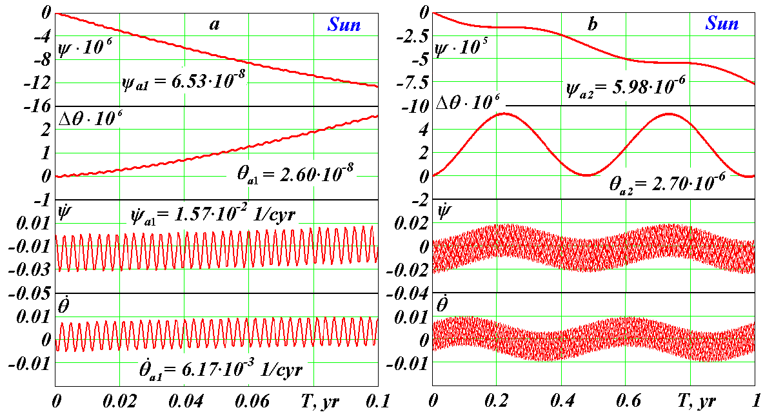
Fig. 3 Action of the Sun on the Earth’s rotation: a – during 0.1 yr; b – during 1 yr. Precession angle $ψ$ and nutation angles difference $Δθ=θ−θ_{0}$ are in radians and rates $\overset{˙}{ψ}$ and $\overset{˙}{θ}$ are in radians per century; T – begins with initial epoch 30.12.1949.

As it is seen from Fig. 3, a initial values of the rates ${\overset{˙}{θ}}_{0}$ and ${\overset{˙}{ψ}}_{0}$ do not exceed their extreme values. Therefore an error in definition ${\overset{˙}{θ}}_{0}$ and ${\overset{˙}{ψ}}_{0}$ causes only change of an initial phase of fluctuations. Hence, in this case dynamics of the rates ${\overset{˙}{θ}}_{0}$ and ${\overset{˙}{ψ}}_{0}$ is not changed at an error of initial conditions described in p. 4. There are similar properties of solutions for the action of other bodies, thus this property will be kept for the action of all bodies. Consequently, the initial conditions in this case calculated according to (43)-(44), may be specified on a phase of observed daily oscillations $\overset{˙}{θ}$ and $\overset{˙}{ψ}$.
As the accepted initial conditions, according to (43)-(44), are artificial, there arises the question. Which values of derivatives ${\overset{˙}{θ}}_{0}$and ${\overset{˙}{ψ}}_{0}$ might be, if a long-time action of a single body on the Earth preceded the beginning of calculation? Apparently, there would be an occurrence of equilibrium and derivatives would come nearer to the mean values. With this purpose there were defined mean values ${\overset{˙}{ψ}}_{\text{01}}$ = 1.61891·10⁻² and ${\overset{˙}{θ}}_{\text{01}}$ = -1.32398·10⁻³ according to the first daily oscillations (see Fig. 3, a). Integrating Eqs. (41)-(42) with initial values ${\overset{˙}{ψ}}_{\text{01}}$ and ${\overset{˙}{θ}}_{\text{01}}$ has resulted in reduction of daily oscillations in 20 times (see Tab. 2). Hereat character of solutions behavior for the long-time actions has not changed.

Table 2
Amplitudes of daily oscillations for the action of the Sun at specification of the steady-state initial rates.
No. | Initial rates |  | Daily amplitudes
No. | $${\overset{˙}{ψ}}_{0}$$ | $${\overset{˙}{θ}}_{0}$$ | $${\overset{˙}{ψ}}_{a}$$ | $${\overset{˙}{θ}}_{a}$$
No. | rad/cyr
1 | -1.20483·10⁻⁶ | -7.09773·10⁻⁸ | 1.55690·10⁻² | 6.17065·10⁻³
2 | -1.61891·10⁻² | 1.32398·10⁻³ | 8.53536·10⁻⁴ | 3.72235·10⁻⁴
3 | -1.59342·10⁻² | 1.08328·10⁻³ | 2.38888·10⁻⁴ | 1.39865·10⁻⁴
4 | -1.59710·10⁻² | 9.90860·10⁻⁴ | 2.48460·10⁻⁵ | 5.10429·10⁻⁵

At averaging derivatives in new solutions there obtained mean values ${\overset{˙}{ψ}}_{\text{02}}$ = 1.59342·10⁻² and ${\overset{˙}{θ}}_{\text{02}}$ = -1.08328·10⁻³, submitted in Tab. 2. Repeated calculation with these initial values has resulted in diminution of amplitudes of oscillations in several times. Thus, there were executed 4 calculations with specification of the mean values of initial rates. Consequently, amplitudes of daily oscillations have decreased in several hundred times, according to Tab. 2.
It is possible to account the final values of derivatives ${\overset{˙}{ψ}}_{0}$ and ${\overset{˙}{θ}}_{0}$ as steady-state for long-time action of a single body on the Earth. For the action on the Earth several bodies there, apparently, will not be such steady-state condition for each body. Therefore further we consider the action of single bodies at initial conditions, according to (43)-(44).
Fig. 3, b shows the Earth’s axis dynamics for 1 yr. The precession angle increases clockwise making oscillations with period T₂ = 0.5 yr and amplitude $ψ_{a2}$= 5.98·10⁻⁶ рад = 1232 mas. The nutation angle oscillates with the same period T₂ and amplitude $θ_{a2}$ = 2.70·10⁻⁶ рад = 556.9 mas around mean value. A minimum of the Earth’s inclination is in the reference epoch (30.12.1949). It is explained by the most deviation of the Sun from the equatorial plane, which makes the most moment of force giving $θ_{\text{min}}$.
Fig. 4, a presents axis dynamics for 10 yr. The precession angle $ψ$ changes practically linearly with semi-annual oscillations marked earlier, and the nutation angle with the period T₂ oscillates about mean value. The rates $\overset{˙}{ψ}$ and $\overset{˙}{θ}$ with the periods T₁ и T₂ change in the same bounds, as on Fig. 3 b. The Earth’s axis dynamics over 100 yr is shown on Fig 4, b. The precession angle $ψ$ changes linearly with mean rate ${\overset{˙}{ψ}}_{\text{mn}}$= 7.74·10⁻³ rad/cyr during 1000 yr. The nutation angle in the form of $Δθ$ changes with daily and semi-annual periods in invariable limits. The rates $\overset{˙}{ψ}$ and $\overset{˙}{θ}$ oscillates also in invariable bounds: $\overset{˙}{ψ}$ around the mean value ${\overset{˙}{ψ}}_{\text{mn}}$, and $\overset{˙}{θ}$ around almost zero value. The parameters behavior over 1000 yr is the same, therefore these results are not submitted here.
Obtained as a result of integration (41)-(42) the mean value of precession rate coincides with the mean value ${\overset{˙}{ψ}}_{0m}$= 7.73·10⁻³ rad/cyr calculated on the approximate dependence (49), (Tab. 1). It is necessary to notice that the instant precession rate (Fig. 3, b) changes in bounds ${\overset{˙}{ψ}}_{\text{min}}$$\overset{˙}{ψ}$${\overset{˙}{ψ}}_{\text{max}}$, where ${\overset{˙}{ψ}}_{\text{max}}$= 0.016 rad/cyr, and ${\overset{˙}{ψ}}_{\text{min}}$= -0.032 rad/cyr, i.e. $\overset{˙}{ψ}$ changes more than in 20 times relative to an average. The rate $\overset{˙}{θ}$ changes in more relative bounds in relation to its mean value ${\overset{˙}{θ}}_{m}≈0$. However, at such considerable changes of the instant rates $\overset{˙}{ψ}$ и $\overset{˙}{θ}$ the mean values remain constants during all integration interval. It testifies stability of the integration method. And as mean values ${\overset{˙}{ψ}}_{\text{mn}}$ correspond with observations, it testifies reliability of the solution of the entire problem.

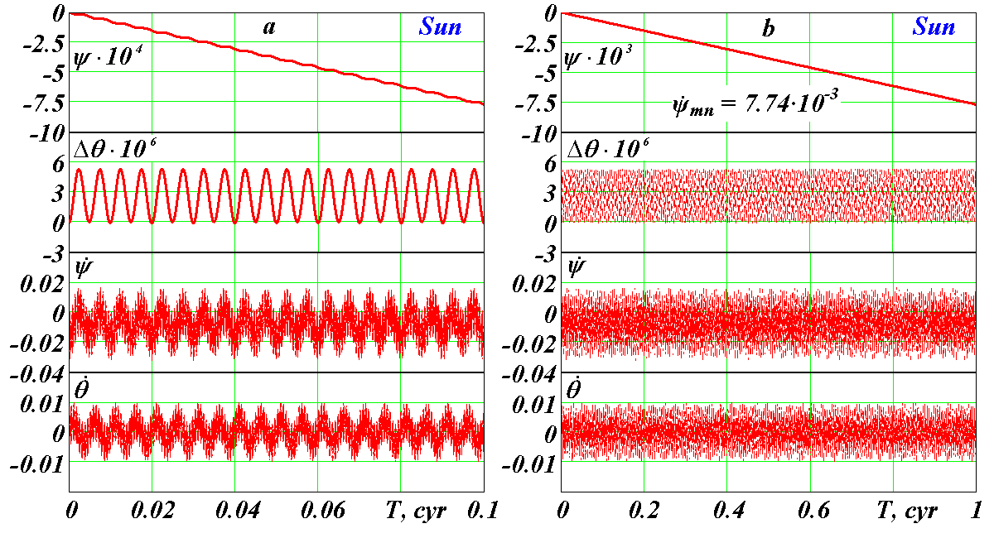
Fig. 4 Action of the Sun on the Earth’s rotation: a – during 10 yr; b – during 100 yr. See captions on Fig. 3

Note, that under consideration of the action of the body B on the Earth (Fig. 1) there was shown that the torque m₀ < 0 and the precession rate $\overset{˙}{ψ}$ < 0. As a result of integration (41)-(42) we have received that precession rate takes positive values also (Fig. 3, b). This result is caused by dynamics: under the action of torque the Earth’s axis speeds up, according to (4), and its motion proceeds even in absence m₀ due to inertia. Therefore |${\overset{˙}{ψ}}_{\text{min}}$| is more than the value given by (4), and ${\overset{˙}{ψ}}_{\text{max}}$> 0.
Here we do not submit graphs of the Earth’s angular velocity dynamics $\overset{˙}{ϕ}$, since, according to (40), the changes of $\overset{˙}{ϕ}$ have contrary sign to the changes of the precession rate $\overset{˙}{ψ}$. This conclusion is proved by results of other authors, for example, [9].
6.2. The Moon’s action
The moon has the strongest action on the Earth’s axis dynamics. Fig. 5, a gives the daily oscillations of the parameters with the period T₁ = 0.99348 d and amplitudes $ψ_{a1}$ = 7.29·10⁻⁸ rad = 15.04 mas, $θ_{a1}$ = 2.83·10⁻⁸ rad = 5.83 mas, ${\overset{˙}{ψ}}_{a1}$ = 1.66·10⁻² rad /cyr and ${\overset{˙}{θ}}_{a1}$ = 6.63·10⁻³ rad /cyr. Against daily oscillations there appear half-monthly oscillations with period T₂ = 13.5143 d, which are well visible on 1 yr interval (see Fig. 5, b). The precession angle has a linear trend and also oscillates with the half-monthly period and amplitude $ψ_{a2}$= 1.16·10⁻⁶ рад = 240.10 mas. For 10 yr interval the parameters behave analogically, therefore these results are not submitted here.
The further changes of parameters we will consider for 100 yr interval (Fig. 5, c). Here there are new oscillations with period T₃ = 18.6 yr. Along with linear the change of precession angle it has oscillations with the period T₃ and the amplitude $ψ_{a3}$= 0.98·10⁻⁴ рад = 20286.33 mas. The nutation angle oscillates with this period at amplitude of fluctuations $θ_{a3}$ = 5.23·10⁻⁵ рад = 10797.80 mas.
As it was told in p. 2, due to the analysis of the theorem of momentum the presence of the oscillations caused by orbital precession of the acting body B (Fig. 1, c) has been established. At integration (41)-(42) with the Moon action to the Earth, we have obtained oscillations with period T₃ = 18.6 yr, which are caused by precession of the Moon orbital axis.
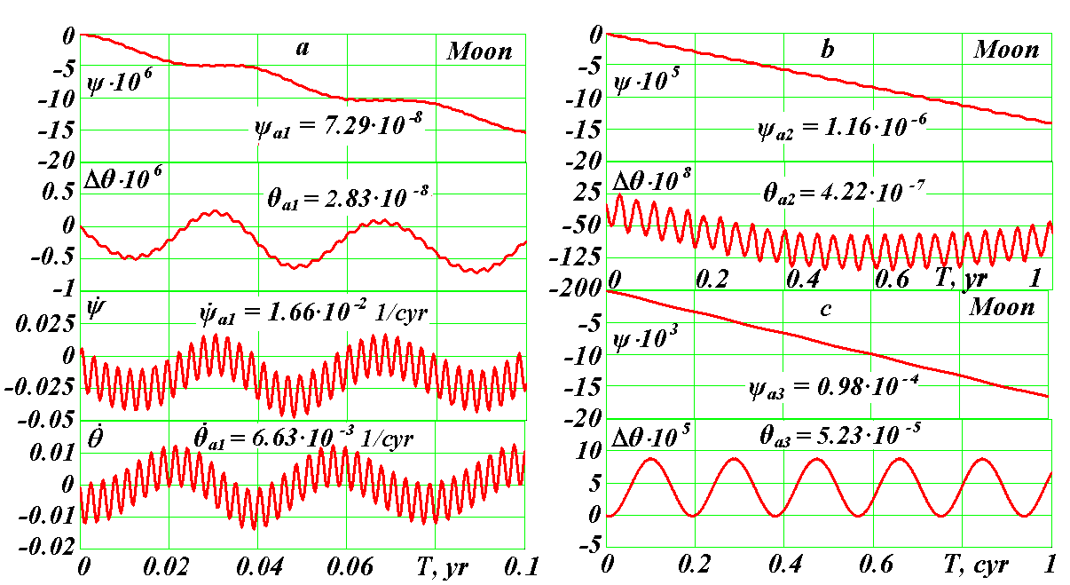
Fig. 5 Action of the Moon on the Earth’s rotation: a – during 0.1 yr; b – during 1 yr; c – during 100 yr. See captions on Fig. 3
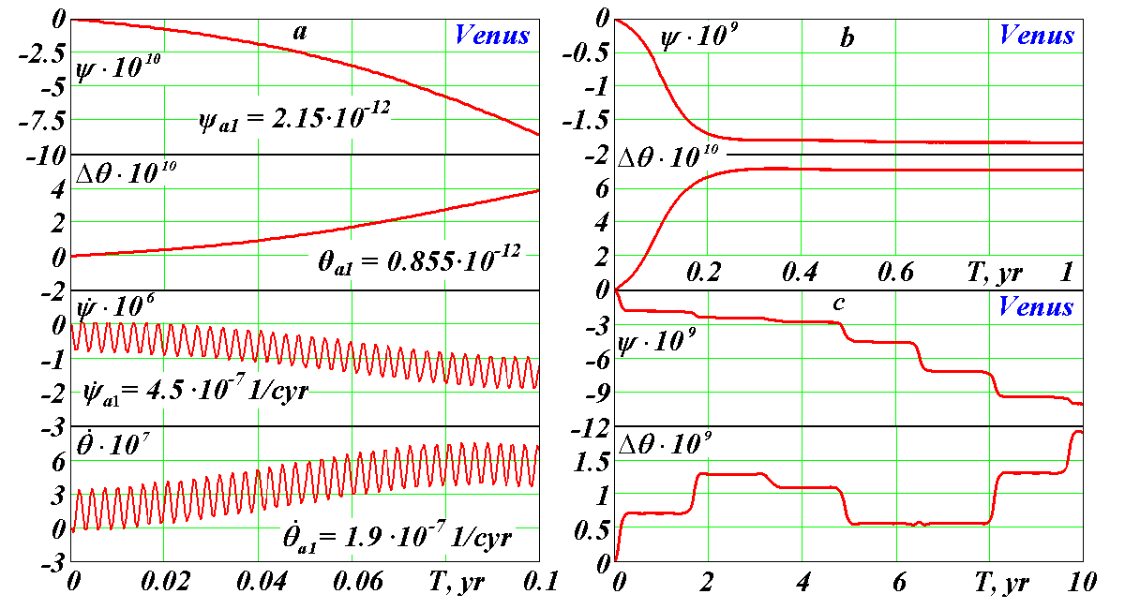
Fig. 6 Action of Venus on the Earth’s rotation: a – during 0.1 yr; b – during 1 yr; c – during 10 yr. See captions on Fig. 3.

For 1000 yr interval the behavior of the precession $ψ$ and the nutation $θ$ angles are similar to Fig. 5, c. Except oscillations with the period T₃ = 18.6 yr others are not present. The mean precession rate is ${\overset{˙}{ψ}}_{\text{mn}}$= 1.70·10⁻² rad/cyr. Oscillations with the period T₃ = 18.6 yr also proceed on 10 kyr interval. The trend of change of the nutation angle $θ$ under the cosine law is tracked.
6.3. Action of Venus and other planets
Eqs. (41)-(42) were integrated separately for the action of all the planets. The Venus makes the most influence on the Earth’s axis. Fig. 6, a shows the Earth’s axis dynamics under the action of the Venus on 0.1 yr interval. The precession and the nutation angles oscillates with daily periods and amplitudes $ψ_{a1}$= 2.15·10⁻¹² рад = 0.443·10⁻³ mas; $θ_{a1}$= 0.855·10⁻¹² рад = 0.176·10⁻³ mas. As we see, the daily amplitudes for the Venus action are in 4 orders less than for the Sun action.
The rates $\overset{˙}{ψ}$ and $\overset{˙}{θ}$ also oscillate with daily period T₁ = 0.99348 d and the amplitudes considerably exceeding a mean values. As amplitudes of daily oscillations shade oscillations with bigger periods, we do not submit $\overset{˙}{ψ}$ and $\overset{˙}{θ}$ diagrams on the subsequent intervals.
Fig. 6, b represents 10 yr dynamics of the precession and nutation. $Δθ$ change shows that the second period of oscillations with duration about 1.6 yr is tracked. These oscillations are expressed by horizontal lines of the change $Δθ$. Their period Т₂ = 1.6 yr is caused by periodicity of approach of Venus with the Earth due to their relative motion. Period of these approaches is $T_{\text{VE}}=T_{E}{T_{V}}/(T_{E}−T_{V})=1\text{.}\text{598}$ yr, whereе T_{E} и T_{V} are sidereal periods of the Earth and Venus. The graph $Δθ$ on Fig. 7, a shows 1 cyr interval where oscillations with the period T₂ = T_{VE} are made against oscillations with the bigger period Т₃ = 8.12 yr and the amplitudes $ψ_{a3}$ = 1.65·10⁻⁹ rad = 0.341 mas and $θ_{a3}$ = 6.16·10⁻¹⁰ rad = 0.127 mas. These oscillations with the period Т₃ are caused by periodicity of approach of Venus with the Earth at the longest distance from the equatorial plane (B₁ and B₃ on Fig. 1, c). Really, after the first approach, for example in the point B₁, following approach will be in Т₂ = 1.6 yr, i.e. will be aside of the point B₂ for 0.1 yr. Therefore 0.5 yr/0.1 yr = 5 approaches, i.e. Т₃ = 5·Т₂ ≈ 8.1 yr so that the last approach will occur again in the point B₁ or B₂ is required.
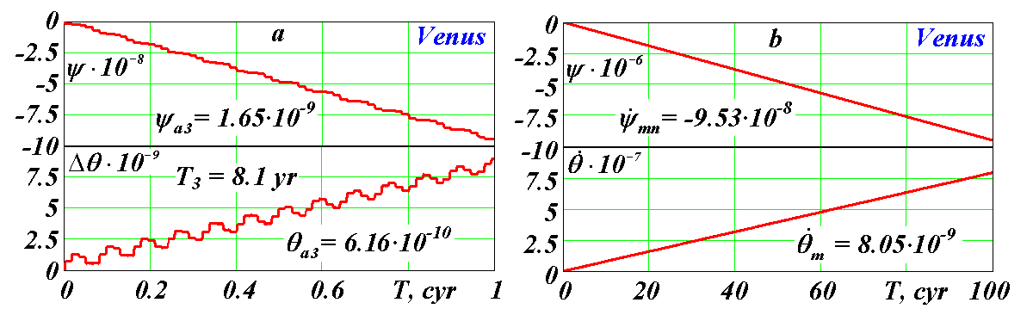
Fig. 7 The Earth’s axis dynamics under the action of Venus: a – during 1 cyr; b – during 10 kyr. See captions on Fig. 3.

Periodicity of approach in points В₁ and В₂ can be given by expression
T_{BC} = 0.5T_{BE}/(T_{BE} – 0.5Int(2T_{BE}) ),
where T_{BE} is the period of approach of the body B with the Earth, and function Int defines an integer part of a number.
Fig. 7, b shows 10 kyr $ψ$ and $θ$ dynamics. The angles change linearly with the mean (for 10 kyr) rates ${\overset{˙}{ψ}}_{\text{mn}}$= -9.53·10⁻⁸ rad/cyr and ${\overset{˙}{θ}}_{m}$= 8.05·10⁻⁹ rad/cyr, and the nutation rate is in 12 times less than the precession rate. Difference of the mean nutation rate from zero on 10 kyr interval is caused by the influence of precession of Venus orbital plane relative to the Earth’s equatorial plane during this time. Apparently, further it will lead to oscillations with a new period.
Graphs of the other planets action on the Earth’s rotational motion look similarly to graphs for the Sun, the Moon and Venus. The most difference proves for the nutation angle. Fig. 8 represents the comparison of influence of the Sun and the planets on the nutation angle. Under the action of the Sun, Mercury (Fig. 8) and Venus (Fig. 7) the nutation angle increases. The action of the other planets leads to its reduction. These changes of the angle $θ$ occur, most likely, via the orbital precession of the acting bodies. In the beginning they change linearly for all the bodies (under the sine law), except for the Sun and the Moon. The semi-annual nutation oscillations for the action of the Sun (Fig. 4) are big enough and shade the trend $θ$. Therefore, Fig. 8 presents the change of sliding average $Δθ$ on 100 next points. From the diagram follows that ${Δθ}_{S}$ changes, apparently, under the cosine law with average rate for 1000 yr ${\overset{˙}{θ}}_{m\text{10}}$ = 3.3·10⁻⁸ rad/cyr.
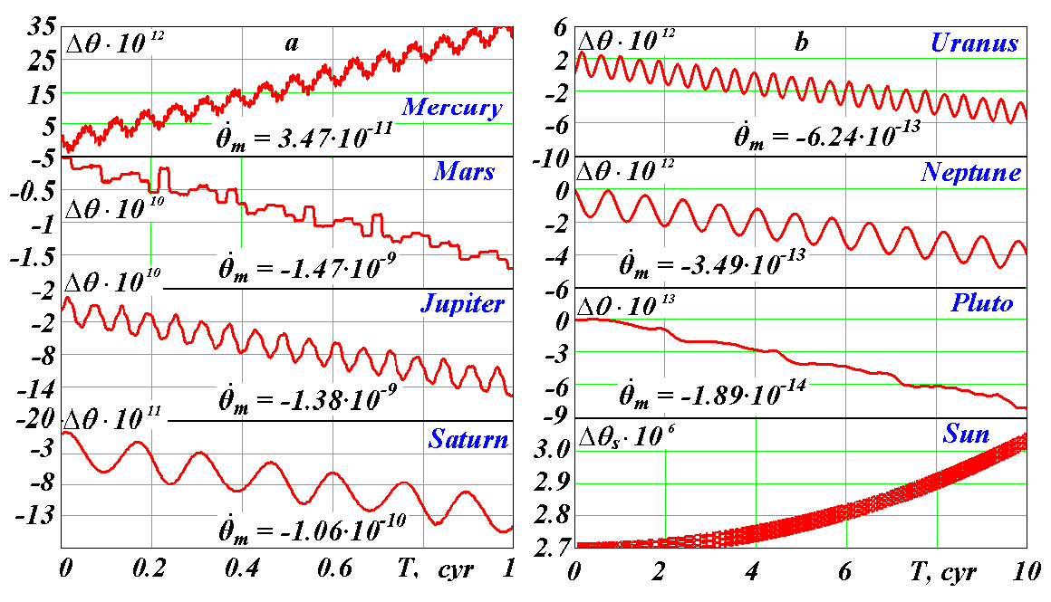
Fig. 8 Nutation oscillations and trends of the Earth’s axis at separate action of the planets and the Sun as difference $Δθ=θ−θ_{0}$ for planets and as sliding average ${Δθ}_{s}$ for the Sun. See captions on Fig. 3

There are traced different kinds of the nutation oscillations. All the bodies have the daily oscillations with the period Т₁. Oscillations with the semi-orbital period Т₂ are brightly expressed for the Sun and external planets, except for Pluto, which has the oscillations $θ$ with the period 2Т₂. For near planets from Mercury to Mars there are oscillations having horizontal maxima with orbital periods Т_{BЕ} of the bodies (B) relative to the Earth (E), for example, 1.6 yr for Venus and 2.14 yr for Mars. Horizontal parts of graphs of the angle $θ$ are caused by long contact of the planet and the Earth during approach. There are brightly expressed oscillations with the period Т₃ = Т_{ВС} = 8.1 yr for Venus, which are caused by approach with the Earth in the points В₁ and В₂. For Mars the doubled periods with Т₃ = 2Т_{ВС.} = 2·7.9 = 1.58 yr are received. The cause of the periods doubling is the result of that the action of the bodies in diametric opposition points relative to the Earth differs due to eccentricity of the orbits and their inclination to the equatorial plane. Therefore the action in one of the points becomes prevailing, thereby the period of oscillations is fixed on it.
The periods and the amplitudes of the Earth’s axis oscillations and the rates of precession ${\overset{˙}{ψ}}_{\text{mn}}$ caused by the action of the Sun, the Moon and the planets are given in Tab. 3. The Moon acts mostly on the amplitudes and the precession rate. Venus renders the most action among the planets.
Having comparing precession rate ${\overset{˙}{ψ}}_{\text{mn}}$ with the mean value ${\overset{˙}{ψ}}_{m}$ calculated under the Eq. (49), it is visible (Tab. 1) that they are close for the Sun, the Moon and the far planets from Jupiter to Neptune. The approximate Eq. (49) gives big errors for the close planets via strong influence on averaging of the planets approach with the Earth. Pluto’s error at averaging arises via the big obliquity of its orbit and big eccentricity.
Tab. 3 gives oscillations of several types. The first, with daily period T₁ = 0.99348 d, is caused by the Earth’s rotational motion. Here the greatest amplitudes have the rates $\overset{˙}{ψ}$ and $\overset{˙}{θ}$. Other kinds of oscillations are caused by periodicity of intersection of the Earth’s equatorial plane by the bodies, periodicity of approaches of the planets with the Earth and periodicity of approaches in points of the greatest removal from the equatorial plane (points B₁ и B₃ on Fig. 1). In these cases the angles $ψ$ and $θ$ reach the greatest amplitudes. At the Moon action the greatest amplitudes of oscillations are caused by precession of its orbital plane.

7. Comparison with works of other researchers
Comparison of the obtained differential equations (41)-(42) with the differential equations of other authors becomes complicated as the majority of authors do not submit these equations in a final kind. With the purpose of their approximate solution the differential equations of the 2nd order are simplified to equations of the first order (the Poisson equations). Additionally, different reference systems, different variables and different designations are used, and no one work known to us has the equations in a final form similar to (41)-(42). P. Bretagnon et al. [9] gives the fullest kind of the differential equations from the latest works. At substitution in the equations of these authors the moment J_{y} = J_{x}, and angular velocity according to (40), terms, caused by the angular momentum, coincide with corresponding terms of our equations (41)-(42). These authors express terms, caused by the torques, by Legendre polynomials, therefore they cannot be compared with our terms.
Our solution (40) for the Earth’s angular velocity $\overset{˙}{ϕ}$ and kinematic terms of Eqs. (41)-(42), taking into account the signs of $ψ$ and $θ$, also coincide with the Eqs. (9.1.04) and kinematic terms of Eqs. (9.1.05) given by G. Duboshin [17], if to consider two typing errors in Eqs. (9.1.05). These typing errors in the subsequent Poisson equations (9.1.06) are eliminated. By comparison of the equations, typing errors in other works are found out. This circumstance is an additional argument in necessity of the work on the derivation of the Earth’s rotational motion equations.
Our derivation of the torques coincides with a traditional derivation [15] up to expression (31) inclusively before the force function U. After that the values r_{i}³ and (z_{i}/r_{i}) are usually represent in series on elements of elliptic motion on the basis of the theory of secular perturbations. So these results also are non-comparable to ours.
As a result it is possible to make the following conclusion. The terms of Eqs. (41)-(42), caused by the angular momentum, coincide with the equations of other researchers. The terms of the equation, caused by the torques, also coincide at identical stages of the derivation. The accepted way of derivation of the equations, the approach to their solution, the initial condition setting and the final kind of (41)-(42) do not repeat the equations, known to us in the literature. Despite originality of these methods for the Earth’s rotational motion equations, they are typical in the mechanic and are traditionally used in its different areas.
In our solutions daily oscillations of the angles of precession $ψ$ and nutation $θ$ are received. P. Bretagnon et al. [9] carried out numerical integration for check of the analytical solutions. Differences between the numerical and analytical results, submitted in their work, have daily oscillations, i.e. numerical solutions of these authors also give daily oscillations. Daily frequencies of oscillations $ψ$ and $θ$ also exist in the observation data presented in the form of series [8].
Tab. 4 gives the comparison of the amplitudes and the periods of the Earth’s axis oscillations of the second and third types received by us (Sm) with the results of Bretagnon et al. [9] analytical solutions (Br). The mean precession and nutation rates, caused by the action of the Sun, the Moon and the planets, are compared here also. The amplitudes of oscillations ${\overset{˙}{ψ}}_{а}$ and ${\overset{˙}{θ}}_{а}$, their period Т for the Sun and the mean precession speed ${\overset{˙}{ψ}}_{\text{mn}}$ coincide well. It is necessary to notice that the rate ${\overset{˙}{θ}}_{m}$, according to Fig. 8, changes nonlinearly, and its almost zero mean value during the initial moment against considerable semi-annual oscillations cannot be defined precisely. Due to this reason it is impossible to obtain the Moon’s rate ${\overset{˙}{θ}}_{m}$.

Table 3
Periods of the Earth’s axis oscillations, their amplitudes and mean nutation rates at separate action of the Sun, the Moon and the planets: 1)* periods and amplitudes caused by approach in equatorial plane; sidereal half-cycles (T_{B}·0.5) of the Earth, the Moon and the planets round the Sun are given after “/”; 2)** period and amplitude caused by precession of orbital plane of the Moon.

Bodies | T₁, d | $$ψ_{a1}$$ | $$θ_{a1}$$ | T₂ (T₃*), yr | $ψ_{a2, a3}$, rad | $θ_{a2, a3}$, rad | ${\overset{˙}{ψ}}_{\text{mn}}$, rad/cyr
Sun | 0.99348 | 6.52987·10⁻⁸ | 2.60203·10⁻⁸ | 0.5/0.5 | 5.97569·10⁻⁶ | 2.69668·10⁻⁶ | -7.73671·10⁻³
Mercury | 0.99348 | 1.03196·10⁻¹⁴ | 3.92567·10⁻¹⁵ | 6.55*/0.12 | 7.48482·10⁻¹² | 2.74472·10⁻¹³ | -1.97555·10⁻⁹
Venus | 0.99348 | 2.15159·10⁻¹² | 8.54552·10⁻¹³ | 8.12*/0.31 | 1.65282·10⁻⁹ | 6.15801·10⁻¹⁰ | -9.52699·10⁻⁸
Mars | 0.99348 | 2.78597·10⁻¹⁵ | 1.33595·10⁻¹⁵ | 15.8*/0.94 | 7.34044·10⁻¹¹ | 2.23168·10⁻¹¹ | -2.42254·10⁻⁹
Jupiter | 0.99348 | 2.32699·10⁻¹³ | 9.30588·10⁻¹⁴ | 5.93/5.93 | 6.69998·10⁻¹⁰ | 2.55712·10⁻¹⁰ | -5.76500·10⁻⁸
Saturn | 0.99348 | 1.01170·10⁻¹⁵ | 4.16323·10⁻¹⁶ | 14.711/14.72 | 8.27493·10⁻¹¹ | 3.21961·10⁻¹¹ | -2.70110·10⁻⁹
Uranium | 0.99348 | 4.65987·10⁻¹⁶ | 1.85499·10⁻¹⁶ | 42.05/42.01 | 3.68679·10⁻¹² | 1.44699·10⁻¹² | -4.74205·10⁻¹¹
Neptune | 0.99348 | 5.34857·10⁻¹⁷ | 2.12967·10⁻¹⁷ | 82.42/82.40 | 2.04549·10⁻¹² | 9.59090·10⁻¹³ | -1.51833·10⁻¹¹
Pluto | 0.99348 | 5.18906·10⁻¹⁹ | 2.06426·10⁻¹⁹ | 248/124 | 1.9394·10⁻¹⁴ | 1.0980·10⁻¹⁶ | -8.19926·10⁻¹⁴
Moon | 0.99348 | 7.28690·10⁻⁸ | 2.28844·10⁻⁸ | 18.6**/3.7·10⁻² | 0.98351·10⁻⁴ | 5.23492·10⁻⁵ | -1.69661·10⁻²
Table 4
Comparison numerically calculated (Sm) the Earth’s axis oscillations and mean rates of its motion with analytical results (Br) P. Bretagnon et al. [9].
Bodies | Oscillations |  |  |  |  |  | Rates  ″/cyr
Bodies | Amplitudes, mas |  |  |  | Periods, yr  T
Bodies | $$ψ_{a}$$ |  | $$θ_{a}$$ |  |  |  | $${\overset{˙}{ψ}}_{\text{mn}}$$ |  | $${\overset{˙}{θ}}_{m}$$
Bodies | Sm | Br | Sm | Br | Sm | Br | Sm | Br | Sm | Br
Sun | 1232.57 | 1276.71 | 556.23 | 552.39 | 0.5 | 0.500 | -1595.811 | -1594.870 | – | 2.923·10⁻⁴
Mercury | 0.00154 | 0.00103 | 0.00057 | 0.00043 | 6.552 | 6.659 | -4.075·10⁻⁴ | -3.698·10⁻⁴ | 7.167·10⁻⁶ | 8.800·10⁻⁶
Venus | 0.34092 | 0.21671 | 0.12701 | 0.09076 | 8.12 | 8.102 | -1.965·10⁻² | -1.815·10⁻² | 1.660·10⁻³ | 1.681·10⁻³
Mars | 0.01514 | 0.01155 | 0.00460 | 0.00095 | 15.8 | 15.78 | -4.997·10⁻⁴ | -5.999·10⁻⁴ | -3.027·10⁻⁵ | -3.570·10⁻⁵
Jupiter | 0.13820 | 0.10441 | 0.05274 | 0.04569 | 5.928 | 5.931 | -1.189·10⁻² | -1.171·10⁻² | -2.844·10⁻⁴ | -2.804·10⁻⁴
Saturn | 0.01707 | 0.01215 | 0.00664 | 0.00516 | 14.71 | 14.73 | -5.571·10⁻⁴ | -5.208·10⁻⁴ | -2.193·10⁻⁵ | -2.200·10⁻⁵
Uranium | 0.00076 | 0.00065 | 0.00030 | 0.00029 | 42.05 | 42.01 | -9.781·10⁻⁶ | -1.000·10⁻⁵ | -1.288·10⁻⁷ | -1.000·10⁻⁷
Neptune | 0.00042 | 0.0004 | 0.00019 | 0.00016 | 82.42 | 82.39 | -3.132·10⁻⁶ | -2.900·10⁻⁶ | -7.196·10⁻⁸ | -1.000·10⁻⁷
Pluto | 4.0·10⁻⁶ | – | 2.3·10⁻⁸ | – | 248 | – | -1.691·10⁻⁸ | – | -3.890·10⁻⁹ | –
Moon | 20286.33 | 17292.17 | 10797.80 | 9227.88 | 18.60 | 18.60 | -3499.51 | -3445.50 | – | 2.544·10⁻²

The periods of oscillations Т of the angles, as we see from Tab. 4, well coincide for all the planets. Amplitudes of oscillations $\overset{˙}{ψ}$ and $\overset{˙}{θ}$ are also well harmonized for the given planets from Jupiter to Neptune. Smaller conformity for the near planets is explained by difficult structure of oscillations $\overset{˙}{ψ}$ and $\overset{˙}{θ}$. In work [9] amplitudes are defined by representation of solutions as harmonious series; their main harmonics are given in Tab. 4. In our work actual amplitudes are defined by a sliding average method. These methods yield different results at difficult structure of oscillations.
The mean rates of change ${\overset{˙}{ψ}}_{m}$ and ${\overset{˙}{θ}}_{m}$ at action of the planets, as we see from Tab. 4, are well correlated. Note, that exact coincidence of our and P. Bretagnon et al. [9] results is impossible, since there are difference in ways of parameters definition and in the initial data also. For example, at identical dynamical ellipticity E_{d} = E_{dS}, our mean rate of precession for the action of the Moon is -3445.90, which practically coincides with P. Bretagnon et al. [9] result (-3445.50), see Tab. 4.
As the solutions of P. Bretagnon et al. [9] are normalized by the observation data, coincidence of our results with results of these authors testifies their confirmation by observation data. The coincidences of our results (given to Tab. 4) testify reliability of the obtained differential equations and their solutions. This coincidence testifies also the correctness of the initial data. The mathematical model of motion of the planets and the Moon, which gives their positions in process of numerical integration of Eqs. (41)-(42), proves to be true also. It is necessary to notice also that in [9] the Earth is considered as non-axisymmetrical, power function is estimated by potential of the surface distribution of gravity and geodetic precession is taken into account. All these additional influences give additives which are in limits of differences of our solutions from P. Bretagnon et al. [9].

8. Conclusions
1. The law of angular momentum change is analyzed and on its basis the differential equations of the Earth’s rotational motion for the gravitational action of the Solar system bodies is derived.
2. The algorithm and the programme of numerical integration of obtained equations are developed.
3. The equations are integrated separately taking into account the action of the Sun, the planets and the Moon on the Earth over 10 kyr and results are analyzed.
3.1. The greatest action on the Earth rotation is from the Moon, then from the Sun, and from Venus among the planets.
3.2. The precession ψ, nutation θ and rotation φ angles change with identical periods controlled by the periodicity at which the bodies cross the Earth’s equatorial plane and approach the Earth, and by the precession of the orbital plane relative to equatorial plane.
3.3. The action of the Moon, the Sun and the planets has caused a clockwise precession of the Earth’s axis at an almost invariable mean rate.
3.4. For this time span, the nutation angle θ has increased under the action from the Sun, the Moon and the inner planets or decreased under the action from the outer planets.
4. The results are confirmed with other reported data and with observations.

Acknowledgements
A.E. Lutsky and A.O. Latsis from the Keldysh Institute of Applied Mathematics (Moscow) assisted in computation on an HVS-1000 supercomputer. Computation was also run on HVS-1000 and NKS-30T supercomputers of SB RAS Computing Center, (Novosibirsk) with the help of A.S. Alekseev, V.P. Kutov, N.V. Kuchin and V.D. Korneev. K.E. Sechenov took part in the study of the Earth’s rotation for the action of the Sun and the planets and K.S. Ivanov took part in the study of the Moon’s action. I express the gratitude to all aforementioned colleagues.
The study was supported by grants from the Governor of Tyumen Region (in 2003 and 2004) and was carried out as part of Integration Programs 13 (2004-2009) of the Presidium of the Russian Academy of Sciences.

References
1. M. Milancovitch, “Mathematische Klimalhre und Astronomische Theorie der Klimaschwankungen,” Gebruder Borntraeger, Berlin, 1930.
2. D. Brouwer and A. J. J. Van Woerkom, “The secular variation of the orbital elements of the principal planets,” Astr. Pap., 13, 1950.

3. Sh. G. Sharaf and N. A. Budnikova, “O vekovykh izmeneniyakh elementov orbity Zemli, vliyayschikh na klimaty geologicheskogo proshlogo (The secular variation of the orbital elements of the Earth as a control of past climates),” Bull. ITA AN SSSR, No. 11, 1967, pp. 231-261.
4. A. Berger and M. F. Loutre, “Insolation values for the climate of the last 10 million years,” Quaternary Science Reviews, No. 10, 1991, pp. 297-317.
5. J. Laskar, F. Joutel, F. Boudin, “Orbital, precessional and insolation quantities for the Earth from -20 Myr to +10 Myr,” Astronomy and Astrophysics, Vol. 270, 1993, pp. 522-533.
6. V. P. Melnikov and J.J. Smulsky, “Astronomical theory of ice ages: New approximations. Solutions and challenges,” Academic Publishing House, Novosibirsk, 2009.

7. P.-S. Laplace, “Précis de l’histore de l’astronomie,” in: Laplace, P.-S., Ocuvres Complétes, Tome VI, Livre V, Gautier – Villars, Paris, 1878-1912, pp. 454-486.

8. P. M. Mathews and P. Bretagnon, “Polar motions equivalent to high frequency nutations for a nonrigid Earth with an elastic mantle,” Astronomy and Astrophysics, Vol. 400, 2003, pp. 1113-1128.

9. P. Bretagnon, P. Rocher, J. L. Simon, “Theory of the rotation of the rigid Earth,” Astronomy and Astrophysics, Vol. 319, 1997, pp. 305-317.
10. T. R. Quinn, S. Tremaine, M. Duncan, “A three million year integration of the Earth's orbit,” Astronomical Journal, Vol. 101, 1991, pp. 2287-2305.

11. P. Bretagnon and J. L. Simon, “Towards the construction of a new precession-nutation theory of nonrigid Earth,” Celest. Mech & Dyn. Astr., Vol. 80, 2001, pp. 177-184.
12. J. J. Smulsky, “The Theory of Interaction,” Publishing house of Novosibirsk University, Novosibirsk, 1999. (In Russian: http://www.ikz.ru/~smulski/TVfulA5_2.pdf).
13. J. J. Smulsky, “The Theory of Interaction,” Publishing house "Cultural Information Bank", Ekaterinburg, Russia 2004 (In English: http://www.ikz.ru/~smulski/TVEnA5_2.pdf).

14. H. Lamb, “Dynamics,” University Press, Cambridge, 1929.

15. W. M. Smart, “Celestial Mechanics,” John Wiley, New York, 1961.
16. S. Newcomb, “The elements of the four inner planets and the fundamental constants of astronomy,” Government printing office, Washington, 1895.

17. G. N. Duboshin (Editor), “Nebesnaya Mekhanica I Astrodinamica (Celestial Mechanics and Astrodynamics),” Nauka, Moskva, 1976.

18. F. Roosbeek and V. Dehant, “RDAN97: an analytical development of rigid nutation series using the torque approach,” Celest. Mech & Dyn. Astr., Vol. 70, 1998, pp. 215-253.

19. J. L. Simon, P. Bretagnon, J. Chapront, M. Chapront-Touzé, G. Francou, J. Laskar “Numerical expressions for precession formulae and mean elements for the Moon and planets,” Astronomy and Astrophysics, Vol. 282, 1994, pp. 663-683.
20. J. J. Smulsky, “Osesimmetrichnaya zadacha vzaimideistviya N-tel (The axisymmetrical problem of gravitational interaction of N bodies),” Matematicheskoe Modelirovanie, Vol. 15, No. 5, 2003 pp. 27-36. (In Russian http://www.smul1.newmail.ru/Russian1/IntSunSyst/Osvnb4.doc).
21. J.J. Smulsky, “Matematicheskaya model solnechnoi sistemy (A Mathematical model of the Solar System)” In: V. A. Bereznev, (Ed.), “Teoreticheskie i pricladnye zadachi nelineinogo analiza”. Vychislitelny centr imeni Dorodnitsyna, Moskva, 2007, pp. 119-139. (In Russian http://www.ikz.ru/~smulski/Papers/MatMdSS5.pdf).

