Some Astronomical Problems of the Cryosphere Evolution

I.I. Smulskiy
Institute of the Earth Cryosphere of SB RAS, Tyumen

Abstract
We examined the issues connected with the Astronomical theory of glacial periods from the perspective of celestial mechanics. Former researchers obtained unstable motions, when integrating simplified equations of motion for long periods of time. For this reason, they concluded that it is impossible to estimate the Earth's insolation for the periods covering more than 20 million years. In the given research we solve an unsimplified problem of the orbital motion employing a numerical method. At the same time, the equations were integrated for the period of 100 million years. We obtained all oscillation periods and oscillation amplitudes of the planets' orbits as well as of the Moon's orbit and established their stability. Differential equations of rotational motion are also solved with the help of the numerical method without simplification. We determined the results of the impact exerted separately by planets and by the Sun on the Earth's axis. The evolution of the Earth's axis was also examined on the basis of the compound model of the Earth's rotation. We obtained the periods of its oscillations that coincide with the observed ones. The research revealed that only the solution for unsimplified equations of the Earth's rotation will make it possible to reliably calculate the evolution of the insolation and to determine all the periods of its change.

Keywords: calculations; eccentricity; equations; inclination; insolation; perihelion.

Introduction
When studying the issue of climate warming (that occurred in the second half of the 20th century) and developing its models (Climate change 2007), researchers also consider the Astronomical theory of glacial periods that was produced by M. Milankovich (1939). The indeterminacies of the climate warming models depend to some degree on the indeterminacies of this theory. A number of researchers (e.g. Bolshakov and Kapitsa 2001) think that since the time of M. Milankovich there accumulated paleoclimatic data indicating the necessity for further development of the theory. The given research examines the results of the specification of the Astronomical theory of paleoclimate from the perspective of celestial mechanics or astronomy.

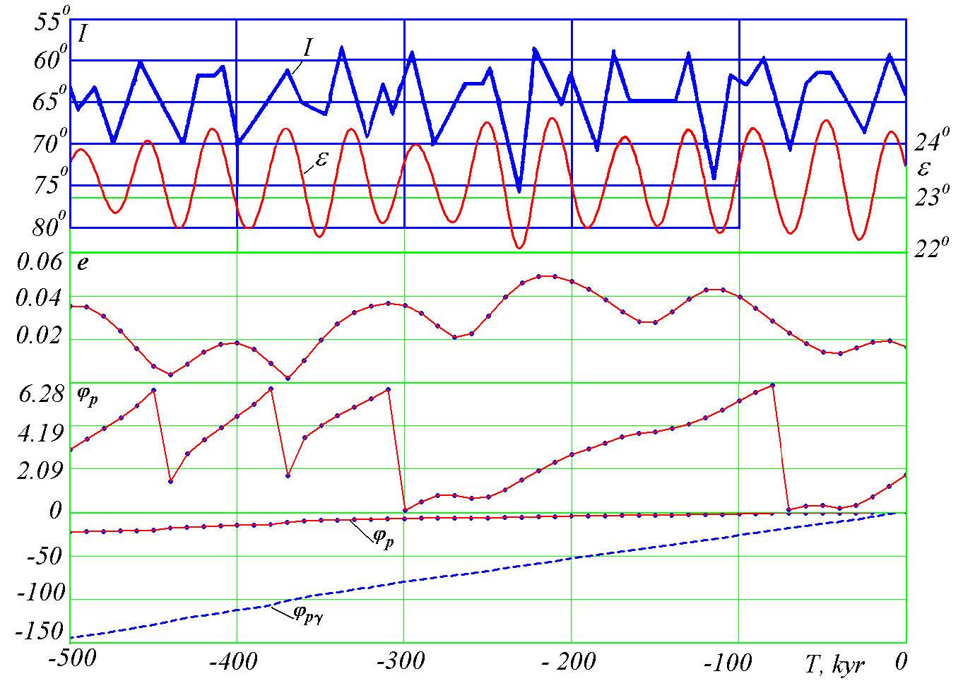
Figure 1. The comparison between the insolation and the parameters of the Earth's orbit: I - insolation at equivalent latitudes at the latitude of 65° of the Northern Hemisphere according to the data of Sharaf and Budnikova (1969) and the angle of inclination of the Earth's orbit to the moving plane of the Equator (ε) according toBerger and Loutre (1991); eccentricitye and the angles (in radians) of the perihelion's position from the fixed φ_{p} and from the moving φ_{pγ} ascending node γ – according to our estimates (Melnikov & Smulskiy 2009). T – the time in kyr (one thousand years) that is counted in thousands of years into the past from the modern epoch (12.30.1949)

The dependence of insolation on the orbital and rotational motions of the Earth
According to the astronomical theory (Milankovich 1939), the insolation of the Earth's surface is determined by the eccentricity of the Earth's orbite and by two parameters of the orbit: by the angle of the perihelion position φ_{pγ} from the moving ascending angle γ and by the angle of the orbit's inclinationε to the moving Equator. The typical change in the insolation I for the past 500 thousand years is presented in Figure 1. The Figure also shows the evolution of the following parameters: the angle of the inclination ε of the moving Earth's equator to the moving plane of the Earth's orbit, the eccentricity e and the perihelion angle ϕ_{p}. The perihelion angle ϕ_{p} is shown in the form of cycles from 0 to π and in the continuous form. Figure 1 shows that the insolation I changed in the Northern Hemisphere for the past 500 thousand years in an oscillating way: the maximums indicate possible warmings, while the deep minimums indicate possible glaciations when T = -120 kyr and T = -230 kyr. For example, the maximum of the last warming occurred 10 thousand years ago (when T = -10 kyr). It coincides with the time when the ice sheet disappeared in Eurasia and in North America.
As Figure 1 shows, the period of the change in the inclination angle ε (equaling Tε = 41.1 thousand years) represents the main oscillation period of the insolation I. The period of the change in the eccentricity e ( equaling T_{e1} = 95 thousand years) represents the second significant period of the insolation change. The perihelion angle ϕ_{p} changes irregularly. The perihelion of the Earth's orbit rotates in the direction of the Earth's orbital motion with the average period T_{p} = 147 thousand years relative to the motionless space. The plane of the Earth's equator precesses in the direction opposite to the orbital motion of the Earth with the period T_{pr} = 25.7 thousand years. Therefore, the circulation period of the perihelion (the angle ϕ_{p}γ) relative to the moving plane of the equator makes up on average T_{p}γ = 21.9 thousand years. This is the minimum oscillation period of the insolation I that is presented in Figure 1.

The disadvantages of the previous theories and the research program
Thus, the evolution of the Earth's insolation is determined by the changes of the Earth's orbit and by the changes of the Earth's rotation axis. Since the time of I. Newton the orbital problem was simplified and reduced to the interaction of two bodies: the Sun and a planet or a planet and a satellite. The rest of the bodies were regarded as the factors of minor disturbances and their impact was divided into series. Thus, the problem was solved with approximate analytical methods. This approach was also used in the 20th century but the accuracy in the representation of solutions with series was constantly improved. For instance, these series presently contain a few hundred members.
The differential equations of rotational motion were simplified more radically: the second derivatives and the products of the first derivatives were disregarded in them. Researchers considered only the impact of the Moon and the Sun on the rotational motion of the Earth, while their motion was described approximately. Thus, the analytical expressions were obtained for the precession of the Earth's equator. They did not contain short-period fluctuations of parameters of the Earth's rotational motion. The precession speed of the Earth's axis was basically determined by the observed speed of the precession, i.e. its evolution remained unknown. At the same time, the only obtained oscillation period of the Earth's axis covering 41.1 thousand years could not be confirmed in any other way.
The approximate nature of the solution to the orbital and rotational problems led to the fact that the results began to diverge when these problems were solved for longer periods of time. For this reason, a number of authors (e.g. J. Laskar et al. 2004) concluded that the Solar System is unstable and that it is impossible to determine the Earth's insolation for the period of time covering more than 20 million years.
In this connection, there arises a necessity to solve these two problems with minimum simplifications, which can be done with the help of the modern numerical methods and supercomputers. At first, we must solve the first problem connected with the evolution of the orbital motion the results of which will render it possible to solve the second problem of the evolution of the Earth's axis. The solution for the two problems will allow us to estimate the evolution of the Earth's insolation. Further, when comparing the insolation changes with the evolution of natural processes, we will be able to establish the dependences making it possible to predict the development of cryosphere processes on the Earth.

The solution for the orbital problem
The orbital motion equations represent the system 3n of non-linear differential equations (Smulskiy 1999)
$\frac{d^{2}{\vec{r}}_{i}}{{\text{dt}}^{2}}=−G\sum_{k≠i}^{n}{\frac{m_{k}{\vec{r}}_{\text{ik}}}{r_{{\text{ik}}^{3}}},}$ i = 1,2,…,n, (1)
where ${\vec{r}}_{i}$ – the radius vector relative to the center of masses of the Solar System; G – the gravitational constant;
${\vec{r}}_{\text{ik}}$– the radius vector from the body with the mass m_{k} to the body with the mass m_{i}; п = 11 (nine planets, the Sun and the Moon).
To solve equation (1), we developed a new method of numerical integration (Smulskiy 1999) that allowed us to solve them for the period covering 100 million years (Melnikov & Smulskiy 2009). Figure 2 shows the evolution of the Earth's orbit parameters for the period of 3 million years into the past.
The eccentricity e undergoes short-period changes with the main period Т_{е1} = 95 kyr (thousand years) around the average value е_{m} = 0.028. Besides, one observes longer oscillations with the periods Т_{е2} = 413 kyr and Т_{е3} = 2.31 Myr that lead to the extreme values of the eccentricity е = 0.0003 and е = 0.065. Figure 3 illustrates the change of the moving average values of the eccentricity e_{s} within the interval 2·T_{el}. Besides, we can see the eccentricity oscillations with the longest period T_{e3}.
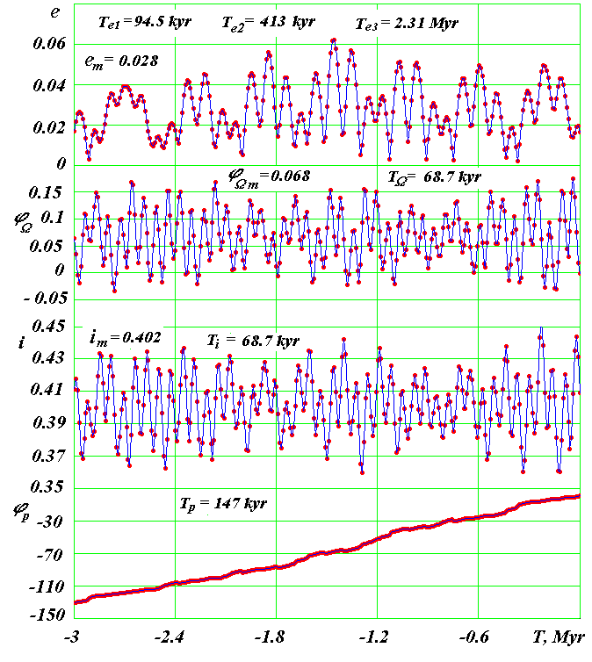
Figure 2. The evolution of the Earth's orbit for the period of 3 million years into the past: е - the eccentricity; φ_{Ω} - the angular position of the ascending node of the orbital plane; i - the angle of the orbital plane's inclination to the motionless equatorial plane; φ_{р} - the angular position of the perihelion; Т – the time in million years from 1950. The angles are in radians.

When solving the orbital problem, we consider the angles of the orbit position relative to the motionless equatorial plane. The longitude of the ascending node φ_{Ω} of the orbit and the angle of its inclination i undergo the oscillations with the period Т_{S} = 68.7 thousand years around the average value і_{m} = 0.402 radian. The range of oscillations makes up 5.64º. We established that the changes depend on the rotation of the orbit axis $\vec{S}$ with the period Т_{S} = 68.7 kyr around the motionless moment vector $\vec{M}$ of the entire Solar System in the direction opposite to that of the planet rotation around the Sun. This rotation or precession of the orbit axis $\vec{S}$ is shown in Figure 3 as the change of the precession angle ψ_{s}. Apart from the precession motion, the orbit axis $\vec{S}$ undergoes the nutational oscillations of the angle of inclination θ_{S} to vector $\vec{M}$. The maximum deviation of axis $\vec{S}$ from moment $\vec{M}$ makes up θ_{Smax} = 2.94º. The main period of nutational oscillations Тθ₁ = 97.35 thousand years. The graph shows the moving average values of nutation angle θ_{Ss} that were averaged out within the interval 2·Тθ₁. In Figure 3 we can see the second period of nutational oscillations Тθ₂ = 1.164 million years.
The orbit perihelion (see φ_{p} in Fig. 2) moves in the direction of the Earth's rotation around the Sun, making on average one rotation for T_{p} = 147 kyr. Meanwhile, the perihelion angle φ_{р} nonmonotonically increases with time and, along with the perihelion rotation in a counter-clockwise direction, we observe the reverse motion in a clockwise direction. As it was already noted above, the periods of a full rotation of the perihelion change by several times.
It was established that the evolution of the planets' orbits as well as of the Moon's orbit takes place as a result of four motions: 1) the rotation or, in other words, the precession of the orbit axis; 2) the nutational oscillations of the orbit axis; 3) the oscillations of the orbit eccentricity; 4) rotations of the orbit within its own plane (the perihelion rotation). The research revealed that the axes of the Earth's orbit, the planets' orbits and of the Moon's orbit as well as the rotation axis of the Earth behave in an identical way. At the same time, unlike the axes of planetary orbits that rotate around the fixed vector of the angular momentum of the Solar System $\vec{M}$, the axis of the Moon's orbit as well as the rotation axis of the Earth precess around the moving axis of the Earth's orbit.
The pericenters of the planets and of the Moon rotate in the direction of orbital motion except for Pluto the perihelion of which rotates in the reverse direction.
In Figure 3 the change of the Earth's orbit parameters has a similar view within the interval of -50 Myr ≥ T ≥ -100 Myr, i.e. the orbit parameters oscillate under the invariable regime. We carried out the same investigations on all planets and obtained the invariable regimes of the oscillations of their orbit parameters. Thus, the evolution of the planets' orbits within the investigated interval of 100 million years is invariable and stable. In the works of the authors (Laskar et al 2004) the chaotic solutions to the simplified equations of motion are explained by the presence of resonances and instabilities that do not occur during the integration of the unsimplified equations of the planets' orbital motion.
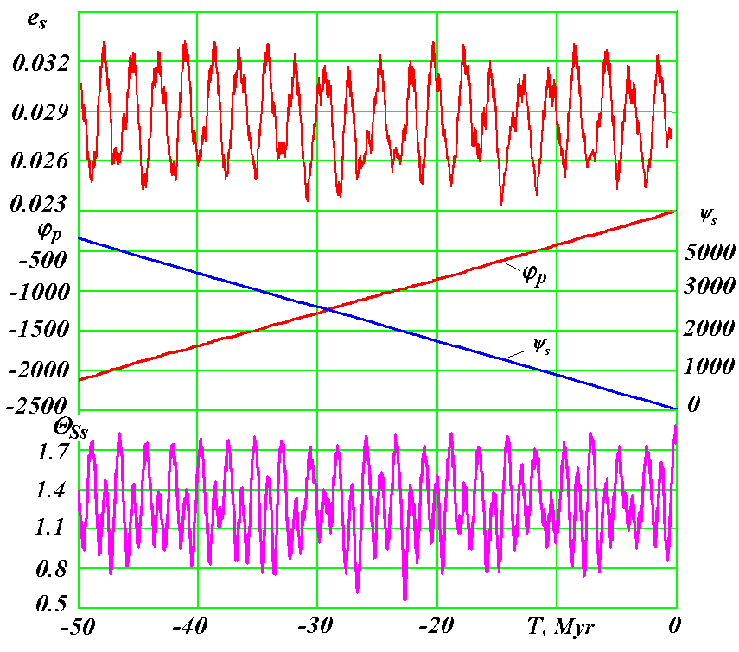
Figure 3. The evolution of the Earth's orbit parameters for the period of -50 million years into the past: e_{s} – the moving average values of the eccentricity; φ_{p} – the perihelion angle; ψ_{s} – the precession angle; θ_{Ss} – the moving average values of the nutation angle of the orbit axis. The angles ϕ_{р} and ψ_{s} are in radians, θ_{Ss} – in degrees. Myr – one million years.

The research into the rotational motion
We investigate the rotational motion simultaneously by two methods. Utilizing the first method, we integrate differential equations of the rotational motion, while in the second method we model the rotational motion of the Earth with a set of material points.
We newly developed the differential equations of rotational motion (Smulskiy 2011) based on the theorem of change of angular momentum. Having analyzed the consequences of this theorem, we established that the rotation axis of the Earth will undergo precessional and nutational oscillations with the following periods: 1) with periods equal to half-periods of the planets, of the Sun and of the Moon relative to the moving rotation axis of the Earth; 2) with periods equal to the intervals of the nearest planets' convergence with the Earth in the most remote points from the the Earth's equator; 3) with the periods equal to the periods of the passage of impacting bodies at these points at the moments of greatest inclination of the body's orbital plane to the equatorial plane. These periods will have the length from several tens of thousand years to several hundreds of thousand years.
When solving the problem of the Earth's rotation, we consider the angle of inclination θ to the orbit axis (the nutation angle) and the angle of precession ψ relative to the motionless plane of the Earth's orbit. The differential equations of the Earth's rotation were obtained in the following form:

(2) $\overset{¨}{ψ}=−2\overset{˙}{ψ}\overset{˙}{θ}\frac{\text{cos}θ}{\text{sin}θ}+\overset{˙}{θ}\frac{J_{z}ω_{E}}{J_{x}\text{sin}θ}−\sum_{i=1}^{n}{2G_{\text{mi}}}\left\{0\text{.}5\text{sin}(2ψ)(x_{{1i}^{2}}−y_{{1i}^{2}})−\right.x_{1i}y_{1i}⋅\text{cos}(2ψ)+\left.z_{1i}\frac{\text{cos}θ}{\text{sin}θ}(x_{1i}\text{cos}ψ+y_{1i}\text{sin}ψ)\right\};$$\overset{¨}{θ}=0\text{.}5{\overset{˙}{ψ}}^{2}\text{sin}(2θ)−\frac{J_{z}ω_{E}\overset{˙}{ψ}\text{sin}θ}{J_{x}}−\sum_{i=1}^{n}{G_{\text{mi}}}\left\{\text{sin}(2θ)[x_{{1i}^{2}}{\text{sin}}^{2}ψ+\right.y_{{1i}^{2}}{\text{cos}}^{2}ψ−z_{{1i}^{2}}−x_{1i}y_{1i}\text{sin}(2ψ)]+2z_{1i}(x_{1i}\text{sin}ψ−\left.y_{1i}\text{cos}ψ)\text{cos}(2θ)\right\},$ (3)
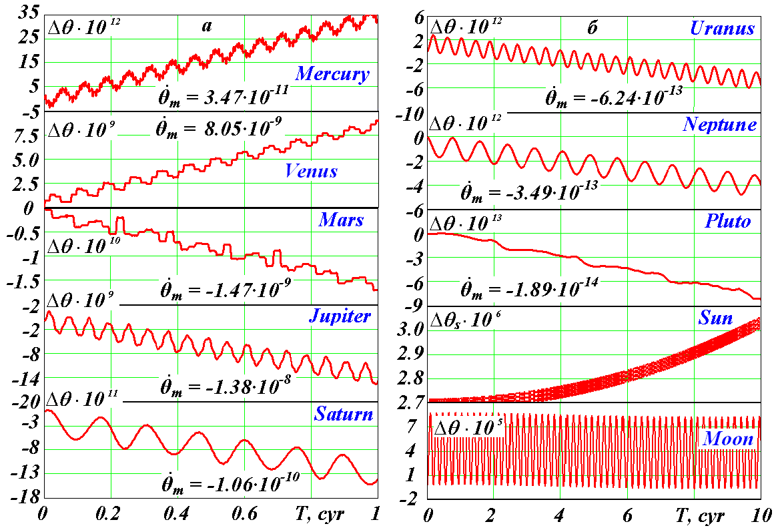
Figure 4. The nutational oscillations and the trends of the Earth's axis under the separate impact of each planet: а – within the interval of 100 years = 1 cyr, b – within the interval of 1000 years; $Δθ=θ−θ_{0}$ – the difference of the nutation angles where θ₀ – the nutation angle in the initial epoch; ${\overset{˙}{θ}}_{m}$ – the average speed of nutation in radians per century; the graphs show the periods of main oscillations of the Earth's axis that equal (from Mercury to the Moon, respectively): 6.6, 8.1, 15.8, 5.9, 14.7, 42, 82.4, 248, 0.5, 18.6 years. The angles are in radians.

$\overset{˙}{ϕ}=ω_{E}−\overset{˙}{ψ}⋅\text{cos}θ$, (4)
where J_{x}, J_{y} and J_{z} – the moments of the Earth's inertia at the axis of the rotating coordinate system xyz;
$E_{d}=(J_{z}−J_{x})/{J_{z}}$ - dynamic ellipticity of the Earth;
$G_{\text{mi}}=\frac{3{\text{Gm}}_{i}⋅E_{d}J_{z}}{2r_{i^{5}}J_{x}}$ – the set of parameters;
$ω_{E}$= const – the projection of the absolute speed of the Earth's rotation on its axis z;
$\overset{˙}{ϕ}$ – the relative speed of the Earth's rotation;
n – the number of bodies affecting the Earth;
m_{i} and x_{1i}, y_{1i}, z_{1i} – the mass and the coordinates of affecting body i.
The aforementioned conclusions drawn from the theorem of oscillation periods were confirmed during the integration of equations of the rotational motion (2)-(4) under the impact exerted by the planets, by the Moon and by the Sun on the Earth separately (see Fig. 4). As the graphs show, the nutation angle θ increases under the influence exerted by the Sun, by Mercury and by Venus, while the influence of other planets decreases it. The graphs show the average speeds ${\overset{˙}{θ}}_{m}$ of the change of the nutation angle θ. The speeds depend on the motion of the orbits' planes of the affecting bodies.
Different types of nutational oscillations can be observed. Most of the bodies create oscillations θ with the half-period of their orbital motion. The maximum oscillations of the nearest planets depend on the period of their convergence with the Earth at the most remote point from the equator. For instance, the periods (see Fig. 4) of 5.9, 14.7, 42, 82.4 and 0.5 years are equal to the half-periods of rotation of the planets and of the Sun; the periods of 6.6, 8.1 и 15.8 years are equal to the periods of the planets' convergence with the Earth at the most remote points from the equator; the period of 18.6 years is equal to the oscillation period of the Moon's orbit plane relative to the equatorial plane.
The rotational motion of the Earth is mostly influenced: firstly, by the Moon, then by the Sun and by Venus. The main oscillations' periods of the Earth's axis presented in Figure 4 are not considered in the Astronomical theory of the cryosphere evolution. Our further research is linked with the completion of our approach aimed at the integration of the equations of rotational motion under the joint impact exerted by all planets on the Earth for long periods of time.
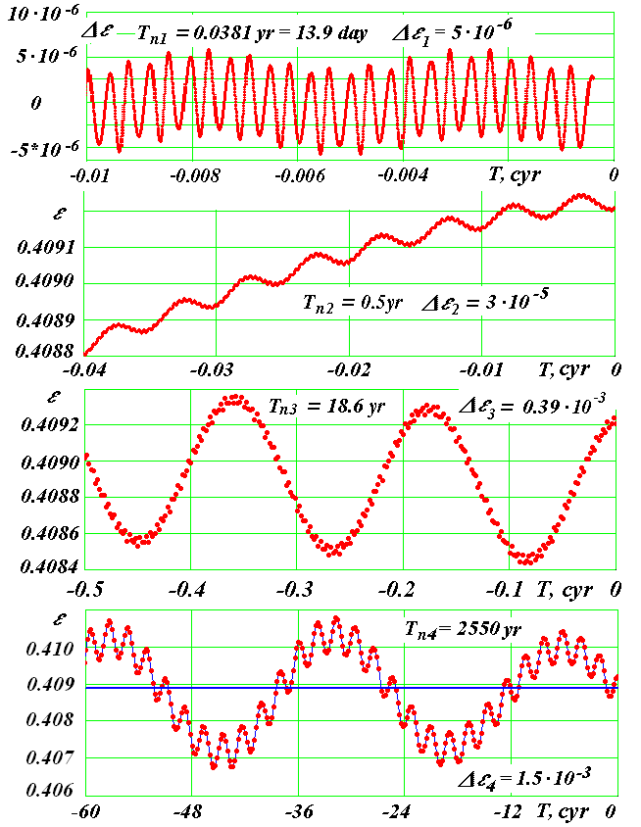
Figure 5. The nutational oscillations of the rotation axis of the compound Earth model No. 3 within different time intervals : Δε – the deviation of the nutation angle from the moving average angle; Δε₁, Δε₂, Δε₃, and Δε₄ – oscillations' amplitudes, 1 cyr =100 years. The angles are in radians.

The compound model of the rotational motion of the Earth
The rotational motion is modeled with a set of bodies that are axisymmetrically located in the equatorial plane around the central body. This system evolves under the influence of gravitational attraction of the Moon, planets and of the Sun. Meanwhile, the orbit axis of a peripheral body imitates the evolution of the Earth's rotation axis. Several models with different parameters were investigated. Figure 5 shows the nutational oscillations of the rotation axis obtained for Model 3. We examine the angle ε of the Earth's axis position relative to the moving axis of its orbit. The orbit axis of the peripheral body precesses relative to the moving axis of the Earth's orbit in all the models. This result is conceptually important. It makes it possible to control the accuracy of integration of the differential equations of rotational motion within long time intervals.
We obtained the following oscillation periods of the Earth's axis (see Fig. 5): half-monthly periods (13.9 days), semiannual periods (0.5 years), 18.6 years (dependent on the precession of the Moon's orbit) and 2580 years. The first three years follow from the theorem of angular momentum and are confirmed with the observation data. The compound models do not have the oscillation period of 41.1 thousand years. The further solutions for the problem of rotational motion will allow us to clarify the issue of this period and to determine other long periods.

Conclusions
We focused our attention on the issues of the astronomical theory of the cryosphere evolution that are connected with the accuracy of solution for the orbital and rotational problems. These are the most challenging problems that still have a number of unsolved questions. Unlike our predecessors, we solve equations numerically instead of simplifying them. For this reason, we will possibly manage to shed light on the part of the unsolved problems. For example, now we can say with certainty that the Solar System is stable. Many peculiarities of orbital motion were established. Solving the problem of the Earth's rotation by two methods, we obtained the concepts of its evolution that supplement each other. We hope that this approach will make it possible to make the points of the astronomical theory of the cryosphere evolution more accurate.
Acknowledgments
At different stages, the following researchers took part in the research work: L.I. Smulskiy, Ya.I. Smulskiy, O.I. Krotov, K.E. Sechenov, A.A. Pavlova, I.A. Shabolina, M.L. Panova, E.F. Safina and others. The main calculations were made with the help of supercomputers of the Siberian Supercomputer Center of SB RAS (Novosibirsk) and of M.V. Keldysh Institute for Applied Mathematics. The present research was carried out with the support of the grants of the Governor of Tyumen Region and the integration program of the Presidium of RAS No. 13.

References
Berger A. & Loutre M. F. 1991. Insolation values for the climate of the last 10 million years. Quaternary Science Reviews 10: 297 - 317
Bolshakov, V.A. & Kapitsa, A.P. 2011 . Lessons of the Development of the Orbital Theory of Paleoclimate. Vestnik Rossiyskoy Akademii Nauk 81, No. 7 : 603-612. (In Russian)
Laskar J., Robutel P., Joutel F., Gastineau M., Correia A. C. M., and Levrard B. 2004. A Long-term numerical solution for the Earth. Icarus 170. 108, Iss. 2: 343-364.
Melnikov, V.P. & Smulskiy, I.I. 2009. Astronomical theory of ice ages: New appendixes. The solved and unsolved problems. - Novosibirsk: Akademicheskoe izd-vo GEO, 192 pp. The book in two languages. On the back cover of the book: Melnikov V.P. & Smulsky J.J. Astronomical theory of ice ages: New approximations. Solutions and challenges. http://www.ikz.ru/~smulski/Papers/AsThAnR.pdf.
Milankovich, M. 1939. Mathematical Climatology and the Astronomical Theory of Climate Change. - M.-L. - GONTI, 207 pp. (in Russian)
Sharaf, Sh.G. & Budnikova, N.A. 1969. Secular changes in the orbital elements of Earth and the astronomical theory of climate change. Tr. Inst. teoretich. Astronomii. Issue XIV. - L: Nauka. 48 - 109 (In Russian)
Smulskiy, I.I . 1999. The theory of interaction. - Novosibirsk: Iz-vo Novosibirskogo un-ta, NNTS OIGGM SO RAN. 294 pp. (in Russian) http://www.ikz.ru/~smulski/TVfulA5_2.pdf.

Smulsky, J.J. 2011. The Influence of the Planets, Sun and Moon on the Evolution of the Earth’s Axis. International Journal of Astronomy and Astrophysics. 1: 117-134.
The climate change, 2007: The Physical Science Basis. Contribution of Working Group I to the Fourth Assessment Report of MGEIK. Iz-vo kembridzhskogo un-ta, 163 pp.

