New Components of Mercury’s Perihelion Precession
J. J. Smulsky
Institute of Earth’s Cryosphere of Siberian Branch of Russian Academy of Sciences
PO Box 1230, 625000, Tyumen, RUSSIA
e-mail: Jsmulsky@mail.ru

The velocity of perihelion rotation of Mercury's orbit relatively motionless space is computed. It is proven that it coincide with that calculated by the Newtonian interaction of the planets and of the compound model of the Sun’s rotation.

- Introduction
A number of phenomena are known to science the understanding of which is crucial, but for decades and some for centuries they have not received a final explanation. One such phenomenon is the precession of the perihelion of Mercury's orbit. Wikipedia [1] posted an article "Tests of general relativity" of evidence confirming the General Relativity (GR) by the observations. In particular, Table 1 gives the confirmation of General Relativity in the perihelion of Mercury. The data in Table 1 are well known in theoretical physics. However, sadly unknown to theoretical physicists, several lines of this table are incorrect. Therefore, we consider the rotation of the perihelion of Mercury in detail.
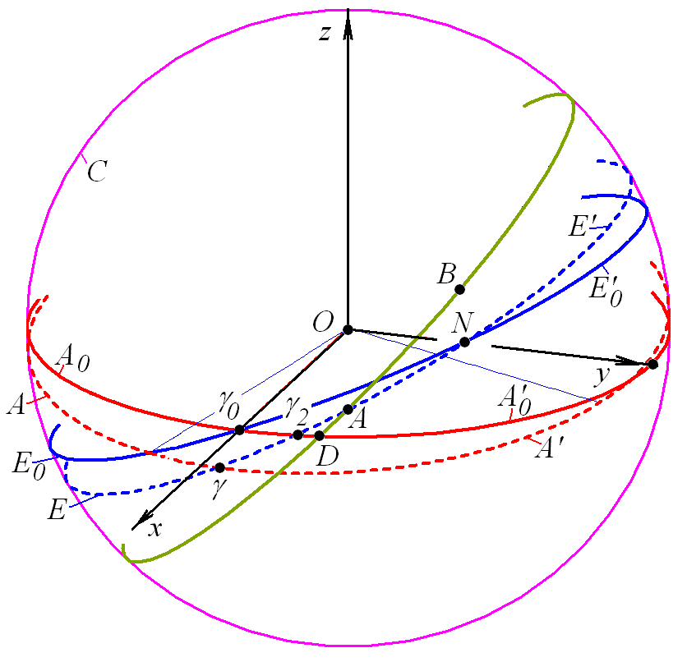
Fig. 1. The basic planes on celestial sphere C: A₀A₀' - a motionless plane of the Earth’s equator for epoch Т_{S}; E₀E₀' - a motionless plane of the Earth’s orbit for epoch Т_{S} (a plane of motionless ecliptic); AA' - a mobile plane of the Earth’s equator in epoch Т; EE' - a mobile plane of the Earth’s orbit in epoch Т (the inclination for presentation is increased); γ₀ - vernal equinox point of epoch Т_{S}; γ - a point on a line of crossing of the mobile equator in epoch Т with a mobile ecliptic (vernal equinox point in epoch Т); DAB - a plane of the Mercury’s orbit in epoch Т.

Amount (arcsec /Julian century) | Cause
5028.83 ±0.04 | Coordinate (due to the precession of the equinoxes)
530 | Gravitational tugs of the other planets
0.0254 | Oblateness of the Sun (quadrupole moment)
42.98 ±0.04 | General relativity
5603.24 | Total
5599.7 | Observed
-3.54 (-0.0632%) | Discrepancy
Table 1. Sources of the precession of perihelion for Mercury according to the encyclopedia Wikipedia [1].
- Observed Motion of the Vernal Equinox
The rotation of the Mercury perihelion can be determined as a result of the analysis of changes of several parameters of the planets’ orbits. For this purpose we shall consider, what changes of the planets’ orbits occur and from which points the readout of key angles is carried out. On Figure 1 in the heliocentric equatorial system of coordinates xyz the orbital plane of planet (Mercury) is drawing an arc of circle DAB on celestial sphere, and the projection of the orbit’s perihelion is marked by point B. The motionless planes of the equator A₀A₀' and the ecliptics E₀E₀' are fixed on a certain epoch Т_{S}, for example, 1950.0 or 2000.0. Other planes of the equator AA', of the ecliptics EE' and of Mercury DAB in the epoch Т are moving in space.
The angles between planes are sketched in Figure 2, and Fig. 2a of our work [2] corresponds to this, where the results are given for Mars, but they hold for any planet, including Mercury. As the planes of Earth’s equator AA' and of Earth’s orbit EE' on Fig. 2 move in space, the vernal equinox point γ retreats on an arc γ₂γ from motionless equator plane A₀A₀' with velocity
(1)
where p_{c} – velocity in arcsec/century, T_{t} – time in tropical centuries from epoch of 1900.0. It should be noted that in the geocentric system the Sun passes the point γ during spring, and in the heliocentric system the Earth passes the point γ during autumn.
The formula (1) is obtained by S. Newcomb [3] as a result of an approximation of observational data from an interval of several hundred years. It gives the velocity of the point γ retreating from a motionless equatorial plane A₀A₀', which equals -5026.75 arcsec/century for 1950.0 and -5027.86 arcsec/century for 2000.0. As the point γ moves clockwise, the velocity is written using the sign «-». Note that in the modern treatment of observational data by J.L. Simon et al [4], the velocity of retreat of the point γ is -5028.82 arcsec per century.
Thus, the number 5028.83 arcsec per century in the first row in the Table 1 represents the motion of the vernal equinox γ relative to the motionless space.
- The Relative Velocity of the Perihelion on the Observations
In Astronomy the motion of perihelion point B is defined by a longitude π_{a}, which as result of the approximation of observational data S. Newcomb [3] represents as a polynomial of the third power in time:
(2)
where – time counted in Julian centuries for 36525 days from the fundamental epoch 1900.0. The value represents the sum of two different arcs (see Fig. 2)
(3)
where arc refers to the longitude of the ascending node of Mercury’s orbit.
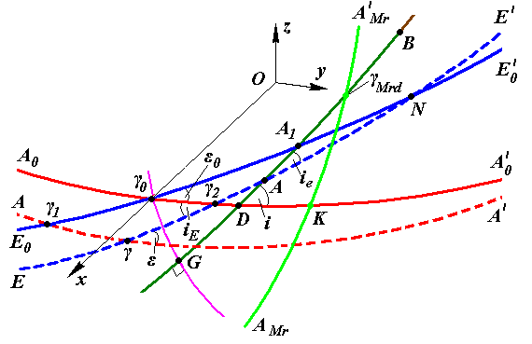
Fig. 2. The parts of the Mercury’s perihelion rotation on the celestial sphere. The designations of planes it is given on Fig. 1; γ_{0G} – an arc of the big circle, which is perpendicular to plane of the Mercury’s orbit GDAB; B – the heliocentric projection of the Mercury’s perihelion to celestial sphere; А – ascending node of the Mercury’s orbit on mobile ecliptic; D – ascending node of the Mercury’s orbit on the motionless equator of epoch Т_{S}; the parameters of the Mercury’s orbit in the inertial equatorial reference frame: ϕ_{Ω} = γ_{0D}; ϕ_{р}.= DB; i = ∠γ₀DG; i_{E} – inclination of the Earth mobile orbit (mobile ecliptic); and in mobile ecliptic system Ω_{a} = γA; ω_{a} = AB; πa = γA + AB = Ω_{a} + ω_{a}; i_{еа} = i_{е} = ∠γAG; index «_{e}» – the angles relative to the mobile ecliptic; index “_{a}” – by the results of approximation of observation data.
From Eq. (2) the velocity of the perihelion rotation along the arcs γA + AB is equal 5602.9 arcsec/century for 1950.0 and 5601.9 arcsec/century for 2000.0. For the elements (Ω_{a}, ω_{a}, i_{еа} etc) of J. L. Simon et al [4] it is equal to 5603.0 arcsec par century to 2000.0. From Fig. 2 it is seen that the determination of the perihelion point B by the value π_{a}, in the velocity of perihelion will require: 1) the velocity of movement of the point γ on the mobile ecliptic EE'; 2) the velocity of displacement of the point A of mobile ecliptic EE' due to its rotation around point N and 3) the velocity of displacement of the ascending node A of Mercury’s orbit GDAB on the mobile ecliptic EE', caused by the rotation of the plane GDAB.
Thus, the value 5599.7 arcsec per century in the 6-th row of Table 1 gives the velocity of the perihelion rotation from the moving point γ of the vernal equinox with the inclusion of velocities of change of the ecliptic and of the Mercury orbit. It is slightly differs from the values 5602 ÷ 5603 arcsec per century determined by the elements of S. Newcomb [3] and J. L. Simon et al [4]. This velocity is not absolute but rather relative. In addition, as shown above, it includes the rates of change of the ecliptic and the orbit of Mercury.
- Absolute Velocity of the Perihelion on Observations
So that these velocities do not affect the velocity of perihelion movement, they should be computed relative a motionless point. As such point we have taken the point G, which is on the crossing of the circle GDAB with the perpendicular circle to it γ₀G. In [2] we derived Eq. (29) for arc GB which depends on parameters of the mobile orbit planes of the Earth (EE') and of Mercury (GDAB) and have the following form:
(4)
The designations are given in the caption of Figure 2. For angles ϕ_{Ω}ª and i_{Ea} , in [2] one may find formulas, which depend on the ecliptic angles of orbits: Ω_{a}, i_{еа} etc. As a result of the approximation of observation data, S. Newcomb [3] represented ecliptic angles by polynomials of the third degree in time of which an example is the formula (2). J.L. Simon et al. [4] have modified Newcomb's results for the epoch of 2000.0 and have utilized polynomials of the 6-th degree.
Eq. (4) gives velocity of the perihelion rotation of Mercury orbit relative to motionless space which equals 582.05 arcsec/century for 1950.0 and 583.15 for 2000.0 [5, 6]. It is the velocity of perihelion rotation according to observation. According to the orbit elements of J.L. Simon et al [4] it equals 582.53 arcsec/century for 2000.0. It equals the absolute velocity of the perihelion based on observational data.
Thus, in the Table 1 the velocity of the perihelion rotation on observational data has not been correctly computed. It is equal to 582 - 583 arcsec per century relative to motionless space.
- The Rotation of Perihelion for Mercury Under Action of the Planets and the Sun

Gravitational Tugs of the Other Planets
The interaction of the Solar system bodies under Newton’s law of gravitation results in changes in their orbits (see Fig. 3), including the rotation of the perihelion. We have developed a refined approach for integrating the equations of celestial and space dynamics, resulting in the software program Galactica. In many of our works, for example [2] and [7], the periods and the amplitudes of the changes of the planets orbits elements are obtained for different time spans, even up to 100 million years. In these calculations the bodies are considered as material points, which interact according to Newton's law of gravity. In Figure 3 in span of 7 thousand years the points 1 show the evolution of the elements of the Mercury orbit, obtained with Galactica. For comparison, the approximations of observation data, made in 1895 by S. Newcomb [3] (line 2) and a hundred years later by J.L. Simon et al [4] (line 3) are given. The evolution of the Mercury perihelion angle relative to the motionless point G in Figure 2 is seen on points 1 on Figure 3 for element ϕ_{р0}. Its velocity is 529.86 arcsec per century. This differs from the observation data of 53 arcsec per century, not 43 arcsec per century, as previously thought.
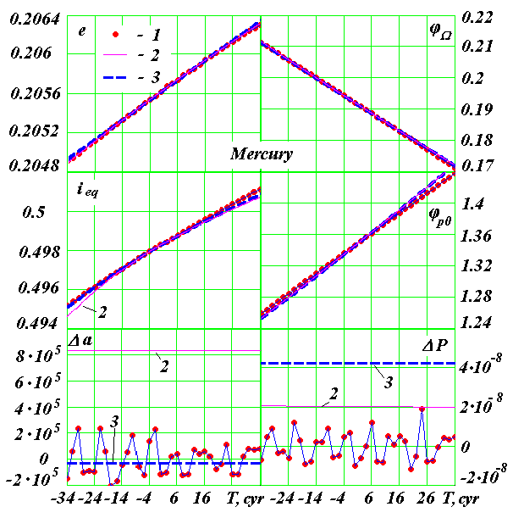
Fig. 3. The secular changes in the orbital elements of Mercury in the interval 7 thousand years and oscillations of the semi-major axis (a) and the orbital period (P): Δa and ΔP are deviations from the means for 7 thousand years; 1 is result of the numerical solution of the program Galactica; 2 is secular variations on Newcomb S., 3 is secular variations on Simon J.L. et al; e is eccentricity; i is the angle of inclination of the orbital plane to the plane of the motionless Earth’s equator at the epoch 2000.0, ϕ_{Ω} is the angular position of the ascending node of the orbit from the motionless equatorial plane; ϕ_{р0} = GB (see Fig. 2). The angles are in radians, the time T in centuries from 1949 December 30.0, Δa in meters and ΔP in years.
In order to find the reason for the difference between calculations based on Newtonian interactions and that according to observation of the velocity of Mercury’s perihelion rotation, we have approached the matter in different ways. First, we have established, that such differences of velocity of the perihelion rotation are present only for the Mercury, which is the closest planet to the Sun. Second, the calculations involving Newtonian interactions of the parameters of the Mercury orbit and the velocity of their changes practically coincided with the data of observation [5, 6].

Influence of Finite Propagation on Speed of Gravity
We investigated influence of gravity propagation velocity on results of interaction of two bodies. The General Theory of Relativity was created to take into account the velocity of gravtitational action. A. Einstein has based his theory on the equations and results obtained by Paul Gerber. Paul Gerber thought up a mechanism of gravity propagation with velocity of light that explains the rotation of perihelion in 43 arcsec/century [8]. However, as we have shown in paper [6], this mechanism is proved by nothing and is erroneous. Besides as is shown above, the difference between the calculations based upon Newtonian interaction and that which is observed is not equal to 43 arcsec/century, but rather to 53 arcsec/century.
In nature, only one mechanism of the interaction propagation with the speed of light is known: it is mechanism of propagation of electromagnetic interaction. From the experimental laws of electromagnetism we have deduced the expression for the force of interaction of two charged particles having charges q₁ and q₂ [9, 10]:
(5)
where , , r and v – distance and velocity of one particle relatively another; – dielectric permeability of media between particles, and – speed of light in media.
Apparently from (5), the force depends not only on distance r between particles, but also on their relative velocity v. For gravity to follow the same mechanism of interaction propagation, the formula (5) must define the gravitational force law such that , where and – masses of interacting bodies, and G – gravitational constant. Utilizing the force law we have calculated a trajectory of movement of one body relatively another at all possible changes of an eccentricity and velocity of body in a perihelion [10] - [13]. In the case of an elliptic orbit the perihelion rotates and the faster it does, the greater the velocity of the body at the perihelion. In such an orbit, the length of the semi-major axis and the period change in comparison with the orbit obtained for the interaction of two bodies due to the Newtonian law of gravitation is as follows: the changes of the semi-major axis and the period are of the same order as the change of the perihelion angle.
The calculation of rotation of Mercury perihelion using the force law has yielded a velocity 0.23 arcsec/century, i.e. almost in 200 times smaller value, than explained by Paul Gerber’s velocity of 43 arcsec/century [8] which is accepted in GR. One must conclude that the excess of the perihelion rotation in 52÷53 arcsec/century may not be explained by the mechanism of gravitational interaction propagation with the speed of light.

Perihelion Precession under the Action of the Sun
The explanation of the excess of perihelion rotation of the Sun oblateness is now complicated by the complexities of the model of interaction and absence of the knowledge of distribution of the Sun density on the radius and along an axis of the Sun. Therefore the calculations (see Table 1) concerning the influence of the Sun’s oblateness, most likely, are doubtful.
If inside the Mercury orbit there was a planet of the certain mass it might produce necessary rotation of the Mercury perihelion and at the same time to not render appreciable influence on other planets. Such a planet is not present. But the Sun rotates about its axis, and the moving masses of its substance may influence Mercury the same as the planet mentioned above. For two centuries these ideas were put forward in various forms. However, satisfactory solutions were not obtained. In 2007, the axis symmetric gravitational n-body interaction problem was solved exactly (see [10] and [14]). Before this solution, there was only one exact solution of the problem of bodies interaction, namely for two bodies, it was obtained by I. Newton 300 years ago. In the references [10] and [14] the exact solution for a symmetrically located on a plane bodies is obtained for all possible cases. The bodies, as in the case of the two bodies, can move in a circle, ellipse, parabola, hyperbola and straight lines. This solution allows one to create a compound model of the Earth's rotation (see [7] and [15]), in which a part of the Earth's mass is distributed between the bodies symmetrically located in the equator plane of Earth. The orbital plane of one of these bodies simulates the evolution of the Earth's equatorial plane under the action of other Solar system bodies.
With assistance from the compound model of the Sun's rotation (see [5, 6] and [16]) one may consider the inverse problem: what changes in the planets motion would such a model of the Sun’s rotation imply? The papers [5] and [6] considered various variants for the action of the compound of the Sun’s rotation with jointly action of other Solar system bodies. It would seem that using the some masses of peripheral bodies of the model, the same velocity of rotation of the perihelion may be obtained and it is the same as the observed one, i.e. 583 arcsec/century. In this case, the rates of change of other parameters of the Mercury’s orbit are unaltered. The velocity of the Venus perihelion does not change appreciably, and parameters of planets more distant from the Sun also change to even a lesser degree. Let's note that the compound model of the Sun rotation takes into account of the Sun oblateness and rotation of its masses.
To make sure that the additional rotation of the perihelion is due only to the compound model, we studied the action only one compound model of the Sun’s rotation (without planets) on Mercury [16]. The differential equations of motion of all bodies have been integrated numerically and have been used to simulate the evolution of Mercury for three thousand years. In this case the rotation of its orbit is received of 53 arcsec per century, i.e. precisely the surplus at the joint influence of compound model of the Sun at the planets.
As a result of our research we shall write down the basic characteristics of rotation of Mercury’s perihelion in such a form (see. Table 2) that they can be compared to the data on Wiki site. The rotation velocities obtained by observation are given for 2000.0 by the orbit elements of S. Newcomb [3] (Ncb) and J.L. Simon et al [4] (Sim).
Apparently, from the above, the problem of perihelion rotation involves many factors. Here we have not mentioned any problem of reliability of observation data approximations. We have tried to state all other problems clearly and with all necessary explanations so that everyone might understand them and be convinced of our conclusions.

Amount (arcsec/century) | Explanation
Based on Observational Data
-5027.86 – Ncb  -5028.82– Sim  (5028.83 – Wiki) | Velocity of movement of vernal equinox point γ relatively motionless space (according Eq. (1))
5601.9 – Ncb  5603.0 – Sim  (5599.7 – Wiki) | Velocity of perihelion rotation relatively the mobile vernal equinox point γ with including velocities changes of ecliptic and of Mercury orbit (according Eq. (2))
583.15 – Ncb  582.53 – Sim | Velocity of perihelion rotation relatively motionless space (according Eq. (4))
By results of interaction under the Newton law of gravity. Velocity of rotation of a perihelion relative to motionless space
530  (530– Wiki) | Planets and the Sun interact as material points
582 | Planets interact as material points, and the oblateness and rotation of the Sun is taken into account as compound model
Table 2. Velocity of rotation of the Mercury perihelion on observation and on Newton interaction. To compare in round brackets (- Wiki) – accordingly Wikipedia [1].
We have briefly outlined a number of stages of the research phenomenon of rotation of the Mercury perihelion, using computer software. We used the numerical integration of the differential equations systems, a variety of calculations with geometric transformations, the mathematical treatment of time series and other computer calculations. As a result, it was found that the components of the perihelion rotation of the Mercury's orbit can be explained by the correct utilization of Newton's gravitational force law applied to the interaction of the celestial bodies.
- Conclusion
- The velocity of perihelion rotation relative to motionless space according to observational data is equal to 583 arcsec per century.
- The velocity of perihelion rotation relative to motionless space as a result of interaction of the planets under Newton’s law of gravitation is 530 arcsec per century.
- The Newtonian interaction of planets and of the compound model of the Sun’s rotation gives the observed Mercury's perihelion precession.
- Acknowledgement
I am grateful to David Weber for interest to the problem and his work to notify the scientific community of our results. Dr. Dennis P. Allen, Jr. revised English of my paper and Gregory D. Volk prepared it for publication; I am most grateful for their assistance. Many calculations in the above-mentioned studies were performed on the supercomputers of the Siberian Supercomputer Center of the Russian Academy of Science.

References
[ 1 ] Wikipedia (2011), http://en.wikipedia.org/wiki/Tests_of_gene ral_relativity.
[ 2 ] Grebenikov, E.A., Smulsky, J.J. 2007. “Evolution of the Mars Orbit on Time Span in Hundred Millions Years“, Reports on Applied Mathematics. Russian Academy of Sciences: A.A. Dorodnicyn Computing Center. Moscow. 63 p. (In Russian http://www.ikz.ru/~smulski/Papers/EvMa100m4t2.pdf).
[ 3 ] Newcomb, S. 1895. The Elements of the Fourth Inner Planets and the Fundamental Constants of Astronomy. Washington: Government printing office. 202 p.
[ 4 ] Simon, J.L., Bretagnon, P., Chapront, J. et al. 1994. Numerical Expression for Precession Formulae and Mean Elements for the Moon and the Planets. Astron. Astrophys. Vol. 282, p. 663-683.
[ 5 ] Smulsky, J.J. 2008. Compound model of rotation of the Sun and displacement of Mercury perihelion / The Fundamental and Applied Problems of the Mechanics: Proceeding of the VI All-Russian scientific Conference, devoted 130-th anniversary of Tomsk state university and 40-th anniversary NII of Applied Mathematics and the Mechanics of Tomsk State University. Tomsk, September 30 - October 2, 2008 - Tomsk: University Publishing House. Pp. 433-434.(In Russian) http://www.ikz.ru/~smulski/Papers/ModSun51c.pdf.
[ 6 ] Smulsky, J.J. 2009. Gravitation, Field and Rotation of Mercury Perihelion / Proceedings of the Natural Philosophy Alliance. 15th Annual Conference 7-11 April 2008 at the University of New Mexiko, Albuquuerque, USA. Vol. 5, No. 2. Published by Space Time Analyses, Ltd. Arlington, MA, USA. Pp. 254-260. http://www.ikz.ru/~smulski/Papers/08Smulsky2c.pdf.
[ 7 ] Melnikov, V.P., Smulsky, J.J. 2009. Astronomical theory of ice ages: New approximations. Solutions and challenges. - Novosibirsk: Academic Publishing House "GEO",. - 84 p. The book in two languages. On the back side in Russian: Mel'nikov V.P., Smul'skiy I.I. Astronomicheskaya teoriya lednikovykh periodov: Novye priblizheniya. Reshennye i nereshennye problemy. - Novosibirsk: Akademicheskoe izdatel'stvo "Geo". 98 stranitz. http://www.ikz.ru/~smulski/Papers/AsThAnE.pdf.
[ 8 ] Gerber, P. 1898. Die raumliche und zeitliche Aubreitung der Gravitation / Z. Math. Phis. Vol. 43.- Pp. 93-104. http://bourabai.narod.ru/articles/gerber/gerber.htm.
[ 9 ] Smulsky, J.J. 1994. "The New Approach and Superluminal Particle Production", Physics Essays. Vol. 7. No. 2. Pp. 153 - 166. http://www.smul1.newmail.ru/English1/FounPhisics/NApSup.pdf.
[ 10 ] Smulsky, J.J. 1999. The Theory of Interaction. - Novosibirsk: Publishing house of Novosibirsk University, Scientific Publishing Center of United Institute of Geology and Geophysics Siberian Branch of Russian Academy of Sciences. -293 p. (In Russian).
[ 10a ] Smulsky, J.J. 2004. The Theory of Interaction. - Ekaterinburg, Russia: Publishing house "Cultural Information Bank". 304 p. (In English) http://www.smul1.newmail.ru/English1/FounPhisics/TVANOT1.doc.
[ 11 ] Smulsky, J.J. 1995. "The Trajectories at Interaction of Two Bodies, which Depend on Relative Distance and Velocity", Mathematical Modeling. Vol. 7. No. 7. Pp. 111-126. (In Russian). http://www.smul1.newmail.ru/Russian1/FounPhisics/TrV2tl.pdf.
[ 12 ] Smulsky, J.J. 2002. The new Fundamental Trajectories: part 1 - Hyperbolic/Elliptic trajectories / Galilcan Electrodynamics. Vol. 13, No. 2. Pp. 23-28.
[ 13 ] Smulsky, J.J. 2002. The new Fundamental Trajectories: part 2 - Parabolic/ Elliptic trajectories / Galilcan Electrodynamics. Vol. 13. No. 3. Pp. 47-51. http://www.smul1.newmail.ru/English1/FounPhisics/NFT.pdf.
[ 14 ] Smulsky, J.J. 2003. Axisymmetrical problem of gravitational interaction of N-bodies / Mathematical modelling. Vol. 15. No 5. Pp. 27-36. (In Russian). http://www.smul1.newmail.ru/Russian1/IntSunSyst/Osvnb4.doc.
[ 15 ] Mel’nikov, V.P., Smul’skii I.I., Smul’skii Ya.I., 2008. Compound modeling of Earth rotation and possible implications for interaction of continents // Russian Geology and Geophysics. Vol. 49. Pp. 851–858. http://www.ikz.ru/~smulski/Papers/RGG190.pdf.
[ 16 ] Smulsky, J.J. 2008. Numerical modeling of evolution of the satellite of a rotating body / In Col. The Theoretical and Applied tasks of the Nonlinear Analysis. Russian Academy of Sciences: A.A. Dorodnicyn Computing Center. Moscow. Pp. 100-118. (In Russian). http://www.ikz.ru/~smulski/Papers/ModSun07c.pdf).

