Smulsky J.J. Superluminal jet engine for interstellar flights // Space Colonization Journal, Vol. 14, 2014, p. 1-7. http://spacecolonization.info/volume/vol14/vol14_en.pdf.
Note. When the paper was published its title has been changed, deleted the Appendix and made some mistakes. Below is the original text of the paper. The Appendix is in Russian.

TO INVESTIGATION STRATEGY
FOR INTERSTELLAR MISSIONS

Smulsky J.J.
E-mail: jsmulsky@mail.ru, http://www.smul1.newmail.ru/
625000, Tyumen, P. O. Box 1230, Institute of Earth's Cryosphere of Siberian Branch of the Russian Academy of Sciences
Abstract. The proposed principles of propulsion for interstellar flights were analyzed and their futility was shown. In space, you can move only by virtue of the reaction of matter ejected from the ship. The greater the velocity of the jet out, the greater the propulsion efficiency. If the jet velocity is equal to the light velocity the acceptable vehicle parameters for flight to the planets of nearest stars can be achieved. Based on no hypotheses notions of electromagnetic interactions, the superluminal particles deriving methods were shown. The idea of superluminal jet blast propulsion is based on one of them. The tasks sequence for solution of the interstellar flights problem was considered. The immediate task is to create the propulsion with a jet velocity of about 100 km/s. This propulsion will provide the Earth asteroid defense. In addition, it can be used to prepare an asteroid as a spacecraft base for interstellar flight.
Keywords: NASA, interstellar, flights, supersonic, motions, jet, propulsion, use, asteroids.

1. Introduction

This article is based on the text of the report: " The grounding of the research strategy for interstellar flights" at the 6th International Conference "The System Analysis and Control of Space Complexes", Yevpatoria 02.07-08.07.2001 The subject of the report was determined after studying of the conference proceedings for invited experts with the following title “NASA Breakthrough Propulsion Physics Workshop, August 12-14, 1997, NASA Lewis Research Center, Cleveland, OH”. The purpose and the title of this conference claimed attention. The mankind progress in making the first steps of space exploration gave rise to the conference of interstellar flights research strategy creation. The main problem of such flights is mover. When I studied the conference proceedings, it was found that all proposed movers are unrealistic. In this regard the question arose: whether in principle there is a method that will allow human to reach the planets of other stars. This paper presents such a method. The question arises: whether this method is the only one? At the international conference ”Asteroid-Comet Hazard-2009”, Russia, St. Petersburg, September 21-25, 2009, an engineer from Serbia Zoran Ilica proposed the propulsion for dangerous asteroids inclination. [1] The essence of his proposal was that the block is unwinded by a thin and long thread, and then it is let off. The motion impulse that is reversed in direction to the block kinetic moment affects the asteroid. I was interested in this method and made rough calculations. However, despite the apparent attractiveness of this method, its efficiency was low. Nevertheless, this example showed that it is necessary to continue the search in the propulsion development. It is possible that propulsion that is better than the one proposed in this article may be found. This raises the question: in what area the search of new mover should be conducted and what is the guide? These issues are also discussed in the article.

2. Suggested methods for interstellar flights

The question "What is outside our living area?" is always a reason for the continuing human interest for learning the new worlds. The space researches of the 20th century showed that the Earth is the only habitable planet of the Solar system. So now the human interest focused on the planets of other stars. Nowadays, space flights are conducted using the jet blast of burning fuel burning the velocity of which is on the order of υ = 5 km/s. According to the formula of K.E. Tsiolkovsky, to conduct a flight to the nearest star the starting mass of the spacecraft m0 must exceed the mass of the returning one by the following factor [2]:
$\frac{m_{0}}{m_{\text{rt}}}=е^{\frac{4с}{v}}=e^{2\text{.}4⋅{\text{10}}^{5}}$. (1)
This large number indicates the impossibility of achieving the planets of other stars using the jet blast of burning fuel. As mentioned above, on the 12-14 August 1997 the U.S. astronautical associations conducted a Breakthrough Propulsion Physics Workshop. The reports can be divided into the following topics or methods:
1. Interstellar flights using the space-time geometry changing:
1.1. tunneling for the purpose of motion;
1.2. warp drive;
1.3. Motion through the space worm hole.
2. The inertial mass changing as a vacuum response to jet propulsion, including:
2.1. researching the mysteries of gravity and inertia;
2.2. using the Casimir force (Casimir force - the force of attraction between the nearby located metal plates);
2.3. using the hypotheses of inertial wind.
3. The use of zero point energy (zero-point energy (ZPE)), including:
3.1. The light radiation microcavity for ZPE implementation;
3.2. Resonant dielectric microspheres for ZPE extraction.
4. The superluminal propulsion in the general theory of relativity (GTR).
5. Possible interactions of rotary type for the unsupported motion.

3. How realistic are the proposed solutions?

Four of the above methods are hypothetical assumptions, inspired by the abstract world building of the 20th century physics. In regard to the fifth method: rotating type of interaction for the unsupported motion, many materials have be collected by me. Supporters of this way till now address to me. I have answered one of them in enough full form, therefore this answer I have applied in the Appendix.
The reason for the mistaken belief that you can drive the spacecraft using unsupported method as well as the four abovementioned methods is a misunderstanding of the mechanics. There are mentions of the force acting on bodies in the theoretical mechanics textbooks, both domestic and foreign, for example Leonard Eisenbud: ”On the classical laws of motion”, there is no force in reality. One body affects another. Man invented the force to explain this phenomenon. Unfortunately, many people do not understand it. To my surprise, when he was teaching theoretical mechanics, I he found out that many of the teachers seriously believe that a force acts on the body. Therefore, in my lecture course "Dynamics" I did not use the slang “a force acts on the body”. I always tried to speak and write as follows: one body affects another, and we describe this impact by the force in this form. Unfortunately, even in the submitted for publication my papers editors often correct the expression "one body affects another, and we describe this impact by the force in this form" to "a force acts on the body” and I cannot correct it. Substantially all of the modern physics mistakes are caused by the literal understanding of slang "a force acts on the body".
I did not mention above another proposed method of moving in space using reflection of light from the mirror surface, which is used for photon propulsion. They are used not only in science fiction novels, but they are also laid in the projects of planned space missions. If the matter particles having a certain mass and velocity bounced from the mirror the mirror would have received the impulse of motion, reversed in direction to the thrown particles. Why it would it have received an impulse of motion? Because of the mirror would have affected the particles accelerating them. Therefore, the particles impact on the mirror in the opposite direction. However, the light reflected from the mirror is not a particle. Light is electromagnetic interference. In other words, the light is the name of phenomenon in which certain interactions occur. Therefore, the mirror does not gain any impulse of motion when reflecting the light. As such the photon rockets are not suitable for movement in space. The idea of photonic rockets followed two erroneous hypotheses about: 1) radiation emission of accelerate moving charge and 2) the comet tail curvature under sunlight. The first hypothesis is partially rejected: electron does not radiate on Bohr orbits. It needs to be dropped completely. Curvature of the comets tails is conditioned by the inner particles motion paths. In addition, the light heats the bodies, and the interaction between heated areas and surrounding particles changes due to heating. This phenomenon is well described by the so-called thermophoretic forces. So considered hypothetical ways of moving in space do not create the possibility for human to make interstellar flights. So let's consider what possibilities we have in no-hypothesis approach to learning the world.

4. Methods for deriving the superluminal particles

I think that the basic philosophical mistake of 19-20 centuries physics is that instead of exploring the surrounding world its construction is based on the input abstract concepts: phlogiston, the electric fluid, ether, field, space-time, string, etc. Rather than to describe the interaction of bodies in those terms, that human observes and measures, the explanation was created through hypothetical constructions, some of which are mentioned above. For example, all the experiments show that the interaction between two charged bodies depends on their relative velocity. However, the theory of relativity (TR) assumes in order to please these hypothetical constructions that the interaction of bodies does not depend on their velocity. Therefore, to address the experimental data, it was assumed that the mass of the moving body $m_{v}$ changes with its velocity υ in such a manner:
$m_{v}=\frac{m_{0}}{\sqrt{1−β^{2}}}$. (2)
where m₀ is body mass at a standstill, $β=\frac{v}{c}$, and c is light velocity.
Forty years ago, scientists have thoroughly studied this problem and, relying only on the experimental results, which are described by Coulomb's, Biot-Savart-Laplace and Faraday’s laws, identified the interaction force between two charged bodies q₁ and q₂, the vector form of which can be written as
$\vec{F}=\frac{q_{1}q_{2}\vec{R}\left(1−β^{2}\right)}{{\left\{1−{\left[\vec{β}∗\vec{R}\right]}^{2}\right\}}^{3/2}}$. (3)
As seen, the body’s approach to the light velocity ($β→1$) causes that not its mass approaches zero, as follows from ( 2) but its action force (3) approaches zero. The mass approach infinity in the TR led to the hypothesis of the superluminal motions inaccessibility. As we can see, such a hypothesis is wrong. There are no restrictions on velocity of motion. In the same way we have defined the interaction forces between the moving magnets and electrified bodies, and we also have developed a procedure for calculation of the bodies’ electromagnetic interactions that move with any velocities [2-6]. We have demonstrated this procedure technique we have demonstrated by examples of various interactions, including examples of accelerators calculation. The TR method is an approximate one and its perceptions are mistaken. Therefore we urgently advise scientists and engineers to apply our method. Without serious consequences it is possible to forget about the Theory of Relativity and it is necessary to throw out it from use.
As we can see, the proposed variants of propulsion are hypothetical and the only real mover in space is a jet blast of substance. Its effectiveness increases with increasing velocity. For example, when the light velocity of jet blast is υ =c, according to (1) the initial mass of the spaceship is $m_{0}=m_{\text{rt}}e^{4}=\text{55}m_{\text{rt}}$. That is quite reasonable. With such propulsion one can in 10 years make a flight to nearby planets and stars and return to Earth. At superluminal velocity of the jet blast the travel time will be even less.
According to (3) when the relative velocity is υ = c force exerted on a charged particle approaches zero. Therefore, the interaction of two charged bodies allows reaching only the light velocity relative to accelerating body. But if the body will move at the velocity in the acceleration direction υ (e.g., relative to the Earth surface), the accelerated particle will move at the absolute velocity $v_{\text{абс}}=с+v>с$, i.e. at the superluminal velocity.
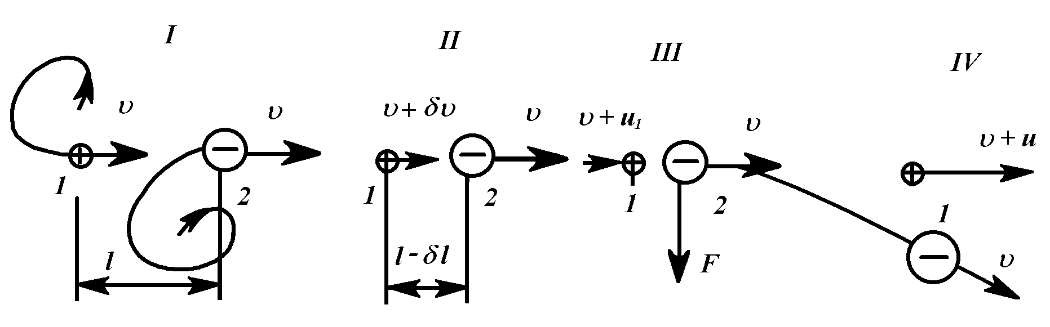
Fig. 1. Superluminal acceleration under the interaction of oppositely charged bunches: 1, 2 – Bunch index; I, II, III, IV – position indexes.

For example, we consider the acceleration of the positive particles bunch 1 (see Fig. 1) and of negative particles bunch which mass is $m_{2}\text{>>}m_{1}$. Let us assume that bunches are got out of accelerators at the same velocity υ approximate to the light velocity. In the process of rapprochement bunch 1 acquires the relative velocity υ₁, and its absolute velocity becomes higher than c, and the velocity of bunch 2 does not change practically because of its great mass. Then, the transverse action F is exerted on bunches and bunch 1 is diverted from the acceleration line. Because of the high velocity of 1 bunch transverse action F does not divert it. Calculations show [2] that if we speak about the actually achievable bunch of electrons 2 with particle number N₂=6∙10⁶ and of 2 centimeters in diameter it can accelerate the proton bunch to the absolute velocity of 1.3c.
There may be other acceleration schemes. We consider the collision acceleration of similarly charged particles. Let us assume that a proton at the velocity υ₀ at infinite is oriented to fixed positron (Fig. 2). It approaches the positron and the positron is accelerating simultaneously.
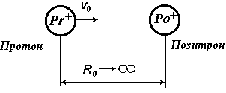

Fig. 2. Starting of the acceleration phase.

When approaching for the smallest distance R min (Fig. 3) the positron velocity relative to proton becomes equal to zero, and to the device – υ₀.
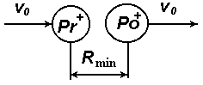

Fig. 3. The middle acceleration phase.
Then positron starts to move away from the positron proton (Fig. 4). Its velocity is υ_{rel} = υ₀ when moving off to infinity relative to proton, and relative to the device is υ_{po} = υ₀ + υ_{rel} = 2υ₀.
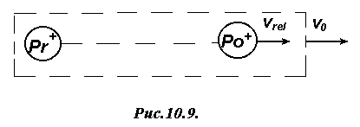
Fig. 4. The end phase of acceleration.

The initial velocity of the proton, which allows particles getting close for the distance equal to the sum of proton and positron radiuses R_{min} = R_{pr}+ R_{po} is determined by the formulas [2]:
$v_{0} = \sqrt{\text{1 -exp} α_{\text{pr}}}$, (4)
where
$α_{\text{pr}} = − \frac{2e^{2}}{c_{1}^{2}m_{\text{po}}\left(R_{\text{pr}}+ R_{\text{po}}\right)}$. (5)
After the substitution of the parameters we have α_{pr} = -1.34 and the proton initial velocity is υ₀ = 0.859c. At this proton velocity the positron accelerates to . υ_{po} = 2 υ₀ = 1.72c, e.g. there are superluminal positrons. In such a way one can accelerate the electrons by antiprotons.

5. The variant of superluminal jet propulsion

These methods of particles accelerating to superluminal velocity can be used for superluminal jet propulsion engine, that is shown schematically in Fig. 5 below. It consists of two accelerating devices for heavy particles: 1 - for protons (Pr); 2 - for antiprotons (aPr) and two deflectors 3 – for antiprotons and 4 - for protons. These devices provide the circulation of heavy particles in the xy plane through two circuits: the circuit I - protons; circuit II - antiprotons. In the devices 1 and 2, heavy particles are introduced alternately at a velocity υ₀ on the centerline x of the jet propulsion engine. In the deflecting devices 3 and 4, these particles are derived from the axial line: protons to the circuit I and antiprotons to the circuit II.
In the plane perpendicular to the drawing (see Fig. 5 section A-A, the plane xz) there are two ejection and light particles acceleration circuits: 5 is for electrons (e), 6 is for positrons (po). These devices introduce light particles alternately at the velocity of υ₀ - δυ to the centerline x of jet propulsion.
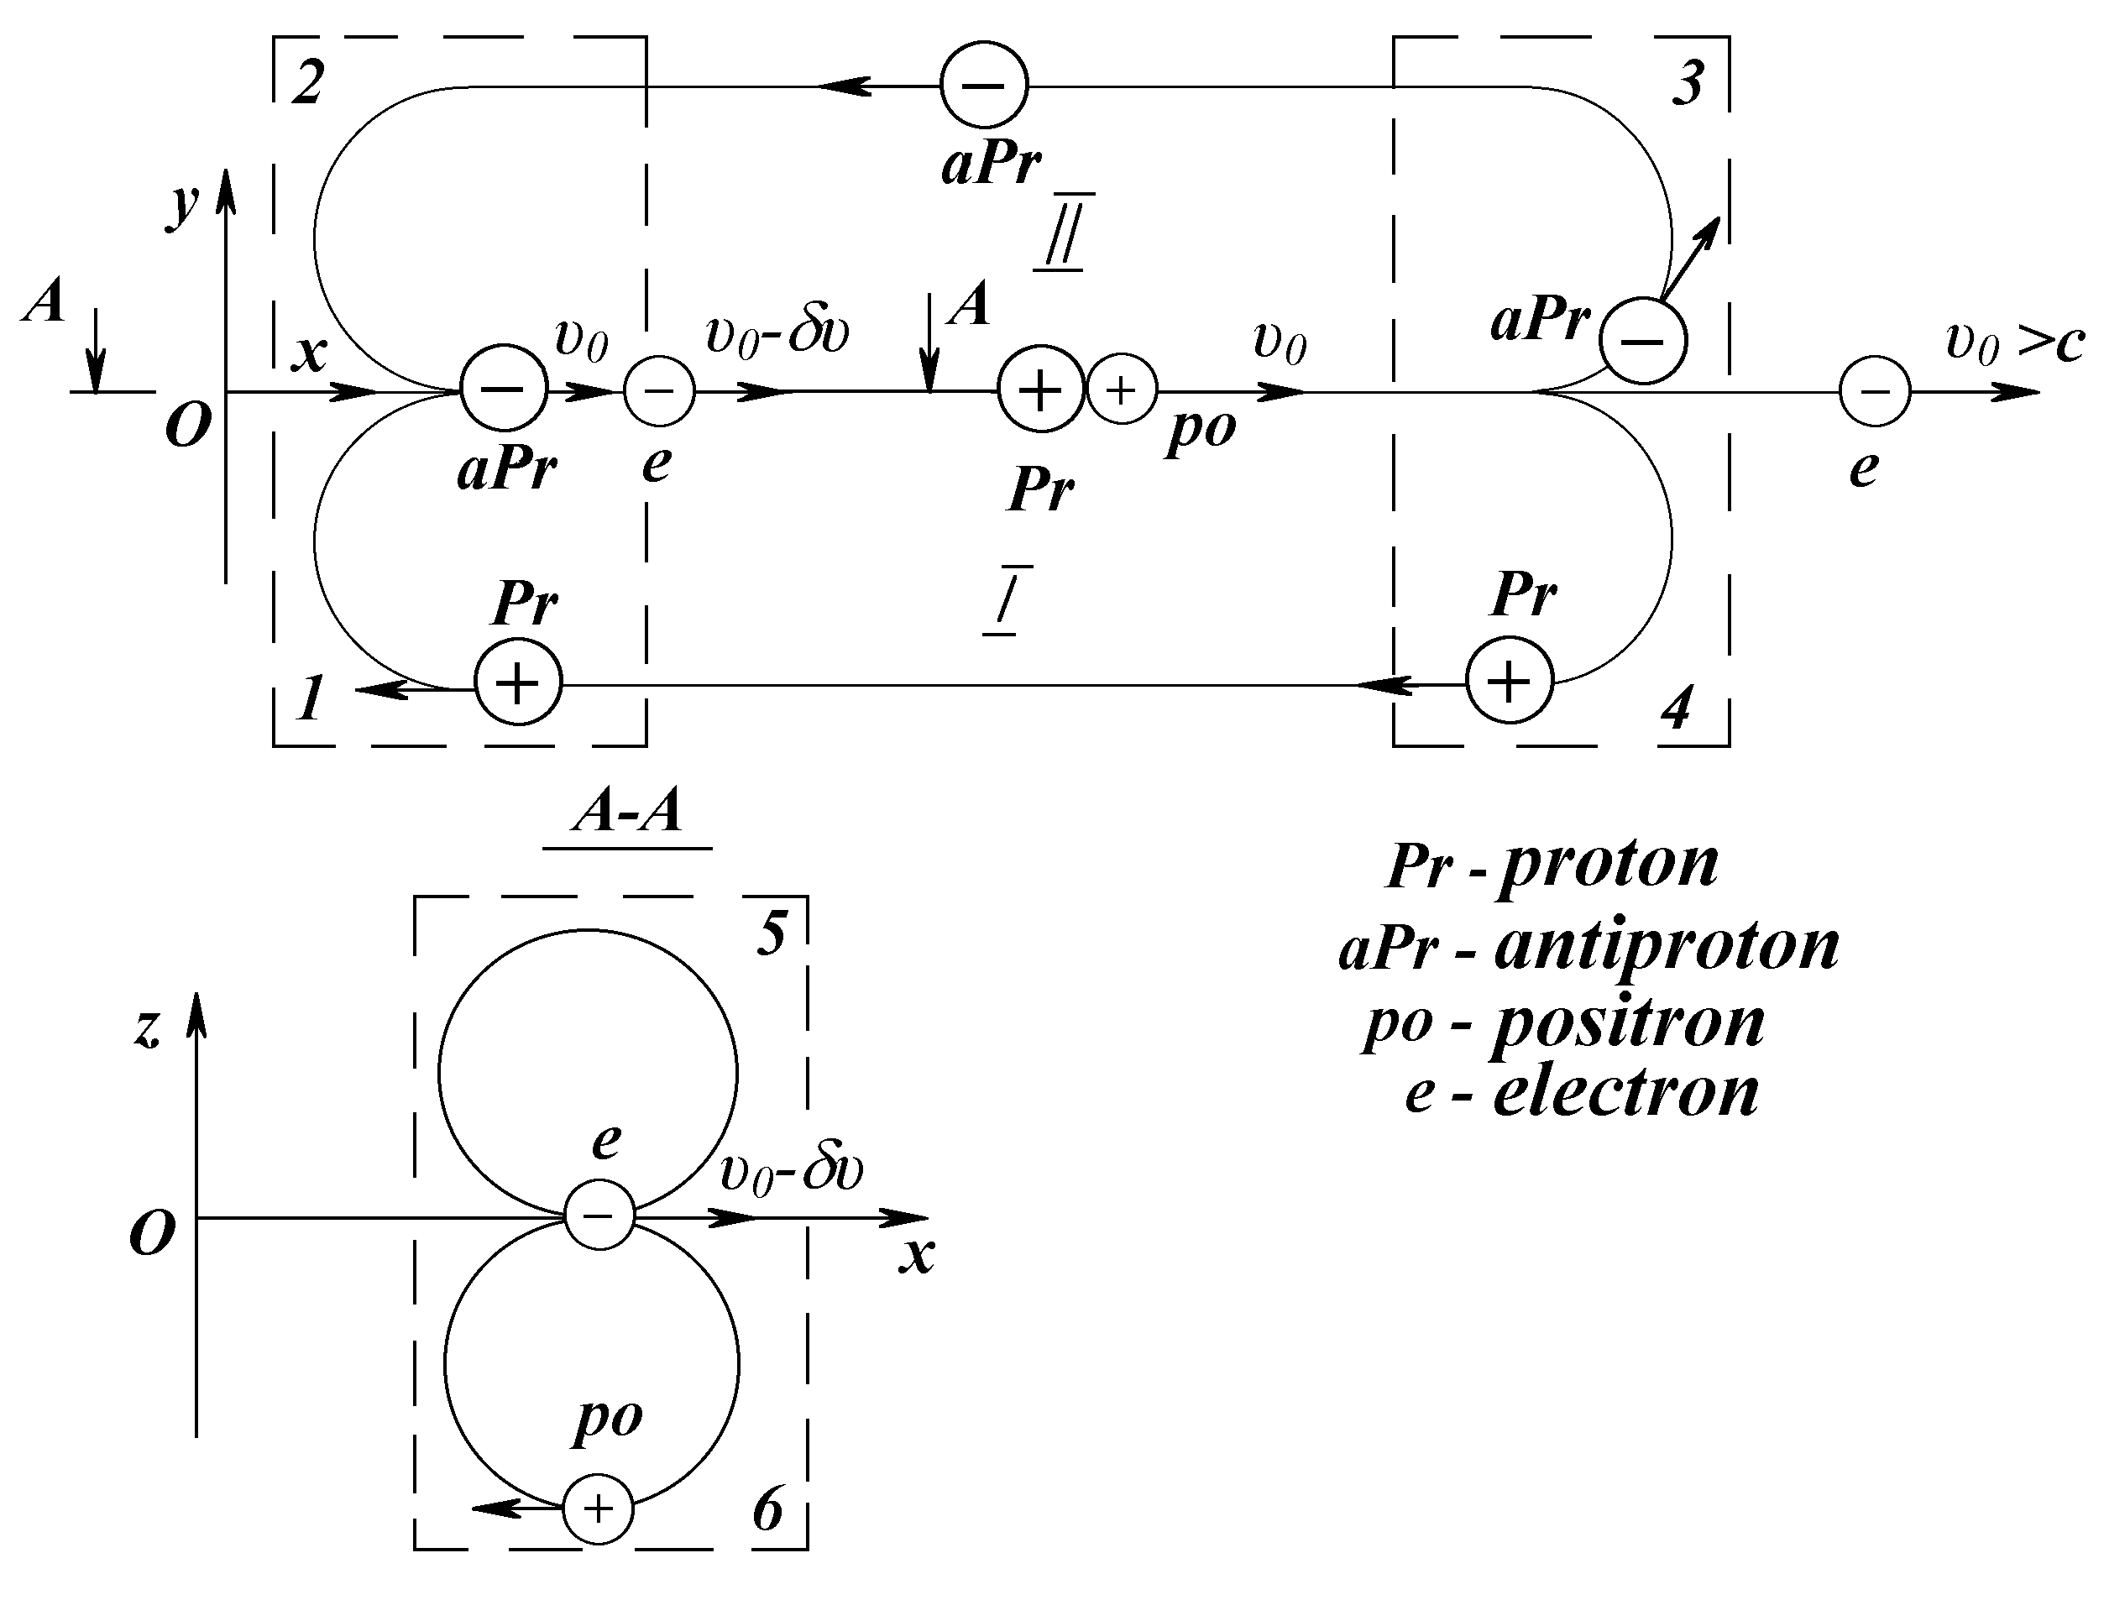

Fig. 5. The scheme of the jet propulsion engine with superluminal jet blast of accelerated particles.

The acceleration collision of similarly charged particles occurs on the centerline x. The initial stage of electron acceleration by antiproton is shown on the left side (Fig. 5). Since the electron 5 injection velocity is less that the antiproton velocity, so antiproton catching up with it. At that the electron velocity increases. At the moment of rapprochement the electron velocity is equal to υ₀, then the electron starts trooping off the antiproton, and its velocity will increase. The moment of rapprochement in the interaction of protons and positrons is shown in the middle part of the propulsion, and in the right side there is the final phase of the antiproton and electron interaction. Antiproton returns to the circulation circuit II by the deflector 3, and superluminal electron continues to move along the axis x. Thus there is an alternate ejection of the oppositely charged particles, so propulsion remains electrically neutral. Due to the symmetry of the devices the spin moments are not created therein. For υ₀ = 0.859 с jet blest velocity is equal to 1.72 с.

6. Research objectives for the implementation of superluminal motions

As we have noted, jet propulsion of superluminal particles allows us to reach the planets of nearest stars in a few years. It is quite realistic means way to allow human to go beyond its habitat. However, its implementation needs to solve many scientific problems. You can select the following research objectives.
1. Learning superluminal motions. The first step is to create particle accelerators to superluminal velocity and study the properties of superluminal particles. Then you need to analyze flows of superluminal particles coming to us from outer space, and learn to recognize the information about space objects they carry. Superluminal particles can be used for probe of space objects and for Deep Space Communication. It is also possible to use them for destruction of substance that can be used and in asteroid and comet defenses.
2. Revise of all physical notions. Distant space travels will hold human to have specific knowledge of macro-and microcosm, which should not be burdened with hypothetical constructs. Therefore, all modern physics, from Rutherford's experiments should be revised on the no-hypotheses basis. The microcosm objects must be determined clearly and simply. If we speak about bodies, they must have the dimensions, move relative to other bodies, they will move driven by other bodies, and the impact on them can be expressed in terms of force. If this is not the body, there are the properties of other bodies. Which bodies? If it is neither one thing and nor the other, it is something new: ether, field, matter, energy, etc. And if it is determined, we know its properties and can use them properly. At this stage human know no objects of his environment but bodies. And all hypothetical constructs must be removed from modern physics.
3. Creating of superluminal jet blast require huge power drains. Nowadays such sources of energy are known: chemical, nuclear, thermonuclear; they are unable to meet emerging needs. Only an in-depth insight into the microcosm secrets, studying of the components properties and their interactions will allow human to reach a new level of energy development. Therefore, the strategy of creating the necessary energy source for interstellar flights will be based on the no-hypotheses physics results of the 21st century.

7. Conclusions

The most rapid development of tools and techniques of human occurs during the delivery of certain works. Works associated with changes in the asteroid orbits mature in outer space. For example, in the coming decades the asteroid Apophis was offered to transform into the Earth satellite [7, 8]. Then, in future more massive asteroid 1950 DA could be transformed into the Earth satellite [9]. In the case of danger, there may be an urgent need to change the path of the asteroid approaching the Earth. These works need to create highly efficient propulsion. A method proposed by Ilica that was mentioned in the introduction [1], appeal that any asteroid substance is appropriate for the rejected jet blest. However, the apparent simplicity of this substance acceleration due to the rotational motion raises many problems under close examination. Therefore, it is advisable to accelerate and reject the asteroid substance in a straight direction. The type of accelerator-substance interaction and the acceleration method is largely determined by energy source. For the abovementioned tasks of changing the asteroid path it is needed to approach achieving the ejection velocity of about 100 km/sec. Currently the velocities of less order were achieved in laboratories [10]. Therefore, a research strategy for interstellar flights will soon be branched into two directions. Research is needed to be established in the fiels of creation flows of superluminal particles and increasing their power.
To solve practical problems in interplanetary space the propulsion having an ejection velocity of about 100 km/s should be developed, as well as energy supply for him.
If the latter problem is solved, mankind will be able to prevent the asteroid threat to the Earth if appeared. For another thing the technology of asteroid path changing will be used to create a spacecraft for interstellar flight. Such spacecraft mass is comparable to the mass of the asteroid. For example, if the mass of the returning spacecraft is m_{rt} = 10000 tons, the initial mass of the spacecraft must be at least m₀ = 0.55 million tons even at a jet blast velocity equal to the light velocity. This mass is comparable to the 30 million tons mass of such asteroid as Apophis. Apparently, an interstellar spacecraft will be based on the "tame" asteroid in the vicinity of the Earth. During the flight to the planets of other star its substance will be spent on the motion. For the return flight to the Earth the crew learns the asteroid of this star and returns home due to its substance.

REFERENCES

[1]. Ilitz Z.M. Rotational mass driver – an efficient NEO deflection concept/“Protecting the Earth against collisions with asteroids and comet nuclei” Proceeding of International Confrence “Asteroid–Comet Hazard – 2009”, St. Petersburg “Nauka”, pp. 381-389, 2010.
[2]. Smulsky J. J. Theory of Interaction. - Novosibirsk: Publishing House of Novosibirsk University, NSC UIGGM SB RAS. 1999. - 294 p. URL: http://www.ikz.ru/~smulski/TVfulA5_2.pdf.
[3]. Smulsky J.J. The New Approach and Superluminal Particle Production//Physics Essays.-1994.- Vol.7.-No. 2, pp.153-166. URL: http://www.smul1.newmail.ru/English1/FounPhisics/NApSup.pdf.
[4]. Smulsky J. J. Producing Superluminal Particles//Apeiron, Vol. 4, No.2-3, pp. 92-93, 1997.
[5]. Smulsky J. J. Appeal to Experimental Physicists//Galilean Electrodynamics. – 1998. – Vol. 9, No. 5. – p. 88. URL: http://www.smul1.newmail.ru/Russian1/FounPhisics/OBRASCH2.doc.
[6]. Smulsky J. J. Electromagnetic and gravitational effects (non-relativistic treatises.) - Novosibirsk: "Science". Sib. izdat. firm, 1994.– 224 p. URL: http://www.ikz.ru/~smulski/ElGrVz.djvu
[7]. Joseph J. Smulsky. Asteroid Apophis: evolution of the orbit and the possible use. Space Colonization Journal, Vol. 10, 2014.URL: http://spacecolonization.info/volume/vol10/ (in English).
[8]. Smulsky J. J. and Smulsky Ya. J. Dynamic Problems of the Planets and Asteroids, and Their Discussion//International Journal of Astronomy and Astrophysics, Vol. 2, No. 3, pp. 129-155, 2012. doi:10.4236/ijaa.2012.23018. URL: http://www.ikz.ru/~smulski/Papers/AsAp1950E13cJ.pdf.
[9]. Smulsky J. J., Smulsky Ya. J. Asteroids Apophis and 1950 DA: 1000 Years Orbit Evolution and Possible Use//Horizons in Earth Science Research. Vol. 6. Editors: Benjamin Veress and Jozsi Szigethy. Nova Science Publishers, USA, pp. 63-97, 2012. URL: https://www.novapublishers.com/catalog/index.php.
[10]. Khristenko Yu. F. Ways to improve the velocity in throwing light-gas installations/Modern ballistics and related matters mechanics: Collection of scientific conference. Tomsk State University, pp. 106-107, 2010. 7

Appendix
ABOUT UNSUPPORTED MOVEMENT
Smulsky J.J
О БЕЗОПОРНОМ ДВИЖЕНИИ
Смульский И.И.
Периодически всплывают идеи о движении тела без взаимодействия его с другими телами, т.е. движении тела без опоры его о другие тела. Напомню, что поезд приобретает движение, потому что локомотив своими колесами отталкивается от рельс. Корабль отталкивает винтами воду, а самолет – воздух. Ракета приобретает движение, потому что с большой скоростью отталкивает от себя вещество в газообразном состоянии.
Все это просто и понятно до тех пор, пока человек не погрузится в математические дебри современной механики и физики. Находясь в них и забыв свой жизненный опыт, человек теряет ориентиры и критерии истинности, и выдвигает различные варианты безопорного движения: за счет внутренних сил, внутренней энергии, силовых или торсионных полей и т.п.
Ниже прилагаю письмо одного представителя из их числа, фамилию которого я изменил. Он разместил письмо на форуме моей веб-страницы "Главное направление" http://www.smul1.newmail.ru/Smulsky.dhtml, посвященной проблеме полета к планетам других звезд. Ниже, в ответе на это письмо я объясняю, почему безопорное движение невозможно.

Здравствуйте, уважаемый Иосиф Иосифович.
Несколько месяцев назад, я выставил в Интернете задачу по теоретической механике. Мои решения данной задачи допускают перемещение центра масс замкнутой механической системы только за счет внутренней энергии. Это перемещение происходит в полном соответствии с законами сохранения.
Нет, я не являюсь сторонником сверхсветовых скоростей. Не хочу также, чтобы меня относили к "инерционщикам". Я хочу убедить многих в том, что моя работа есть настоящее исследование из области теоретической механики. Хотел бы обратиться к Вам, как к специалисту по теормеху. Быть может, Вы посмотрите сами, или порекомендуете кому-нибудь рассмотреть мой материал? Математика, которую я выставил – совсем несложная. Но разобраться в ней может лишь специалист.
С уважением, В. Тубов

Уважаемый Василий Сергеевич!
С идеями движения за счет внутренних сил я сталкивался, начиная с 1963 г., много раз. Помню, в 1963 г. на информационном стенде в Харьковском авиационном институте были вывешены вырезки из газет и журналов о машине Дине. Там же были представлены мнения сотрудников кафедры теоретической механики. Только один преподаватель отозвался о машине Дина отрицательно и определенно. Больше всего меня удивил ответ заведующего кафедры Якова Лазаревича Геронимуса, чл.-корр. АН УССР. Его лекции я слушал три семестра. Знал он теоретическую механику великолепно, а читал лекции с таким мастерством, выше которого быть не может. Лет 5 назад я познакомился с его большой книгой о теоретической механике и с удивлением обнаружил, что многие мои соображения о теоретической механике и о ее преподавании совпадают с его.
Тогда, в студенческие годы, меня удивил ответ Я.Л. Геронимуса: с позиций классической механики движение за счет внутренних сил невозможно. Этот ответ можно было интерпретировать так: с других позиций движение за счет внутренних сил возможно. Поэтому я заинтересовался этой проблемой. В областной научной библиотеке имени Короленко мне помогли найти материалы о машине Дина. Суть ее заключалась в том, что вертикально колеблющаяся платформа при движение вниз воздействует на корпус через пружину, и при движении вверх – жестким ударом. В течение года я составлял дифференциальные уравнения движения ее составных частей и их решал. Наконец решил и получил нулевой результирующий эффект.
Потом этот аппарат я использовал в своем дипломном проекте «Космический лифт» http://zhurnal.lib.ru/editors/s/smulxskij_i_i/kosmlifthtm.shtml. Здесь при движении вниз платформа взаимодействовала с канатом, а при движении вверх – с корпусом. В этом случае, естественно, аппарат получал возможность двигаться вверх.
Эти идеи движения за счет внутренних сил периодически всплывали вблизи меня: давали мне на отзыв работу с экспериментами по «эффекту Рима», на конференциях слушал доклады об инерциоидах и видел демонстрацию их горизонтального движения и т.п. О причине горизонтального движения инерциоидов я рассказывал студентам (см. стр. 37 «Динамика» http://www.ikz.ru/~smulski/Dinmk3A5.pdf). Все эти идеи обусловлены незнанием теоретической механики и непониманием ее основ. В конспективном виде основы механики даны вначале конспекта лекций «Динамика», а детально – приведены в первых главах моей книги «Теория взаимодействия».
В чем же суть невозможности движения за счет внутренних сил? Почему невозможно такое движение не только с позиций классической механики?
Ответ чрезвычайно прост. Одно тело или совокупность тел (механическая система) могут начать движение лишь в том случае, когда на тело или на совокупность тел будет действовать другое тело.
К сожалению, об этой простой истине забывают все, кто увлекается движением за счет внутренних сил. Затем они допускают другие ошибки при доказательстве своих идей. В каждом конкретном случае ошибки могут быть одинаковыми, а могут отличаться. Поэтому советую Вам осознать эту главную причину и даже, не вскрывая своих ошибок, забыть о своем увлечении. На моей памяти имеется несколько случаев, когда эти навязчивые идеи доводили их приверженцев до психических расстройств.
Ваше заявление: «Я не являюсь сторонником сверхсветового движения» заслуживает моего комментария. Такие заявления: я не являюсь сторонником…, он не является героем моего романа… и т.п. часто можно услышать в средствах массовой информации. Однако, они, по своему существу, безответственны. Ученые не должны их применять. Если ученый высказывает какое-либо мнение, оно должно быть определенным и обоснованным. Вот, если Вы проанализируете мои доказательства возможности сверхсветовых движений и увидите их ошибочность, тогда об этом нужно сказать аргументировано. А в таком виде: «Я не являюсь сторонником сверхсветового движения» Ваше суждение не имеет никакого смысла.
С уважением 18.06.07 г. И.И. Смульский

